Association between White Blood Cell Count and Remnant Cholesterol Inflammatory Index in Middle-Aged and Older Adults: A Cross-National Database Study Using NHANES and CHARLS
Zhan Ye*
Hebei Medical University, Shijiazhuang 050017, Hebei, China
*Corresponding author: Zhan Ye, 3303065125@qq.com

Copyright: © 2026 Author(s). This is an open-access article distributed under the terms of the Creative Commons Attribution License (CC BY 4.0), permitting distribution and reproduction in any medium, provided the original work is cited.

Abstract: Objectives: The remnant cholesterol inflammatory index (RCII) is a novel composite biomarker that integrates lipid residual risk and inflammatory status. White blood cell (WBC) count, one of the most routine clinical inflammatory indicators, has an undefined association with RCII and unknown joint prognostic significance. This study aimed to investigate the cross-sectional association and longitudinal prognostic implications of WBC and RCII in middle-aged and older populations, so as to deepen the understanding of the “lipid-inflammation” cycle. Methods: Cross-sectional analyses were performed in two cohorts of adults aged 45 years and older: NHANES (2015–2016, n = 2,839) and CHARLS (2011, n = 5,955). Multivariable logistic regression and restricted cubic spline (RCS) analyses were used to assess the association and its nonlinearity. Longitudinal analyses utilized CHARLS follow-up data (2011–2015), applying Kaplan-Meier curves and Cox proportional hazards models to examine differences in long-term survival across categories of RCII and WBC. Results: In fully adjusted models, WBC was significantly and positively associated with RCII in both cohorts (NHANES: OR = 1.097, 95% CI: 1.038–1.158; CHARLS: OR = 1.309, 95% CI: 1.266–1.354). RCS analyses further revealed a nonlinear relationship. Longitudinal analyses demonstrated a noteworthy interactive phenomenon: in the low RCII group, individuals with high WBC exhibited significantly lower 5-year survival than those with low WBC, whereas in the high RCII group, the survival curves for different WBC levels tended to overlap. Conclusion: WBC count is nonlinearly and positively associated with RCII in both U.S. and Chinese middle-aged and older adults, with elevated WBC independently predicting higher mortality specifically in low-RCII individuals. This supports WBC as a low-cost adjunctive marker for risk stratification and highlights its prognostic value beyond RCII alone.
Keywords: China health and retirement longitudinal study; White blood cell count; National health and nutrition examination survey; Remnant cholesterol inflammatory index; Middle-aged and older adults

Online publication:

1. Introduction
Cardiovascular disease (CVD) is the leading cause of global mortality, imposing substantial burdens on middle-aged and older populations ^{[1]}. Chronic inflammation is pivotal in CVD pathogenesis. The remnant cholesterol inflammatory index (RCII), a novel cardiovascular risk biomarker, integrates lipid residual risk and systemic inflammation. White blood cell (WBC) count, a routine clinical indicator, reflects inflammatory status. However, the quantitative relationship between WBC and RCII remains unexplored ^{[2]}.
Remnant cholesterol (RC), calculated as total cholesterol minus HDL-C and LDL-C, is a key CVD risk factor. High-sensitivity C-reactive protein (hs-CRP) is used for both inflammation monitoring and CVD risk assessment ^{[3]}. Middle-aged and older adults have higher atherosclerotic burden and chronic inflammation ^{[4]}. Although RC and hs-CRP independently predict cardiovascular residual risk, they represent intertwined dimensions of the “lipid-inflammation” axis ^{[5]}. Evaluating either alone may underestimate high-risk individuals with acceptable lipid levels but chronic inflammation. RCII was thus proposed to capture the synergistic effects of dyslipidemia and inflammation ^{[6]}. Its computational simplicity makes it a potential tool for epidemiological research and primary care ^{[7]}.
WBC count is a readily available peripheral blood indicator. Even within the normal range, subtle WBC fluctuations may reflect low-grade systemic inflammation ^{[8]}, closely linked to atherosclerosis. WBC thus serves as both an “alarm” for infection and a “barometer” of cardiometabolic risk ^{[9]}. However, whether a quantitative association exists between WBC and RCII, and whether this association carries differentiated clinical significance, remains largely unexplored.
This association is rooted in a “lipid-inflammation” vicious cycle ^{[10]}. Oxidized remnant cholesterol particles activate endothelial cells and monocytes, releasing IL-6, TNF-α, and MCP-1 ^{[11]}. These cytokines stimulate hepatic CRP synthesis (elevating RCII) and activate bone marrow hematopoiesis (raising WBC). Conversely, inflammatory cells infiltrate the vessel wall, exacerbating plaque progression ^{[12]}. Thus, the WBC-RCII association is a population-level manifestation of this cycle.

2. Methods
2.1. Study design and participants
This study utilized data from two nationally representative cohorts: NHANES (2015–2016) and CHARLS (2011), including participants aged ≥45 years. After applying inclusion and exclusion criteria, 2,839 NHANES and 5,955 CHARLS participants were included.

2.2. Definition of white blood cell count
WBC count (×10⁹/L) was obtained from laboratory data in both cohorts. RC was calculated as: RC (mg/dL) = TC − (HDL-C + LDL-C). RCII was computed as: in NHANES, RCII = RC (mg/dL) × hs-CRP (mg/L); in CHARLS, RCII = RC (mg/dL) × CRP (mg/dL) / 10 (unit conversion for consistency).
Covariates included sociodemographic characteristics (age, sex, race/ethnicity [NHANES only], education, marital status, income), health status (hypertension, diabetes, coronary heart disease, stroke, cancer, based on self-reported physician diagnosis or measured parameters), and physical/laboratory measurements (BMI, etc.).

2.3. Calculation of RC and RCII
Remnant cholesterol (RC) was calculated as: RC (mg/dL) = total cholesterol (TC) − [high-density lipoprotein cholesterol (HDL-C) + low-density lipoprotein cholesterol (LDL-C)]. The remnant cholesterol inflammatory index (RCII) was computed as follows: in NHANES, RCII = RC (mg/dL) × hs-CRP (mg/L); in CHARLS, because the measurement unit for C-reactive protein is mg/dL, these units were converted to maintain consistency of magnitude with NHANES, and the formula used was: RCII = RC (mg/dL) × CRP (mg/dL) / 10.

2.4. Covariate assessment
Covariates were collected through standardized questionnaires and physical examinations, covering three main categories of information:
(1) sociodemographic characteristics, including age, sex, race/ethnicity (NHANES only), education level, marital status, and household income level;
(2) health status and disease history, with hypertension defined as self-reported physician diagnosis, current use of antihypertensive medication, or measured systolic blood pressure ≥ 140 mmHg or diastolic blood pressure ≥ 90 mmHg; other self-reported chronic disease histories including diabetes, coronary heart disease (encompassing heart failure, angina pectoris, and myocardial infarction), stroke, and cancer, all based on physician diagnosis reported by participants;
(3) physical measurements and laboratory indicators, including body mass index (BMI), among others.

2.5. Statistical analysis
Analyses were performed using RevMan 5.4. Cross-sectionally, WBC and RCII were continuous variables. Logistic regression and RCS assessed the association. Longitudinally, Cox regression and Kaplan-Meier curves examined survival. Statistical significance was set at two-sided P < 0.05.

3. Results
3.1. Baseline characteristics
Table 1. Baseline characteristics of the CHARLS database stratified by RCII
Variable | Low RCII group | High RCII group | p value
Sex | 0.5 ± 0.5 | 0.5 ± 0.5 | 0.0202
Age | 60.20 ± 9.64 | 61.56 ± 9.63 | 0.0000
Hypertension | 22% | 35% | 0.0000
Dyslipidemia | 7% | 13% | 0.0000
Diabetes | 4% | 8% | 0.0000
Region | 0.0% | 0.0% | 0.3840
Education category | 1.1 ± 0.3 | 0.7 ± 0.4 | 0.2700
BMI | 22.80 ± 13.58 | 24.35 ± 10.33 | 0.0000
Body mass category | 8.0% | 7.5% | 0.0002
MetS | 59.0% | 65.6% | 0.0000
Platelet count | 208.24 ± 75.39 | 214.51 ± 82.38 | 0.0022
Blood urea nitrogen | 16.10 ± 4.79 | 15.74 ± 4.48 | 0.0028
Blood glucose | 104.27 ± 25.42 | 117.93 ± 47.09 | 0.0000
Creatinine | 0.77 ± 0.21 | 0.80 ± 0.23 | 0.0000
Total cholesterol | 189.18 ± 35.45 | 197.99 ± 40.86 | 0.0000
Triglycerides | 94.21 ± 41.59 | 168.39 ± 115.69 | 0.0000
HDL-C | 56.84 ± 14.84 | 45.90 ± 13.94 | 0.0000
LDL-C | 113.49 ± 34.94 | 119.27 ± 35.38 | 0.0000
C-reactive protein | 0.78 ± 0.69 | 5.20 ± 11.55 | 0.0000
HbA1c | 5.18 ± 0.68 | 5.40 ± 0.97 | 0.0000
Uric acid | 4.21 ± 1.16 | 4.70 ± 1.30 | 0.0000
Serum creatinine | 41.23 ± 6.25 | 41.91 ± 6.38 | 0.0000
Hemoglobin | 14.18 ± 2.22 | 14.56 ± 2.32 | 0.0000
Cystatin C | 1.02 ± 0.24 | 1.06 ± 0.32 | 0.0000
White blood cell count | 5.87 ± 1.68 | 6.70 ± 2.76 | 0.0000

Table 2. Baseline characteristics of the NHANES database stratified by RCII
Variable | High RCII group | Low RCII group | p value
Sex (Male %) | 51.9 | 65.4 | 0.0364
Sex (Female %) | 48.1 | 34.6 | 0.0258
Age | 62.4 ± 10.9 | 0.0066 | <0.0001
Race/ethnicity | 64 ± 10.3 | 47 ± 6.6 | <0.0001
Education (College % or above) | 86 ± 13.8 | 90 ± 12.7 | <0.0001
Marital status (Married %) | 58.5 | 53.2 | <0.0001
White blood cell count (LBXWBCSI) | 7.0 ± 2.7 | 6.2 ± 2.2 | <0.0001
Red blood cell count (LBXRBCSI) | 4.6 ± 0.5 | 6.5 ± 0.4 | <0.0001
Dyslipidemia | 14.1 | 13.7 | <0.0001
Hematocrit (LBXHCT) | 41.4 ± 4.0 | 40.4 ± 4.2 | <0.0001
Mean corpuscular volume (LBXMCVSI) | 90.5 ± 5.5 | 90.8 ± 6.3 | 0.3886
Platelet count (LBXPLTSI) | 235.5 ± 60.1 | 223.7 ± 63.0 | 0.0005
Hypertension (%) | 56.4 | 49.5 | 0.0229
Urine microalbumin (URXUMA) | 374.1 ± 71.6 | 312.0 ± 53.3 | 0.0335
Urine creatinine (URXCRS) | 10476.5 ± 5888.0 | 10352.7 ± 6089.8 | 0.0079
Diabetes | 26.4 | 21.7 | <0.0001
Aspartate aminotransferase (LBXSASSI) | 26.7 ± 17.9 | 25.1 ± 12.8 | 0.0743
Alkaline phosphatase (LBXSAPSI) | 74.0 ± 34.9 | 69.5 ± 24.0 | 0.0064
Calcium (LBXSCA) | 9.4 ± 0.4 | 9.3 ± 0.3 | 0.0208
Creatine kinase (LBXSCK) | 144.5 ± 121.6 | 127.2 ± 13.3 | 0.0079
Total cholesterol (LBXSCH) | 200.8 ± 43.1 | 186.6 ± 40.0 | <0.0001
Creatinine (LBXSCR) | 1.0 ± 0.4 | 0.9 ± 0.6 | 0.8190
γ-glutamyl transferase (LBXSGTSI) | 34.6 ± 2.8 | 26.1 ± 3.3 | 0.0001
Blood glucose (LBXSGL) | 114.1 ± 40.8 | 103.9 ± 29.5 | <0.0001
Total cholesterol (LBXTC) | 203.3 ± 42.4 | 188.7 ± 40.0 | <0.0001
LDL-C (LBDLDL) | 120.2 ± 38.9 | 112.5 ± 33.6 | 0.0001
HDL-C (LBDHDD) | 48.2 ± 11.7 | 60.2 ± 16.9 | <0.0001
RC | 34.9 ± 11.7 | 16.0 ± 3.8 | <0.0001

Table 1 and Table 2 summarize the baseline characteristics of the CHARLS (n = 5,955) and NHANES (n = 2,588) cohorts stratified by RCII. In both populations, the high RCII group exhibited significantly higher WBC counts (CHARLS: 6.70 vs. 5.87 ×10⁹/L; NHANES: 7.0 vs. 6.2 ×10⁹/L, both p < 0.001) and a greater burden of cardiometabolic risk factors, including hypertension, diabetes, dyslipidemia, and elevated BMI, triglycerides, and blood glucose (p < 0.05).

3.2. Weighted univariate analysis
Table 3. Weighted univariate logistic regression analysis in the CHARLS database
Variable | OR | 95% CI lower | 95% CI upper | P value | Sample size
WBC | 1.272 | 1.235 | 1.311 | 0.0000 | 5955
Age | 1.015 | 1.009 | 1.020 | 0.0000 | 5955
Sex | 0.945 | 0.854 | 1.047 | 0.2807 | 5955
Hypertension | 1.887 | 1.683 | 2.117 | 0.0000 | 5955
Dyslipidemia | 1.795 | 1.508 | 2.136 | 0.0000 | 5955
Diabetes | 2.012 | 1.612 | 2.511 | 0.0000 | 5955
Income | 1.000 | 1.000 | 1.000 | 0.1124 | 5955
Education | 1.010 | 0.958 | 1.065 | 0.7074 | 5955
BMI | 1.072 | 1.058 | 1.087 | 0.0000 | 5955
MetS | 3.380 | 3.017 | 3.786 | 0.0000 | 5797
Total cholesterol | 1.006 | 1.005 | 1.007 | 0.0000 | 5955
Marital status | 0.973 | 0.848 | 1.116 | 0.6961 | 5955
Education level | 0.935 | 0.785 | 1.114 | 0.4517 | 5955
Platelet count | 1.001 | 1.000 | 1.002 | 0.0024 | 5954

Table 4. Weighted univariate logistic regression analysis in the NHANES database
Variable | OR | 95% CI lower | 95% CI upper | P value | Sample size
Sex (RIAGENDR) | 0.830 | 0.565 | 1.219 | 0.3568 | 1332
Age (RIDAGEYR) | 1.002 | 0.983 | 1.022 | 0.8075 | 1332
Race/ethnicity (RIDRETH3) | 0.942 | 0.800 | 1.110 | 0.4877 | 1332
Education (DMDEDUC2) | 0.836 | 0.738 | 0.947 | 0.0125 | 1332
Marital status (DMDMARTL) | 0.994 | 0.901 | 1.096 | 0.9002 | 1332
Hypertension (BPQ020) | 0.655 | 0.425 | 1.009 | 0.0728 | 1332
WBC (LBXWBCSI) | 1.279 | 1.183 | 1.383 | 0.0000 | 1332
Platelet count (LBXPLTSI) | 1.004 | 1.002 | 1.007 | 0.0076 | 1332
Total cholesterol (LBXTC) | 1.008 | 1.005 | 1.011 | 0.0002 | 1332

Table 5. Weighted logistic regression analysis of the association between white blood cell count and remnant cholesterol inflammatory index in the CHARLS database (stepwise adjustment)
Model | Sample size | OR | 95% CI lower | 95% CI upper | P value
Model 2: +Age | 5955 | 1.272 | 1.235 | 1.311 | <0.001
Model 3: +Income | 5955 | 1.273 | 1.235 | 1.312 | <0.001
Model 4: +Education | 5955 | 1.274 | 1.236 | 1.313 | <0.001
Model 5: +Hypertension5955 | 1.271 | 1.233 | 1.310 | <0.001 | <0.001
Model 6: +Sex | 5955 | 1.275 | 1.237 | 1.315 | <0.001
Model 7: +Urban residence5955 | 1.309 | 1.266 | 1.354 | <0.001 | <0.001
Note: Model 1 (unadjusted) OR=1.272 (95% CI: 1.235–1.311, P < 0.001)

Table 6. Logistic regression analysis of the association between white blood cell count and remnant cholesterol inflammatory index in the NHANES database (stepwise adjustment)
Model | OR | 95% CI lower | 95% CI upper | P value
Model 1 (univariate) | 1.075 | 1.028 | 1.124 | 0.0059
Model 2 (+demographics) | 1.126 | 1.060 | 1.196 | 0.0032
Model 3 (+socioeconomic) | 1.110 | 1.050 | 1.174 | 0.0217
Model 4 (+hypertension) | 1.097 | 1.038 | 1.158 | 0.0458

Table 7. Association between white blood cell count quartiles and remnant cholesterol inflammatory index in the NHANES database
Group | OR | 95% CI | P value
Q1 | 1.000 | Reference | Reference
Q2 vs Q1 | 0.755 | 0.354 – 1.613 | 0.601
Q3 vs Q1 | 0.982 | 0.540 – 1.785 | 0.962
Q4 vs Q1 | 1.273 | 0.574 – 2.825 | 0.659
Test for trend | 1.109 | 0.845 – 1.456 | 0.508

Weighted univariate logistic regression (Tables 3–4) identified WBC as a significant correlate of high RCII in both cohorts (CHARLS: OR=1.272, 95% CI: 1.235–1.311; NHANES: OR=1.279, 95% CI: 1.183–1.383). Metabolic syndrome and its components (hypertension, diabetes, dyslipidemia) were strongly associated with RCII in CHARLS; in NHANES, higher education emerged as a protective factor (OR=0.836, p=0.0125), while hypertension did not reach significance.

3.3. Multivariable logistic regression analysis of WBC and RCII
After stepwise adjustment (Tables 5–6), the WBC-RCII association remained significant in both cohorts. In CHARLS, the fully adjusted OR was 1.309 (95% CI: 1.266–1.354); in NHANES, it was 1.097 (95% CI: 1.038–1.158) (Table 7). Categorical analyses revealed a graded relationship: in NHANES (tertiles, Table 8), the ORs for T2 and T3 were 1.532 and 1.982, respectively; in CHARLS (quartiles, Tables 9–10), the adjusted OR for Q4 versus Q1 was 3.537 (95% CI: 2.997–4.174, p < 0.001).

Table 8. Association between white blood cell count tertiles and remnant cholesterol inflammatory index in the NHANES database
Group | OR | 95% CI | P value
T1 | 1.000 | Reference | Reference
T2 vs T1 | 1.532 | 1.086 – 2.160 | 0.015
T3 vs T1 | 1.982 | 1.389 – 2.828 | <0.001
Test for trend | 1.402 | 1.176 – 1.672 | <0.001

Table 9. Association between white blood cell count quartiles and remnant cholesterol inflammatory index in the CHARLS database (unadjusted)
Group | OR | 95% CI | P value
Q1 | 1.000 | Reference | Reference
Q2 | 1.383 | 1.198 – 1.598 | <0.001
Q3 | 2.072 | 1.791 – 2.397 | <0.001
Q4 | 3.072 | 2.649 – 3.561 | <0.001

Table 10. Association between white blood cell count quartiles and remnant cholesterol inflammatory index in the CHARLS database (adjusted for all covariates)
Group | OR | 95% CI | P value
Q1 | 1.000 | Reference | Reference
Q2 | 1.464 | 1.255 – 1.708 | <0.001
Q3 | 2.257 | 1.926 – 2.643 | <0.001
Q4 | 3.537 | 2.997 – 4.174 | <0.001

3.4. Nonlinear analysis
Table 11. Restricted cubic spline analysis: OR at specific percentiles of white blood cell count
Percentile | WBC | OR | 95% CI
5% | 3.80 | 0.571 | 0.409 – 0.797
25% | 5.00 | 0.797 | 0.576 – 1.102
75% | 7.30 | 1.457 | 1.062 – 1.999
95% | 9.70 | 2.556 | 1.836 – 3.559

Restricted cubic spline analysis confirmed a nonlinear association between WBC and RCII in both cohorts (Table 11, Figures 1–2). The inflection points differed markedly: ~3.79 ×10⁹/L in CHARLS versus ~10.01 ×10⁹/L in NHANES, suggesting population-specific thresholds in the lipid-inflammation cycle.

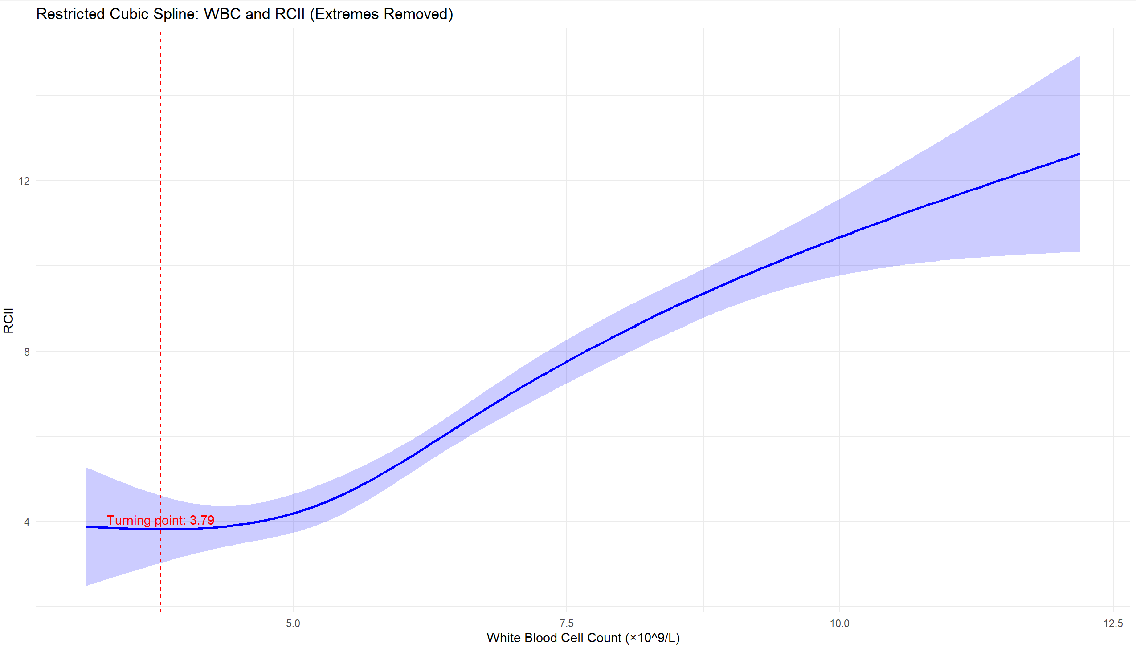
Figure 1. Restricted cubic spline analysis (RCS analysis) with extreme values excluded — CHARLS results.

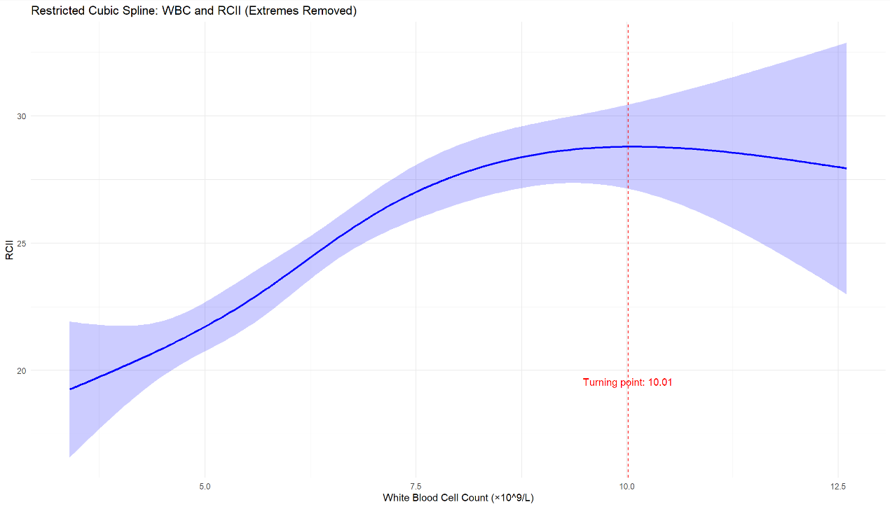
Figure 2. Restricted cubic spline analysis (RCS analysis) with extreme values excluded — NHANES results.

3.5. Subgroup analysis and interaction tests
Table 12. Description of white blood cell count in different subgroups of the CHARLS database
Subgroup | N | Mean ± SD | 95% CI | P value
Overall | 5955 | 6.29 ± 2.32 | 6.23 – 6.34 | 0.0000
Male | 2780 | 6.43 ± 2.74 | 6.33 – 6.53 | 0.0000
Female | 3175 | 6.17 ± 1.93 | 5.98 – 6.25 | 0.0000
Hypertension | 1696 | 6.43 ± 3.16 | 6.28 – 6.58 | 0.0000
No hypertension | 4259 | 6.23 ± 1.89 | 6.17 – 6.28 | 0.0000
Hyperlipidemia | 598 | 6.32 ± 1.89 | 6.16 – 6.47 | 0.0000
No hyperlipidemia | 5357 | 6.28 ± 2.37 | 6.22 – 6.35 | 0.0000
Diabetes | 369 | 6.68 ± 1.93 | 6.48 – 6.87 | 0.0001
No diabetes | 5586 | 6.26 ± 2.35 | 6.20 – 6.32 | 0.0000
Older age group | 2928 | 6.29 ± 1.91 | 6.22 – 6.36 | 0.0000
Younger age group | 3027 | 6.28 ± 2.66 | 6.19 – 6.38 | 0.0000
High BMI group | 2977 | 6.38 ± 2.66 | 6.29 – 6.48 | 0.0000
Low BMI group | 2978 | 6.19 ± 1.92 | 6.12 – 6.25 | 0.0000
Metabolic syndrome | 3706 | 6.37 ± 1.89 | 6.31 – 6.43 | 0.0000
No metabolic syndrome | 2091 | 6.11 ± 2.93 | 5.99 – 6.24 | 0.0000
High total cholesterol group | 2968 | 6.45 ± 1.90 | 6.38 – 6.52 | 0.0000
Low total cholesterol group | 2987 | 6.12 ± 2.67 | 6.02 – 6.21 | 0.0000
High-income group | 2976 | 6.19 ± 1.83 | 6.13 – 6.26 | 0.0000
Low income group | 2979 | 6.38 ± 2.73 | 6.28 – 6.47 | 0.0000
Married | 4978 | 6.27 ± 2.39 | 6.20 – 6.34 | 0.0045
Unmarried | 977 | 6.36 ± 1.96 | 6.24 – 6.48 | 0.0000
High education group | 401 | 6.01 ± 1.67 | 5.84 – 6.17 | 0.0023
Low education group | 5554 | 6.31 ± 2.36 | 6.24 – 6.37 | 0.0000
High platelet group | 2974 | 6.71 ± 2.72 | 6.61 – 6.81 | 0.0000
Low platelet group | 2980 | 5.86 ± 1.75 | 5.80 – 5.92 | 0.0000

Table 13. Description of white blood cell count in different subgroups of the NHANES database
Subgroup | N | Mean ± SD | 95% CI | P value
Overall | 2839 | 6.85 ± 2.32 | 6.76 – 6.93 | 0.0000
Male | 1392 | 6.91 ± 2.66 | 6.77 – 7.05 | 0.0002
Female | 1447 | 6.79 ± 1.95 | 6.69 – 6.89 | 0.0000
Older age group | 1388 | 6.81 ± 2.62 | 6.67 – 6.95 | 0.0054
Younger age group | 1451 | 6.89 ± 2.00 | 6.78 – 6.99 | 0.0000
Hypertension | 1475 | 7.00 ± 2.49 | 6.87 – 7.13 | 0.0011
No hypertension | 1361 | 6.68 ± 2.11 | 6.57 – 6.79 | 0.0000
High total cholesterol group | 1350 | 6.80 ± 2.32 | 6.68 – 6.93 | 0.0000
Low total cholesterol group | 1396 | 6.85 ± 2.30 | 6.73 – 6.97 | 0.0000
High platelet group | 1401 | 7.27 ± 1.99 | 7.16 – 7.37 | 0.0001
Low platelet group | 1438 | 6.44 ± 2.55 | 6.31 – 6.57 | 0.0005
High WBC group | 1414 | 8.41 ± 2.30 | 8.29 – 8.53 | 0.3243
Low WBC group | 1425 | 5.30 ± 0.85 | 5.26 – 5.35 | 0.0000
Married | 1636 | 6.82 ± 2.39 | 6.70 – 6.93 | 0.0000
Unmarried | 1201 | 6.89 ± 2.23 | 6.76 – 7.02 | 0.0253
Less than high school | 787 | 7.07 ± 2.52 | 6.89 – 7.25 | 0.1233
High school or above | 2050 | 6.76 ± 2.24 | 6.67 – 6.86 | 0.0000
White | 1119 | 7.17 ± 2.67 | 7.01 – 7.33 | 0.0037
Black | 774 | 6.37 ± 2.18 | 6.22 – 6.53 | 0.1361
Mexican American | 226 | 7.22 ± 1.90 | 6.98 – 7.47 | 0.1066
Other race | 720 | 6.74 ± 1.88 | 6.61 – 6.88 | 0.0000

Subgroup descriptions of WBC are provided in Table 9 (CHARLS) and Table 10 (NHANES). In interaction analyses, nationality, sex, age, BMI, diabetes, smoking, stroke, and CKD significantly modified the WBC-RCII association (all interaction p < 0.05), whereas race/ethnicity and hypertension status were significant effect modifiers in NHANES.

3.6. Survival analysis
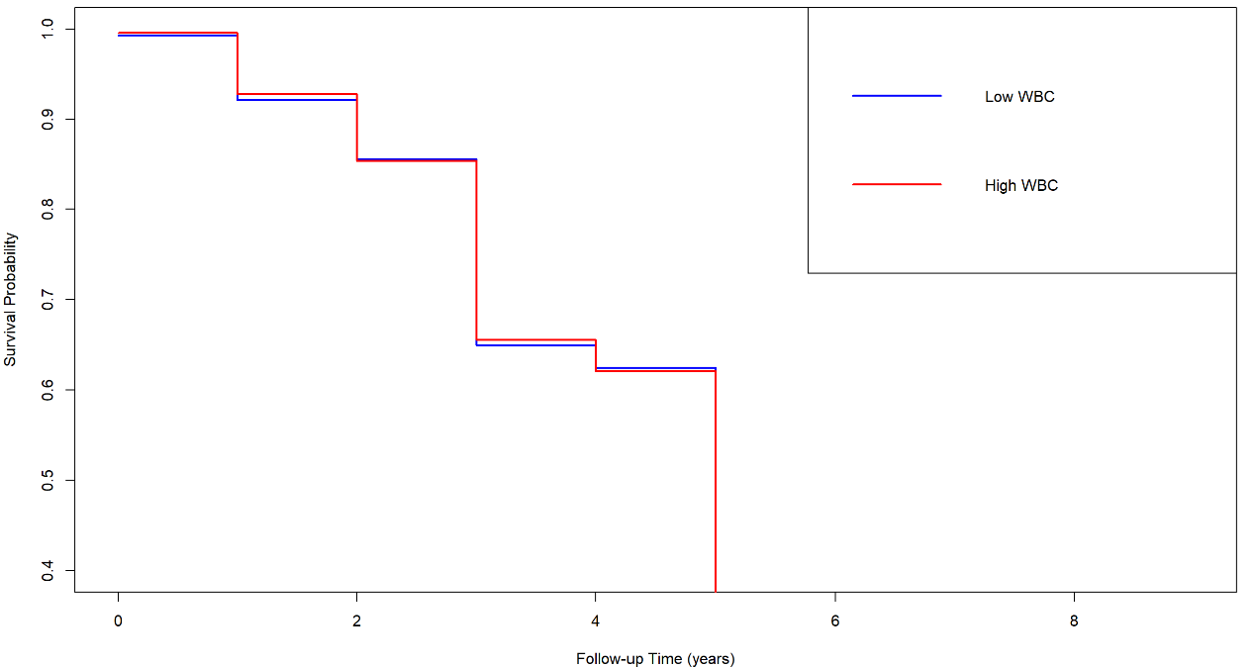
Figure 3. Kaplan-Meier survival curves for high WBC and low WBC.

Kaplan-Meier analysis of CHARLS longitudinal data (Figure 3) revealed a distinct interactive pattern. In the high RCII group, high and low WBC strata showed overlapping survival curves. In contrast, within the low RCII stratum, individuals with high WBC had markedly worse long-term survival, with a roughly 10–12 percentage point absolute risk difference emerging by year 8. This indicates that WBC offers incremental prognostic value specifically among those with a low residual cholesterol inflammatory burden.

4. Discussion
This study systematically evaluated the association between WBC and RCII by mining data from the CHARLS and NHANES databases. The principal findings can be summarized at three levels: first, in cross-sectional analyses, WBC exhibited a robust positive association with RCII in both populations, independent of traditional risk factors; second, restricted cubic spline analysis revealed that this association is nonlinear, displaying differentiated risk gradients across WBC intervals; third, longitudinal survival analysis further demonstrated that the prognostic value of WBC is highly dependent on the RCII background—among individuals with low RCII, elevated WBC can identify a group with significantly increased long-term mortality risk, whereas among those with high RCII, WBC virtually loses additional risk discrimination capacity. This “context-dependent” interactive pattern is the most central finding of this study.
The positive association aligns with prior research on systemic inflammatory markers and cardiovascular residual risk. Evidence indicates that WBC, as a basic inflammatory marker, is closely linked to insulin resistance, endothelial dysfunction, and increased risk of future cardiovascular events ^{[13]}. On the other hand, remnant cholesterol (RC), as an important atherogenic lipid component, has been shown to independently promote inflammatory responses and increase metabolic syndrome risk ^{[14]}. By linking WBC with the composite indicator RCII, our study further reveals that the systemic inflammatory state characterized by WBC and the “lipid residual risk-chronic inflammation” axis characterized by RCII exhibit significant synchrony ^{[15]}.
The underlying mechanism may be rooted in the “lipid-inflammation” cycle, a core pathobiological process ^{[16]}. Under conditions of chronic low-grade inflammation, an elevated WBC (especially neutrophils and monocytes) marks sustained immune activation, and the released pro-inflammatory cytokines such as IL-6 and TNF-α directly disrupt lipid metabolic homeostasis ^{[17]}. These inflammatory signals can stimulate the liver to increase VLDL synthesis while inhibiting lipoprotein lipase activity, impairing the clearance of triglyceride-rich lipoproteins and their remnants (i.e., RC), thereby driving RC accumulation in the blood ^{[18]}. This accumulated RC, especially after oxidative modification, is not an inert metabolic product ^{[19]}; it can act as a potent inflammatory stimulus, recognized and phagocytosed by macrophages within the vascular wall, which in turn activates intracellular signaling pathways such as the NLRP3 inflammasome and triggers the release of additional cytokines like IL-1β, further exacerbating systemic inflammation ^{[20]}. Thus, inflammation and disordered lipid metabolism constitute a self-reinforcing cycle ^{[21]}: inflammation promotes RC generation and retention, while RC acts as “fuel” to continuously aggravate the inflammatory response ^{[22]}. The synchronous elevation of WBC and RCII in this study is a population-level manifestation of this cycle—WBC reflects the level of activated immune cells in circulation ^{[23]}, while RCII quantifies the composite lipid-inflammatory burden jointly characterized by RC and CRP ^{[24]}.
The Chinese-American differences revealed in this study point to deeper mechanisms that multiple factors may modulate, and this basic mechanistic framework helps explain such cross-national heterogeneity ^{[25]}. First, differences in obesity types and fat distribution characteristics likely play a role. The obesity prevalence is higher in the U.S. population, with a predominance of subcutaneous fat accumulation; the obesity profile in the Chinese population differs markedly, primarily manifesting as a relatively lower obesity rate but a tendency for fat to accumulate in visceral adipose tissue, particularly in the abdominal area. Visceral adipose tissue is a potent source of inflammatory cytokines, and its inflammatory spillover effects may act more strongly on the liver, simultaneously exacerbating systemic inflammation (WBC elevation) and the generation of lipoprotein remnants, leading to a tighter “coupling” between WBC and RCII in the Chinese cohort. Second, differences in diet and gut microbiota may contribute: the U.S. diet is rich in saturated fats and refined carbohydrates, while the Chinese diet is primarily grain-based with higher dietary fiber. Third, genetic factors—owing to racial differences- the frequencies of relevant loci that significantly influence lipid metabolism and inflammatory response pathways may differ, modulating an individual’s metabolic response to inflammatory stimuli.
Comparison with previous studies also highlights the innovations of this research. Most prior studies either analyzed the relationship between lipid profile and inflammation separately or focused on lipid modulation in specific immune responses such as allergy ^{[26]}. In contrast, our study employs the composite indicator RCII and, for the first time, brings overall immune system activity (represented by WBC) and systemic residual inflammatory risk into the same analytical framework. Furthermore, through a design combining cross-sectional and longitudinal cohorts, we significantly enhance the credibility of the conclusions.
From a clinical application perspective, this study emphasizes that while focusing on the cardiovascular risk reflected by multidimensional composite indicators such as RCII, the independent value of classic hematological indicators like WBC should not be overlooked. Although WBC, as a coarse-grained inflammatory marker, has limited specificity, it features low testing cost, wide accessibility, and good applicability across populations. Therefore, WBC fluctuations can serve as a low-cost, high-efficiency screening tool to help clinicians identify potential high inflammatory response states at an early stage, especially in settings where resources are limited or refined biomarker testing is unavailable.
Nevertheless, several limitations should be acknowledged. First, although WBC count is a convenient hematological parameter, it lacks specificity; the impact of different leukocyte subtypes (e.g., neutrophils, lymphocytes) on RCII and cardiovascular risk may differ considerably. Future studies incorporating derived indicators such as the neutrophil-to-lymphocyte ratio may provide more refined information. Second, because publicly available databases were used, some variables relied on self-report and may be subject to recall bias or measurement error. Third, some of the cross-national differences observed in this study are difficult to fully explain through existing mechanisms and may involve unmeasured confounders.
Based on these findings and limitations, future research directions may include the following: first, prospective cohorts are needed to validate the predictive value of baseline WBC for long-term RCII changes or cardiovascular events, clarifying their temporal sequence and clinical utility; second, studies incorporating more precise inflammatory markers (e.g., IL-6, TNF-α) and detailed lipoprotein particle subfraction analyses should be conducted to reveal the specific molecular pathways underlying the WBC-RCII association; third, in cohorts with genomics, metabolomics, and microbiomics data, machine learning methods should be employed to explore the decisive biological and environmental factors contributing to cross-national heterogeneity and their interactions.

5. Conclusion
Through analysis of large-scale population data, this study reveals a significant nonlinear positive association between peripheral WBC and RCII levels, highly consistent across Chinese and U.S. populations. Notably, subgroup and survival analyses indicate that among individuals with lower RCII, even a slight rise in WBC is significantly associated with increased mortality risk, suggesting a special state of “low RCII but high inflammatory burden” that may relate to microvascular dysfunction or metabolic stress not fully captured by RCII. Clinically, WBC serves as a low-cost, accessible screening tool to identify high-risk inflammatory states, particularly in resource-limited settings. Pathophysiologically, the nonlinear association provides new insights into the “lipid-inflammation” cycle, positioning WBC not as a mere bystander but as a participant and driver of this vicious cycle. In summary, WBC is a valuable supplementary indicator when combined with RCII for multidimensional risk assessment in middle-aged and older adults. Future studies exploring WBC subtypes and anti-inflammatory interventions in low-RCII individuals may offer new entry points for primary CVD prevention strategies.

Disclosure statement
The author declares no conflict of interest.

References
[1] Chen J, Wu Q, Liu H, et al., 2024, Predictive Value of Remnant Cholesterol Inflammatory Index for Stroke Risk: Evidence from the China Health and Retirement Longitudinal Study. J Adv Res, 76: 543–552.
[2] Yang H, Sun C, Li Y, et al., 2025, Combined Effects of Residual Cholesterol Inflammatory Index and Triglyceride-Glucose-BMI on Risk of Cardio-Cerebrovascular Disease: A Cohort Study. Medicine (Baltimore), 104(43): e45395.
[3] Yu Y, Zhang Y, Zhu C, Duan T, Rao Z, 2025, Remnant Cholesterol Inflammatory Index, Calculated from Residual Cholesterol to C-Reactive Protein Ratio, and Stroke Outcomes: A Retrospective Study Using the National Institutes of Health Stroke Scale and Modified Rankin Scale. Lipids Health Dis, 24(1): 228.
[4] Doi T, Langsted A, Nordestgaard BG, 2023, Dual Elevated Remnant Cholesterol and C-Reactive Protein in Myocardial Infarction, Atherosclerotic Cardiovascular Disease, and Mortality. Atherosclerosis, 379: 117141.
[5] Chevli PA, Islam T, Pokharel Y, et al., 2022, Association Between Remnant Lipoprotein Cholesterol, High-Sensitivity C-Reactive Protein, and Risk of Atherosclerotic Cardiovascular Disease Events in the Multi-Ethnic Study of Atherosclerosis (MESA). J Clin Lipidol, 16(6): 870–877.
[6] Zhang Y, Li S, Xu RX, et al., 2015, Systemic Inflammatory Markers Are Closely Associated with Atherogenic Lipoprotein Subfractions in Patients Undergoing Coronary Angiography. Mediators Inflamm, 2015: 235742.
[7] Mengstu MK, Girmay G, Altaye KD, et al., 2025, Comparison of Inflammatory Cells, C-Reactive Protein, and Lipid Profile in Atherosclerotic Cardiovascular Disease Patients and Healthy Controls in Northwest Ethiopia. Sci Rep, 15(1): 32056.
[8] Rivera JJ, Nasir K, Campbell C, et al., 2007, Relation of Plasma Lipoprotein Levels with Low-Grade Inflammation in White Men Without Clinical Evidence of Myocardial Ischemia. Am J Cardiol, 99(12): 1642–1645.
[9] Gillum RF, Ingram DD, Makuc DM, et al., 1993, White Blood Cell Count, Coronary Heart Disease, and Death: The NHANES I Epidemiologic Follow-Up Study. Am Heart J, 125(3): 855–863.
[10] Brown DW, Giles WH, Croft JB, 2001, White Blood Cell Count: An Independent Predictor of Coronary Heart Disease Mortality Among a National Cohort. J Clin Epidemiol, 54(3): 316–322.
[11] Pan Y, Yuan Y, Yang J, et al., 2025, U-Shaped Relationship Between Frailty and Non-HDL-Cholesterol in the Elderly: A Cross-Sectional Study. Front Nutr, 12: 1596432.
[12] Liu G, Sha W, Wu Y, et al., 2025, The Association Between Estimated Pulse Wave Velocity and Cardio-Cerebrovascular Disease Risk: A Cohort Study. Eur J Med Res, 30(1): 16.
[13] Engell AE, Bathum L, Siersma V, Andersen CL, Lind BS, Jørgensen HL, 2025, Elevated Remnant Cholesterol and Triglycerides Are Predictors of Increased Total Mortality in a Primary Health Care Population of 327,347 Patients. Lipids Health Dis, 24(1): 189.
[14] Varbo A, Benn M, Tybjærg-Hansen A, Jørgensen AB, Frikke-Schmidt R, Nordestgaard BG, 2013, Remnant Cholesterol as a Causal Risk Factor for Ischemic Heart Disease. J Am Coll Cardiol, 61(4): 427–436.
[15] Nordestgaard BG, Varbo A, 2014, Triglycerides and Cardiovascular Disease. Lancet, 384(9943): 626–635.
[16] Libby P, Ridker PM, Maseri A, 2002, Inflammation and Atherosclerosis. Circulation, 105(9): 1135–1143.
[17] Ridker PM, Hennekens CH, Buring JE, Rifai N, 2000, C-Reactive Protein and Other Markers of Inflammation in the Prediction of Cardiovascular Disease in Women. N Engl J Med, 342(12): 836–843.
[18] Hansson GK, 2005, Inflammation, Atherosclerosis, and Coronary Artery Disease. N Engl J Med, 352(16): 1685–1695.
[19] Wei S, Yu S, Qian C, et al., 2025, Residual Cholesterol Inflammatory Index and Its Prognostic Role in Mortality Among Individuals with Cardiovascular-Kidney-Metabolic Syndrome Stages 0–3 Based on U.S. and Chinese National Cohorts. Eur J Med Res, 31(1): 35.
[20] Xie N, Zeng L, Hu X, et al., 2026, Association of Remnant Cholesterol Inflammation Index with Future Cardiovascular Disease Risk in Patients with Cardiovascular-Kidney-Metabolic Syndrome Stages 0–3. Diabetes Res Clin Pract, 233: 113146.
[21] Chen H, Wu JY, Yan H, et al., 2026, Association of Remnant Cholesterol Inflammatory Index with Stroke, Heart Disease and All-Cause Mortality Across Cardiovascular-Kidney-Metabolic Syndrome Stages 0–3: A National Cohort Study. Nutrients, 18(2): 205.
[22] Ren X, Tian Y, Tian J, et al., 2026, Predictive Value of Remnant Cholesterol Inflammatory Index for Cardiovascular-Kidney-Metabolic Syndrome Progression: A Prospective Cohort Study. Exp Gerontol, 214: 113030.
[23] Yu Y, Jiao Y, Chang S, et al., 2026, The Remnant Cholesterol Inflammatory Index and Risk of Future Cardiovascular Disease in Early CKM Syndrome: Findings from CHARLS. J Health Popul Nutr, 45(1): 117.
[24] Ren X, Tian Y, Tian J, et al., 2026, Predictive Value of Remnant Cholesterol Inflammatory Index for Cardiovascular-Kidney-Metabolic Syndrome Progression: A Prospective Cohort Study. Exp Gerontol, 214: 113030.
[25] Orakzai SH, Orakzai RH, Nasir K, et al., 2007, Relationship Between White Blood Cell Count and Framingham Risk Score in Asymptomatic Men. Arch Med Res, 38(4): 386–391.
[26] Lohsoonthorn V, Dhanamun B, Williams MA, 2006, Prevalence of Metabolic Syndrome and Its Relationship to White Blood Cell Count in a Population of Thai Men and Women Receiving Routine Health Examinations. Am J Hypertens, 19(4): 339–345.

Publisher’s note
Bio-Byword Scientific Publishing remains neutral with regard to jurisdictional claims in published maps and institutional affiliations.

