Application of Lymphocyte Subset Analysis in Early Warning of Infection Risk in Patients with Hematologic Malignancies
Yuanlan Yang, Yujun Li, Ya Chen, Xinying Dai, Wenting Chen, Chuyun Wu
People’s Hospital of Qianxinan Prefecture, ‌Qianxinan Prefecture 562400, Guizhou, China
*Author to whom correspondence should be addressed.

Copyright: © 2026 Author(s). This is an open-access article distributed under the terms of the Creative Commons Attribution License (CC BY 4.0), permitting distribution and reproduction in any medium, provided the original work is cited.

Abstract: Objectives: Infection is a significant complication in patients with hematologic malignancies, and CD4+ T-cell count serves as a critical indicator for assessing immune defense function. Methods: This retrospective study enrolled patients with hematologic malignancies and detected peripheral blood lymphocyte subsets via flow cytometry. Receiver operating characteristic (ROC) curve analysis was employed to evaluate the predictive performance of each subset for infection and to determine optimal cutoff values, while logistic regression was used to identify risk factors associated with infection. The aim was to investigate the predictive value of peripheral blood lymphocyte subsets, particularly CD4+ T cells, for infection risk in these patients. Results: Limited by insufficient sample size, this study did not identify any statistically significant high-risk factors for infection (p > 0.05). However, an increased risk of opportunistic infections was observed when CD4+ T-cell counts fell below 278/μL. Additionally, decreased B-cell counts and reduced CD8+ T-cell levels were also indicative of increased infection risk. Conclusion: Peripheral blood lymphocyte subsets can serve as early warning tools for infection occurrence in patients with hematologic malignancies. Furthermore, B-cell counts may also serve as a preliminary screening reference for the diagnosis of hematologic malignancies.
Keywords: Lymphocyte subsets; Infection risk; Hematologic malignancies; CD4+ T cells

Online publication:

1. Introduction
Infection is a common and serious complication in patients with hematologic malignancies, severely affecting the treatment process and prognosis. CD4+ T cells play a key role in immune defense, and their absolute count is closely associated with the risk of opportunistic infections. Previous studies suggest that the synergistic action of lymphocyte subsets is crucial for resisting infection, but systematic dynamic monitoring and multi-stage validation are lacking. This study focuses on CD4+ T-cell count and other key subsets, addressing the predictive efficacy of CD4+ T-cell count for infection risk and the supplementary value of other subsets (such as CD8+ T, B, and NK cells) in infection warning.

2. Patients and methods
2.1. Clinical data
This was a single-center retrospective study that collected patients with hematologic malignancies (including leukemia, myelodysplastic neoplasms, lymphoma, and myeloma) who were hospitalized in the Department of Hematology of People’s Hospital of Qianxinan Prefecture from December 2024 to February 2026. Follow-up was conducted until June 1, 2026, mainly through outpatient follow-up records, inpatient medical records, and telephone follow-up.

2.2. Flow cytometric detection and indicators
Peripheral blood flow cytometry was used to detect lymphocyte subsets, including CD4+ T-cell count, CD8+ T-cell count, B-cell count, NK-cell count, and CD4/CD8 ratio.

2.3. Statistical analysis
SPSS 27.0 software was used for data analysis. Non-normally distributed continuous data were expressed as median (range), and categorical data as number of cases (proportion). ROC curves were used to evaluate the predictive performance of each subset for infection, and cutoff values were determined according to the Youden index. Univariate and multivariate logistic regression analyses were performed, incorporating age, CD4+ T-cell count, and other key variables. A p-value < 0.05 was considered statistically significant.

3. Results
3.1. Patient characteristics
A total of 35 patients with hematologic malignancies were enrolled in this study, with a median age of 56 (29–92) years; 20 patients (57.1%) were male. The diagnoses included acute leukemia in 19 cases, marginal zone lymphoma in 3, multiple myeloma in 3, myelodysplastic neoplasms in 2, Hodgkin lymphoma in 1, follicular lymphoma in 1, chronic myeloid leukemia in 2, and diffuse large B-cell lymphoma in 4. There was no statistically significant difference in data distribution between the infected and non-infected groups, allowing for analysis (Table 1).

Table 1. Clinical characteristics of patients with hematologic malignancies in the infected and non-infected groups
Characteristic | Overall | Infection | Non-infection | P value
Age | 56 (29–92) | 56 (29–92) | 64 (50–76)
Sex |  |  |  | 0.29
Male | 20 | 19 | 1
Female | 15 | 12 | 3
White blood cell count, ×10⁹/L | 5.69 (0.15–119.11) | 5.69 (0.15–119.11) | 4.73 (1.7–39.81) | 0.75
NK cell count | 80 (1–449) | 77 (1–449) | 136.5 (6–291) | 0.23
CD4+ T cell count | 278 (11–1103) | 313 (11–1103) | 230 (220–1000) | 0.98
CD8+ T cell count | 221 (8–1087) | 201 (8–1087) | 344 (80–638) | 0.75
B cell count | 74 (1–2629) | 84 (0–2629) | 40.5 (1–396) | 0.86
CD4/CD8 ratio | 1.08 (0.23–4.54) | 1.08 (0.23–4.54) | 1.165 (0.29–2.73) | 0.86

3.2. Differences in lymphocyte subsets among hematological malignancies
B cell counts exhibited significant differences among different types of hematological malignancies (Figure 1), whereas no statistically significant differences were observed in the CD4/CD8 ratio, NK cell count, total T cell count, CD4+ T cell count, or CD8+ T cell count.

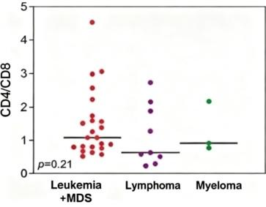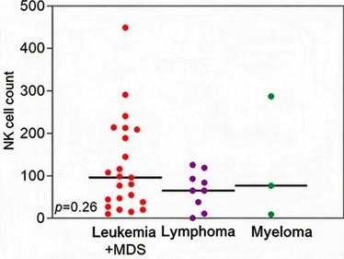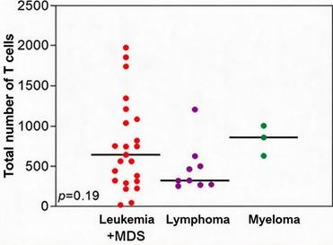
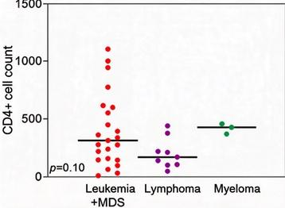 | 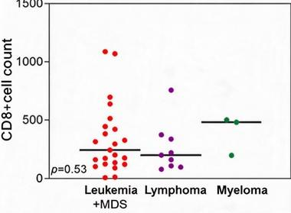 | 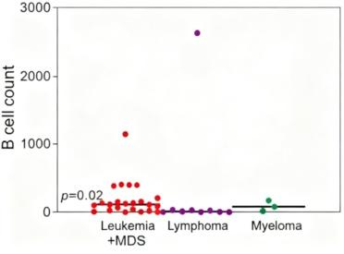
Figure 1. Differences in lymphocyte subsets among hematological malignancies.

3.3. Predictive efficacy of lymphocyte subsets for infection in hematological malignancies.
According to the area under the ROC curve (AUC), B cell count showed the highest predictive efficacy (AUC = 0.532), followed by CD4+ T cell count, total lymphocytes (AUC = 0.50), total T cell count (AUC = 0.47), CD8+ T cell count (AUC = 0.44), and NK cell count (AUC = 0.31) (Figure 2). Because the p-values of the area under the ROC curve for the above indicators were greater than 0.05 (Figure 3), the median of each indicator was used as the cutoff value; those with values greater than or equal to the cutoff were assigned to the high group, and those with values less than the cutoff were assigned to the low group (Figure 4).

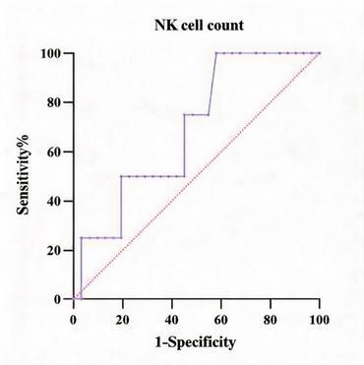 | 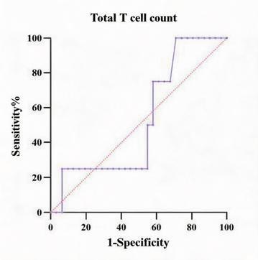 | 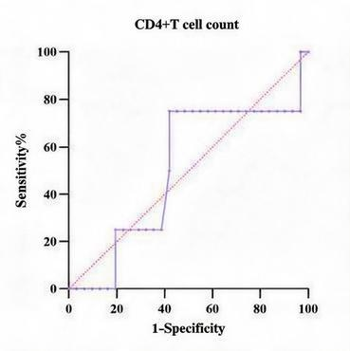
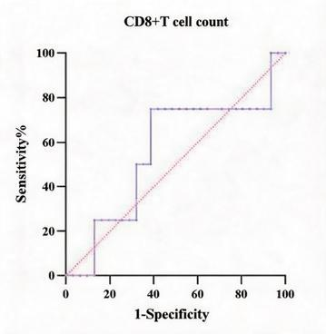 | 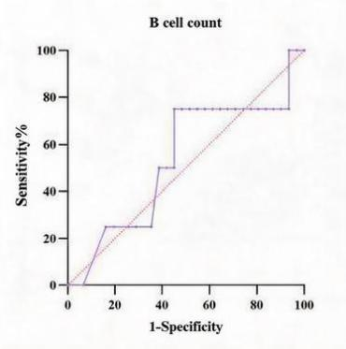
Figure 2. Predictive performance of lymphocyte subsets for infection in hematological malignancies.

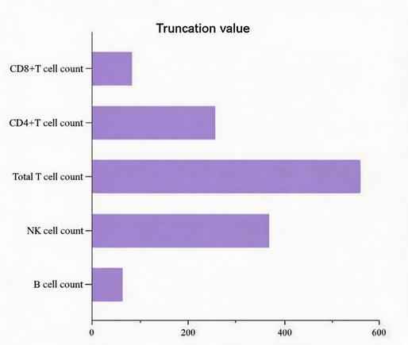
Figure 3. Truncated values determined based on the ROC curve.

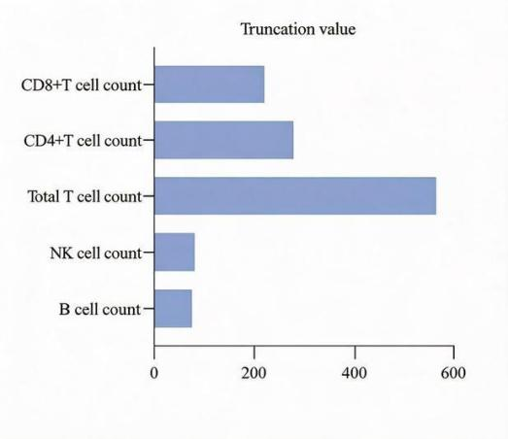
Figure 4. Truncation value determined based on the median.

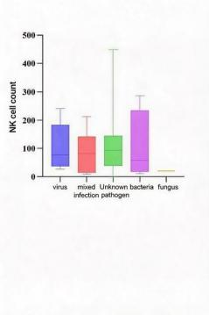 | 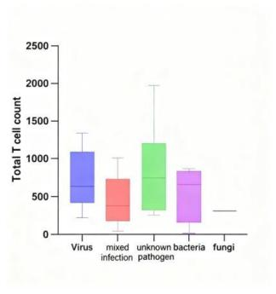 | 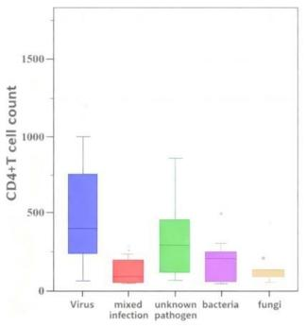
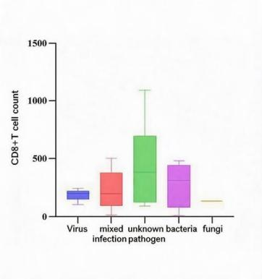 | 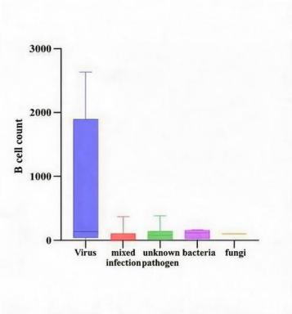
Figure 5. Impact of lymphocyte subsets on pathogens.

3.4. Lymphocyte subsets and pathogen types
No significant association was observed between lymphocyte subsets and pathogen types (p > 0.05), suggesting that this examination is not suitable for use alone in predicting pathogen species (Figure 5).

3.5. Correlation between lymphocyte subsets and infection in hematological malignancies
In univariate and multivariate analyses using logistic regression, no high-risk factors for infection were identified (p > 0.05), which may be attributable to the small number of cases included (Table 2).

Table 2. Univariate and multivariate analysis of infection in patients with hematological malignancies
Characteristic | Univariate analysis |  | Multivariate analysis
Characteristic | OR (95% CI) | p value | OR (95% CI) | p value
Age | 0.24 (0.03-2.07) | 0.19
Gender | 4.75 (0.44-51.11) | 0.20 | 8.58 (0.30-246.54) | 0.21
White blood cell count | 1.43 (0.13-15.52) | 0.77
B cell count | 1.82 (0.22-14.75) | 0.58
CD4+ T cell count | 3.64 (0.34-39.01) | 0.29
CD8+ T cell count | 0.31 (0.03-3.34) | 0.34 | 0.12 (0.01-3.94) | 0.24
NK cell count | 0.36 (0.03-3.80) | 0.39
Total T cell count | 1.07 (0.13-8.56) | 0.95

4. Discussion
This study aimed to investigate the clinical value of peripheral blood lymphocyte subsets, particularly CD4+ T cell counts, in predicting infection risk and aiding disease diagnosis in patients with hematological malignancies. Although limited by sample size, multivariate logistic regression analysis failed to identify statistically significant independent risk factors (p > 0.05), descriptive analysis and trend observation nonetheless revealed important associations between the distribution of lymphocyte subsets and the occurrence of infection as well as tumor type, providing valuable reference evidence for clinical immune monitoring.
This study found that when CD4+ T cell counts fell below 278/μL, patients exhibited a markedly increased risk of opportunistic infection. This cutoff value is close to the clinical threshold of < 200/μL adopted in most guidelines and classic studies ^{[1-3]}, though slightly higher than the threshold associated with increased opportunistic infection incidence in previous HIV-infected patients. This suggests that in the non-HIV hematological malignancy population, the immune system may be in a more fragile or complex state of dysregulation, requiring a higher cell threshold to maintain effective defense ^{[4, 5]}. Bone marrow suppression caused by hematological malignancies themselves and their chemotherapy regimens not only induces neutropenia but also leads to severe T cell immune deficiency ^{[5-7]}. Therefore, using 278/μL as a potential early warning threshold may help clinicians identify high-risk patients before infectious symptoms manifest, thereby enabling early initiation of prophylactic anti-infective strategies or adjustment of anti-tumor treatment regimens.
B cells mediate humoral immunity, and a reduction in their number indicates impaired capacity for specific antibody production. Previous studies have shown that circulating CD19+ B cells are significantly reduced in patients with multiple myeloma, which is closely associated with an increased risk of bacterial infection ^{[8-13]}. In addition, B cell deficiency may hinder the proliferation and memory formation of CD4+ T cells during the early stage of infection, further exacerbating susceptibility to infection ^{[14, 15]}. CD8+ T cells, as cytotoxic T lymphocytes, are key effector cells for clearing intracellular bacteria and viral infections. Existing literature indicates that abnormal CD8+ T cell function is associated with increased host susceptibility to infection ^{[16-18]}, and the results of this study are consistent with this, further validating the critical role of B cell and CD8+ T cell defects in the decline of immune surveillance function in patients with hematological malignancies. This suggests that in clinical assessment, attention should not be focused on a single subset alone; rather, a comprehensive immune scoring system incorporating multiple subsets should be constructed to more fully quantify patients’ susceptibility to infection.
This study further analyzed the distribution characteristics of lymphocyte subsets among different types of hematological malignancies. The results showed that the CD4/CD8 ratio, NK cells, total T cells, and various T cell subsets did not differ significantly among the leukemia/MDS, lymphoma, and myeloma groups, which may reflect the presence of extensive T cell immune dysfunction across various hematological malignancies. However, the absolute B cell count differed significantly among the three groups, a finding with important diagnostic implications. B cells originate in the bone marrow and mature in lymphoid tissues, and abnormal fluctuations in their numbers often directly reflect the burden of B cell lineage tumors (such as chronic lymphocytic leukemia, certain types of non-Hodgkin lymphoma, or multiple myeloma) ^{[19-21]}. In contrast, changes in T cells and NK cells are more often secondary to tumor microenvironment suppression or treatment-related nonspecific reactions ^{[22-25]}. Therefore, B cell counts can serve not only as an indicator of infection risk but also as an auxiliary screening tool for differentiating the types of hematological malignancies and assessing tumor burden, especially providing additional laboratory evidence when clinical manifestations are atypical.
This study found no obvious association between lymphocyte subsets and pathogen type. Existing evidence indicates that peripheral blood routine lymphocyte subsets often overlap among different pathogens, making precise discrimination difficult; therefore, they are not suitable for predicting pathogen species alone. In infectious states such as sepsis, decreased lymphocyte counts and imbalanced T cell subset proportions more often reflect an overall state of immunosuppression rather than specific etiological clues. Consequently, lymphocyte subset testing is more appropriate for assessing immune function status, identifying populations at high risk for opportunistic infection, and conducting dynamic monitoring, but it cannot serve as the primary basis for pathogen identification.
The main limitation of this study is the small number of included cases, which resulted in insufficient statistical power, failure to establish independent predictive factors through multivariate analysis, and inability to perform more detailed subgroup analyses (such as different chemotherapy stages or different pathological subtypes). In addition, this study was a single-center retrospective analysis and may have selection bias. Future studies need to expand the sample size and conduct multicenter prospective cohort studies to verify the sensitivity and specificity of the 278/μL cutoff value and to explore the feasibility of constructing a dynamic prediction model by combining multiple lymphocyte subsets.

5. Conclusion
In summary, peripheral blood lymphocyte subset testing is simple and rapid and represents an important means of assessing the immune status of patients with hematological malignancies. A CD4+ T cell count < 278/μL can serve as a potential early warning signal for opportunistic infection, while significant differences in B cell counts may aid in the preliminary differentiation of different hematological malignancies. Although large-sample statistical evidence remains to be supplemented, the existing trend results support the routine incorporation of lymphocyte subset monitoring into the risk stratification and follow-up management system for patients with hematological malignancies.

Funding
Clinical Significance of Lymphocyte Subset Analysis in Patients with Hematologic Malignancies (Project No.: Zhoukehe Medical 2024-23)

Disclosure statement
The authors declare no conflict of interest.

References
[1] Kovacs JA, Masur H, 2000, Prophylaxis Against Opportunistic Infections in Patients With Human Immunodeficiency Virus Infection. The New England Journal of Medicine, 342(19): 1416–1429.
[2] Bertaina A, Abraham A, Bonfim C, et al., 2022, An ISCT Stem Cell Engineering Committee Position Statement on Immune Reconstitution: The Importance of Predictable and Modifiable Milestones of Immune Reconstitution to Transplant Outcomes. Cytotherapy, 24(4): 385–392.
[3] Hammoudi T, Nucera S, Troullioud Lucas AG, et al., 2025, Harmonized Immune Recovery Monitoring After HCT: Evidence and Practical Guidance From the Westhafen Intercontinental Group. Blood Advances, 9(23): 6141–6157.
[4] Masur H, Ognibene FP, Yarchoan R, et al., 1989, CD4 Counts as Predictors of Opportunistic Pneumonias in Human Immunodeficiency Virus (HIV) Infection. Annals of Internal Medicine, 111(3): 223–231.
[5] Coghill AE, Bender Ignacio R, 2026, Further Unraveling the Association Between HIV, Immune Suppression, and Cancer Survival. Clinical Infectious Diseases: An Official Publication of the Infectious Diseases Society of America, ciag334.
[6] Duduveche A, Mohorea-Neata A, Badelita S, 2026, Review of Infections in Immunocompromised Travellers: Epidemiology, Infection Prevention and Management. Microorganisms, 14(3): 721.
[7] Timiryasova A, Greenberg L, Domingo P, et al., 2026, CD4+ Cell Count Trends After Common Cancers in People With HIV: A Multicohort Collaboration. AIDS (London, England), 10: 1097.
[8] Schütt P, Brandhorst D, Stellberg W, et al., 2006, Immune Parameters in Multiple Myeloma Patients: Influence of Treatment and Correlation With Opportunistic Infections. Leukemia & Lymphoma, 47(8): 1570–1582.
[9] Teh BW, Harrison SJ, Pellegrini M, et al., 2014, Changing Treatment Paradigms for Patients With Plasma Cell Myeloma: Impact Upon Immune Determinants of Infection. Blood Reviews, 28(2): 75–86.
[10] Caro J, Braunstein M, Williams L, et al., 2022, Inflammation and Infection in Plasma Cell Disorders: How Pathogens Shape the Fate of Patients. Leukemia, 36(3): 613–624.
[11] Kannan A, Jeffrey K, Misbah S, et al., 2025, Practical Guidance on the Prevention and Management of Infection in Multiple Myeloma Patients: A Case-Based Approach. Blood Reviews, 72: 101287.
[12] Tranter E, Busch D, Heck C, et al., 2025, Advanced Disease and CD8(+) TEMRA Cells Predict Severe Infections in Multiple Myeloma. Frontiers in Immunology, 16: 1532645.
[13] Allegra A, Tonacci A, Musolino C, et al., 2021, Secondary Immunodeficiency in Hematological Malignancies: Focus on Multiple Myeloma and Chronic Lymphocytic Leukemia. Frontiers in Immunology, 12: 738915.
[14] Opata MM, Hollifield ML, Lund FE, et al., 2015, B Lymphocytes Are Required During the Early Priming of CD4+ T Cells for Clearance of Pneumocystis Infection in Mice. Journal of Immunology (Baltimore, Md.: 1950), 195(2): 611–620.
[15] de la Rua NM, Samuelson DR, Charles TP, et al., 2016, CD4(+) T-Cell-Independent Secondary Immune Responses to Pneumocystis Pneumonia. Frontiers in Immunology, 7: 178.
[16] Cabug AF, Scott NE, Zhang H, et al., 2026, CTL Lymph Node Entrapment Drives Lymphopenia in Severe Influenza Infection. Mucosal Immunology, 100346.
[17] Mortezaee K, Majidpoor J, 2022, CD8(+) T Cells in SARS-CoV-2 Induced Disease and Cancer-Clinical Perspectives. Frontiers in Immunology, 13: 864298.
[18] Symmonds J, Gaufin T, Xu C, et al., 2024, Making a Monkey Out of Human Immunodeficiency Virus/Simian Immunodeficiency Virus Pathogenesis: Immune Cell Depletion Experiments as a Tool to Understand the Immune Correlates of Protection and Pathogenicity in HIV Infection. Viruses, 16(6): 972.
[19] Chowdhury SM, Bhatta S, Voorhees TJ, et al., 2025, Impact of Circulating Lymphoma Cells at Diagnosis on Outcomes in Patients With Newly Diagnosed De Novo Diffuse Large B-Cell Lymphoma. Journal of Hematology & Oncology, 18(1): 4.
[20] Semenzato G, Ghobrial IM, Ghia P, 2023, Monoclonal B-Cell Lymphocytosis, Monoclonal Gammopathy of Undetermined Significance, and T-Cell Clones of Uncertain Significance: Are These Premalignant Conditions Sharing a Common Identity? The Lancet Haematology, 10(7): e549–e556.
[21] Jain N, Wierda WG, O'Brien S, 2024, Chronic Lymphocytic Leukaemia. Lancet (London, England), 404(10453): 694–706.
[22] Maletin N, 2026, From Immune Exclusion to Exhaustion: Tumor Microenvironment Drives Therapy Response. Frontiers in Immunology, 17: 1785587.
[23] Retamal MA, Salazar-Onfray F, González FE, et al., 2025, Tumor Hypoxia Shapes Natural Killer Cell Anticancer Activities. Journal of Molecular Medicine (Berlin, Germany), 103(7): 755–777.
[24] Hou H, Luo Y, Tang G, et al., 2021, Dynamic Changes in Peripheral Blood Lymphocyte Subset Counts and Functions in Patients With Diffuse Large B Cell Lymphoma During Chemotherapy. Cancer Cell International, 21(1): 282.
[25] Qiu L, Xing L, Zhao M, et al., 2025, Prognostic Value of Lymphocyte Subsets in Diffuse Large B Cell Lymphoma. Frontiers in Oncology, 15: 1671062.

Publisher’s note
Bio-Byword Scientific Publishing remains neutral with regard to jurisdictional claims in published maps and institutional affiliations.

