Effects of Enemas with Short-Peptide-Based Enteral Nutritional Formulas of Different Osmotic Pressures on the Structure and Immune Barrier of the Excluded Ileum in Patients with Colorectal Cancer
Shijia Fan¹, Chaowu Chen²*, Yuzhi Wan¹, Feng Xiao¹, Chenglong Li¹
¹Department of Gastrointestinal Surgery, Hunan Provincial People’s Hospital, Changsha 410002, Hunan, China
²Department of General Surgery, Hunan Provincial People’s Hospital, Changsha 410002, Hunan, China
*Corresponding author: Chaowu Chen, chenchaowu1986@126.com

Copyright: © 2026 Author(s). This is an open-access article distributed under the terms of the Creative Commons Attribution License (CC BY 4.0), permitting distribution and reproduction in any medium, provided the original work is cited.

Abstract: This study investigated the effects of isosmotic and hyperosmotic short-peptide enteral nutritional formula enemas on the structure and immune barrier of the excluded ileum in patients with colorectal cancer. Eighty-six patients with preventive terminal ileum double-barrel stomas were randomized to receive isosmotic formula, hyperosmotic formula, or normal saline for 2 weeks. Ileal mucosal tissues were collected before enema and at ileostomy reversal. Villus height (VH), crypt depth (CD), VH/CD ratio, histopathology, and MAdCAM-1, CD4⁺, and CD8⁺ expression were assessed. VH and CD increased after enema, with greater improvements in the isosmotic group than in the hyperosmotic and control groups, whereas VH/CD showed no significant between-group difference after treatment. MAdCAM-1, CD4⁺, and CD8⁺ expression also increased after enema; pairwise comparisons showed greater increases in MAdCAM-1 and CD8⁺ levels in the isosmotic group than in the hyperosmotic and control groups. These findings suggest that short-peptide formula enemas may support repair of the excluded ileal mucosa and partial recovery of mucosal immune activity, with the isosmotic formula showing more favorable effects on mucosal structure and selected immune markers.
Keywords: Colorectal cancer; Isosmotic small peptide formula; Enemas; Excluded ileum

Online publication:

1. Introduction
The intestinal mucosal barrier maintains nutrient absorption, immune homeostasis, and protection against luminal pathogens and toxins ^{[1,2]}. Barrier injury caused by intestinal disease, major surgery, shock, or inadequate enteral stimulation may impair absorption, promote inflammation and bacterial translocation, and worsen clinical outcomes ^{[3-6]}. Therefore, preserving or restoring mucosal barrier function is important in patients with impaired gastrointestinal function ^{[7,8]}.
In colorectal cancer surgery, preventive terminal ileostomy can reduce the clinical consequences of anastomotic leakage but leaves the distal segment without luminal nutrients or mechanical stimulation ^{[9,10]}, which may lead to diversion colitis, mucosal atrophy, and immune barrier dysfunction ^{[5,6,11-13]}. Enema through the stoma may help maintain intestinal function before stoma closure.
Short-peptide enteral formulas are readily absorbed and may provide nutritional support for injured mucosa with limited digestive burden ^{[14,15]}. This study compared isosmotic and hyperosmotic short-peptide formula enemas with normal saline in patients undergoing preventive terminal ileum double-barrel stoma to evaluate their effects on ileal mucosal structure and immune-related markers.

2. Materials and methods
2.1. General information
Eighty-six patients who underwent preventive terminal ileum double-barrel stoma for colorectal malignancy between October 2021 and January 2024 were randomized into the isosmotic short-peptide formula group (n = 30), hyperosmotic short-peptide formula group (n=27), or normal saline control group (n = 29). Baseline age, sex, body mass index, and intestinal exclusion time were comparable among groups (P > 0.05).
Eligible patients had colorectal malignancy treated with a preventive terminal ileum double-barrel stoma, planned stoma closure 3–6 months after surgery, no severe cardiovascular disease or diabetes, and consented to enema with a short-peptide formula or saline. Patients were excluded for postoperative recurrence, severe complications such as anastomotic fistula or stenosis, allergy to enema preparations, or irregular or terminated enema.

2.2. Enema procedure
All patients returned 3–6 months after stoma creation. Before enema, ileal mucosal tissue from the distal stoma segment was collected by electronic colonoscopy without bowel preparation. Patients then received antegrade enema through a 16F double-lumen catheter placed approximately 6 cm into the distal ileum. The assigned solution was infused by an enteral nutrition pump from 30 mL/h to 125 mL/h at room temperature, 500 mL/day for 2 weeks, followed by 50 mL normal saline flushing. Enema was discontinued if intolerance occurred. At ileostomy reversal, proximal and distal stoma segments were resected and processed for hematoxylin-eosin staining and immunohistochemistry.

2.3. Enema solutions
The isosmotic group received a short-peptide formula from Fresenius Kabi SSPC Pharmaceutical Co., Ltd. (500 mL; 300 mOsm/L; protein:fat:carbohydrate approximately 18%:25%:57%). The hyperosmotic group received a short-peptide formula from Nutricia Pharmaceutical Co., Ltd. (500 mL; 440 mOsm/L; protein:fat:carbohydrate approximately 16%:15%:69%). The control group received 0.9% sodium chloride injection (500 mL; 308 mOsm/L).

2.4. Observation indicators
VH, CD, and VH/CD were measured from five intact villi and adjacent crypts in three randomly selected 40× fields using ImageJ. Lymphocyte infiltration was graded from 0 to 4. MAdCAM-1, CD4⁺, and CD8⁺ expression was assessed by immunohistochemistry in three 400× fields and quantified as average optical density.

2.5. Statistical analysis
SPSS 26.0 was used for statistical analysis. Count data were expressed as n (%), and measurement data as mean ± standard deviation (SD). Between-group comparisons used chi-square tests or analysis of variance, as appropriate; paired t-tests were used for pre- and post-enema comparisons within groups. Non-normally distributed data were analyzed using Fisher’s exact test or rank-sum tests. P < 0.05 was considered statistically significant.

3. Results
No significant differences were observed in VH, CD, VH/CD ratio, or immunological indexes among the three patient groups at enrollment (P > 0.05; Table 1).

3.1. Comparison of ileal tissue structure
Distal ileal VH and CD increased after enema, with greater improvements in the isosmotic group than in the hyperosmotic and control groups. VH/CD showed no significant between-group difference after treatment (Table 2; Figure 1).

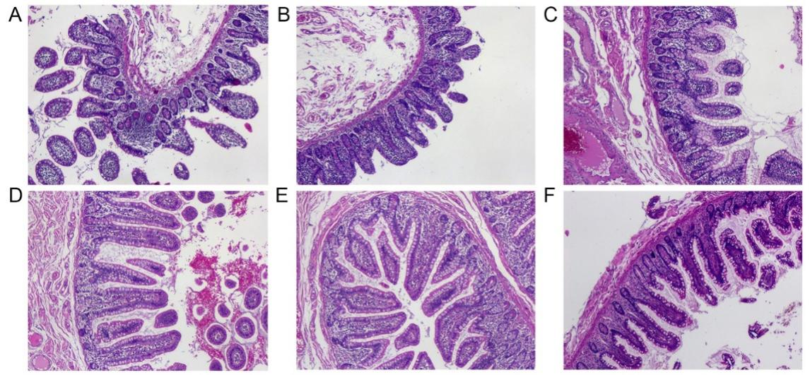
Figure 1. Distal ileum tissue at the stoma (40×). A–C: pre-enema samples from the isosmotic, hyperosmotic, and control groups; D–F: corresponding post-enema samples.

Table 1. Comparison of various indicators among the three patient groups at enrollment
Group | Villus Height (μm) |  | Crypt Depth (μm) |  | VH/CD |  | MAdCAM-1 level |  | CD4+ |  | CD8+
Group | Proximal Segment | Distal Segment Before Enema | Proximal Segment | Distal Segment Before Enema | Proximal Segment | Distal Segment Before Enema | Proximal Segment | Distal Segment Before Enema | Proximal Segment | Distal Segment Before Enema | Proximal Segment | Distal Segment Before Enema
Isosmotic group | 468.38 ± 34.28 | 330.08 ± 26.81 | 150.69 ± 8.29 | 111.39 ± 11.61 | 3.11 ± 0.14 | 2.99 ± 0.35 | 0.65 ± 0.06 | 0.35 ± 0.05 | 0.48 ± 0.03 | 0.31 ± 0.03 | 0.41 ± 0.04 | 0.27 ± 0.03
Hyperosmotic group | 472.70 ± 27.70 | 325.98 ± 28.83 | 147.72 ± 10.00 | 111.47 ± 13.25 | 3.21 ± 0.15 | 2.96 ± 0.43 | 0.66 ± 0.49 | 0.34 ± 0.05 | 0.50 ± 0.03 | 0.32 ± 0.02 | 0.40 ± 0.03 | 0.26 ± 0.02
Control | 464.33 ± 36.71 | 328.06 ± 31.92 | 148.55 ± 10.78 | 108.27 ± 8.86 | 3.14 ± 0.27 | 3.04 ± 0.32 | 0.68 ± 0.04 | 0.37 ± 0.06 | 0.49 ± 0.04 | 0.31 ± 0.02 | 0.41 ± 0.03 | 0.27 ± 0.04
F Value | 0.443 | 0.139 | 0.714 | 0.748 | 1.828 | 0.344 | 1.832 | 1.338 | 2.772 | 2.609 | 0.948 | 2.418
P Value | 0.643 | 0.870 | 0.493 | 0.476 | 0.167 | 0.710 | 0.167 | 0.268 | 0.068 | 0.080 | 0.392 | 0.095

Table 2. Integrated comparison of distal ileal structural and immune indicators before and after enema
Indicator | Time point | Isosmotic group | Hyperosmotic group | Control | Between-group P
VH (μm) | Before / After | 330.08±26.81 / 372.79±29.78 | 325.98±28.83 / 355.63±26.47 | 328.06±31.92 / 337.98±33.03 | <0.001
CD (μm) | Before / After | 111.39±11.61 / 134.80±9.16 | 111.47±13.25 / 129.30±10.32 | 108.27±8.86 / 117.32±8.57 | <0.001
VH/CD | Before / After | 2.99±0.35 / 2.77±0.25 | 2.96±0.43 / 2.77±0.32 | 3.04±0.32 / 2.89±0.30 | 0.211
MAdCAM-1 | Before / After | 0.35±0.05 / 0.53±0.04 | 0.34±0.05 / 0.49±0.05 | 0.37±0.06 / 0.42±0.04 | <0.001
CD4⁺ | Before / After | 0.31±0.03 / 0.39±0.02 | 0.32±0.02 / 0.41±0.02 | 0.31±0.02 / 0.37±0.03 | <0.001
CD8⁺ | Before / After | 0.27±0.03 / 0.35±0.02 | 0.26±0.02 / 0.34±0.01 | 0.27±0.04 / 0.29±0.03 | <0.001

3.2. Changes in histopathological grade of distal ileal tissue at the stoma
Between-group P values refer to comparisons of changes from before to after enema among the three groups.
Before enema, distal excluded ileal tissue showed lymphocyte infiltration, villus atrophy or fracture, crypt deformation, and occasional crypt abscesses. These changes were alleviated after enema, particularly in the isosmotic group (Figure 2).

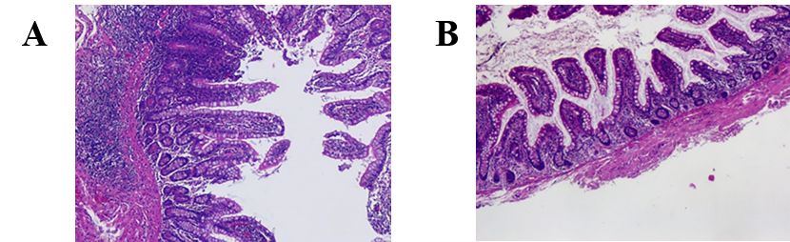
Figure 2. Histopathological changes in excluded ileal tissue before and after enema: A, pre-enema; B, post-enema.

3.3. Comparison of immunohistochemical markers
3.3.1. Expression of MAdCAM-1, CD4⁺, and CD8⁺
MAdCAM-1, CD4⁺, and CD8⁺ expression increased after enema, suggesting partial recovery of mucosal immune activity. Pairwise comparisons showed that the increase in MAdCAM-1 and CD8⁺ levels was greater in the isosmotic group than in the hyperosmotic and control groups (P < 0.001), Table 2; Figure 3.

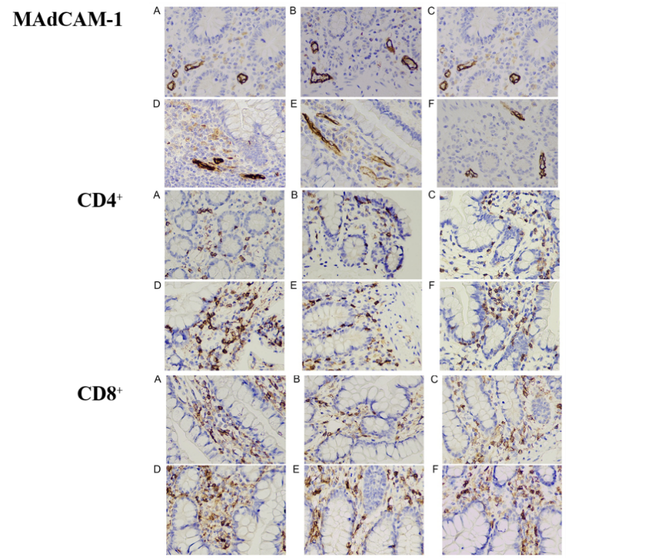
Figure 3. Immunohistochemical expression of MAdCAM-1, CD4⁺, and CD8⁺ in the distal ileum at the stoma before and after enema (400×).

For each marker, panels A–F show the isosmotic group before enema, hyperosmotic group before enema, control before enema, isosmotic group after enema, hyperosmotic group after enema, and control after enema, respectively.

4. Discussion
The intestinal mucosal barrier maintains intestinal homeostasis through mechanical, chemical, biological, and immune components ^{[1,7]}. In patients with colorectal cancer undergoing preventive ileostomy, the excluded distal ileum lacks normal luminal nutrients, digestive secretions, and mechanical stimulation, which may contribute to villus atrophy, crypt deformation, inflammatory infiltration, and weakened local immune activity ^{[4-6,11-13]}. The baseline findings in this study were consistent with structural and immune barrier dysfunction in the excluded ileum.
The results suggest that short-peptide formula enemas may help restore the morphology of the excluded ileal mucosa. Villus height and crypt depth increased after enema, with greater improvement in the isosmotic formula group than in the hyperosmotic formula and saline groups. Because saline enema may also provide hydration, washout, and mild mechanical stimulation, the observed benefit should be interpreted as the additional effect of peptide-based nutrition over saline stimulation, rather than as a comparison with no intervention.
Short peptides can be absorbed with limited digestion and may be suitable for injured or functionally impaired mucosa ^{[14,15]}. Local exposure through the stoma may support epithelial proliferation, crypt activity, and mucosal repair ^{[2,8]}, while the alleviation of villus injury and inflammatory infiltration further suggests a trophic effect of luminal nutritional stimulation. MAdCAM-1, CD4⁺, and CD8⁺ expression also increased after enema, indicating partial recovery of mucosal immune activity. Reduced enteral stimulation has previously been associated with changes in mucosal immune chemokines and MAdCAM-1 expression [4,6]. Pairwise comparisons further showed greater increases in MAdCAM-1 and CD8⁺ levels in the isosmotic group than in the hyperosmotic and control groups; however, because CD4⁺ expression was numerically highest in the hyperosmotic group after treatment and histopathological grading data are not fully displayed, these immunological and pathological findings should be interpreted as endpoint-specific improvement rather than uniform superiority of the isosmotic formula across all immune and pathological endpoints.
The difference between isosmotic and hyperosmotic formulas may be related to osmotic tolerance in the excluded ileum. Hyperosmolar enteral formulas have been discussed as a potential contributor to gastrointestinal intolerance, including diarrhea ^{[16]}. Near-physiological osmotic pressure may reduce osmotic irritation and fluid shifts while maintaining nutrient delivery, which may explain the more favorable effects of the isosmotic formula on villus height, crypt depth, and MAdCAM-1 expression. These findings support the clinical rationale for selecting an isosmotic short-peptide formula when local nutritional stimulation is intended for an excluded or functionally compromised intestinal segment.
This study has limitations, including its single-center design, modest sample size, and focus on morphological and immunohistochemical endpoints rather than direct functional measures of absorption, permeability, nutritional status, clinical tolerance, or long-term outcomes. Future multicenter studies with standardized symptom assessment and functional endpoints are needed.

5. Conclusion
Short-peptide-based enteral nutritional formula enemas may promote structural repair and partial restoration of mucosal immune activity in the excluded ileum of patients with colorectal cancer undergoing preventive ileostomy. Compared with the hyperosmotic formula and normal saline, the isosmotic formula was associated with greater improvements in villus height, crypt depth, and the expression of MAdCAM-1 and CD8⁺. These findings indicate a potentially more favorable effect of the isosmotic formula on selected morphological and immunohistochemical endpoints; however, they should not be interpreted as evidence of superior clinical outcomes. Further multicenter studies incorporating functional measures, treatment tolerance, nutritional status, and longer-term clinical endpoints are warranted.

Disclosure statement
The authors declare no conflict of interest.

References
[1] Camilleri M, Lyle BJ, Madsen KL, et al., 2019, Role for Diet in Normal Gut Barrier Function: Developing Guidance Within the Framework of Food-Labeling Regulations. Am J Physiol Gastrointest Liver Physiol, 317: G17–G39.
[2] Brubaker PL, 2018, Glucagon-like Peptide-2 and the Regulation of Intestinal Growth and Function. Compr Physiol, 8: 1185–1210.
[3] Moore FA, Weisbrodt NW, 2003, Gut Dysfunction and Intolerance to Enteral Nutrition in Critically Ill Patients. Nestle Nutr Workshop Ser Clin Perform Program, 8: 149–165; discussion 165–170.
[4] Hermsen JL, Gomez FE, Maeshima Y, et al., 2008, Decreased Enteral Stimulation Alters Mucosal Immune Chemokines. JPEN J Parenter Enteral Nutr, 32: 36–44.
[5] Demehri FR, Krug SM, Feng Y, et al., 2016, Tight Junction Ultrastructure Alterations in a Mouse Model of Enteral Nutrient Deprivation. Dig Dis Sci, 61: 1524–1533.
[6] Gomez FE, Lan J, Kang W, et al., 2007, Parenteral Nutrition and Fasting Reduces Mucosal Addressin Cellular Adhesion Molecule-1 (MAdCAM-1) mRNA in Peyer's Patches of Mice. JPEN J Parenter Enteral Nutr, 31: 47–52.
[7] McCarty MF, Lerner A, 2021, Perspective: Prospects for Nutraceutical Support of Intestinal Barrier Function. Adv Nutr, 12: 316–324.
[8] Ren W, Wu J, Li L, et al., 2018, Glucagon-like Peptide-2 Improves Intestinal Mucosal Barrier Function in Aged Rats. J Nutr Health Aging, 22: 731–738.
[9] Yun JA, Cho YB, Park YA, et al., 2017, Clinical Manifestations and Risk Factors of Anastomotic Leakage After Low Anterior Resection for Rectal Cancer. ANZ J Surg, 87: 908–914.
[10] Cai M, Li C, Xiong Z, et al., 2022, Techniques in Prophylactic Ileostomy Reversal. Zhonghua Wei Chang Wai Ke Za Zhi, 25: 976–980.
[11] Korelitz BI, Cheskin LJ, Sohn N, et al., 1985, The Fate of the Rectal Segment After Diversion of the Fecal Stream in Crohn’s Disease: Its Implications for Surgical Management. J Clin Gastroenterol, 7: 37–43.
[12] Roe AM, Warren BF, Brodribb AJ, et al., 1993, Diversion Colitis and Involution of the Defunctioned Anorectum. Gut, 34: 382–385.
[13] Roediger WE, 1990, The Starved Colon—Diminished Mucosal Nutrition, Diminished Absorption, and Colitis. Dis Colon Rectum, 33: 858–862.
[14] Luan J, Ji Q, Liu S, et al., 2018, Progress in Clinical Application of Enteral Nutrition Preparations. Chinese Journal of New Drugs and Clinical, 12: 665–670.
[15] Tu D, Xu Z, Deng Y, et al., 2015, Effects of Peptide-based Enteral Nutrition on Inflammatory Response and Immune Function in Intestinal Mucositis Rat. Chinese Journal of Clinical Nutrition, 23: 41–47.
[16] Pu Q, Yuan Y, Shen L, 2016, Research Progress and Prospect of Risk Factors of Diarrhea in Enteral Nutrition. Evidence-based Nursing, 2: 162–166.
[17] van Beekum CJ, Willis MA, von Websky MW, et al., 2021, Electrical Vagus Nerve Stimulation as a Prophylaxis for SIRS and Postoperative Ileus. Auton Neurosci, 235: 102857.
[18] Peng L, Zhao J, Zhao P, et al., 2015, Effect and Mechanism of Early Enteral Nutrition on Intestinal Immune Barrier in Rats with Severe Acute Pancreatitis. Journal of Clinical Gastroenterology, 27: 31–35.
[19] Kawasaki N, Suzuki Y, Nakayoshi T, et al., 2009, Early Postoperative Enteral Nutrition Is Useful for Recovering Gastrointestinal Motility and Maintaining the Nutritional Status. Surg Today, 39: 225–230.

Publisher’s note
Bio-Byword Scientific Publishing remains neutral with regard to jurisdictional claims in published maps and institutional affiliations.

