The Role of Butyrate-GPR109A Axis That Faecalibaculum rodentium Helps Control in How Sea Buckthorn Berries Extract Works Against Ulcerative Colitis
Zicheng Wang¹, Jianbo Sun², Weisen Ma³, Zhuoyu Gu¹
¹School of Pharmacy, China Pharmaceutical University, Nanjing 210009, Jiangsu, China
²School of Pharmacy, Changchun University of Chinese Medicine, Changchun 130117, Jilin, China
³School of Clinical Medicine, China Medical University, Shenyang 110122, Liaoning, China

Copyright: © 2026 Author(s). This is an open-access article distributed under the terms of the Creative Commons Attribution License (CC BY 4.0), permitting distribution and reproduction in any medium, provided the original work is cited.

Abstract: Ulcerative Colitis, also known as UC, is a long-term inflammatory bowel disease. Current clinical treatments do not work very well for it, and the disease often comes back after treatment. Imbalanced bacteria in the gut is one of the main reasons why this disease develops. Sea buckthorn berry extract, which is called SBE here, is already used in clinics to treat colitis, but no one is really sure how exactly it works. In this study, we built an acute UC mouse model by inducing it with dextran sulfate sodium, which is also called DSS. We did the research by combining 16S rRNA sequencing, co-housing tests, and experiments that let us colonize the microbes in the gut. The results show that SBE made UC symptoms a lot better in these mice, and the effect it had was similar to 5-amino salicylic acid (5-ASA), sometimes even better. If we look at the actual mechanism, SBE increased the amount of Faecalibaculum rodentium (F. Rodentium) in the mouse gut. This bacterium helps the body make more butyric acid (BA). BA then connects to the GPR109A receptors that are on colon epithelial cells, which lowers the inflammation in that area. This finding gives people a totally new way to do microbe-targeted therapy when treating UC.
Keywords: Sea buckthorn berries; Ulcerative colitis; Intestinal flora; Faecalibaculum rodentium; Butyric acid

Online publication:

1. Introduction
Ulcerative colitis, which people usually call UC for short, is a long-term inflammatory bowel disease (IBD). It appears with diarrhea, pain in the abdomen, bleeding from the rectum, and many other symptoms that affect parts outside the gut ^{[1]}. Epidemiology papers claim that by 2023, the total number of people living with UC around the world reached around 5 million. The highest rates of new cases are found in rich countries in Europe and North America. It is worth pointing out that places that are still developing are seeing UC new cases go up year by year ^{[1, 2]}. There are many different factors that work together to cause UC, and the whole process is really complex. What researchers know right now is that getting UC depends on how your genes make you susceptible, and how that interacts with things in your daily environment. The main ways that the disease develops include problems with the barrier that lines the inside of the intestine, immune system reactions that don’t work the way they should, and a broken balance of the good bacteria that live in your gut ^{[3]}.
Right now, the main drug treatments for UC include 5-aminosalicylic acid (5-ASA) compounds, corticosteroids, and biologic agents. These treatment methods often do not work to keep symptoms gone for a long time. People with UC who do not respond well to treatment may have to get a proctocolectomy, which hurts their quality of life a lot ^{[1, 4]}.
Metabolites made by gut microbiota, which include bile acids, short-chain fatty acids (SCFAs), and tryptophan metabolites, are really important for keeping the intestinal barrier working properly. One example is butyrate, which is a SCFA made by Faecalibacterium prausnitzii. It reduces inflammation by helping regulatory T cells (Tregs) grow and work better, and by turning up the expression of the Dact3 gene. This step then cuts down on how much interleukin-8 (IL-8) the body makes ^{[8]}. Because of this, fixing the balance of gut microbes looks like a good treatment option for UC. New treatments that use microbes, like fecal microbiota transplantation (FMT) and adding probiotics, have already shown they work well to ease UC symptoms in clinical tests ^{[9-11]}.
Even though some types of microbes and groups of microbes do help the development of UC ^{[5]}, what current research can only prove is that SBE changes the gut microbiota. We still have big unanswered questions about whether these microbial changes actually cause UC symptoms to get better, and we also don’t understand much about how the treatment actually works. More specifically, we still haven't found the main types of bacteria that directly help SBE fight colitis by working together with the processes that cause UC.
Based on these observations and the gaps we found in existing research, we hypothesize that SBE eases UC symptoms by changing specific key functional microbes and their metabolic features. Figuring out these important microbial targets and the pathways connected to them would not just make clear how SBE works to treat UC, it could also help find new specific targets for clinical treatment. This could then help move forward treatment strategies for UC that work with the human microbiota.

2. Materials and methods
2.1. Experimental reagents and materials
Dextran sulfate sodium (called DSS for short, with molecular weight 36,000-50,000; sourced from MP Biomedicals, Santa Ana, CA, USA); 5-aminosalicylic acid (called 5-ASA; purchased from Aladdin, Shanghai, China); Sea buckthorn berries extract (SBE), which our own research team made in our lab; vancomycin, metronidazole, neomycin sulfate, ampicillin, mepenzolate bromide, sodium butyrate, and HPLC-grade ethanol, all these were got from Aladdin (Shanghai, China); 2-ethylbutyric acid (2-EBA; bought from Macklin, Shanghai, China); hemin, vitamin K₁, L-cysteine, sodium acetate, and sodium propionate were bought from Sigma-Aldrich (St. Louis, MO, USA).

2.2. Animal handling and sample collection
To build the DSS-induced acute ulcerative colitis model, we split mice randomly into six different groups, with n=6 mice in each group: the control group, the vehicle group which got only DSS, a low-dose SBE group (called SBE-L, 50 mg/kg), a medium-dose SBE group (SBE-M, 100 mg/kg), a high-dose SBE group (SBE-H, 200 mg/kg), and also a positive control group (5-ASA, 50 mg/kg).
For the co-housing test we did, we got recipient mice ready by making them pseudo-germ-free. We gave them a mix of broad-spectrum antibiotics in their drinking water for seven full days; the mix contained 0.5 g/L metronidazole, 0.5 g/L ampicillin, 0.25 g/L vancomycin hydrochloride, and 0.5 g/L neomycin sulfate. After that, we let a 3-day washout period occur, during which they received only normal drinking water. We split donor mice into two different groups: one group was vehicle donors, who got oral gavage with physiological saline, the other was SBE-treated donors, who got oral gavage with 100 mg/kg SBE. Both groups were treated for 10 days straight. After that, we put donor and recipient mice together to co-house them, with a 1: 1 ratio of the two groups. While they were co-housed, we induced colitis by adding 2.5% DSS to their drinking water and kept that going for 7 days. Then we switched them back to regular drinking water for 3 days. On day 10, all mice were killed to collect the study samples.
After the mice were euthanized, we quickly took out the whole colon and washed it with ice-cold phosphate-buffered saline (PBS). Then we measured the colon’s length and recorded the measurement. We split the colon tissues into two parts. One part was fixed in 4% paraformaldehyde (PFA); this part was used for histopathological analysis later. The other part was frozen right away and kept at -80°C, so we can do molecular biology analyses with it later.

2.3. Histological analysis
First, we took colon tissues and fixed them in 4% PFA, then embedded them in paraffin and cut them into thin sections. We did Hematoxylin and eosin (H&E) staining to check how much damage the colonic mucosa had and how many inflammatory cells got into the tissue. We also did Alcian blue-periodic acid-Schiff (AB-PAS) staining, this was done to count how many goblet cells there were in the sample.

2.4. 16S rRNA gene sequencing
Frozen colon samples were shipped on dry ice to Shanghai Majorbio Bio-Pharm Technology Co., Ltd., where they were used for 16S rRNA gene sequencing.

2.5. GC-MS/MS analysis of short-chain fatty acids (SCFAs)
To analyze bacterial supernatant, we took 10 μL of the supernatant and added it to 500 μL of ethanol that already had 1.5 mM hydrochloric acid (HCl), plus 10 μL of internal standard 2-EBA (10 μg/mL). We vortexed this mixture hard for 10 full minutes, then spun it at 20,000 × g for another 10 minutes — we did this centrifugation step two times total. After that, we collected the final supernatant, and used 1 μL of it for GC-MS/MS analysis. When we worked on fecal sample analysis, we added the fecal samples to 5 mL of ethanol containing 1.5 mM HCl and 100 μL of internal standard 2-EBA (10 μg/mL). We homogenized the whole mix for 10 minutes. Then we centrifuged it at 20,000 × g for 10 minutes and repeated the centrifugation step twice, as before. We collected the resulting supernatant and also used a 1 μL injection volume for GC-MS/MS analysis.

2.6. Faecalibaculum rodentium culture, depletion, and colonization
We obtained the reference strain Faecalibaculum rodentium KCTC15484 (strain number BNCC363015) from Beina Biotechnology, which is located in Xinyang, Henan, China. We grew this strain in changed peptone-yeast extract-glucose (PYG) broth bought from Top Bioengineering of Zhaoyuan, Shandong, China. The broth had an extra 5 μg/mL hemin, 1 μg/mL vitamin K₁, and 0.05% L-cysteine added, and we kept the strain in a Baker Ruskinn Bugbox anaerobic workstation. We determined the bacterial concentration by measuring how much light the solution absorbed at 600 nm, which gives the OD₆₀₀ reading.
To get rid of F. Rodentium in advance, mice got 50 mg/L vancomycin added to their drinking water for three straight days. After that, there was a 3-day washout period before we did F. Rodentium colonization and 2.5% DSS treatment. After the washout, the F. Rodentium colonization groups got 200 μL of saline with 1 × 10⁸ CFU of F. Rodentium every day through oral gavage, and this went on for 10 days in a row. Some groups got SBE at the same time, and others did not. For the GPR109A antagonist treatment, we gave mice daily intraperitoneal injections of mepenzolate bromide, which is also called MPN. The dose was 5 mg/kg, and the injections were given for 10 straight days.

2.7. Statistical analysis
All the data we got are shown as mean ± standard error of the mean (SEM). We did all the statistical analyses with GraphPad Prism, version 8.0.2. When we looked at 16S rRNA sequencing data, we compared two groups with the Wilcoxon rank-sum test. For other types of data, comparisons among multiple groups used one-way analysis of variance (ANOVA), and time-course data were analyzed by two-way ANOVA instead. We set the threshold for statistical significance at P < 0.05.

3. Results
3.1. SBE alleviates DSS-induced UC symptoms
To see how well SBE works as a treatment for UC, we built an acute colitis model by giving mice 2.5% DSS in their drinking water for 7 days, then switched them to normal drinking water for 3 days, making a total of 10 days. Over these 10 full days, mice received daily oral doses (gavage) of either plain vehicle, SBE at three different doses (50, 100, or 200 mg/kg), or 5-ASA as a positive control at 50 mg/kg.
DSS treatment significantly shortened colon length, reduced body weight, and elevated Disease Activity Index (DAI) scores compared to the control group.

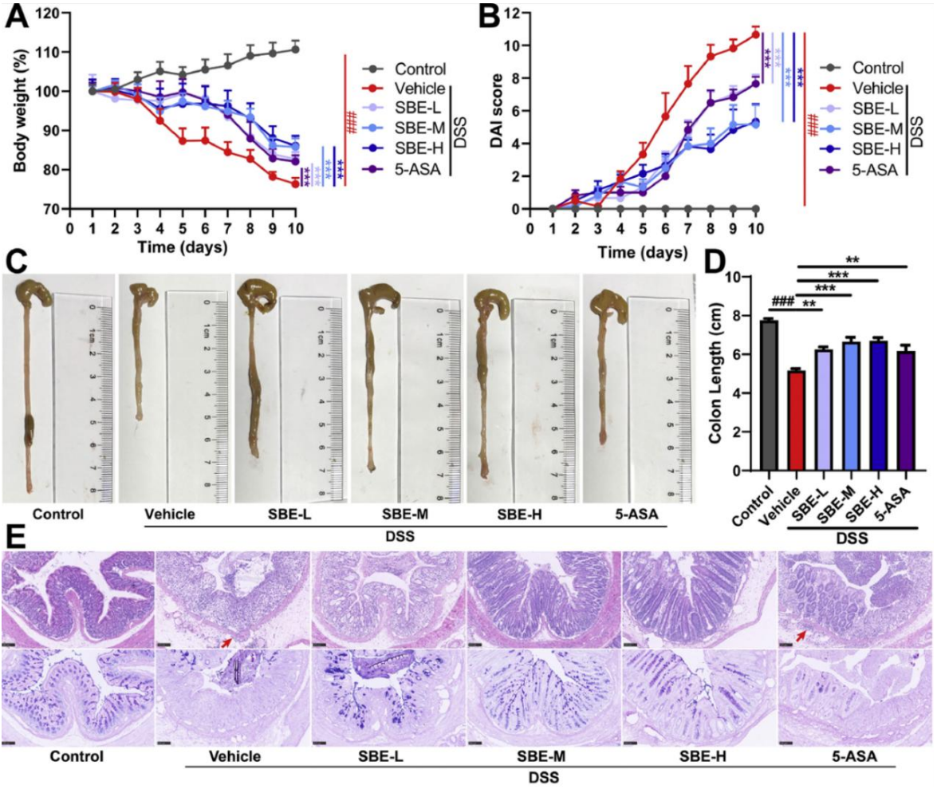
Figure 1. SBE improves UC symptoms caused by DSS. (A) Percentage change in starting body weight in the tested mice. (B) Scores of the disease activity index (DAI). (C) Example pictures of mouse colons taken from each group. (D) Calculated values for colon length. (E) Example pictures from H&E staining (top row) and AB-PAS staining (bottom row) of colon tissues (Scale bar = 100 μm). All data are shown as mean ± SEM (there are 6 mice in each group, n=6). #p< 0.05, ##p < 0.01, and ###p < 0.001 when compared to the control group; *p < 0.05, **p < 0.01, and ***p < 0.001 vs. the model group.

Medium-dose (SBE-M, 100 mg/kg) and high-dose (SBE-H, 200 mg/kg) SBE administration markedly attenuated these pathological changes, increasing colon length, restoring body weight, and decreasing DAI scores, with efficacy comparable to or superior to 5-ASA (50 mg/kg). Histological examination revealed severe colonic mucosal ulceration and inflammatory infiltration in DSS-treated mice, which were substantially ameliorated by SBE-M and SBE-H intervention. Furthermore, DSS-induced depletion of goblet cells was significantly reversed by SBE-M and SBE-H treatment. Collectively, these findings demonstrate that SBE exerts therapeutic effects against UC by attenuating colonic inflammation and restoring mucosal barrier integrity, with high-dose SBE showing efficacy comparable or superior to the clinically used drug 5-ASA, suggesting its potential as a therapeutic strategy for UC.

3.2. SBE ameliorates gut microbiota dysbiosis in UC primarily by increasing Faecalibaculum rodentium abundance
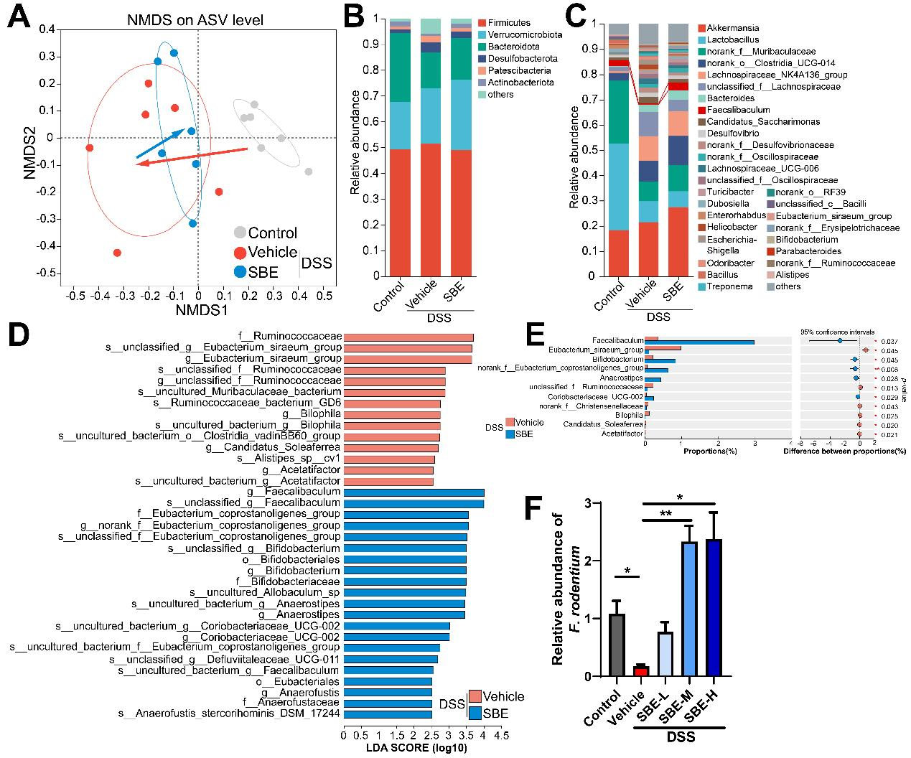Figure 2. SBE helps fix the imbalance of gut bacteria when UC develops, mainly by making more Faecalibaculum rodentium grow there. (A) Non-metric multidimensional scaling (NMDS) analysis done on ASV-level microbial groups, which uses the Bray-Curtis distance method. (B) A histogram that shows how much each bacterial community takes up at the phylum level. (C) A histogram that shows the relative amounts of bacterial communities at the genus level. (D) Linear discriminant analysis (LDA) scores obtained from LEfSe analysis, which compares the vehicle control group with the group treated with SBE. (E) Difference analysis of relative abundance for bacterial taxa at the genus level. (F) The amount of Faecalibaculum rodentium in colon contents of UC mice, measured with qPCR. Data are shown as mean ± SEM, n=6. *p < 0.05, **p < 0.01, ***p < 0.001.

16S rRNA gene sequencing was performed to investigate the impact of SBE on the microbiota. Beta diversity analysis using non-metric multidimensional scaling (NMDS) at the ASV level revealed distinct clustering of microbial communities between control and DSS-treated groups, with SBE intervention shifting the overall microbial composition toward that of the control group (Figure 2A).
When we look at the phylum level, DSS treatment lowered the relative abundance of Bacteroidetes, and this effect was partially reversed by SBE intervention (Figure 2B). At the genus level, giving SBE greatly increased the amount of Faecalibaculum, Bifidobacterium, Eubacterium coprostanoligenes group, Anaerostipes, and Coriobacteriaceae UCG-002. At the same time, it reduced the amount of Eubacterium siraeum group, unclassified Ruminococcaceae, norank Christensenellaceae, Bilophila, and Acetatifactor. Moreover, Acetatifactor and Bilophila are known to be pro-inflammatory bacteria that live in the gut, and they can trigger colitis.

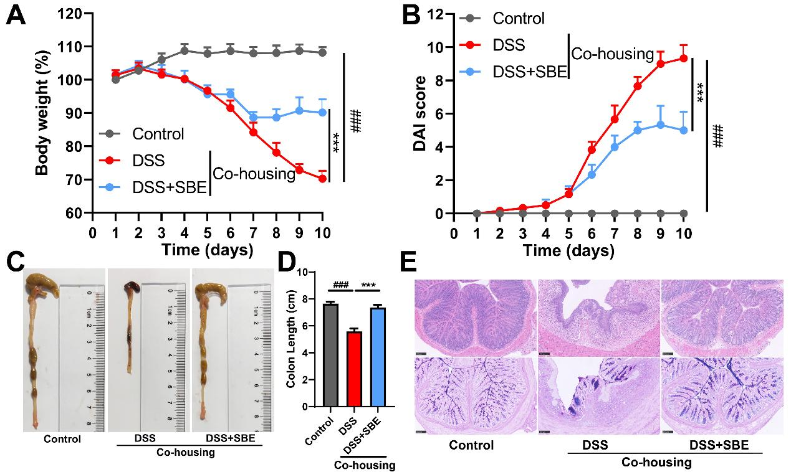
Figure 3. SBE changes the gut microbiota structure and helps protect against UC. (A) The percent change in starting body weight of mice after they received DSS treatment. (B) Scores of the Disease Activity Index (DAI. (C) Example colon pictures from each of the experimental groups. (D) Measurements of colon length for each group. (E) Example pictures from stained colon slices: the top panels are stained with hematoxylin and eosin (H&E), and the bottom panels use Alcian blue-periodic acid-Schiff (AB-PAS) staining. The scale bar equals 100 μm. The data shown here are the average value plus or minus the standard error of the mean, with n=6 for each group. #p < 0.05, ##p < 0.01, ###p < 0.001 compared to the control group; *p < 0.05, **p < 0.01, ***p < 0.001 compared to the vehicle group. One-way ANOVA was used to compare multiple groups; two-way ANOVA was used to analyze the time-course data.

3.3. SBE alleviates ulcerative colitis by regulating the F. rodentium-mediated butyrate-GPR109A axis
To definitively establish the functional role of Faecalibaculum rodentium in SBE-mediated protection against UC, we employed a combination of antibiotic-mediated depletion and targeted recolonization strategies. Following vancomycin treatment to deplete endogenous F. rodentium, the therapeutic efficacy of SBE was substantially abrogated. Depletion of F. rodentium abolished SBE-induced improvements in colon length, body weight recovery, and DAI score reduction in colitic mice (Figure 5A-E).
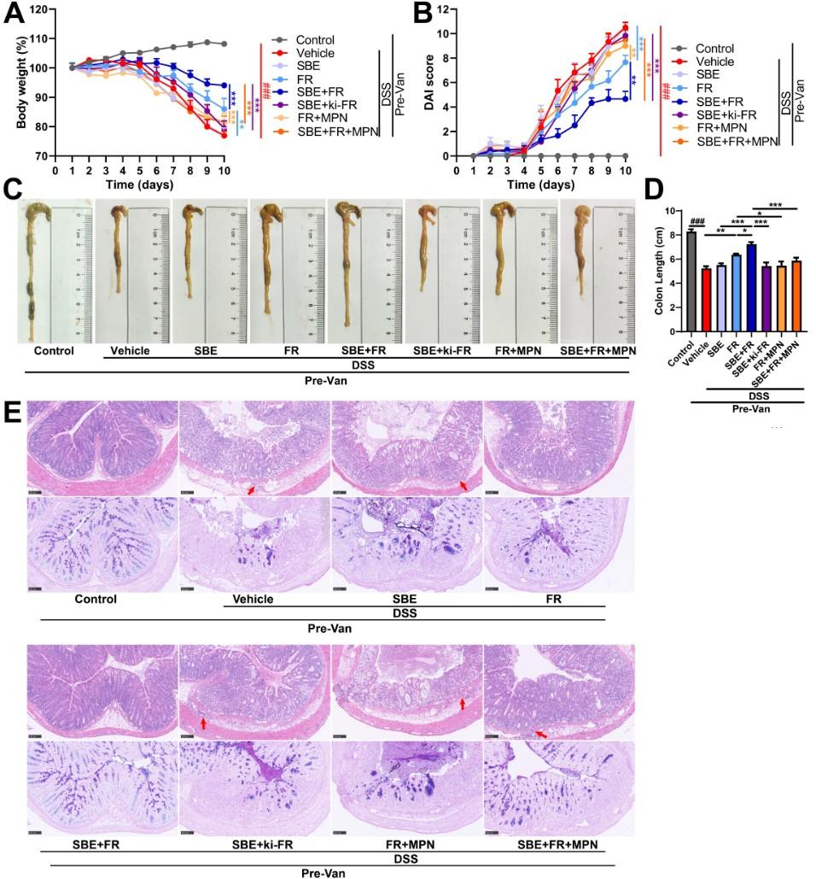
Figure 5. SBE eases ulcerative colitis by working through the F. Rodentium-controlled butyrate-GPR109A pathway. (A) Percent change in starting body weight of mice after they received DSS treatment. (B) Scores for the Disease Activity Index (DAI). (C) Example photos of colons taken from every test group. (D) Measurements of colon length for each group. (E) Example staining photos: hematoxylin and eosin (H&E) on the top row, and Alcian blue-periodic acid-Schiff (AB-PAS) on the bottom row, both from colon tissue slices. The scale bar has a length of 100 μm. All data are shown as mean ± SEM, with n=6 for each group. #p < 0.05, ##p < 0.01, ###p < 0.001 when compared to the control group; *p < 0.05, **p < 0.01, ***p < 0.001 when compared to the vehicle group.

SBE has therapeutic effects against UC because it increases the amount of intestinal F. Rodentium, which in turn makes more butyrate. This butyrate then turns on the GPR109A receptor that sits on colonic epithelial cells, and in the end it makes intestinal inflammation weaker and fixes the integrity of the mucosal barrier. What we found here shows a new mechanism through which SBE works on the F. Rodentium-butyrate-GPR109A axis to improve UC symptoms.

4. Discussion
This study looks carefully at the molecular way that sea buckthorn berry extract (SBE) helps improve ulcerative colitis (UC). It shows for the first time that SBE works to treat the condition by making more intestinal Faecalibaculum rodentium grow in the gut. This bacterium then makes more butyrate (BA), which goes on to activate the GPR109A receptor on colon epithelial cells. In the end, this process reduces inflammation in the intestine and fixes the integrity of the mucosal barrier.
16S rRNA sequencing reported that Faecalibaculum is the bacterial genus that gets the biggest boost from SBE treatment. The most common species in this genus, F. Rodentium, had much lower amounts in UC mice, and SBE treatment brought its levels back to normal in a really clear way. Most importantly, co-housing tests showed that the good effects of SBE can be passed on through transplanting microbiota. This directly proves that microbiota plays a middle role in how SBE works, and also confirms that F. Rodentium is the key bacterium that causes SBE's anti-UC effects.
GPR109A is one of the main receptors for SCFAs that sits on colonic epithelial cells. Researchers have already shown that when this receptor gets activated, it can hold back inflammation and help the mucosal lining fix itself ^{[20, 21]}. When we did receptor-blocking experiments, we found that blocking GPR109A got rid of all of SBE's helpful effects. This clearly shows that the BA-GPR109A pathway is the main thing that makes SBE work against UC. Heat-inactivated F. Rodentium did not bring back SBE’s good effects. That means the useful metabolites the bacteria make (which include butyrate) are what matter for the protective effect, not the structural parts of the bacteria themselves.
Based on these results, there are several good directions that need more research. Sea buckthorn berries have lots of different bioactive things in them, like flavonoids and polyphenols. Later studies should use activity-guided fractionation and in vitro culture systems to find which specific single compounds directly help F. Rodentium grow or change its butyrate biosynthesis gene clusters. We also need to study how important this regulatory axis is for many different gut diseases. If we expand this kind of research to models of Crohn’s disease, irritable bowel syndrome, infectious enteritis, and colorectal cancer, we can figure out if the F. Rodentium-butyrate-GPR109A axis has a general role in keeping the gut healthy and stable. This would make these findings more scientifically meaningful and also increase their potential to be translated into real clinical use one day.

5. Conclusion
This study shows that sea buckthorn berry extract (SBE) has clear healing effects on DSS-induced acute ulcerative colitis in mice. This works by boosting the number of the important probiotic bacteria Faecalibaculum rodentium in the gut, which then helps the body make more butyrate and other short-chain fatty acids. Butyrate then turns on the GPR109A receptor that sits on colonic epithelial cells. This process reduces inflammation inside the intestine and fixes the damaged mucosal barrier, making it work properly again. This research finds the key microbial groups and the signaling pathway that make SBE work against colitis. It gives test-based proof for treatment plans that target gut microbiota when managing UC, and also sets up a basic scientific background for using sea buckthorn in clinical work later on.

Disclosure statement
The authors declare no conflict of interest.

References
[1] Ungaro R, Mehandru S, Allen PB, et al., 2017, Ulcerative Colitis. Lancet (London, England), 389(10080): 1756–1770.
[2] Le Berre C, Honap S, Peyrin-Biroulet L, 2023, Ulcerative Colitis. Lancet (London, England), 402(10401): 571–584.
[3] Porter RJ, Kalla R, Ho GT, 2020, Ulcerative Colitis: Recent Advances in the Understanding of Disease Pathogenesis. F1000Research, 9: F1000 Faculty Rev-294.
[4] Segal JP, LeBlanc JF, Hart AL, 2021, Ulcerative Colitis: An Update. Clinical Medicine (London, England), 21(2): 135–139.
[5] Zhang SL, Wang SN, Miao CY, 2017, Influence of Microbiota on Intestinal Immune System in Ulcerative Colitis and Its Intervention. Frontiers in Immunology, 8: 1674.
[6] Lloyd-Price J, Arze C, Ananthakrishnan AN, et al., 2019, Multi-Omics of the Gut Microbial Ecosystem in Inflammatory Bowel Diseases. Nature, 569(7758): 655–662.
[7] Machiels K, Joossens M, Sabino J, et al., 2014, A Decrease of the Butyrate-Producing Species Roseburia Hominis and Faecalibacterium Prausnitzii Defines Dysbiosis in Patients With Ulcerative Colitis. Gut, 63(8): 1275–1283.
[8] Lenoir M, Martín R, Torres-Maravilla E, et al., 2020, Butyrate Mediates Anti-Inflammatory Effects of Faecalibacterium Prausnitzii in Intestinal Epithelial Cells Through Dact3. Gut Microbes, 12(1): 1–16.
[9] Costello SP, Hughes PA, Waters O, et al., 2019, Effect of Fecal Microbiota Transplantation on 8-Week Remission in Patients With Ulcerative Colitis: A Randomized Clinical Trial. JAMA, 321(2): 156–164.
[10] Paramsothy S, Kamm MA, Kaakoush NO, et al., 2017, Multidonor Intensive Faecal Microbiota Transplantation for Active Ulcerative Colitis: A Randomised Placebo-Controlled Trial. Lancet (London, England), 389(10075): 1218–1228.
[11] Jin W, Ai H, Huang Q, et al., 2023, Preclinical Evidence of Probiotics in Ulcerative Colitis: A Systematic Review and Network Meta-Analysis. Frontiers in Pharmacology, 14: 1187911.
[12] Żuchowski J, 2023, Phytochemistry and Pharmacology of Sea Buckthorn (Elaeagnus Rhamnoides; Syn. Hippophae Rhamnoides): Progress From 2010 to 2021. Phytochemistry Reviews: Proceedings of the Phytochemical Society of Europe, 22(1): 3–33.
[13] Wang Z, Zhou S, Jiang Y, 2022, Sea Buckthorn Pulp and Seed Oils Ameliorate Lipid Metabolism Disorders and Modulate Gut Microbiota in C57BL/6J Mice on High-Fat Diet. Frontiers in Nutrition, 9: 1067813.
[14] Xia CX, Gao AX, Zhu Y, et al., 2023, Flavonoids From Seabuckthorn (Hippophae Rhamnoides L.) Restore CUMS-Induced Depressive Disorder and Regulate the Gut Microbiota in Mice. Food & Function, 14(16): 7426–7438.
[15] Lan Y, Ma Z, Chang L, et al., 2023, Sea Buckthorn Polysaccharide Ameliorates High-Fat Diet Induced Mice Neuroinflammation and Synaptic Dysfunction via Regulating Gut Dysbiosis. International Journal of Biological Macromolecules, 236: 123797.
[16] Ouyang Q, Li X, Liang Y, Liu R, 2024, Sea Buckthorn Polysaccharide Ameliorates Colitis. Nutrients, 16(9): 1280.
[17] Fukuda T, Naganuma M, Kanai T, 2019, Current New Challenges in the Management of Ulcerative Colitis. Intestinal Research, 17(1): 36–44.
[18] Dong W, Tang Y, Qiao J, et al., 2025, Sea Buckthorn Bioactive Metabolites and Their Pharmacological Potential in Digestive Diseases. Frontiers in Pharmacology, 16: 1637676.
[19] Recharla N, Geesala R, Shi XZ, 2023, Gut Microbial Metabolite Butyrate and Its Therapeutic Role in Inflammatory Bowel Disease: A Literature Review. Nutrients, 15(10): 2275.
[20] Singh N, Gurav A, Sivaprakasam S, et al., 2014, Activation of Gpr109a, Receptor for Niacin and the Commensal Metabolite Butyrate, Suppresses Colonic Inflammation and Carcinogenesis. Immunity, 40(1): 128–139.
[21] Chen G, Ran X, Li B, et al., 2018, Sodium Butyrate Inhibits Inflammation and Maintains Epithelium Barrier Integrity in a TNBS-Induced Inflammatory Bowel Disease Mice Model. EBioMedicine, 30: 317–325.

Publisher’s note
Bio-Byword Scientific Publishing remains neutral with regard to jurisdictional claims in published maps and institutional affiliations.

