A Study on the Quantitative Evaluation of the Invasiveness of Lung Adenocarcinoma Based on the Texture Features of Pulmonary Nodules Using United Imaging uCT968 Ultra-High-End CT
Man Zhang*
Xiangyang Hospital of Traditional Chinese Medicine, Xiangyang 441000, Hubei, China
*Author to whom correspondence should be addressed.

Copyright: © 2026 Author(s). This is an open-access article distributed under the terms of the Creative Commons Attribution License (CC BY 4.0), permitting distribution and reproduction in any medium, provided the original work is cited.

Abstract: Objective: To explore the quantitative evaluation of the invasiveness of lung adenocarcinoma based on the texture features of pulmonary nodules using United Imaging uCT968 ultra-high-end CT. Methods: A total of 100 patients with pulmonary mixed ground-glass nodules confirmed by pathological examination after lung surgery in our hospital from December 2024 to December 2025 were selected. Based on whether the lesion invaded the surrounding tissues, minimally invasive cancer and invasive cancer were classified into the invasive group, while benign lesions and carcinoma in situ were classified into the non-invasive group. Both groups underwent CT examinations in our hospital. Clinical data and CT texture features were compared between the two groups. Logistic regression analysis was used to identify factors influencing the invasiveness of pulmonary nodules and to predict the diagnostic efficacy for pulmonary nodule invasion. Results: There were no statistically significant differences between the two groups in terms of gender, clinical stage, maximum lesion diameter, spiculation sign, lobulation sign, air bronchogram, and average CT value of the lesion (P > 0.05). Statistically significant differences were observed in pleural indentation sign, vacuole sign, and texture features, including entropy, correlation, contrast, energy, and homogeneity, between the two groups (P < 0.05). Logistic regression analysis revealed that pleural indentation sign, vacuole sign, and texture features including entropy, correlation, contrast, energy, and homogeneity were risk factors influencing the invasiveness of pulmonary nodules clinically. Compared to individual texture features, the combined use of texture features demonstrated higher diagnostic value for detecting the invasiveness of lung adenocarcinoma. Conclusion: The quantitative texture features (entropy, correlation, contrast, energy, and homogeneity) of pulmonary nodules obtained using United Imaging uCT968 ultra-high-end CT have good diagnostic value for the invasiveness of lung adenocarcinoma and possess high clinical application value.
Keywords: CT detection; Texture features of pulmonary nodules; Lung adenocarcinoma; Invasiveness

Online publication:

1. Introduction
Lung adenocarcinoma, as the most predominant pathological subtype of lung cancer, poses a significant global public health threat due to its high incidence and mortality rates. Different pathological subtypes of lung adenocarcinoma exhibit marked differences in biological behavior and invasiveness, directly influencing the choice of treatment regimen and the prognosis of patients ^{[1]}. Although traditional CT examinations play an indispensable role in the diagnosis of lung adenocarcinoma, they remain inadequate in assessing its invasiveness. Traditional CT signs, such as nodule size, shape, and edge characteristics, often rely heavily on the subjective interpretation of physicians and struggle to fully reveal the complex internal heterogeneity of lesions. While lung puncture biopsy can provide definitive pathological diagnosis, its inherent sampling bias and requirements for lesion location may result in assessment outcomes that do not fully represent the true invasive state of the entire lesion ^{[2-3]}. Therefore, there is an urgent need for a more objective and quantifiable assessment method to overcome the limitations of traditional approaches. The United Imaging uCT968 ultra-high-end CT demonstrates significant advantages in the detection and fine characterization of pulmonary nodules, thanks to its outstanding spatial resolution and extremely low image noise. This device not only clearly presents the subtle internal structures of ground-glass nodules (GGNs) but also extracts rich and high-fidelity texture features through its advanced post-processing techniques ^{[4-5]}. However, the current challenge lies in how to fully utilize the imaging data from the United Imaging uCT968, particularly its texture features, to assess the invasiveness of lung adenocarcinoma quantitatively. This study employs texture features extracted from chest plain scan images obtained using the United Imaging uCT968 ultra-high-end CT to predict the invasiveness of pulmonary nodules, providing a foundational basis for subsequent research.

2. Subjects and methods
2.1. Study subjects
This prospective study included 240 patients with pulmonary mixed ground-glass nodules confirmed by pathological examination after lung surgery in our hospital from December 2025 to December 2026. Based on whether the lesions invaded the surrounding tissues, minimally invasive cancer and invasive cancer were classified into the invasive group (n = 120), while benign lesions and carcinoma in situ were classified into the non-invasive group (n = 120). Clinical and pathological information, including age, gender, smoking status, and pathological diagnosis, was obtained from the electronic medical record system of our hospital.
Inclusion Criteria: (1) Pathological confirmation of lung adenocarcinoma following surgery; (2) All patients had pulmonary nodules detected and underwent lung resection treatment; (3) Received low-dose chest CT scans and quantitative analysis after admission; (4) Complete CT quantitative parameters.
Exclusion Criteria: (1) Presence of nodules or malignant tumors in other parts of the body; (2) History of preoperative radiotherapy or chemotherapy; (3) The time interval between CT examination and surgery exceeded 3 months; (4) Motion artifacts present in CT scan images; (5) Incomplete clinical data.

2.2. Imaging examination
All enrolled patients underwent plain chest CT scans using the United Imaging uCT968 ultra-high-end multi-slice spiral CT. Prior to the scan, patients were instructed to lie supine with their arms raised above their heads and to breathe quietly during the procedure. The scan positioning line started horizontally from the bilateral lung apices (thoracic inlet) and continued downward to the bilateral lung bases (above the diaphragm), ensuring complete coverage of the entire lung fields. The scanning parameters were set as follows: tube voltage of 120 kV, reference tube current of 50 mAs under automatic tube current modulation technology, pitch of 0.609, field of view (FOV) of 350 mm × 350 mm, acquisition slice thickness of 5 mm, reconstruction slice thickness of 5 mm, and reconstruction matrix of 512 × 512. After transferring the raw image data to the workstation, high-resolution (HR) reconstruction algorithms were used for processing, generating images in both lung window (window level: -450 HU, window width: 1500 HU) and mediastinal window (window level: 40 HU, window width: 400 HU) settings for subsequent observation and analysis of the lesions.
Plain Chest CT Scan Interpretation: Two radiologists with more than 5 years of experience independently interpreted the plain chest CT scan images.
Plain Chest CT Scan Texture Feature Interpretation: The specific steps are shown in the following figure.

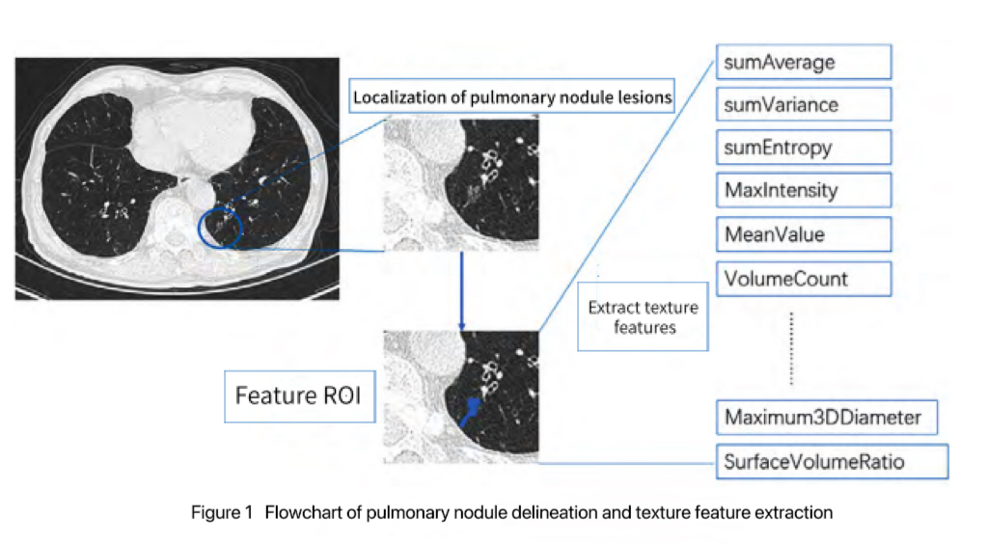
Figure 1. Flowchart of pulmonary nodule delineation and texture feature extraction.

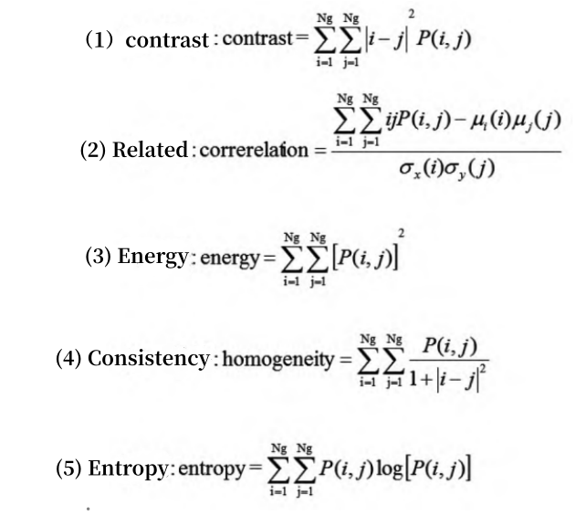
Figure 2. Formulas for calculating texture features.

2.3. Pathological evaluation
Pathological evaluations of frozen sections during or after surgery were conducted based on the International Association for the Study of Lung Cancer/American Thoracic Society/European Respiratory Society classification, which includes atypical adenomatous hyperplasia, adenocarcinoma in situ, minimally invasive adenocarcinoma, lepidic-predominant adenocarcinoma (LPA), acinar-predominant adenocarcinoma, papillary-predominant adenocarcinoma, micropapillary-predominant adenocarcinoma, solid-predominant adenocarcinoma with mucin production, and four other variant subtypes. Atypical adenomatous hyperplasia, adenocarcinoma in situ, minimally invasive adenocarcinoma, and LPA are considered less invasive nodules due to their higher 5-year survival rates, whereas other subtypes of invasive adenocarcinoma are regarded as invasive nodules due to their aggressive biological behavior.

2.4. Index analysis
2.4.1. Collection of general patient information
This includes age, gender, disease duration, smoking history, family history, and history of benign pulmonary diseases.

2.4.2. Factor analysis
Multivariate logistic regression analysis was performed to identify factors influencing the invasiveness of pulmonary nodules.

2.4.3. CT texture features
Using postoperative pathological results as the gold standard, the sensitivity, specificity, and accuracy of direct interpretation of plain chest CT scans and interpretation based on CT texture features were compared.

2.5. Statistical analysis
Statistical analysis was performed using SPSS 26.0 software. For univariate analysis, the chi-square test was used to compare the composition of categorical data between groups. Non-normally distributed continuous data were described using mean ± standard deviation (SD), and comparisons between groups with homogeneous variance were conducted using the t-test. Categorical data were expressed as cases or percentages. Multivariate analysis was performed using a logistic regression model. The significance level was set at α = 0.05, with a P-value < 0.05 considered statistically significant.

3. Results
3.1. Baseline and texture feature analysis of the two groups
As shown in Table 1, there were no statistically significant differences between the two groups in terms of gender, clinical stage, maximum lesion diameter, spiculation sign, lobulation sign, air bronchogram, and average CT value of the lesion (P > 0.05). Statistically significant differences were observed in pleural indentation sign, vacuole sign, and texture features including entropy, correlation, contrast, energy, and homogeneity between the two groups (P < 0.05).

Table 1. Baseline and texture feature analysis of the two groups
Item |  | Invasive Group  (n=120) | Non-invasive Group  (n=120) | χ²/t value | P value
Gender | Male | 73 | 70 | 0.156 | 0.693
Gender | Female | 47 | 50 | 0.156 | 0.693
Clinical Stage | Stage I | 59 | 55 | 0.124 | 0.637
Clinical Stage | Stage II | 38 | 43 | 0.124 | 0.637
Clinical Stage | Stage III | 23 | 22 | 0.124 | 0.637
Texture Features | Entropy | 2.56 ± 0.19 | 2.10 ± 0.12 | 22.420 | 0.001
Texture Features | Correlation | 0.31 ± 0.05 | 0.58 ± 0.11 | 24.480 | 0.001
Texture Features | Contrast | 6.81 ± 1.35 | 5.19 ± 1.03 | 10.450 | 0.001
Texture Features | Energy | 0.10 ± 0.02 | 0.16 ± 0.04 | 14.700 | 0.001
Texture Features | Homogeneity | 0.38 ± 0.03 | 0.49 ± 0.10 | 11.540 | 0.001
Maximum Lesion Diameter (cm) |  | 2.91 ± 0.10 | 2.93 ± 0.09 | 1.628 | 0.105
Pleural Indentation Sign |  | 61 | 35 | 11.730 | 0.001
Spiculation Sign |  | 59 | 53 | 1.069 | 0.301
Lobulation Sign |  | 61 | 58 | 0.150 | 0.698
Vacuole Sign |  | 66 | 39 | 12.340 | 0.001
Air Bronchogram Sign |  | 53 | 51 | 0.068 | 0.794
Mean CT Value of Lesion |  | 0.71 ± 0.03 | 0.72 ± 0.02 | 2.031 | 0.063

3.2. Logistic regression analysis of factors influencing the invasiveness of pulmonary nodules
As shown in Table 2, pleural indentation sign, vacuole sign, and texture features including entropy, correlation, contrast, energy, and homogeneity are risk factors clinically influencing the invasiveness of pulmonary nodules.

Table 2. Logistic regression analysis of factors influencing the invasiveness of pulmonary nodules
Factor | β | SE | Wald χ² value | P value | OR | 95% CI
Pleural indentation sign | 0.516 | 0.037 | 3.195 | 0.001 | 2.675 | 1.345~4.861
Vacuole sign | 0.318 | 0.061 | 2.415 | 0.001 | 1.946 | 1.063~3.946
Entropy | 0.152 | 0.084 | 3.842 | 0.001 | 1.842 | 1.013~4.761
Correlation | 0.216 | 0.391 | 5.673 | 0.001 | 1.639 | 1.269~3.175
Contrast | 0.311 | 0.277 | 4.812 | 0.001 | 2.946 | 1.765~5.137
Energy | 0.219 | 0.294 | 4.913 | 0.001 | 2.758 | 1.346~5.976
Homogeneity | 0.137 | 0.372 | 2.948 | 0.001 | 2.791 | 1.338~5.729

3.3. Predictive value of pulmonary nodule texture features for the invasiveness of lung adenocarcinoma
As shown in Table 3, compared to individual texture features, the combined use of texture features demonstrates higher diagnostic value for detecting the invasiveness of lung adenocarcinoma.

Table 3. Predictive value of pulmonary nodule texture features for the invasiveness of lung adenocarcinoma
Index | P value | Youden's Index | Cut-off value | Sensitivity (%) | Specificity (%) | Accuracy (%) | 95% CI
Entropy | 0.001 | 0.533 | 0.394 | 84.59 | 81.50 | 81.26 | 0.419~0.913
Correlation | 0.001 | 0.501 | 0.371 | 81.76 | 82.76 | 86.49 | 0.412~0.811
Contrast | 0.001 | 0.475 | 0.519 | 79.67 | 81.09 | 84.91 | 0.467~0.916
Energy | 0.001 | 0.496 | 0.317 | 85.43 | 86.74 | 83.59 | 0.138~0.721
Homogeneity | 0.001 | 0.518 | 0.421 | 81.26 | 84.19 | 85.49 | 0.167~0.946
Combined | 0.001 | 0.913 | 0.728 | 96.53 | 93.47 | 96.72 | 0.175~0.837

4. Discussion
The invasiveness of lung adenocarcinoma is closely related to its pathological basis. The degree of tumor cell infiltration determines the malignancy and clinical manifestations of the lesion, while the complex microenvironment regulatory network not only affects tumor growth rate but also determines its invasive capacity toward surrounding tissues. In recent years, texture feature analysis based on CT images has demonstrated significant application value in the diagnosis of pulmonary nodules. As a quantitative tool for describing the gray-level distribution and spatial structure of images, texture features can effectively reflect the internal heterogeneity of pulmonary nodules, thereby aiding in the differentiation between benign and malignant lesions. Previous studies have shown that CT image texture parameters such as energy, entropy, and standard deviation are significantly higher in malignant pulmonary nodules compared to benign ones, and these parameters also exhibit good performance in distinguishing subsolid nodules with different degrees of infiltration ^{[6,7]}. Furthermore, the development of radiomics technology has enabled the extraction of more high-dimensional texture features, providing new insights for the precise diagnosis of pulmonary nodules. However, existing research has primarily focused on the application of texture features in differentiating between benign and malignant lesions, with insufficient exploration of their value in assessing the invasiveness of lung adenocarcinoma, particularly their performance in subsolid nodules with varying degrees of infiltration, which still requires in-depth validation.
This study found that the quantitative evaluation of the invasiveness of lung adenocarcinoma using texture features from United Imaging uCT968 ultra-high-end CT has considerable value. Statistically significant differences were observed between the two groups in terms of pleural indentation sign, vacuole sign, and texture features including entropy, correlation, contrast, energy, and homogeneity (P < 0.05). Logistic regression analysis revealed that pleural indentation sign, vacuole sign, and texture features including entropy, correlation, contrast, energy, and homogeneity are risk factors clinically influencing the invasiveness of pulmonary nodules. Compared to individual texture features, the combined use of texture features demonstrates higher diagnostic value for detecting the invasiveness of lung adenocarcinoma. These findings suggest that United Imaging uCT968 ultra-high-end CT holds significant value in assessing the invasiveness of lung adenocarcinoma, which can be attributed to its advanced technological characteristics that provide unique advantages in the field of pulmonary disease diagnosis. The device employs a wide-detector design and an intelligent scanning platform, enabling rapid, low-dose, large-scale imaging while delivering high-resolution and high-clarity image quality, laying the foundation for precise detection and feature extraction of pulmonary nodules ^{[8,9]}. In practical applications, United Imaging uCT968 has been successfully used for the early diagnosis and treatment efficacy evaluation of various pulmonary diseases, particularly excelling in the qualitative analysis and quantitative measurement of pulmonary nodules. For instance, an artificial intelligence-assisted system can automatically segment pulmonary nodules and extract their morphological features and texture parameters, enabling a preliminary assessment of lesion nature. Additionally, United Imaging uCT968 offers significant advantages in texture feature extraction, with its high sensitivity and resolution facilitating the capture of subtle changes in the internal microstructure of pulmonary nodules, providing reliable data support for subsequent texture analysis.

5. Conclusion
In conclusion, the application of United Imaging uCT968 ultra-high-end CT for diagnosing the invasiveness of lung adenocarcinoma demonstrates high diagnostic efficacy. Through dynamic monitoring of texture features, it can predict disease progression risk and guide the formulation of follow-up plans.

Funding
Quantitative Evaluation of the Invasiveness of Lung Adenocarcinoma Based on Texture Features of Pulmonary Nodules Using the United Imaging uCT968 Ultra-High-End CT (Project No.: XYZY2025Y10)

Disclosure statement
The author declares no conflict of interest.

References
[1] Zhou C, Ren W, Chen J, et al., 2025, Predicting the Aggressiveness of Different Pathological Grades in Stage IA Lung Adenocarcinoma Based on CT Radiomics Models. Doctor Online, 15(11): 54–57.
[2] Cai X, Wang P, Zhou H, et al., 2023, CT-Based Radiomics Nomogram for Predicting Visceral Pleural Invasion in Peripheral T1-Sized Solid Lung Adenocarcinoma. American Journal of Cancer Research, 13(12): 5901–5913.
[3] Zuo Z, Li Y, Peng K, et al., 2022, CT Texture Analysis-Based Nomogram for the Preoperative Prediction of Visceral Pleural Invasion in cT1N0M0 Lung Adenocarcinoma: An External Validation Cohort Study. Clinical Radiology, 77(3): e215–e221.
[4] Zeng L, 2024, The Value of Predicting the Aggressiveness of Ground-Glass Nodule-Type Lung Adenocarcinoma Based on CT Morphology and Quantitative Parameters, thesis, Medical School of Nanchang University.
[5] Xu Q, Cheng H, 2025, The Predictive Value of Different Metabolic Parameters from 18F-FDG PET/CT for the Aggressiveness of Lung Adenocarcinoma. Imaging Diagnosis and Interventional Radiology, 34(3): 191–197.
[6] Zuo YQ, Gao D, Cui JJ, et al., 2025, Peritumoral and Intratumoral Radiomics for Predicting Visceral Pleural Invasion in Lung Adenocarcinoma Based on Preoperative Computed Tomography (CT). Clinical Radiology, 80: 106729.
[7] Song Y, Chen D, Lian D, et al., 2022, Study on the Correlation Between CT Features and Vascular Tumor Thrombus Together With Nerve Invasion in Surgically Resected Lung Adenocarcinoma. Frontiers in Surgery, 9: 931568.
[8] Han C, Shi G, Liu D, et al., 2025, The Predictive Value of CT for the Aggressiveness of Sub-Centimeter Pure Ground-Glass Nodule Lung Adenocarcinoma. Journal of Guizhou Medical University, 50(12): 1854–1860.
[9] Huang Y, Tan Y, Lin L, et al., 2025, The Predictive Value of Quantitative Parameters from Dual-Energy CT for the Differential Diagnosis and Pathological Aggressiveness of Lung Adenocarcinoma. Journal of Practical Radiology, 41(3): 394–398.

Publisher’s note
Bio-Byword Scientific Publishing remains neutral with regard to jurisdictional claims in published maps and institutional affiliations.

