Analysis of Influencing Factors for Pulmonary Consolidation in Children with Mycoplasma Pneumoniae Pneumonia and Construction‑Validation of a Nomogram Model
Lanlan Su¹, Guanghui Yin¹, Peishan Liang¹, Yanping Wei², Chunlin Li¹, Kun Lin¹*
¹Department of Pediatrics, Wuming Hospital Affiliated to Guangxi Medical University, Nanning 530199, Guangxi, China
²Department of Critical Care Medicine, Wuming Hospital Affiliated to Guangxi Medical University, Nanning 530199, Guangxi, China
*Author to whom correspondence should be addressed.

Copyright: © 2026 Author(s). This is an open-access article distributed under the terms of the Creative Commons Attribution License (CC BY 4.0), permitting distribution and reproduction in any medium, provided the original work is cited.

Abstract: Objective: To explore the independent influencing factors for pulmonary consolidation complicated by mycoplasma pneumoniae pneumonia (MPP) in children, and construct a nomogram prediction model capable of individualised quantitative risk assessment, so as to provide evidence for early clinical identification of high‑risk children and formulation of precise intervention strategies. Methods: A retrospective cohort design was adopted in this study. A total of 316 children diagnosed with MPP at Wuming Hospital Affiliated to Guangxi Medical University from June 2023 to June 2024 were enrolled as research subjects. According to imaging findings, the children were divided into pulmonary‑consolidation group (n = 177) and non‑pulmonary‑consolidation group (n = 139). Baseline clinical data and laboratory indicators of the two groups were compared via univariate analysis. Variables with statistical differences in univariate analysis were included in multivariate binary Logistic regression analysis to screen independent risk factors for pulmonary consolidation among children with MPP. A nomogram prediction model was constructed based on screened results, and internal validation was performed using the Bootstrap method (1 000 repeated samplings). The discrimination, calibration and predictive performance of the model were comprehensively evaluated by calculating the concordance index (C‑index), plotting calibration curves and receiver operating characteristic (ROC) curves. Results: Univariate analysis showed that peripheral white blood cell count (WBC), high‑sensitivity C‑reactive protein (hs‑CRP), erythrocyte sedimentation rate (ESR) and fibrinogen (FIB) levels in the pulmonary‑consolidation group were significantly higher than those in the non‑pulmonary‑consolidation group (all p < 0.05). Multivariate Logistic regression analysis further confirmed that elevated WBC (OR = 1.054, 95%CI: 1.001–1.111), elevated hs‑CRP (OR = 1.044, 95% CI: 1.018–1.070) and elevated FIB (OR = 1.492, 95% CI: 1.007–2.212) were independent risk factors for pulmonary consolidation in children with MPP (all p < 0.05). For the nomogram prediction model constructed based on the above three indicators, the C‑index from internal validation was 0.718 (95% CI: 0.659–0.802), suggesting acceptable discrimination capacity of the model. The calibration curve indicated high consistency between predicted probabilities and actually‑observed probabilities. ROC‑curve analysis yielded an area under curve (AUC) of 0.731 for the model to predict pulmonary consolidation, with a sensitivity of 61.4 % and specificity of 75.2 %. Clinical decision‑curve analysis further verified positive net clinical benefit of the model across a wide range of threshold probabilities. In summary, this nomogram model achieves a sensitivity of 61.4 % and specificity of 75.2 %, with acceptable discrimination and calibration, and possesses certain clinical practical value. Conclusion: WBC, hs‑CRP and FIB are independent risk factors for pulmonary consolidation complicated by paediatric MPP. This study successfully constructed and validated a nomogram prediction model based on these three indicators. With favourable predictive performance and clinical practicality, the model can serve as clinical reference. It facilitates early individualised risk assessment of pulmonary consolidation for children with MPP and provides an intuitive, quantitative decision‑supporting tool for prospective clinical interventions.
Keywords: Mycoplasma pneumoniae; Pulmonary consolidation; Influencing factors; Nomogram model

Online publication:

1. Introduction
Mycoplasma pneumoniae pneumonia (MPP) is a common respiratory disease in children. Cases of severe and refractory MPP have increased in recent years. Pulmonary consolidation represents one of the most frequent severe manifestations. Pulmonary consolidation is significantly correlated with longer fever duration, more persistent cough symptoms and more complicated clinical courses. It also acts as an important risk marker indicating possible progression to necrotising pneumonia, atelectasis, and even sequelae such as bronchiolitis obliterans ^{[1]}. It may prolong hospital stay, raise treatment difficulty and affect long‑term pulmonary function, thus leading to unfavourable prognosis ^{[2]}. Existing researches mostly focus on severe or refractory MPP, while specialised prediction models targeting the specific complication of pulmonary consolidation remain insufficient ^{[3,4]}. Analysing influencing factors for pulmonary consolidation in MPP bears great significance for assessing children’s conditions and improving prognosis. As a visual prediction model, a nomogram can integrate multiple risk factors to realise individualised risk evaluation. Therefore, this study aims to screen independent risk factors for pulmonary consolidation in children with MPP via retrospective analysis, construct and validate a nomogram prediction model, and offer reference evidence for early clinical identification and intervention strategies.

2. Materials and methods

2.1. Sample‑size estimation
This study followed methodological specifications for prediction‑model research and adopted the pmsampsize package of R software for sample‑size calculation. To follow a conservative principle, parameters were set as below: preset model discrimination (C‑index) = 0.8, expected number of predictive variables = 3, and estimated prevalence of the outcome (pulmonary consolidation) = 22 % according to literature ^{[5]}. Calculation yielded a theoretical minimum total sample size of 301 cases with 67 pulmonary‑consolidation events. Finally, 316 children were enrolled in this study; the total sample size met requirements, among which 177 pulmonary‑consolidation events were observed, 2.6 times the theoretical value. The events‑per‑predictor parameter (EPP) reached 59.0, far exceeding the standard of EPP ≥ 10. This guaranteed extremely stable parameter estimation and reliable internal validation of the model. Adopting a relatively low estimated prevalence for calculation was a strategy adopted in this study to enhance argumentative rigour.

2.2. Research subjects
A total of 316 children infected with MPP treated in our hospital from June 2023 to June 2024 were selected as research subjects. They were divided into pulmonary‑consolidation group (n = 177) and non‑pulmonary‑consolidation group (n = 139) according to pulmonary‑consolidation status. This study obtained approval from the Hospital Medical Ethics Committee.

2.2.1. Inclusion criteria
Conforming to diagnostic criteria specified in Diagnosis and Treatment Guidelines for Children with Mycoplasma Pneumoniae Pneumonia (2023 Edition) ^{[6]}; children aged below 14 years; complete clinical data; first‑time hospital admission.

2.2.2. Exclusion criteria
Suffering from other respiratory diseases; long‑term glucocorticoid therapy; other infectious diseases; complicated cardiac, hepatic or renal dysfunction.

2.3. Collection of clinical data
Clinical medical records of the 316 subjects were collected, including age, gender, disease course, cough, wheezing, fever, WBC, hs‑CRP, ESR, activated partial thromboplastin time (APTT), FIB, complement C3, complement C4, lactate dehydrogenase (LDH), alanine aminotransferase (ALT), aspartate aminotransferase (AST).

2.4. Statistical analysis
SPSS 26.0 software was used for statistical analysis. Count data were expressed as case number and percentage, and the Chi‑square test was adopted for inter‑group comparison. Measurement data with non‑normal distribution were presented as median and interquartile range $\text{[}\text{M}\text{(}{\text{Q}}_{\text{1}}\text{,}{\text{Q}}_{\text{3}}\text{)]}$, and the Mann‑Whitney U test was used for inter‑group comparison. Variables with p < 0.05 in univariate analysis were imported into multivariate Logistic regression analysis to identify independent risk factors. Based on regression outputs, R language was utilised to construct the nomogram prediction model, and the Bootstrap method (1 000 repeated samplings) was applied for internal validation. Receiver operating characteristic (ROC) curve, calibration curve, Hosmer‑Lemeshow test and decision curve were employed to assess model discrimination, calibration and clinical practicality. p < 0.05 was defined as statistically significant difference.

3. Results

3.1. Baseline characteristics and univariate analysis of children with MPP
Among the 316 enrolled children with MPP, 159 were male and 157 were female. Levels of WBC, ESR, hs‑CRP and FIB in the pulmonary‑consolidation group were higher than those in the non‑pulmonary‑consolidation group, with statistically‑significant differences (p < 0.05), see Table 1.

Table 1. Baseline characteristics of children infected with MPP
Factor |  | Non‑pulmonary‑consolidation group (n = 139) | Pulmonary‑consolidation group (n = 177) | $${\text{χ}}^{\text{2}}\text{/}\text{z}$$ | $$\text{p}$$
Age (years) |  | 5.00 (3.00, 7.00) | 5.00 (3.00, 7.00) | ‑0.037 | 0.970
Gender | Male | 74 (53.20 %) | 85 (48.00 %) | 0.874 | 0.357
Gender | Female | 65 (46.80 %) | 92 (52.00 %) | 0.874 | 0.357
Disease course (d) |  | 8.00 (6.00, 14.00) | 7.00 (5.00, 10.00) | ‑2.347 | 0.019
Cough | Yes | 136 (43.50 %) | 177 (56.50 %) | 4.964 | 0.026
Cough | No | 3 (100.00 %) | 0 (0.00 %) | 4.964 | 0.026
Wheezing | Yes | 11 (50.00 %) | 11 (50.00 %) | 0.347 | 0.556
Wheezing | No | 128 (43.50 %) | 166 (56.50 %) | 0.347 | 0.556
Fever | Yes | 79 (40.50 %) | 116 (59.50 %) | 2.495 | 0.114
Fever | No | 60 (49.60 %) | 61 (50.40 %) | 2.495 | 0.114
WBC | 9.26 (7.02, 12.26) | 10.73 (8.46, 14.34) | 3.244 | 0.001 | WBC
hs‑CRP (mg/L) | 6.05 (2.74, 13.61) | 11.19 (6.97, 24.22) | 5.753 | 0.000 | hs‑CRP (mg/L)
ESR (mm/h) | 23.00 (14.00, 37.00) | 29.00 (20.00, 42.00) | 2.792 | 0.005 | ESR (mm/h)
APTT (s) | 41.5 (39.20, 45.30) | 41.3 (38.40, 45.00) | ‑1.302 | 0.193 | APTT (s)
FIB (g/L) | 4.00 (3.51, 4.61) | 4.38 (3.88, 4.94) | 4.014 | 0.000 | FIB (g/L)
C3 (g/L) | 1.25 (1.10, 1.38) | 1.25 (1.13, 1.36) | 0.719 | 0.472 | C3 (g/L)
C4 (g/L) | 0.30 (0.25, 0.36) | 0.33 (0.25, 0.39) | 1.964 | 0.050 | C4 (g/L)
LDH (U/L) | 260.00 (223.10, 297.00) | 268.00 (234.00, 305.50) | 1.703 | 0.089 | LDH (U/L)
ALT (U/L) | 13 (11.00, 16.00) | 12.40 (10.00, 16.00) | ‑1.056 | 0.291 | ALT (U/L)
AST (U/L) | 31.00 (27.00, 37.00) | 33.00 (28.00, 38.00) | 1.342 | 0.180 | AST (U/L)
Note: Since the positive rate of cough reached 100 % in the pulmonary‑consolidation group with quasi‑complete separation, this variable was not incorporated into the multivariate regression model.

3.2. Binary logistic regression analysis of influencing factors for pulmonary consolidation in MPP
The occurrence of pulmonary consolidation was taken as the dependent variable (assignment: 0 = non‑consolidation, 1 = consolidation). Variables yielding p < 0.05 in univariate analysis were selected as candidate independent variables. The variable “cough” was excluded for quasi‑complete separation risk due to extremely skewed distribution (100 % positive rate in consolidation group). After multicollinearity diagnosis and elimination of variables with severe multicollinearity (VIF＞5), WBC, hs‑CRP, ESR and FIB were imported into the multivariate binary Logistic regression model via the Enter method (forced‑entry approach) to screen independent risk factors, see Table 2.

Table 2. Binary logistic regression analysis of influencing factors for pulmonary consolidation in MPP
Factor | $$\text{β}$$ | SE | Wald ${\text{χ}}^{\text{2}}$ | $$\text{p}$$ | OR | 95 % CI
WBC | 0.053 | 0.027 | 3.965 | 0.046 | 1.054 | 1.001–1.111
hs‑CRP | 0.043 | 0.013 | 11.305 | 0.001 | 1.044 | 1.012–1.065
ESR | ‑0.003 | 0.008 | 0.162 | 0.688 | 0.997 | 0.980–1.013
FIB | 0.400 | 0.201 | 3.975 | 0.046 | 1.492 | 1.007–2.212

3.3. Construction and clinical application of the nomogram prediction model
R software was adopted to build the nomogram prediction model for pulmonary‑consolidation risk among children with MPP according to influencing factors (Figure 1). In this model, every 5‑unit increment in WBC corresponds to approximately 7 points; every 10 mg/L increment in CRP corresponds to approximately 12 points; every 1 g/L increment in FIB corresponds to approximately 12 points. Clinicians obtain three routine laboratory test results including peripheral‑blood white‑blood‑cell count (WBC), high‑sensitivity C‑reactive protein (hs‑CRP) and fibrinogen (FIB) from children with MPP at early hospital admission. Locate each measured value on corresponding indicator axes above the nomogram, project vertically upwards onto the “Points” axis and read individual scores for each indicator. Sum the three individual scores to obtain “Total Points”. Locate this total score on the “Predicted Probability” axis at the bottom of the nomogram, and the percentage value corresponding to vertical downward projection represents the individualised predicted probability of pulmonary consolidation for this child.

3.4. Validation of the nomogram prediction model
Model validation showed satisfactory performance. For discrimination: training‑set AUC = 0.731 (95 %CI: 0.659‑0.802), sensitivity 61.4 %, specificity 75.2 %; validation‑set AUC = 0.728 (95 %CI: 0.636–0.819); bias‑corrected C‑index values were 0.718 and 0.727 respectively (Figure 2, 3). Calibration was satisfactory (training‑set ${\text{χ}}^{\text{2}}$ = 1.270, $\text{P}$ = 0.530; validation‑set ${\text{χ}}^{\text{2}}$ = 1.005, $\text{P}$ = 0.605). Decision‑curve analysis confirmed significant net clinical benefit within clinically‑relevant threshold ranges, indicating high clinical applicability (Figure 4).

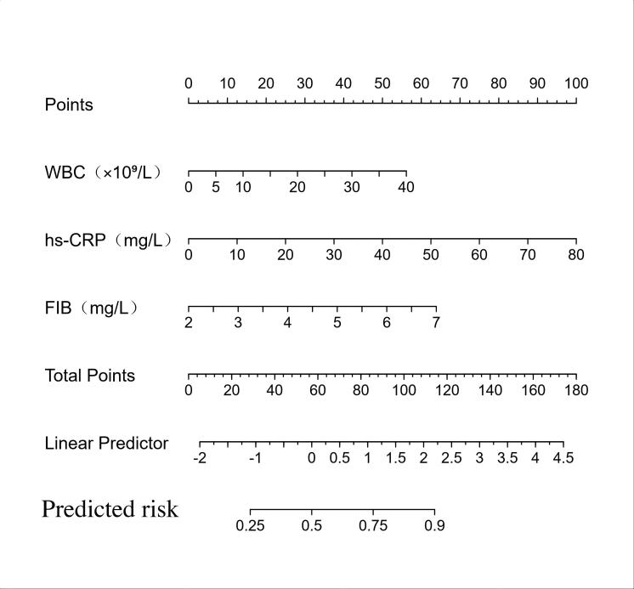
Figure 1. Nomogram prediction model for pulmonary‑consolidation occurrence in MPP.

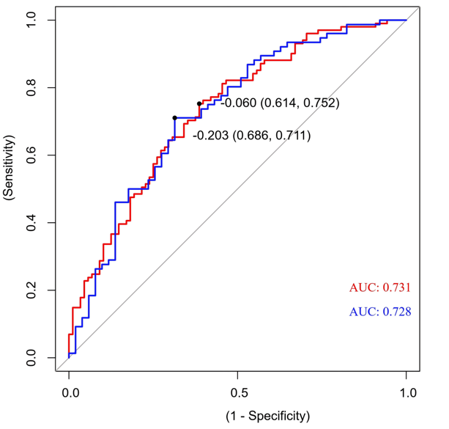
Figure 2. ROC curves of the prediction model for training set and validation set.

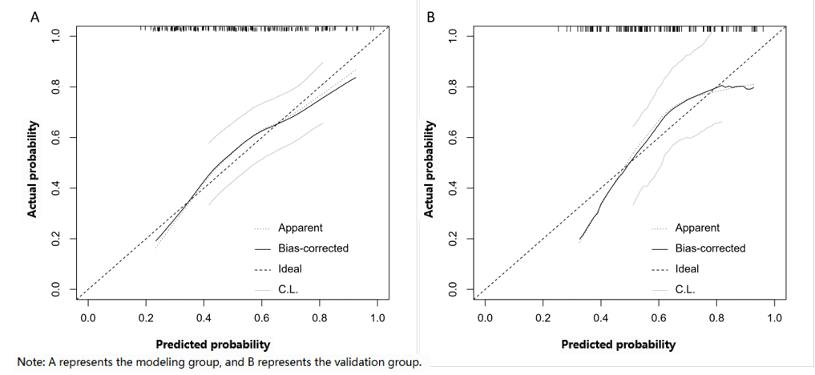
Figure 3. Calibration curves of the prediction model for training set and validation set.

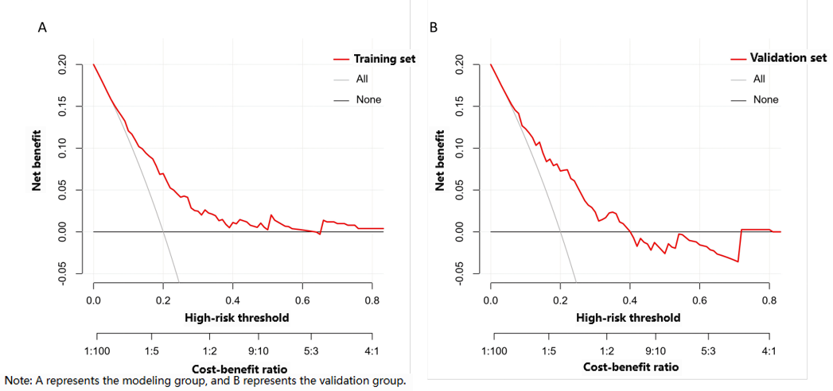
Figure 4. Decision‑curve diagrams for training set and validation set.

4. Discussion
The primary objective of this study was to predict pulmonary‑consolidation risk for children with MPP at an early stage and construct a quantitative tool. Pulmonary consolidation serves as an objective imaging turning point marking progression of MPP into substantive pneumonia and correlates with poor prognosis ^{[6–8]}. Therefore, adopting it as the grouping cut‑off point possesses both objectivity and clinical guiding value. The total sample size of this study satisfied theoretical estimation based on conservative parameters, and event counts were sufficiently abundant. Nevertheless, measured against broader prediction‑model sample‑size criteria (e.g. lower expected C‑index or more anticipated predictors), there remains room for total‑sample‑size improvement. It should be emphasised that the core strength of this study lies in its extremely high positive‑event count (177 cases) and EPP value (59.0). These fundamentally guarantee stable model‑parameter estimation and reliable internal validity. The internal‑validation outputs from the Bootstrap method (C‑index = 0.718, favourable calibration curves) enjoy good credibility and reliably demonstrate acceptable discrimination and calibration of the model under current data patterns and population characteristics.
This study identified that WBC, hs‑CRP, ESR and FIB correlated with pulmonary consolidation in MPP, among which WBC, hs‑CRP and FIB acted as independent risk factors, suggesting intense stress‑immune reactions during MPP‑related pulmonary consolidation. ESR suffers interference from age, anaemia and other factors, hence it showed no independent effect ^{[9,10]}. As inflammatory markers, WBC and hs‑CRP verify that uncontrolled host inflammatory responses constitute core driving forces for disease deterioration. This explains why pathogen‑targeted therapy cannot stop progression towards pulmonary consolidation in some children, and highlights the importance of early monitoring and intervention against excessive inflammation ^{[11]}. This study confirmed correlations between WBC, hs‑CRP and pulmonary consolidation, re‑affirming that inflammatory intensity acts as a key factor influencing MPP prognosis ^{[12]}. The moderate OR values of both indicators indicate limited association between elevated WBC/hs‑CRP and increased pulmonary‑consolidation risk. As a key protein for coagulation cascade and acute‑phase reaction, FIB bears important independent predictive value. It marks coagulation activation during severe MPP progression, possibly associated with endothelial injury and immune‑thrombus formation that promotes pulmonary consolidation ^{[13]}. Multivariate regression analysis in this study demonstrated independent correlation of FIB elevation with increased pulmonary‑consolidation risk, and validated that FIB, as a critical molecule bridging inflammation and coagulation, continuously functions in the pathophysiological process of pulmonary‑parenchymal injury ^{[14,15]}. Nevertheless, controversies exist regarding the independent predictive value of FIB. This study supports the viewpoint that MPP is accompanied by hypercoagulable status. Discrepancies versus some published studies may stem from differences in population disease severity and test timing ^{[16]}. Consequently, clinicians shall pay attention to elevated levels of WBC, hs‑CRP and FIB. This combined indicator panel achieves a sensitivity of 61.4 % and specificity of 75.2 % for predicting MPP‑related pulmonary consolidation and delivers certain clinical reference value.
Previous prediction models incorporating complicated and costly indicators such as LDH, D‑dimer, procalcitonin and specific cytokines mostly apply to severe or refractory cases ^{[17,18]}. In real‑world clinical practice, especially in primary‑level hospitals, most children with pulmonary infection receive hospital admission before developing severe manifestations. This study focuses on three routine items: WBC, hs‑CRP and FIB, which feature rapid, low‑cost detection available in hospitals of all tiers, greatly improving model universality. This model directly predicts the concrete and vital clinical‑decision node “pulmonary consolidation”, instead of the broad concept “severe pneumonia”. Its outputs can more directly guide decisions such as whether to perform chest CT, bronchoscopic therapy or adjust pharmaceutical regimens. Primary‑care physicians only need to obtain risk probabilities from the nomogram according to the three test results of each child to conduct individualised risk stratification, optimise primary‑level referral, realise resource allocation and standardised diagnosis‑treatment. It complies with requirements of the national medical‑health “Strengthening Grass‑roots Initiative” and fits primary‑level medical‑and‑health institutions with limited laboratory resources yet urgent demand for valid risk‑stratification tools. Against the backdrop of DRG payment reform and medical‑resource optimisation, balancing precise diagnosis‑treatment and cost‑effectiveness has become an important clinical topic. Conventional prediction for MPP‑related pulmonary consolidation largely depends on repeated imaging review and monitoring of multiple non‑specific inflammatory markers, which incur high costs with limited efficiency. The nomogram constructed in this study only incorporates three low‑cost, rapidly‑available routine laboratory indicators including WBC, hs‑CRP and FIB, with favourable clinical accessibility and practicality. Relying on initial routine test results obtained at admission, the model enables individualised risk stratification, which further guides differentiated clinical decisions: strengthen monitoring and intervention for high‑risk children to prevent disease deterioration; reduce unnecessary examinations and therapies for low‑risk children so as to optimise resource allocation. This strategy improves diagnosis‑treatment quality while controlling costs. It provides solid empirical evidence and easy‑to‑implement decision‑making tools for stratified standardised management of MPP under DRG payment reform.
Limitations of this study should be noted. This is a retrospective study. The proportion of pulmonary‑consolidation cases (56 %) among enrolled subjects is higher than previously‑reported 22 %, which may result from single‑centre admission bias. The generalisability of the model still requires verification via multi‑centre prospective studies. Single‑centre research carries inherent bias and external validation is needed. Future multi‑centre prospective researches are required to verify model generalisability and incorporate more‑dimensional biomarkers for continuous model optimisation.

5. Conclusion
In conclusion, WBC, hs‑CRP and FIB constitute important independent factors for pulmonary consolidation in MPP. The constructed nomogram prediction model achieves sensitivity of 61.4 % and specificity of 75.2 %. It can serve as clinical reference, facilitates individualised clinical assessment, and delivers certain reference value for early identification of high‑risk children and formulation of intervention strategies.

Disclosure statement
The authors declare no conflict of interest.

References

[1] Zhou N, Jiang Y, Mo J, et al., 2025, Comparative Study of Clinical Characteristics and Long-Term Prognosis Between Macrolide-Resistant and Macrolide-Sensitive Mycoplasma pneumoniae Infections in Children: A Retrospective Case-Control Study. Medicine (Baltimore), 104(39): e44302.

[2] He L, 2021, Analysis of Prognostic-Influencing Factors in Children with Mycoplasma pneumoniae Pneumonia Complicated by Mixed Infection. Nursing Practice and Research, 18(15): 2218–2222.

[3] Yang L, Zang Y, Ma W, et al., 2025, Analysis of Nosocomial-Infection Risk Factors and Construction of Disease-Prediction Model for Paediatric Refractory Mycoplasma pneumoniae Pneumonia. Chinese Journal of Maternal and Child Health Research, 36(6): 25–32.

[4] Liu S, Zhang L, Dai L, et al., 2025, Prediction Model for Severe Mycoplasma pneumoniae Pneumonia and Analysis of Macrolide-Resistance in Children: A Case-Control Study. Italian Journal of Pediatrics, 51(1): 180.

[5] Yang C, 2023, Epidemiological and Clinical-Characteristic Analysis of 1 202 Children with Mycoplasma pneumoniae Pneumonia, thesis, Guangzhou Medical University.

[6] National Health Commission of the People’s Republic of China, 2023, Diagnosis and Treatment Guidelines for Children with Mycoplasma pneumoniae Pneumonia (2023 Edition). International Journal of Epidemiology and Infectious Diseases, 50(2): 79–85.

[7] Chu C, Wang L, Wu Y, et al., 2023, Multidimensional Analysis Using Low-Dose Computed Tomography to Evaluate the Severity of Mycoplasma pneumoniae Pneumonia in Children. Quantitative Imaging in Medicine and Surgery, 13(3): 1874–1886.

[8] Li S, Mu J, Chang L, et al., 2013, Chest CT Features and Outcome of Necrotizing Pneumonia Caused by Mycoplasma pneumoniae in Children (Report of 30 Cases). Zhonghua Er Ke Za Zhi, 51(3): 211–215.

[9] Wang W, Huang F, 2024, Characteristic Analysis of Patients with Tuberculosis Complicated by Diabetes in a Grade-A Tertiary General Hospital in Sichuan. Sichuan Medical Journal, 45(9): 960–964.

[10] Xu W, Zhao W, Qian R, et al., 2021, Clinical Observation of Extremely Elevated Erythrocyte Sedimentation Rate. Zhonghua Wei Zhong Bing Ji Jiu Yi Xue, 33(5): 613–617.

[11] Bi Y, Zhu Y, Ma X, et al., 2021, Development of a Scale for Early Prediction of Refractory Mycoplasma pneumoniae Pneumonia in Hospitalized Children. Scientific Reports, 11(1): 6595.

[12] An S, Zhang L, Li J, 2015, Prognostic Judgment of Children with Mycoplasma pneumoniae Pneumonia Associated with Airway Mucous Plug Formation. Zhongguo Dang Dai Er Ke Za Zhi, 17(5): 487–491.

[13] Wang J, Mao J, Chen G, et al., 2021, Evaluation on Blood Coagulation and C-Reactive Protein Level Among Children with Mycoplasma pneumoniae Pneumonia by Different Chest Imaging Findings. Medicine (Baltimore), 100(3): e23926.

[14] Yanhong R, Shuai Z, Dan C, et al., 2024, Predictive Value of Lactate Dehydrogenase for Mycoplasma pneumoniae Necrotizing Pneumonia in Children Based on Decision Curve Analysis and Dose-Response Analysis. Scientific Reports, 14(1): 9803.

[15] Sitrin R, Brubaker P, Fantone J, 1987, Tissue Fibrin Deposition During Acute Lung Injury in Rabbits and Its Relationship to Local Expression of Procoagulant and Fibrinolytic Activities. American Review of Respiratory Disease, 135(4): 930–936.

[16] Shi X, He X, Chen J, 2025, Risk-Factor Analysis and Nomogram Construction for Macrolide-Unresponsive Mycoplasma pneumoniae Pneumonia Complicated by Plastic Bronchitis in Children. Chinese Journal of Contemporary Pediatrics, 27(1): 62–67.

[17] Lu H, Huang H, Liang L, et al., 2020, Pathogen-Characteristic and Risk-Factor Analysis of Nosocomial Infection Among Children with Refractory Mycoplasma pneumoniae Pneumonia. Clinical Research, 28(1): 11–13.

[18] Sun Y, 2025, Risk-Factor Analysis for Severe Mycoplasma pneumoniae Pneumonia in Children and Application of PII Scoring System, thesis, Guilin Medical University.

Publisher’s note
Bio-Byword Scientific Publishing remains neutral with regard to jurisdictional claims in published maps and institutional affiliations.

