Analysis of Airborne Pollen Concentration and Pollen Sensitization Characteristics in Harbin City
Xinyu Ma, Yaling Xie
Harbin Fourth Hospital, Harbin 150026, Heilongjiang, China

Copyright: © 2026 Author(s). This is an open-access article distributed under the terms of the Creative Commons Attribution License (CC BY 4.0), permitting distribution and reproduction in any medium, provided the original work is cited.

Abstract: Objective: To investigate the species, counts, and dispersal patterns of airborne pollen in the urban area of Harbin over two consecutive years, and to clarify the correlation between airborne pollen and allergic rhinitis in combination with clinical patient data. Methods: The gravity sedimentation method was employed to continuously collect daily pollen particles in Daowai District, Harbin, from March 1 to October 15 in both 2020 and 2021. Pollen species were counted and identified under a light microscope. Specific IgE (sIgE) test results from outpatients attending the hospital between June 2021 and June 2022 were analyzed. Results: A total of 63,080 pollen grains were monitored in 2020, and 29,229 grains in 2021 (pollen count per 1,000 mm² per day). The identified pollen taxa included Salicaceae (Populus and Salix), Ulmaceae, Betulaceae, Juglandaceae, Oleaceae (Fraxinus), Cupressaceae, Pinaceae, Rosaceae, Fabaceae, Moraceae, Cyperaceae, Fagaceae, Polygonaceae, Asteraceae (Artemisia), Poaceae, Chenopodiaceae, Typhaceae, Anacardiaceae, and Tiliaceae. Two annual peaks occurred in April and August. In April, Populus pollen was the most abundant, accounting for 51.47% and 37.21% in the two years, respectively, followed by Ulmus (18.74% and 26.75%). In August, Artemisia pollen dominated, accounting for 7% and 7.83%, followed by Moraceae (6.12% and 2.06%). Among 170 patients with allergic rhinitis who underwent allergen testing, 101 (59.4%) were positive for serum sIgE, with most showing sensitization to multiple allergens. Among these, 78 patients (77.2%) were sensitized to pollen. Specifically, Artemisia allergen positivity accounted for 63.3% (64/101), tree combination 2 positivity for 38.6% (39/101), followed by Ambrosia (23.7%, 24/101) and Humulus (4.95%, 5/101). The onset of symptoms was mainly concentrated in April and August, consistent with the peak periods of major allergenic pollen dispersal. Conclusion: The temporal distribution and concentration of airborne pollen in Harbin are positively correlated with the impact on allergic rhinitis. Tree pollen dominates in spring, while Artemisia pollen causes the most severe allergic symptoms in autumn.
Keywords: Pollen; Allergic rhinitis; Seasonal; Pollen monitoring; Artemisia

Online publication:

1. Introduction
Airborne pollen is a major trigger of allergic rhinitis (AR), with distinct regional and seasonal patterns. AR is a common disease that significantly impairs patients’ quality of life and work productivity, and both individual treatment and social prevention present considerable challenges ^{[1]}. Worldwide, the prevalence of AR ranges from 10% to 40% ^{[2]}. In China, the self-reported prevalence in 11 cities is 17.6%, and nearly 30% of AR cases are attributed to pollen exposure ^{[3,4]}. With social progress and changes in modern lifestyles, the prevalence of AR has been increasing.
Therefore, analyzing the species of allergenic airborne pollen and their seasonal dispersal patterns in a given region can effectively guide the prevention and treatment of allergic diseases and inform choices for urban greening. The present study investigates and analyzes allergenic pollen in Harbin from multiple perspectives, aiming to improve the management of allergic rhinitis and to provide reference for urban greening planning.

2. Materials and methods
2.1. General information
2.1.1. Sample collection
Pollen counts were collected from daily 24-hour continuous exposure slides from March 1 to October 15 in 2020 and 2021. Pollen sampling was performed using the gravity sedimentation method. The sampler (provided by Beijing Tongren Hospital) was placed on the fifth-floor platform of the Emergency-ENT Building of our hospital, at a height of 16 m above ground level. A 24-hour cycle was used as one sampling unit: slides were set up at 8:00 a.m. each day and retrieved at 8:00 a.m. the following day. After retrieval, the slides were stained using the agar staining method, with reagents provided by Beijing Tongren Hospital. Subsequently, 24 mm × 50 mm coverslips were applied, and pollen counting was performed under a light microscope.

2.1.2. Pollen counting and classification
The stained pollen slides were examined under a light microscope. Pollen counts were obtained at low magnification (×10), and pollen types were identified at high magnification (×40). Species identification was conducted with reference to the Atlas of Airborne Pollen in China ^{[5]} and Pollen Morphology of Chinese Plants ^{[6]}. Pollen content was expressed as grains per 1000 mm². The slides were sent to a designated professional institution designated by Beijing Tongren Hospital for classification and verification, ensuring the accuracy and reliability of the test data.

2.1.3. Analysis of allergen test results
Serum specific IgE (sIgE) testing for inhalant allergens was performed on outpatients from the Allergy Department of our hospital using the EU Inhalant Allergen Specific IgE Antibody Detection Kit (immunoblotting method). The tested inhalant allergens included dust mite mix 1 (Dermatophagoides pteronyssinus/Dermatophagoides farinae), house dust, cockroach, cat dander, dog epithelium, mold mix 1 (Penicillium chrysogenum/Cladosporium/Aspergillus fumigatus/Alternaria alternata), tree mix 2 (willow/poplar/elm), hops, common ragweed, and mugwort, totaling 10 types.

2.1.4. Statistical analysis
Statistical analysis was performed using SPSS 16.0 software. A p-value of < 0.05 was considered statistically significant.

3. Results
3.1. Content and species of airborne pollen in Daowai District, Harbin
In the airborne pollen analysis from March to October in 2020 and 2021, a total of 63,080 pollen grains were collected in 2020 and 29,229 in 2021. The identified pollen taxa included Salicaceae (Populus and Salix), Ulmaceae, Betulaceae, Juglandaceae, Oleaceae (Fraxinus), Cupressaceae, Pinaceae, Rosaceae, Fabaceae, Moraceae, Cyperaceae, Fagaceae, Polygonaceae, Asteraceae (Artemisia), Poaceae, Chenopodiaceae, Typhaceae, Anacardiaceae, and Tiliaceae (see Table 1 and Table 2). In both spring seasons, poplar pollen was the most abundant, accounting for 51.47% and 37.21% respectively, followed by elm at 18.74% and 26.75%. In both autumn seasons, mugwort pollen was the most prevalent at 7% and 7.83% respectively, followed by Moraceae at 6.12% and 2.06% (see Figure 1).

3.2. Serum test results of AR patients
From June 2021 to June 2022, a total of 170 patients with allergic rhinitis (AR) were tested, aged 6-72 years. Serum sIgE was positive in 101 cases, with a positive rate of 59.4%. Most positive patients exhibited sensitization to multiple allergens. Among them, 78 cases were sensitized to pollen, accounting for 77.2% of positive patients. Specifically, mugwort allergen positivity accounted for 63.3% (64/101), tree mix 2 positivity for 38.6% (39/101), followed by ragweed at 23.7% (24/101) and hops at 4.95% (5/101). The peak time of disease onset occurred in April and August, which was consistent with the periods of high pollen concentration (see Figure 2).

Table 1. Species and quantities of airborne pollen from March to October 2020
Pollen taxa | Pollen count (grains/1000 mm²)
Pollen taxa | March | April | May | June | July | August | September | October | Total | Percentage (%)
Cupressaceae | 6 | 2 | 152 | 14 | 0 | 0 | 0 | 0 | 174 | 0.27
Betulaceae | 9 | 210 | 2577 | 36 | 0 | 0 | 0 | 0 | 2832 | 4.48
Salicaceae (Salix) | 11 | 1464 | 320 | 0 | 0 | 0 | 0 | 0 | 1795 | 2.85
Salicaceae (Populus) | 37 | 32157 | 444 | 0 | 0 | 0 | 0 | 0 | 32638 | 51.74
Ulmaceae | 86 | 11644 | 95 | 0 | 0 | 0 | 0 | 0 | 11825 | 18.74
Juglandaceae | 0 | 187 | 346 | 55 | 0 | 0 | 0 | 0 | 588 | 0.94
Oleaceae (Fraxinus) | 0 | 210 | 0 | 15 | 0 | 0 | 0 | 0 | 225 | 0.35
Rosaceae | 0 | 42 | 1576 | 70 | 0 | 0 | 0 | 0 | 1688 | 2.67
Pinaceae | 0 | 3 | 2202 | 235 | 7 | 0 | 0 | 0 | 2447 | 3.89
Fabaceae | 0 | 0 | 81 | 7 | 32 | 5 | 0 | 0 | 125 | 0.2
Poaceae | 0 | 0 | 11 | 208 | 79 | 544 | 97 | 9 | 948 | 1.5
Fagaceae | 0 | 0 | 145 | 5 | 0 | 0 | 0 | 0 | 150 | 0.24
Polygonaceae | 0 | 0 | 1 | 40 | 1 | 0 | 0 | 0 | 42 | 0.07
Moraceae | 0 | 0 | 71 | 24 | 15 | 1086 | 105 | 1 | 1302 | 2.06
Cyperaceae | 0 | 0 | 13 | 6 | 0 | 0 | 0 | 0 | 19 | 0.03
Chenopodiaceae | 0 | 0 | 0 | 43 | 126 | 632 | 67 | 1 | 869 | 1.38
Anacardiaceae | 0 | 0 | 0 | 9 | 0 | 0 | 0 | 0 | 9 | 0.02
Typhaceae | 0 | 0 | 0 | 3 | 0 | 0 | 0 | 0 | 3 | 0.004
Tiliaceae | 0 | 0 | 0 | 4 | 0 | 0 | 0 | 0 | 4 | 0.006
Asteraceae | 0 | 0 | 0 | 0 | 0 | 296 | 109 | 49 | 454 | 0.73
Asteraceae (Artemisia) | 0 | 0 | 0 | 13 | 0 | 4437 | 490 | 3 | 4943 | 7.83
Total | 149 | 45919 | 8034 | 787 | 260 | 7000 | 868 | 63 | 63080 | 100

Table 2. Airborne pollen species and counts from March to October 2021
Pollen taxa | Pollen count (grains/1000 mm²)
Pollen taxa | Mar | Apr | May | Jun | Jul | Aug | Sep | Oct | Total | Percentage (%)
Cupressaceae | 16 | 22 | 26 | 0 | 0 | 0 | 0 | 0 | 64 | 0.21
Betulaceae | 184 | 302 | 1100 | 4 | 0 | 0 | 0 | 0 | 1590 | 5.45
Salicaceae (Salix) | 16 | 1134 | 28 | 0 | 0 | 0 | 0 | 0 | 1178 | 4.03
Salicaceae (Populus) | 44 | 10806 | 28 | 0 | 0 | 0 | 0 | 0 | 10878 | 37.21
Ulmaceae | 278 | 7506 | 36 | 0 | 0 | 0 | 0 | 0 | 7820 | 26.75
Juglandaceae | 0 | 34 | 134 | 1 | 0 | 0 | 0 | 0 | 169 | 0.58
Oleaceae (Fraxinus) | 10 | 10 | 88 | 0 | 0 | 0 | 0 | 0 | 108 | 0.37
Rosaceae | 0 | 370 | 288 | 0 | 4 | 0 | 0 | 0 | 662 | 2.27
Pinaceae | 4 | 56 | 1060 | 38 | 10 | 0 | 0 | 0 | 1168 | 3.99
Fabaceae | 0 | 0 | 182 | 20 | 0 | 0 | 0 | 0 | 202 | 0.69
Poaceae | 1 | 0 | 14 | 54 | 144 | 574 | 102 | 4 | 893 | 3.06
Fagaceae | 0 | 0 | 0 | 0 | 0 | 0 | 0 | 0 | 0 | 0
Polygonaceae | 0 | 0 | 6 | 0 | 0 | 0 | 0 | 0 | 6 | 0.02
Moraceae | 0 | 2 | 264 | 40 | 74 | 1324 | 84 | 2 | 1790 | 6.12
Cyperaceae | 0 | 14 | 88 | 4 | 4 | 0 | 0 | 0 | 110 | 0.39
Chenopodiaceae | 1 | 0 | 0 | 0 | 28 | 370 | 16 | 0 | 415 | 1.42
Anacardiaceae | 0 | 0 | 0 | 0 | 0 | 0 | 0 | 0 | 0 | 0
Typhaceae | 0 | 0 | 0 | 0 | 16 | 0 | 0 | 0 | 16 | 0.05
Tiliaceae | 0 | 0 | 0 | 0 | 0 | 0 | 0 | 0 | 0 | 0
Asteraceae | 0 | 0 | 0 | 0 | 2 | 112 | 2 | 0 | 116 | 0.39
Asteraceae (Artemisia) | 0 | 0 | 0 | 0 | 10 | 1972 | 60 | 2 | 2044 | 7.00
Total | 554 | 20256 | 3342 | 161 | 292 | 4352 | 264 | 8 | 29229 | 100

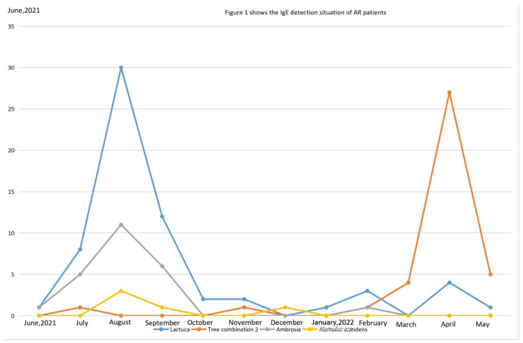
Figure 1. The IgE detection situation of AR patients.

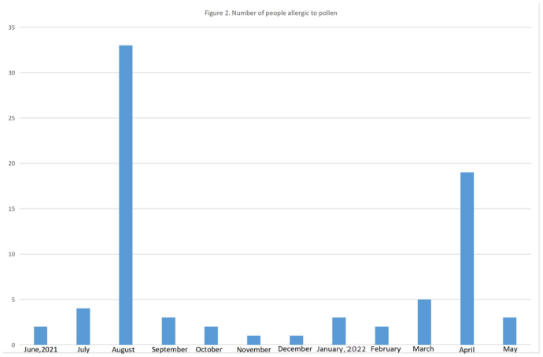
Figure 2. Number of people allergic to pollen.

4. Discussion
With the continuous changes in the social environment, the incidence of allergic rhinitis has been rising, and airborne pollen is one of the major inhalant allergens ^{[5]}. International reports indicate that the prevalence of seasonal allergic rhinitis ranges from 5% to 22% ^{[6]}. A Korean study from 2003 to 2011 demonstrated a positive correlation between the airborne pollen index and outpatient visits for allergic diseases ^{[7]}. In China, pollen allergy ranks second only to dust mite allergy, and the concentration of sensitizing pollen is closely associated with patient symptoms ^{[8]}. Many provinces and cities in China have been conducting pollen monitoring to provide early warning for the protection of patients with allergic rhinitis.
Harbin is located along the Songhua River. The unique vegetation and climatic conditions endow the airborne pollen in Harbin with distinct regional characteristics. Meanwhile, due to the development of urban greening and the introduction of new species, more than 20 genera and families of pollen have been detected in the air over the past two consecutive years. Nevertheless, the predominant types remain poplar and elm pollen in spring, and Artemisia (Compositae) pollen in autumn, which are the main sensitizing allergens for allergic rhinitis. In spring, poplar and elm pollen account for approximately 70% of the total pollen count, while in autumn, Compositae (Artemisia) pollen accounts for about 7%. Based on the two-year monitoring results and analysis of weather conditions, the airborne pollen concentration is significantly affected by weather factors such as temperature, wind, and rainfall, which markedly influence pollen counts. Therefore, there were considerable variations in pollen counts during the same season across the two years, but the dispersal pattern and the timing of peak occurrence remained unchanged. Artemisia pollen shows higher sensitization potency than tree pollen, and increased pollen concentration is closely related to the onset of disease in patients. However, due to the impact of the COVID-19 pandemic in recent years, the number of outpatient visits declined notably, and the quantity of allergen testing for allergic rhinitis patients was relatively small, which could not fully reflect the epidemiological characteristics of pollinosis patients in Harbin.

5. Conclusion
In summary, through two years of pollen monitoring, we have preliminarily obtained the dispersal pattern of airborne pollen in Harbin. Moreover, our study demonstrates that the airborne pollen concentration in Harbin is significantly influenced by weather conditions, and the dispersal time and concentration are directly correlated with the incidence of allergic rhinitis—the higher the concentration, the higher the incidence. Poplar pollen is the most frequent sensitizer in April, while Artemisia pollen causes the most severe sensitization in August. Therefore, a systematic investigation and analysis of the quantity, species, and seasonal distribution patterns of airborne sensitizing pollen, combined with the incidence of allergic rhinitis, can provide a basis for prevention in pollen-allergic individuals. At the same time, it offers references for urban greening and environmental management, such as reducing the planting of poplar trees and timely removal of Artemisia weeds, to decrease the dispersal of sensitizing pollen in the air and better serve public health.

Disclosure statement
The authors declare no conflict of interest.

References
[1] Zhang L, 2017, The Clinical Diagnosis and Treatment of Allergic Rhinitis Has a Long Way to Go. Chinese Journal of Otorhinolaryngology Head and Neck Surgery, 52(7): 481–483.
[2] Bousquet J, Khaltaev N, Cruz A, et al., 2008, Allergic Rhinitis and Its Impact on Asthma (ARIA) 2008 Update (In Collaboration with the World Health Organization, GA(2)LEN and AllerGen). Allergy, 63(Suppl 86): 8–160.
[3] Wang X, Zheng M, Lou H, et al., 2016, An Increased Prevalence of Self-Reported Allergic Rhinitis in Major Chinese Cities From 2005 to 2011. Allergy, 71(8): 1170–1180.
[4] Wang C, Zhang L, Han D, et al., 2006, Analysis of Inhalant Allergen Spectrum in Patients With Allergic Rhinitis in Beijing. Journal of Clinical Otorhinolaryngology, 20: 204–207.
[5] Asher M, Montefort S, Björkstén B, et al., 2006, Worldwide Time Trends in the Prevalence of Symptoms of Asthma, Allergic Rhinoconjunctivitis, and Eczema in Childhood: ISAAC Phases One and Three Repeat Multicountry Cross-Sectional Surveys. Lancet, 368: 733–743.
[6] Fernandez G, Gonzalez P, Vega M, et al., 2010, Platanus Pollen Allergen, Pla a 1: Quantification in the Atmosphere and Influence on a Sensitizing Population. Clinical and Experimental Allergy, 40: 1701–1708.
[7] Kim H, Park Y, Park K, et al., 2016, Association Between Pollen Risk Indexes, Air Pollutants, and Allergic Diseases in Korea. Osong Public Health and Research Perspectives, 7(3): 172–179.
[8] Ouyang Y, Zhao L, Zhang L, 2013, Relationship Between the Pathogenic Characteristics of Pollinosis and the Species and Concentration of Atmospheric Pollen. Journal of Capital Medical University, 34(6): 805–807.

Publisher’s note
Bio-Byword Scientific Publishing remains neutral with regard to jurisdictional claims in published maps and institutional affiliations.

