Study on the Synergistic Mechanism of Modified Shenling Baizhu Powder in Treating Obesity Based on Network Pharmacology and Molecular Dynamics

Yi Hu¹, Yulin Wang¹, Shaoyuan Zhuo², Chao Wang^{2,3}*
¹School of New Medicine, Sciences College, Guangxi University of Traditional Chinese Medicine, Nanning 530200, Guangxi Zhuang Autonomous Region, China
²Basic Medical College, Guangxi University of Traditional Chinese Medicine, Nanning 530200, Guangxi Zhuang Autonomous Region, China
³Key Laboratory of Translational Medicine for Integrated Traditional Chinese and Western Medicine in High-incidence Infectious Diseases, Nanning 530200, Guangxi Zhuang Autonomous Region, China

*Corresponding author: Chao Wang, 761746302@qq.com

Copyright: © 2026 Author(s). This is an open-access article distributed under the terms of the Creative Commons Attribution License (CC BY 4.0), permitting distribution and reproduction in any medium, provided the original work is cited.

Abstract: Objective: To investigate the molecular mechanisms of Shenling Baizhu Powder with modifications in treating obesity using network pharmacology and molecular dynamics approaches. Methods: Active components of Shenling Baizhu Powder were identified from the TCMSP and BATMAN-TCM databases, and their target molecules were predicted using Swiss Target Prediction and SEA; obesity-related targets were retrieved from GeneCards, CTD, NCBI, and the GEO dataset GSE151839, with potential therapeutic targets identified through intersection analysis; drug-component-target networks and protein-protein interaction (PPI) networks were constructed, followed by GO and KEGG enrichment analyses; molecular docking was performed using Schrödinger, and molecular dynamics simulations were conducted with GROMACS. Results: A total of 196 active components were screened, among which 73 were identified as potential targets for obesity. Key components included ent-Epicatechin, licorice glycoside E, and dehydroglyasperins C, with PIK3R1, PIK3CA, and SRC as critical targets. Enrichment analyses revealed involvement in pathways such as insulin resistance, lipid metabolism, and atherosclerosis. Molecular docking demonstrated that PIK3CA exhibited the lowest binding affinity with licorice glycoside E, and molecular dynamics simulations confirmed optimal stability of this complex. Conclusion: The modified Shenling Baizhu Powder exerts multi-target, multi-pathway effects in combating obesity, with core components including ent-Epicatechin, licorice glycoside E, and dehydroglyasperins C, thereby providing a theoretical foundation for clinical applications.
Keywords: Obesity; Modified Shenling Baizhu Powder; Network pharmacology; Molecular dynamics

Online publication:

1. Introduction
Obesity is a chronic metabolic disorder characterized by excessive accumulation and abnormal distribution of fat in the body, influenced by multiple factors including genetics and environment ^{[1]}. It is a significant predisposing factor for cardiovascular diseases, diabetes mellitus, polycystic ovary syndrome, and other conditions ^{[2]}. Western medicine commonly employs central weight-loss agents and lipase inhibitors, though these may cause cardiovascular and gastrointestinal adverse reactions. Recent clinical studies have demonstrated that traditional Chinese medicine exhibits significant efficacy in obesity treatment, particularly compound formulations such as modified Shenling Baizhu Powder, which primarily focuses on strengthening the spleen and eliminating dampness, offering unique advantages ^{[1,2]}. Traditional Chinese Medicine holds that obesity primarily results from excessive consumption of greasy and sweet foods, prolonged sedentary behavior with insufficient physical activity, and emotional disturbances leading to spleen deficiency with impaired transportation and transformation functions, as well as the accumulation of dampness, turbidity, phlegm, and stasis internally. Shenling Baizhu Powder, as a classical herbal formula, plays a significant role in the treatment of obesity ^{[3,4]}. However, the precise mechanisms underlying these modified formulations remain unclear. This study integrates network pharmacology, molecular docking, and molecular dynamics to systematically elucidate the target pathways and molecular mechanisms of modified Shenling Baizhu Powder in treating obesity.

2. Materials and methods

2.1. Collection and screening of active chemical components from compound traditional Chinese medicines and their corresponding predictive targets
From TCMSP the database (OB ≥ 30%, DL ≥ 0.18) was utilized to screen active components from Hyacinth bean, Atractylodes macrocephala, Poria cocos, Glycyrrhiza uralensis, Cinnamon Twig, Platycodon grandiflorus, Lotus Seed, Ginseng, Amomum villosum, Dioscorea opposita, Coix seed, Alisma orientale, and Polyporus umbellatus; the composition of Lotus Seed was obtained from BATMAN-TCM ^{[5]}. Swiss Target Prediction was employed for analysis ^{[6]}. (Species “Homo sapiens”, probability > 0) and the SEA database predict target ^{[7]}.

2.2. Identification of obesity-related therapeutic targets
Search CTD, GeneCards, and NCBI using the term “obesity” ^{[8]}. The databases yielded 5,000,2,194, and 5,000 genes respectively; the GEO2R software was employed to analyze the GSE151839 dataset ^{[9]}. A total of 3,564 differentially expressed genes were identified. The intersection of these four datasets was obtained and standardized using UniProt to identify obesity-related targets.

2.3. Construction of venn diagrams and the “active compound-disease target” regulatory network
Using the MicroBioinformatics Platform Construct a Venn diagram comparing drug targets and disease targets, with the intersection representing potential therapeutic targets ^{[10]}. Use Cytoscape 3.7.2 for analysis ^{[11]}. Establish a “drug-active ingredient-target” network.

2.4. Construction of protein interaction networks and screening of key targets
Import the intersection targets into STRING (with a maximum confidence score of 0.9), construct a protein-protein interaction (PPI) network, and use the Degree algorithm via the CytoNCA plugin in Cytoscape to identify key targets.

2.5. Analysis of GO functions and KEGG pathway enrichment
Using Metascape, we performed GO (binding proteins, cellular components, molecular functions) and KEGG pathway enrichment analyses on potential targets, ranked the results by LogP values, selected the top 20 entries, and visualized them using MicroBioinformatics.

2.6. Molecular docking validation
Select the top three targets by degree in the PPI network and perform docking with all 196 active compounds. Obtain ligand structures (in MOL2 format) from TCMSP and target protein structures (in PDB format) from PDB. Perform molecular docking using Schrodinger and Maestro, generate a heat map based on the top five results with the lowest binding energy, and visualize the optimal binding mode with Pymol.

2.7. Molecular dynamics simulations were conducted for validation.
Molecular dynamics simulations were performed using GROMACS on the three complexes with the lowest binding energies ^{[12]}. Using a total simulation duration of 100 ns with the Amber14SB force field, GAFF2 density functional force field, and TIP3P water model, energy minimization was performed via the steepest descent method (Fmax <1000 kJ·mol⁻¹·nm⁻¹). The system was equilibrated under both NVT and NPT ensembles at 298 K, 1.0 bar, for 100 ps, followed by simulations with a time step of 2 fs, with trajectories saved every 10 ps. Analysis parameters included RMSD, RMSF, RG, and Buried SASA.

3. Results

3.1. Active components and their corresponding target sites
A total of 196 active ingredients were identified, among which 9 were common components. Target prediction identified 1,096 corresponding targets. Through intersection analysis across four databases, 244 disease-related targets and 73 shared targets with drug targets were obtained (Figure 1).

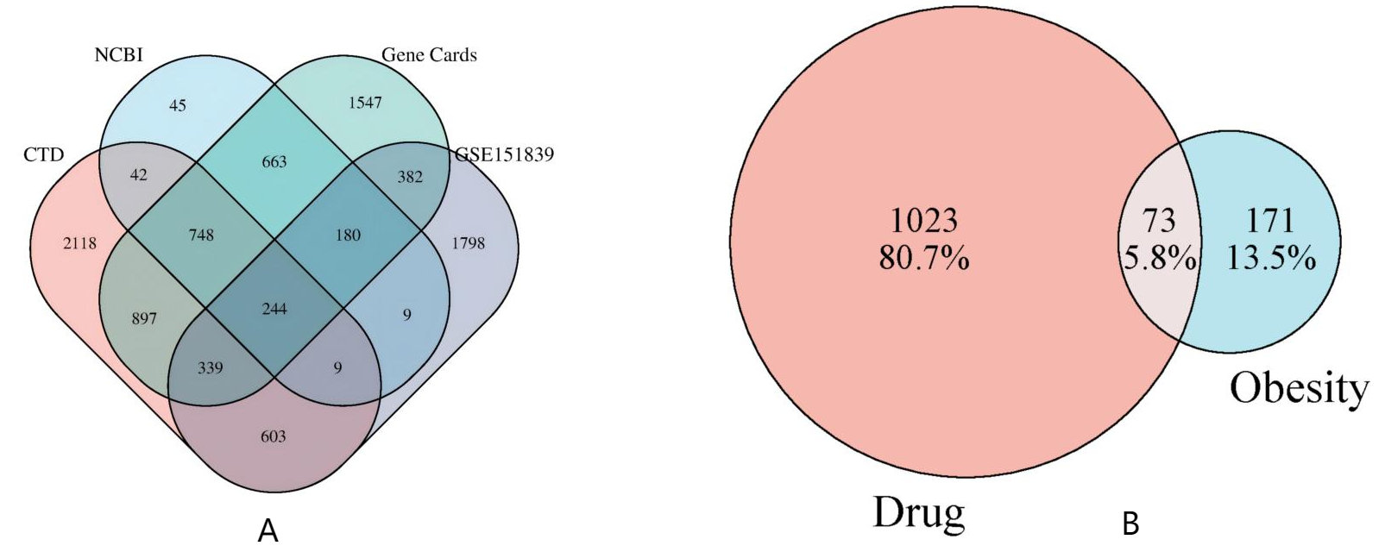

Figure 1. Venn diagram of disease targets (A) and venn diagram of drug active ingredient targets and disease targets (B).

3.2. Construction of a “Drug–Active Ingredient–Target” network
The “Drug-Active Ingredient-Target” network comprises 474 nodes and 475 edges (Figure 2). The PPI network (154 nodes, 1,387 edges) (Figure 3) was filtered using the Degree criterion, retaining 13 nodes, 66 edges, and 13 key targets ranked by Degree value (Figure 4).

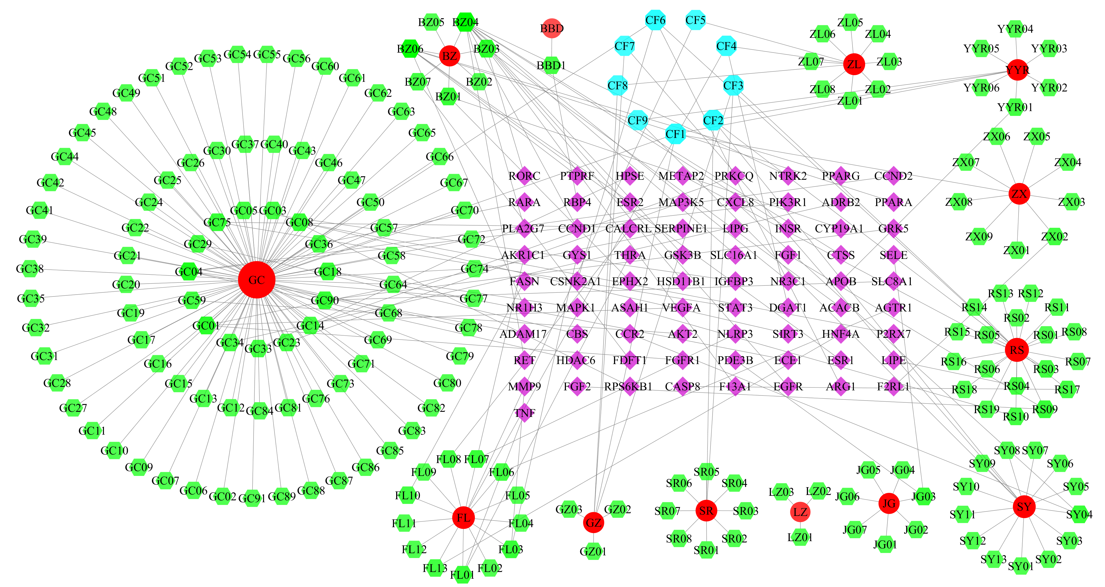
Figure 2. Network diagram of the modified Shenling Baizhu Powder as a traditional Chinese medicine formulation for obesity intervention (the purple circle in the center represents targets corresponding to active ingredients; the outer green circles denote individual active ingredients; the red circles indicate drug components; and the blue circles represent shared active ingredients among the drugs).

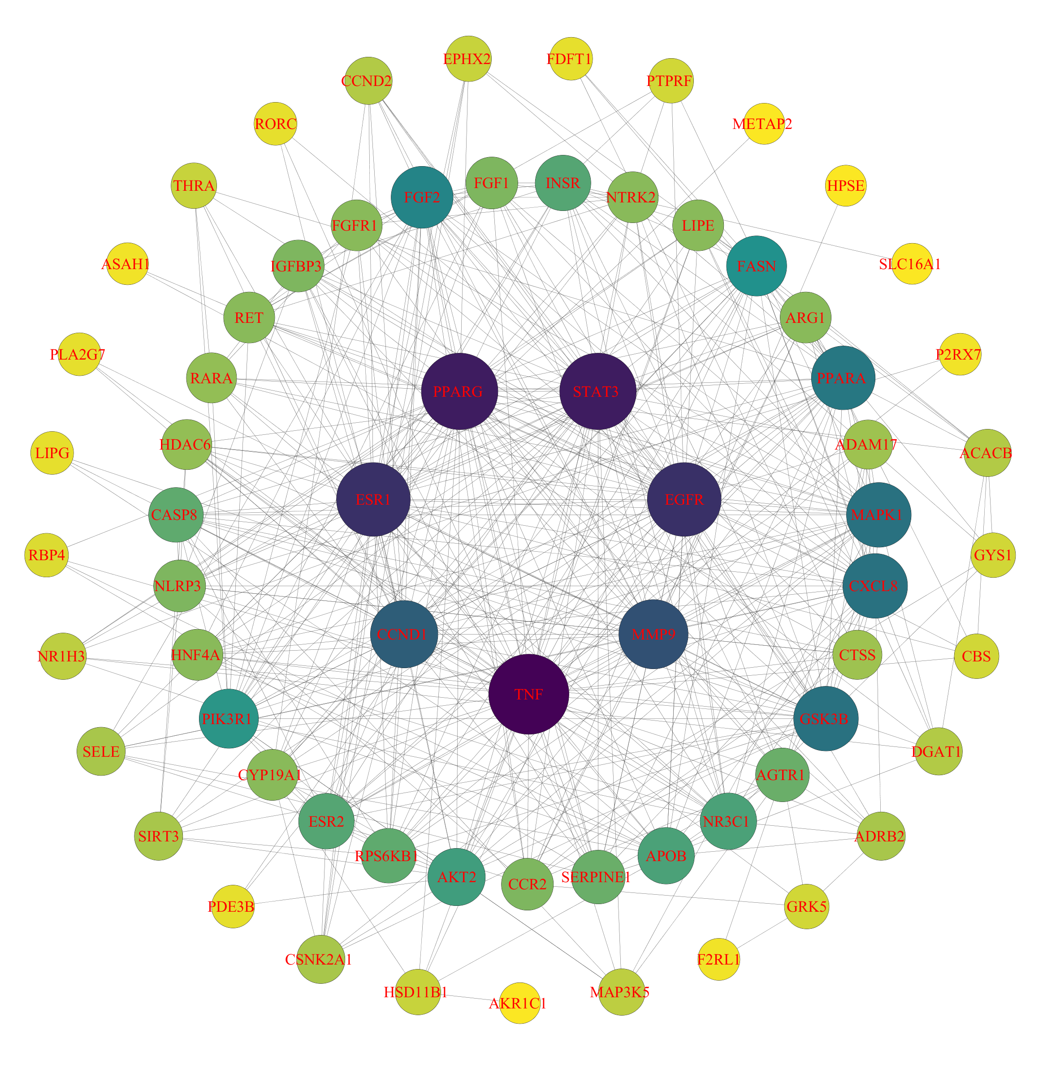
Figure 3. Modified Shenling Baizhu Powder for intervening in obesity: PPI network diagram.

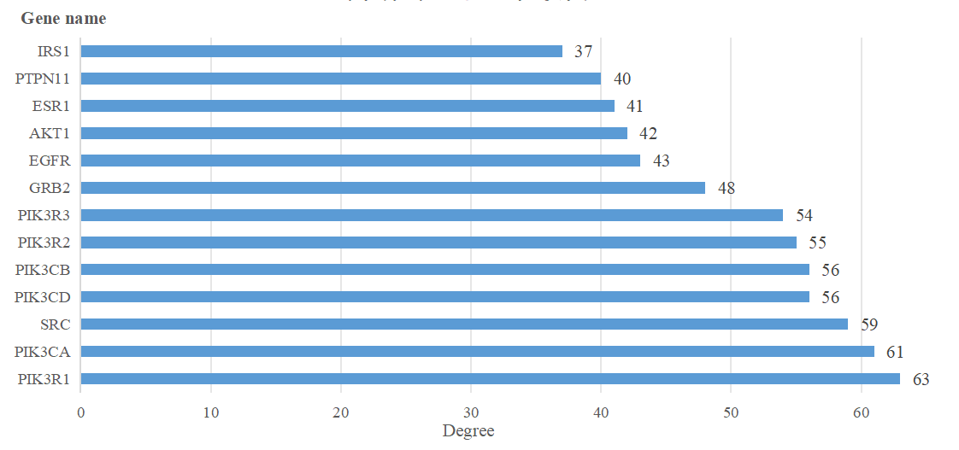
Figure 4. Bar chart of 13 key target genes.

3.3. Enrichment analysis
The GO analysis identified 3,703 pathways (primarily involving lipid metabolism regulation, cellular responses to hormonal stimuli, and growth regulation), 299 CC pathways (including membrane rafts, early endosomes, and vacuolar cavities), and 627 MF pathways (covering nuclear receptor activity, ligand-mediated regulation of transcription factor activity, and transcription factor binding). KEGG enrichment revealed 237 biological pathways, with the top 17 primarily related to insulin resistance, lipid metabolism and atherosclerosis, and the insulin signaling pathway (Figure 5 and Figure 6).

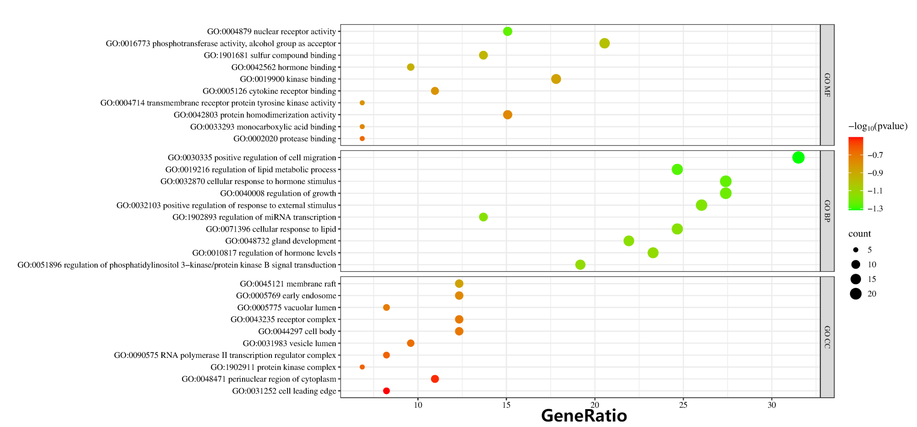
Figure 5. GO MF, GO BP, GO CC bubble charts.

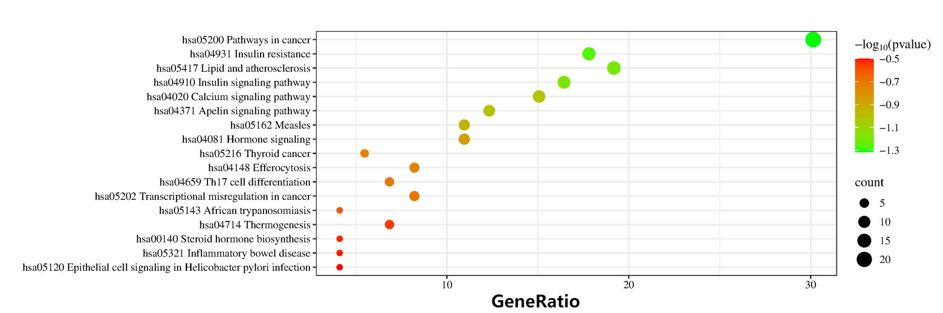
Figure 6. KEGG bubble charts.

3.4. Molecular docking validation results
Three targets (PIK3R1, PIK3CA, and SRC) were docked with 196 compounds, all exhibiting binding energies ≤ -4.514 kcal/mol. The complexes with the lowest binding energies were: PIK3R1 with ent-Epicatechin (-5.708 kcal/mol, forming 4 hydrogen bonds); PIK3CA with licorice glycoside E (-7.124 kcal/mol, forming 7 hydrogen bonds); and SRC with dehydroglyasperins C (-6.166 kcal/mol, forming 3 hydrogen bonds and 1 Pi–Pi bond). The top 15 compounds by binding energy are listed in Figure 7–9.

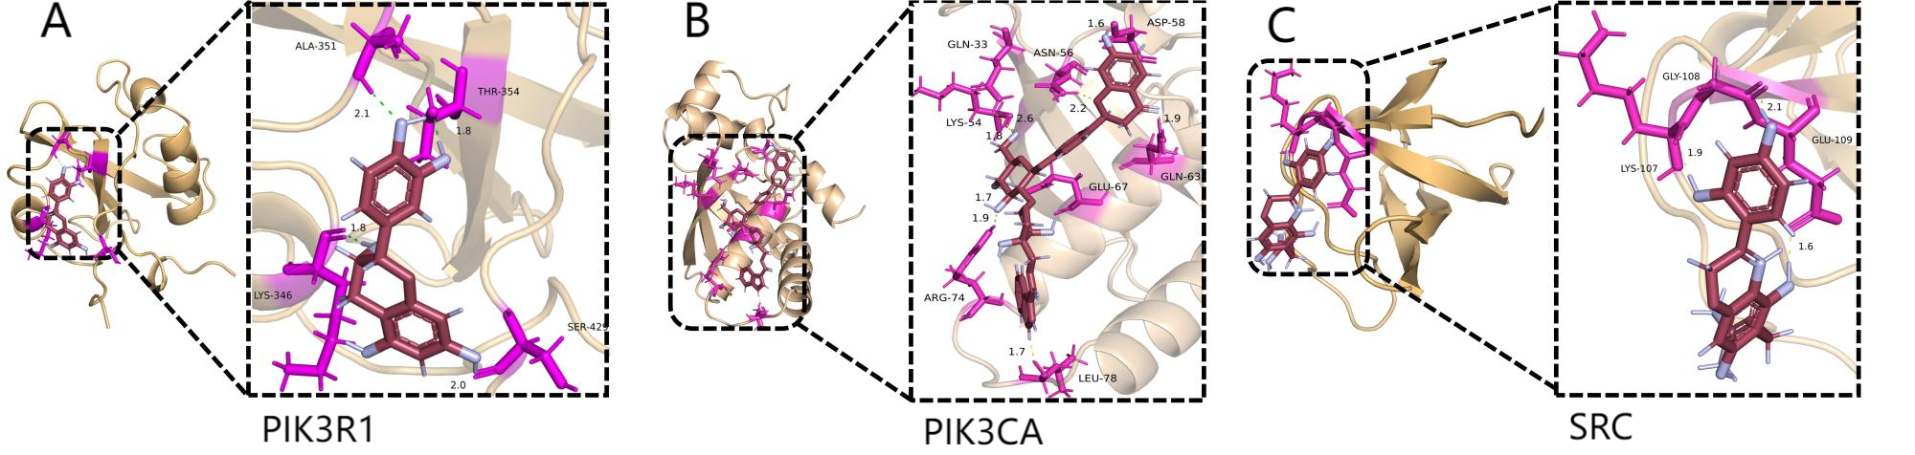
Figure 7. The molecular docking results are displayed in 3D
(A:PIK3R1 with ent-Epicatechin, B:PIK3CA with licorice glycoside E, C:SRC with dehydroglyasperins C).

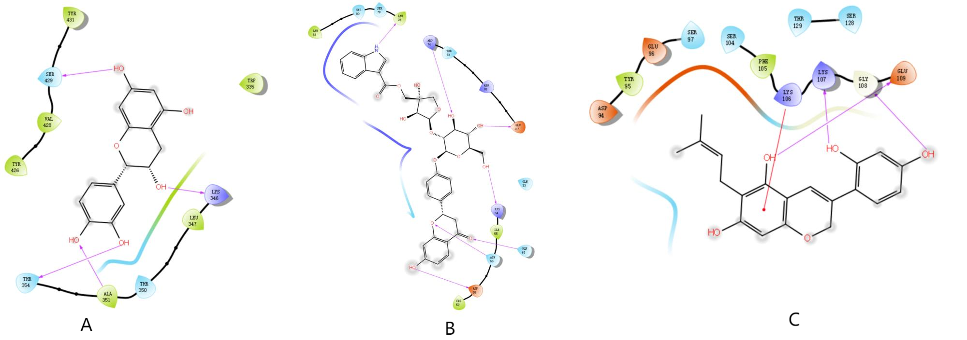
Figure 8. The three results with the lowest molecular docking binding energy
Vimentin: Purple arrows indicate hydrogen bonds; red line segments represent Pi-Cat bonds; and green curves represent Pi-Pi bonds.

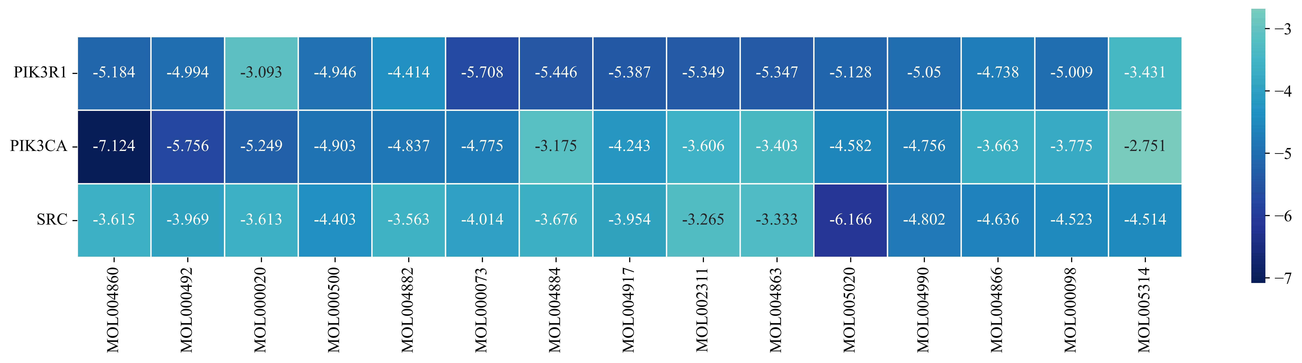
Figure 9. Thermal map of molecular docking and binding energy.

3.5. Molecular dynamics simulations
During the 100 ns simulation, the RMSD of the PIK3CA complex stabilized after 15 ns at an average value of 0.4076 nm; that of the PIK3R1 complex was 0.2400 nm on average, and that of the SRC complex was 0.2359 nm. RMSF analysis revealed relatively stable residue fluctuations in the PIK3CA complex, with residues such as LYS-54, ASN-56, and GLN-63 exhibiting relatively active states. Both RG and Buried SASA analyses indicated a more compact structure and tighter binding in the PIK3CA complex (Figure 11–14).

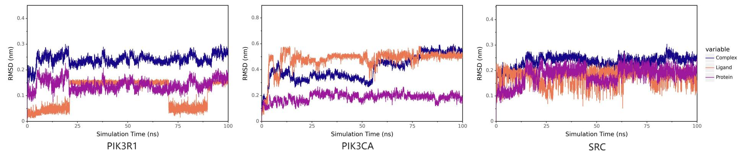
Figure 11. RMSD analysis of complex systems.

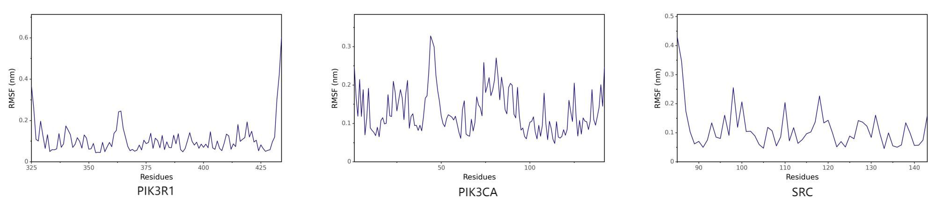
Figure 12. RMSF analysis of complex systems.

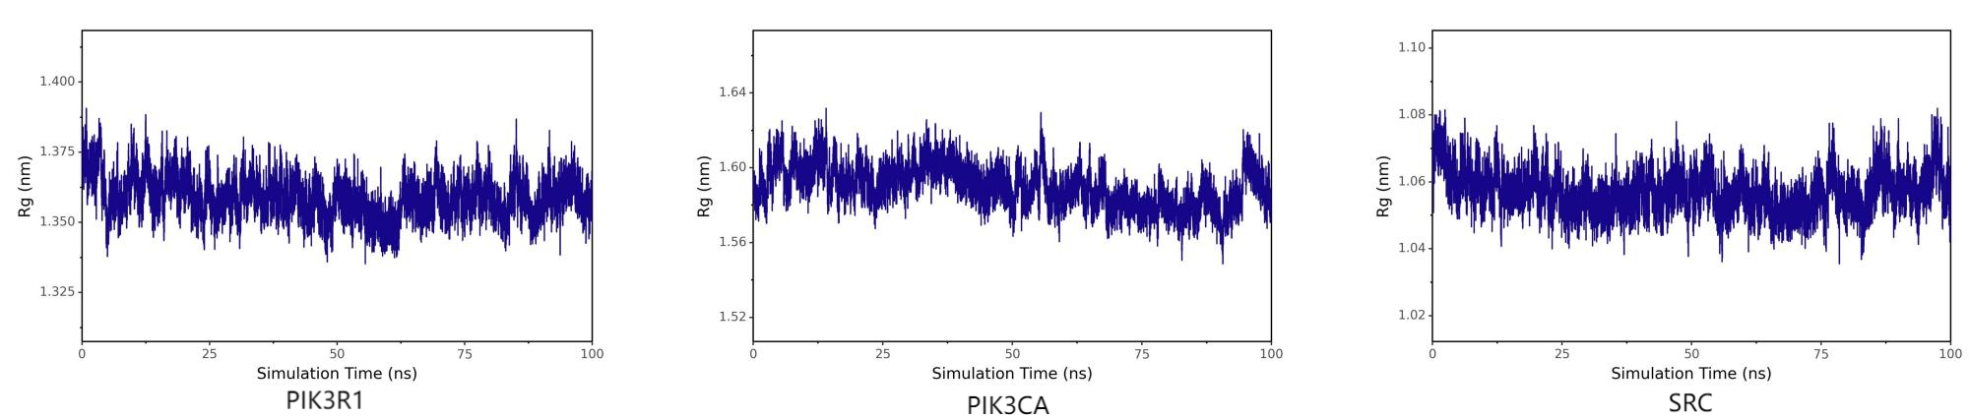
Figure 13. RG analysis of complex systems.

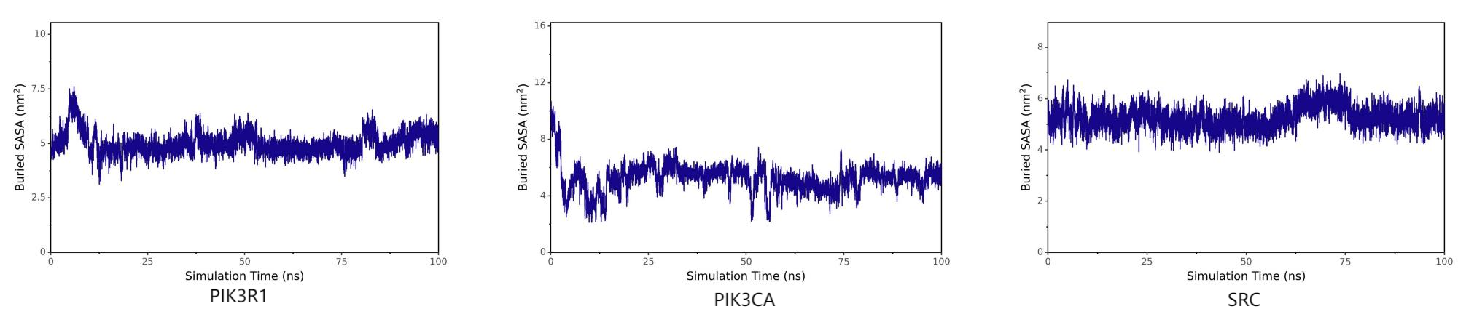
Figure 14. SASA analysis of complex systems.

4. Discussion
Obesity is closely associated with type 2 diabetes mellitus, hypertension, coronary heart disease, and other conditions. Data from the World Health Organization (WHO) indicate that the global prevalence rate continues to rise ^{[13]}. Traditional Chinese Medicine holds that the pathogenesis of obesity involves spleen deficiency leading to impaired transportation, internal obstruction by phlegm-dampness, and stagnation in the middle energizer ^{[14]}. Shenling Baizhu Powder is derived from the “Taiping Huimin Heji Jufang” and consists of ginseng, poria cocos, white atractylodes rhizome, hyacinth bean, Chinese yam, licorice root, lotus seed, amomum villosum, coix seed, and platycodon root ^{[15]}. It strengthens the spleen and replenishes Qi, while eliminating dampness to relieve diarrhea. The formula is supplemented with Alisma plantago-aquatica and Polyporus umbellatus to promote diuresis and resolve dampness, and Cinnamon Twig (Cinnamomum cassia) to warm yang and transform Qi, collectively achieving the therapeutic effect of “strengthening earth to generate metal ^{[14,15]}”.
Pharmacological analysis revealed that the active components of the modified Shenling Baizhu Powder for treating obesity include Dehydroglyasperin C, glycyroside, Licoisoflavone B, among others. These core active constituents primarily derive from Atractylodes macrocephala, Cinnamomum cassia, and Glycyrrhiza uralensis, highlighting their significance. Existing studies have demonstrated that Glycyrrhiza extract exhibits potent inhibitory effects on subcutaneous fat in sheep and significantly downregulates enzyme activity in lipid synthesis pathways ^{[16]}. Clinically, the development of obesity is attributed to multiple factors; therefore, it is recommended to tailor treatment regimens based on fundamental theories of Traditional Chinese Medicine and combine them with other herbal medicines to enhance efficacy and reduce side effects, thereby maximizing the therapeutic potential of Atractylodes macrocephala, Cinnamon Twig Branch, and Licorice Root rather than using them alone. Dehydroglyasperin C, as an isoflavone, exhibits antioxidant, neuroprotective, cancer chemopreventive, and anti-inflammatory properties, and serves as an effective inducer of both NAD(P)H: oxidoreductase (NQO1) and phase 2 enzymes. Within adipocytes, Dehydroglyasperin C enhances NQO1 activity, mitigating oxidative stress responses and inflammatory damage in adipocytes ^{[17,18]}. Furthermore, studies have reported that isoflavones can improve insulin sensitivity, lipid levels, and fat metabolism, primarily by regulating four signaling pathways: miRNAs, AMPK, MCE, and neuroregulation ^{[19]}. As a flavonoid component of licorice, glycyroside exhibits antibacterial, anti-inflammatory, antioxidant, and anti-atherosclerotic effects. Existing studies have demonstrated that glycyroside significantly reduces body weight in obese rats, suppresses insulin resistance, and attenuates oxidative stress responses induced by obesity ^{[20]}. Among the key targets, PIK3 serves as a core component of the PI3K-Akt signaling pathway. It is primarily composed of two subunits: p110 and p85, with PIK3CA encoding the catalytic subunit p110α and PIK3R1 encoding the regulatory subunit p85α. As a critical downstream effector of the insulin receptor, PIK3 facilitates the translocation of the glucose transporter GLUT4 to the cell membrane; proper functioning of this pathway is essential for maintaining systemic insulin sensitivity. Studies have shown that while mutations in the PIK3R1 gene still enable stable p110 subunit formation, they impair its ability to inhibit p110 enzyme activity, thereby enhancing PI3K activity and promoting cellular malignant transformation ^{[21]}. As the catalytic subunit of PIK3, dysfunction of PIK3CA leads to inhibition of the PIK3/AKT signaling pathway, resulting in disturbances in lipid and glucose metabolism ^{[22]}. As a coactivator of the P160 family and a key regulatory factor in maintaining systemic energy homeostasis, SRC regulates the expression of numerous critical metabolic enzymes. There are three main types of SRC: SRC-1 collaboratively activates CEBPα, promoting transcription of key enzymes in the gluconeogenesis pathway; SRC-2 not only enhances insulin sensitivity, stimulates fat breakdown, and reduces fat uptake, but also activates NR1H4 to promote ABCB11 expression, thereby maintaining systemic energy homeostasis; SRC-3 is involved not only in white adipocyte regulation but also in modulating SLC25A20 expression ^{[23]}. This indicates that PIK3R1, PIK3CA, and SRC are all closely associated with the onset and progression of obesity.
It is worth noting that numerous research reports have consistently demonstrated the importance of drug compatibility, as exemplified by Hu Fang et al., studies have shown that “licorice” can be combined with “angelica” and “white peony root” to promote Qi circulation, activate blood flow, and resolve stasis; “white atractylodes” possesses the effects of strengthening the spleen, replenishing Qi, drying dampness, and promoting diuresis; it can also be paired with “poria” and “alisma” to enhance spleen function, eliminate dampness, and facilitate urination ^{[24]}. This is consistent with the pathogenesis of obesity characterized by “deficiency at the root and excess at the surface ^{[24,25]} ”. This approach can effectively target obesity. Additionally, both Poria cocos and Polyporus umbellatus contain the common active component cerevisterol. Studies have demonstrated that Poria cocos and Polyporus umbellatus can significantly improve obesity in rats ^{[26]}. The ginsenoside Rc present in ginseng can upregulate SIRT6 expression, inhibit H3K9ac and H3K56ac acetylation, and enhance the activity of AMPK, PGC-1α, and PPARα, thereby ameliorating dyslipidemia ^{[27]}.
The study identified that the target genes affected by the active components of modified Shenling Baizhu Powder align with those previously reported as associated with obesity development, demonstrating its multi-target and multi-pathway therapeutic mechanism. Analysis of the protein-protein interaction (PPI) network revealed that all 13 selected key target genes participate in these metabolic pathways. Molecular docking results confirmed strong binding affinities between all active components of the formula and the top three core target genes. To validate network pharmacological findings, molecular docking and molecular dynamics simulations were conducted to assess binding stability between core components and targets. The top three complexes based on binding affinity exhibited optimal stability and structural integrity, particularly the complex formed between PIK3CA and licorice glycoside E, which showed the highest binding affinity and compact structure as evidenced by RMSD, RMSF, RG, and SASA analyses. Comprehensive validation using multiple methodologies demonstrated consistent findings across both static and dynamic molecular levels, confirming that the active components of modified Shenling Baizhu Powder play a pivotal role in obesity intervention. The potential mechanisms of Shenling Baizhu Powder with modified formula in treating obesity.

5. Conclusion
Network pharmacology and molecular dynamics analyses revealed that Modified Shenling Baizhu Powder treats obesity through multi-component, multi-target, and multi-pathway mechanisms. Ent-Epicatechin, licorice glycoside E, and dehydroglyasperin C were identified as core active components, acting primarily on PIK3R1, PIK3CA, and SRC. These targets are mainly enriched in insulin resistance, lipid metabolism, and the PI3K-Akt signaling pathway. Molecular docking and dynamics simulations confirmed stable binding, particularly between PIK3CA and licorice glycoside E. These findings provide a theoretical foundation for the clinical application of Modified Shenling Baizhu Powder in obesity treatment.

Funding
General Project of the Guangxi Natural Science Gene Program (Project No.: 2025 GXNSFAA069582); 2024 Student Innovation and Entrepreneurship Project of the Sains New Medicine College at Guangxi University of Traditional Chinese Medicine (Project No.: S202413643012)

Disclosure statement
The authors declare no conflict of interest.

References
[1] Gao Y, Guo H, 2025, Research Progress on the Application of Traditional Chinese Medicine in Obesity Prevention and Treatment. China Drugs and Clinical Practice, 25(9): 573–578.
[2] Chen Z, 2023, Clinical Observation on Traditional Chinese Medicine Treatment for Simple Obesity with Spleen Deficiency and Dampness Obstruction. China Journal of Ethnic Medicine, 29(10): 1–4.
[3] Gu J, Zhang M, 2020, Clinical Study on the Modified Combination of Shenling Baizhu Powder and Wuling Powder in Treating Coronary Heart Disease with Hyperlipidemia in Patients with Phlegm-Dampness Constitution. Journal of Hunan University of Chinese Medicine, 40(2): 236–241.
[4] Jie N, Wang S, Zhang X, 2025, Research Progress on the Treatment of Metabolic Syndrome with Shenling Baizhu Powder. Chinese Journal of Clinical Research in Traditional Medicine, 17(16): 133–139.
[5] Zhang J, Wang L, Liang R, et al., 2016, Study on the Mechanism of Action of Danshen-Shanzha Formula in Combating Atherosclerosis Based on Network Pharmacology Analysis. China Journal of Traditional Chinese Medicine, 41(23): 4408–4415.
[6] Liao Z, Chen R, Chen M, et al., 2006, Introduction to Biological Information Databases. Biology Teaching, 2006(1): 61–62.
[7] Keiser M, Roth B, Armbruster B, et al., 2007, Relating Protein Pharmacology by Ligand Chemistry. Nature Biotechnology, 25(2): 197–206.
[8] Sayers E, Beck J, Brister J, et al., 2020, Database Resources of the National Center for Biotechnology Information. Nucleic Acids Research, 48(D1): D9–D16.
[9] Huang J, Yue L, Sun L, et al., 2025, Systematic Analysis of Potential Drug Targets Related to Multiple Sclerosis Progression Based on the GEO Database and Prediction of Targeted Traditional Chinese Medicine Components. Chinese Herbal Medicine, 56(20): 7472–7484.
[10] Tang D, Chen M, Huang X, et al., 2023, SRplot: A Free Online Platform for Data Visualization and Graphing. PLoS One, 18(11): e0294236.
[11] Doncheva N, Morris J, Gorodkin J, et al., 2019, Cytoscape String App: Network Analysis and Visualization of Proteomics Data. Journal of Proteome Research, 18(2): 623–632.
[12] Liu N, Yang Z, Yan Z, et al., 2025, Exploring the Mechanism of Action and Experimental Validation of Zhuanggu Zhitong Capsule in Treating Osteoporosis Based on Network Pharmacology and Molecular Docking. Journal of Cervical and Lumbar Pain, 1–11.
[13] Zhang M, Li J, Yan W, 2024, Analysis of the Mediating Effects of Global Clustering Distribution of Obesity and Its Impact on Health Expenditure. China Primary Health Care, 38(3): 30–33.
[14] Wang Y, Chen F, He L, 2021, Efficacy Observation of Shenling Baizhu Powder Combined with Acupoint Thread Embedding in the Treatment of Simple Obesity. Hebei Medical Journal, 27(4): 664–669.
[15] Niu C, Liang L, Yin Y, et al., 2024, Exploring the Molecular Mechanisms of Shenling Baizhu Powder in Improving Inflammatory Changes in Adipose Tissue in Children with Obesity and Validating Them Through Animal Experiments Based on Network Pharmacology. China Journal of Traditional Chinese Medicine Information, 31(12): 27–34.
[16] Chang Y, Luo H, Zhang Y, et al., 2013, Effects of Licorice Extract on Subcutaneous Fat Deposition and Activity of Metabolic Enzymes in Sheep. China Animal Husbandry and Veterinary Medicine, 40(11): 115–120.
[17] Wu J, Zhang J, Lü G, et al., 2023, Effect of Trichosanthes kirilowii Peel Extract on the Expression of Inflammatory Factors in High-Sugar-Induced Human Renal Tubular Epithelial Cells Through Regulation of NQO1. China Journal of Immunology, 39(8): 1585–1589.
[18] Yilihan Y, Aikebaier A, Maimaiti Y, et al., 2023, Molecular Mechanisms of Dipeptidyl Peptidase-4 (DPP4) in Promoting Oxidative Stress and Inflammatory Responses in Adipocytes. Advances in Clinical Medicine, 13(2): 2529–2935.
[19] Zhong G, Chen D, 2022, Research Progress on the Mechanisms of Flavonoids in Fat Metabolism. Journal of Animal Nutrition, 34(6): 3483–3494.
[20] Zhao P, Jian J, Ren M, 2021, Research Progress on the Active Components and Mechanisms of Medicinal Foods with Shared Properties in Treating Obesity. Journal of Guangdong University of Pharmaceutical Sciences, 37(3): 141–149.
[21] Abraityte A, Aukrust P, Kou I, et al., 2019, T Cell and Monocyte/Macrophage Activation Markers Associate with Adverse Outcome, but Give Limited Prognostic Value in Anemic Patients with Heart Failure: Results From RED-HF. Clinical Research in Cardiology, 108(2): 133–141.
[22] Shi S, et al., 2020, Advances in the Study of Pyroptotic Apoptosis. Progress in Biochemistry and Biophysics, 47(7): 561–573.
[23] Dasgupta S, O'Malley B, 2014, Transcriptional Coregulators: Emerging Roles of SRC Family of Coactivators in Disease Pathology. Journal of Molecular Endocrinology, 53: R47–R59.
[24] Hu F, Chen Y, Hu J, et al., 2019, Research on Core Traditional Chinese Medicines and Their Combinations in the Syndrome Differentiation and Treatment of Obesity Based on the Fast Newman Algorithm. China Journal of Basic Medicine Sciences of Traditional Chinese Medicine, 25(8): 1082–1085.
[25] Yang X, Li Y, Yuan L, et al., 2021, Exploring the Molecular Mechanisms of Atractylodes macrocephala in Treating Type 2 Diabetes Based on Network Pharmacology and the GEO Dataset. Journal of Shenyang Pharmaceutical University, 38(12): 1309–1318.
[26] Wei W, Xuan Y, Huang X, 2023, The Lipid-Lowering and Gut Microbiota-Regulating Effects of Poria Polysaccharide on Nutritionally Obese Young Mice. Modern Food Science and Technology, 39(10): 35–43.
[27] Gao Z, Yang X, Xu Q, et al., 2023, The Improvement Effect and Mechanism of Ginsenoside Rc Binding Enhancement via the SIRT6/AMPK Pathway on Lipid Metabolism Disorders Induced by High-Fat Diet in Mice. China Journal of Sports Medicine, 42(5): 377–388.

Publisher’s note
Bio-Byword Scientific Publishing remains neutral with regard to jurisdictional claims in published maps and institutional affiliations.

