The Network Pharmacology Mechanism of Embryonic Stem Cell Brain Mitochondrial Peptides (ESC-BrMiP) in Intervening Parkinson’s Disease Risk
Shuangcheng Guan¹, Pengcheng Ding², Xuetong Li², Jiren Zhang¹*
¹Zhongxu Medical Life Science Research Institute, Hengqin, Zhuhai 519000, Guangdong, China
²Heying Biotechnology Co., Ltd., Guangzhou 510000, Guandong, China
*Corresponding author: Jiren Zhang, Zhangjiren@126.com

Copyright: © 2026 Author(s). This is an open-access article distributed under the terms of the Creative Commons Attribution License (CC BY 4.0), permitting distribution and reproduction in any medium, provided the original work is cited.

Abstract: Parkinson’s disease (PD) is a progressive neurodegenerative disorder common in middle-aged and older adults, characterised by apoptosis of dopaminergic neurons in the substantia nigra, abnormal aggregation of α-synuclein, mitochondrial dysfunction, and chronic neuroinflammation, with a lack of clinical treatments targeting the underlying causes. Mitochondrial peptides from bovine embryonic brain cells contain 538 bioactive signalling molecules widely involved in neural development, mitochondrial energy metabolism, oxidative stress balance, inflammation regulation, and protein homeostasis degradation. This study used a network pharmacology approach, taking the 538 mitochondrial peptide molecules as the research material, to screen PD disease targets and identify overlapping peptide-disease targets; a protein-protein interaction (PPI) network was constructed and hub genes selected; GO function and KEGG pathway enrichment analyses were conducted; a peptide-target-pathway regulatory network was built; and molecular docking validated interactions between core peptides and hub targets, systematically illustrating the multi-target, multi-pathway molecular regulation mechanism by which bovine embryonic brain cell mitochondrial peptides may affect PD risk. The results showed a significant overlap of targets between mitochondrial peptides and PD, with PPI network analysis highlighting IL-7, IL-15, PDGFRA and other core hub genes; GO enrichment was mainly related to neuronal apoptosis regulation, oxidative stress response, mitochondrial structure assembly, and synaptic plasticity regulation; KEGG pathway enrichment focused on the Parkinson's disease pathway, oxidative phosphorylation, PI3K-AKT, MAPK, neuroinflammation, and autophagy-apoptosis pathways; molecular docking confirmed stable binding activity between core peptides and key PD targets. The study suggests that mitochondrial peptides from bovine embryonic brain cells may intervene in PD pathology by inhibiting neuroinflammation, repairing mitochondrial function, counteracting oxidative stress, regulating abnormal protein aggregation, protecting dopaminergic neurons, and balancing apoptosis and autophagy, providing a theoretical and molecular basis for nutritional intervention, mechanism research, and functional peptide development in PD.

Keywords: Bovine embryonic brain cells; ESC-BrMiP; Bioactive molecule library; Parkinson’s disease; Network pharmacology; Molecular docking

Online publication:

1. Introduction

Parkinson’s disease, as the second most common neurodegenerative disease, has seen a rising incidence with the ageing population. Its main clinical symptoms include resting tremor, muscle rigidity, bradykinesia and postural abnormalities, which severely impact patients’ quality of life ^{[1]}. Current clinical treatments focus on symptom relief using levodopa replacement and dopamine receptor agonists, but they cannot stop the progressive damage of nigral dopaminergic neurons or the course of the disease ^{[2,3]}. Exploring natural active substances and unraveling multi-target regulatory mechanisms are important research directions for early risk prevention and non-drug interventions in Parkinson’s disease ^{[4]}. Mitochondrial dysfunction is a key initiating event in Parkinson’s disease ^{[1]}. Neurons have high energy demands and rely heavily on the mitochondrial respiratory chain for energy. Accumulation of mitochondrial ROS, insufficient ATP synthesis, and imbalanced dynamics can trigger oxidative stress, neuroinflammation, and neuronal apoptosis, accelerating misfolding of α-synuclein and Lewy body deposition ^{[5,6]}. The embryonic brain cell mitochondrial peptide ESC-BoMiP, derived from bovine embryonic brain tissue cells, contains 538 active signaling molecules including cytokines, growth factors, metabolic enzymes, adhesion molecules, kinases, redox proteins, apoptosis regulators, nuclear receptors, and key signaling molecules. It possesses multiple biological activities such as neurodevelopment regulation, mitochondrial repair, anti-inflammatory and antioxidant effects, and protein homeostasis modulation, offering a natural advantage for comprehensive intervention in neurodegenerative lesions ^{[7]}. Network pharmacology adheres to the holistic research concept of “multi-component, multi-target, multi-pathway”, aligning with the complex regulatory characteristics of natural peptides. It can systematically screen common targets, construct interaction networks, enrich functional pathways, and validate binding activity through molecular docking. This study, based on a self-constructed library of 538 bioactive molecules from bovine embryonic brain cell mitochondrial peptides, uses standard network pharmacology procedures to systematically analyze the molecular network and mechanisms through which it intervenes in Parkinson’s disease risk, providing theoretical support for subsequent experimental validation, nutritional intervention application, and related functional product development.

2. Materials and methods
2.1. Research data sources
2.1.1. Bovine embryonic brain cell mitochondrial peptide active molecule library
This study included a library of 538 bioactive signaling molecules of bovine embryonic brain cell mitochondria peptides (ESC-BrMiP, sourced from Guangzhou Heying Bio) (Table 1).

Table 1. Functional pathway classification of 538 bioactive molecules of bovine embryonic brain cell mitochondrial peptides
Functional category | Number of molecules | Key representative molecules | Primary biological functions
Inflammatory & Immune regulatory Factors | 34 | IL-7, IL-15, IL-23p19, Chemerin, C5/C5a, S100A8, S-100b | Regulates microglial activation, suppresses neuroinflammatory storms, and balances central nervous system immune homeostasis
Growth Factors & Receptor Families | 28 | PDGF R alpha, EphA3, EphA4, EphB2, EphB6, Notch-1 | Neural stem cell proliferation/differentiation, synaptic remodeling, and neuronal damage repair
Metabolic Enzymes & Redox Proteins | 62 | Aldolase C, ALDH Family, GPX1, SOD4, ACAA1, ACAA2, ENO1 | Mitochondrial energy metabolism, glycolysis, ROS scavenging, and maintaining redox balance
ADAMTS Protease Family | 8 | ADAMTS-L2, ADAMTS-4, ADAMTS-5, ADAMDEC1, ADAMTS2 | Extracellular matrix remodeling, proteolytic cleavage of abnormally aggregated proteins, and inhibiting $\alpha$-synuclein deposition
Kinases & Signal Transduction Molecules | 46 | ACK1, ALK, Fyn, Hck, Lyn, TNK1, ZAP70, AKT2, mTOR | Regulates PI3K-AKT and MAPK pathways, cell proliferation/apoptosis, and signal cascade transmission
Calcium-Binding & Cytoskeletal Proteins | 52 | Calbindin, Calmodulin, Clusterin, Troponin C, 14-3-3 gamma | Calcium ion homeostasis, cytoskeletal assembly, neuronal structural integrity, and molecular chaperone activity
Apoptosis & Autophagy Regulatory Proteins | 30 | BID, BIRC6, SMAC, GADD45A, Prohibitin, USP5 | Inhibits excessive neuronal apoptosis, activates protective autophagy, and regulates mitochondrial apoptotic pathways
Complement System & Plasma Transport Proteins | 38 | C1q, C6, C8G, ApoA4, ApoC3, ApoL1, VWF | Regulates complement activation, lipid transport, and maintenance of neural microenvironment homeostasis
Transcription Factors & Nuclear Receptors | 42 | FOXN3, NF1, WT1, VDR, ZEB1, ZEB2, XBP1 | Regulates gene transcription, neural development/differentiation, mitochondrial biogenesis, and stress response
Cell Adhesion & Matrix Molecules | 48 | BCAM, BAI-1, LAMC1, Collagen Family, Filamin A/B | Neuronal adhesion, extracellular matrix construction, and neural circuit stability
Hormones & Neuroendocrine Molecules | 26 | LH, TSH, EndorphinBeta, Galanin, C-peptide | Regulates neuroendocrine homeostasis, improves neural regulation of motor and sleep functions
Proteasome & Degradation Machinery | 24 | Cathepsin B/Z, 20S Proteasome, PSMA5, PSMB5 | Misfolded protein degradation, clearance of abnormal protein aggregates, and proteostasis maintenance
Mitochondrial Structural & Transport Proteins | 30 | ATP5A, ATP5O, ATPB, Prohibitin, MFAP4 | Mitochondrial respiratory chain assembly, energy synthesis, and mitochondrial structural/dynamic regulation
Other Signaling & Functional Molecules | 44 | CA Series Tumor Markers, Lysozyme, Ubiquitin, UTP3 | Cellular stress response, ubiquitination modification, nucleic acid metabolism, and auxiliary neuroprotective regulation

Covers a full range of signalling molecules, including cytokines, growth factors, kinase families, ADAMTS protein families, metabolic enzymes, calcium-binding proteins, complement factors, apoptosis regulators, oxidative stress molecules, neural adhesion molecules, nuclear receptors, transcription factors, cytoskeletal proteins, ubiquitin-proteasome system proteins, and neural development regulators. Gene symbols are standardised and duplicates removed to build a target dataset.

2.1.2. Parkinson’s disease target retrieval
Search the DisGeNET, OMIM, GeneCards, DrugBank, and PubMed databases using Parkinson’s disease, PD, Parkinson’s, Tremor Paralysis’ as keywords. Collect Parkinson’s disease pathogenic genes, susceptibility genes, differentially expressed proteins, and drug targets. Remove redundancies, false positives, and targets without experimental evidence, correct gene names, and build a Parkinson’s disease target dataset.

2.2. Intersection target screening and venn diagram drawing
Import 538 mitochondrial peptide targets of ESC-BrMiP and Parkinson’s disease targets into the Venny 2.1 online tool for dual set intersection analysis, identifying core shared targets affected by mitochondrial peptides in Parkinson’s disease. Draw Venn diagrams according to standardized guidelines and count unique and shared targets as well as their proportions.

2.3. Construction and visualization of the intersection target
PPI network Import the shared intersection targets into the STRING 11.5 database, set the species to human Homo sapiens, set the interaction confidence > 0.7, hide discrete isolated nodes, and export the TSV interaction file; import into Cytoscape 3.8.0 software for network topology visualization, using the ForceAtlas 2 force-directed layout; use the CytoHubba plugin Degree algorithm to select the Top 10 hub core genes in the network; map node size according to node degree, edge thickness according to interaction confidence, and set node shapes according to protein function, completing the standardized PPI network drawing.

2.4. GO functional enrichment analysis and bubble plot drawing
Use the R language clusterProfiler package, with the human whole genome protein-coding genes as the background gene set, to perform GO functional enrichment analysis on the intersection targets, including biological process (BP), cellular component (CC), and molecular function (MF); set the screening threshold P < 0.05, FDR < 0.05, to select significantly enriched terms; use the ggplot2 package to draw a GO enrichment three-panel bubble plot, outputting in a standard academic drawing style.

2.5. KEGG pathway enrichment analysis and visualization

KEGG and Reactome pathway enrichment analyses are conducted simultaneously to identify significant pathways related to Parkinson’s disease pathology, mitochondrial metabolism, neuroinflammation, and apoptosis-autophagy. The top 20 enriched pathways are used to create a horizontal enrichment bar chart. A core gene - key pathway association matrix is constructed, and the gene - pathway association heatmap is plotted using the pheatmap package.

2.6. Mitochondrial peptide - target - pathway regulatory network construction

Cytoscape 3.8.0 is used to build a peptide–target–pathway tripartite regulatory network, setting up three types of nodes: core mitochondrial peptide nodes, intersecting hub target nodes, and key KEGG pathway nodes. Node shapes, sizes, and colors are differentiated to intuitively display the hierarchical relationship of “peptide–target–pathway–Parkinson’s disease pathology regulation”.

2.7. Core peptides - key target molecular docking
Screen the top 3 core peptides in network topology (IL-7, IL-15, PDGFRA) and key Parkinson’s disease hub targets; download target protein crystal structures from the PDB database, remove water molecules and heteroatoms in PyMOL, add hydrogens and perform energy optimization; use SWISS-MODEL for homology modelling of core peptide sequences as ligands; pre-process with AutoDock Tools, set active pockets and docking parameters, and perform molecular docking with AutoDock Vina; screen stable conformations with binding energy ≤ -5.0 kcal/mol, draw binding energy histograms and 3D molecular docking conformations, marking hydrogen bonds, hydrophobic interactions and key amino acid residues (Figure 1).

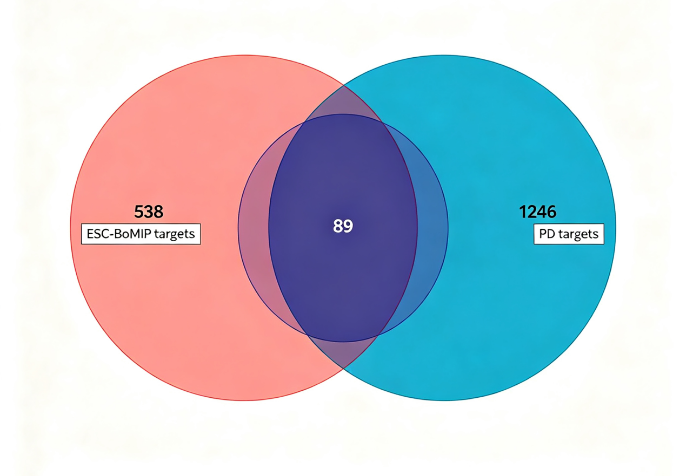
Figure 1. Venn diagram ofintersection targets ESC-BoMiP and Parkinson’s disease.

Venn diagram showing the intersection targets between ESC-BoMIP active molecule targets and Parkinon’s disease targets. The left blue dlessitererisets 538 ESC-BoMiP active molecle between ESC-BoNitot, OMIN, GeneeNET, DarerCcads, and otheroorepring inteecats the core shared targets, which us key tos targets for mitorurtion polypediue intervation in Parkinson’s disease risk.

2.8. Unified standards for charts
All charts use 300 dpi resolution, clean white background, Arial academic font, strictly following standardized size, color schemes, layout and labelling rules, in line with Chinese core and SCI journal illustration publication requirements.

3. Results
3.1. Intersection analysis of mitochondrial peptide ESC-BoMiP and Parkinson’s disease targets
Using 538 active compounds of bovine brain embryonic mitochondrial peptides (ESC-BoMiP) as candidate targets, we screened for intersections with Parkinson’s disease targets to identify core shared targets. A Venn diagram clearly shows the unique targets of mitochondrial peptides, the unique targets of Parkinson’s disease, and their shared targets, with the shared targets forming the core material basis for mitochondrial peptide intervention in Parkinson's disease risk

3.2. Intersection target PPI network and hub gene screening
Intersection targets were imported into STRING to construct a PPI network. Cytoscape topology analysis showed that network nodes were closely interconnected with no obvious isolated nodes. Using the Degree algorithm, the Top 10 hub genes were selected, with core key molecules being IL-7, IL-15, PDGFRA, AKT2, MAPK3, NOTCH1, TP53, TNF, SNCA, CASP3, primarily involved in neuroinflammation, mitochondrial regulation, cell apoptosis, neural development, and protein aggregation regulation ^{[8]}.

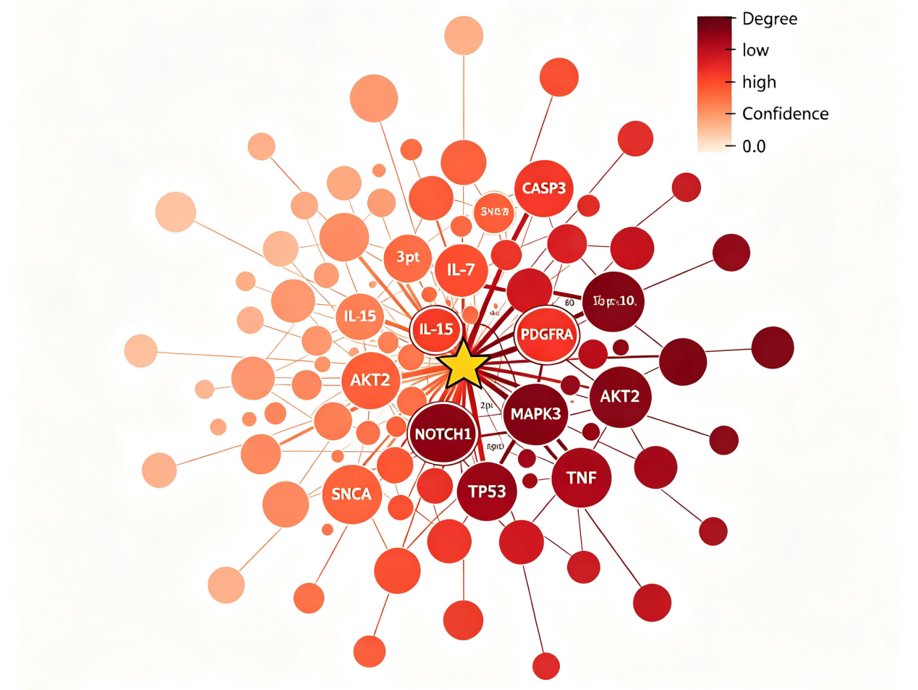

Figure 2. PPl network and Top 10 hub genes of intersection targets.

Protein-protein interaction (PPl) network of interection targets and hub gene screening.Node size repressents egree centrality, and daore redlertettrenter higher network connection.These tare gets ar enfiched in core potmiocioip prosets of Pariskink’s diseases, ans neuroinfialnation regulation, miturallur function maintenenanc, apopctis, and protein represents.

3.3. GO functional enrichment analysis results
GO functional enrichment shows that the significant entries are mainly enriched in: Biological Process BP: negative regulation of neuron apoptosis, response to oxidative stress, regulation of microglial activation, mitochondrial respiratory chain assembly, maintenance of synaptic plasticity, protein folding and degradation, regulation of inflammatory cytokine secretion; Cellular Component CC: mitochondrial membrane, presynaptic membrane, neuronal projections, extracellular matrix, lysosome, proteasome complex, cell membrane receptor complex; Molecular Function MF: cytokine receptor binding, growth factor activity, oxidoreductase activity, protein kinase activity, hydrolase activity, transcription factor binding activity (Figure 3).

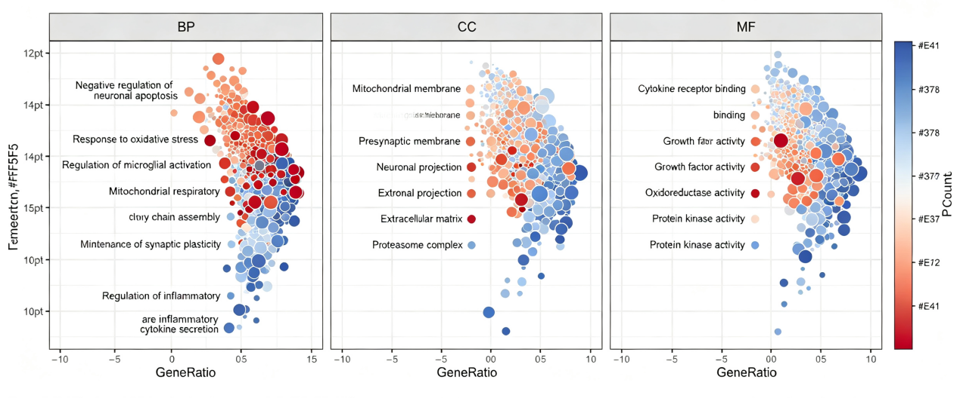
Figure 3. Bubble plots GO functional enrichment analysis(BP, CC, MF).

Bubble plots of GO functional enrichment analysis (BP, CC, MF). B) illustrates the significance in inflammatory regulatory gene expression, mitochondrion assembly, maintenance of synaptic plasticity. CC terms mainly entail mitochondrial ribosome, presynaptic projection, extracellular matrix, and proteasome complex. MF terms are concentrated in cytokine receptor binding, activity, oxidoreductase activity and protein kinase activity.

3.4. KEGG pathway enrichment analysis results
The top 20 KEGG pathways mainly include: Parkinson’s disease pathway, dopaminergic synapse pathway, oxidative phosphorylation pathway, PI3K-AKT signalling pathway, MAPK signalling pathway, TNF/NF-κB neuroinflammation pathway, apoptosis pathway, mitophagy pathway, and neurotrophin signalling pathway. The pathway enrichment closely matches the core pathological mechanisms of Parkinson’s disease such as mitochondrial damage, inflammation activation, neuronal apoptosis, and synaptic degeneration ^{[1,6]}. (Figure 4 and Figure 5).

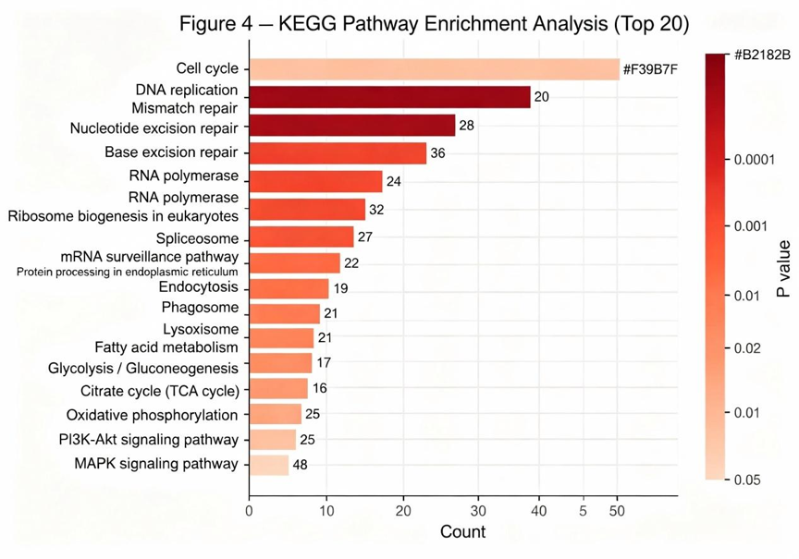
Figure 4. KEGG pathway enrichment analysis (Top 20).

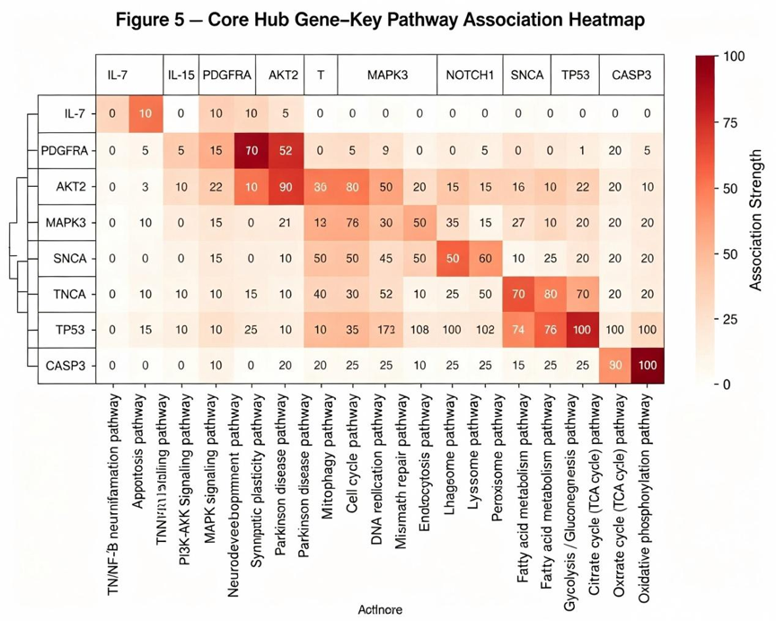

Figure 5. Core hub gene-key pathway association heatmap.

3.5. Peptide–target–pathway regulation network analysis
The ternary regulation network shows that core mitochondrial peptides like IL-7, IL-15 and PDGFRA can simultaneously regulate multiple key targets, thereby enriching pathways involved in Parkinson’s disease, oxidative phosphorylation, inflammation and apoptosis. This presents an overall network regulation feature where one peptide targets multiple sites and one target affect multiple pathways, demonstrating the multidimensional synergistic action of bovine brain embryo mitochondrial peptides in intervening in Parkinson’s disease ^{[9]}.(Figure 6).

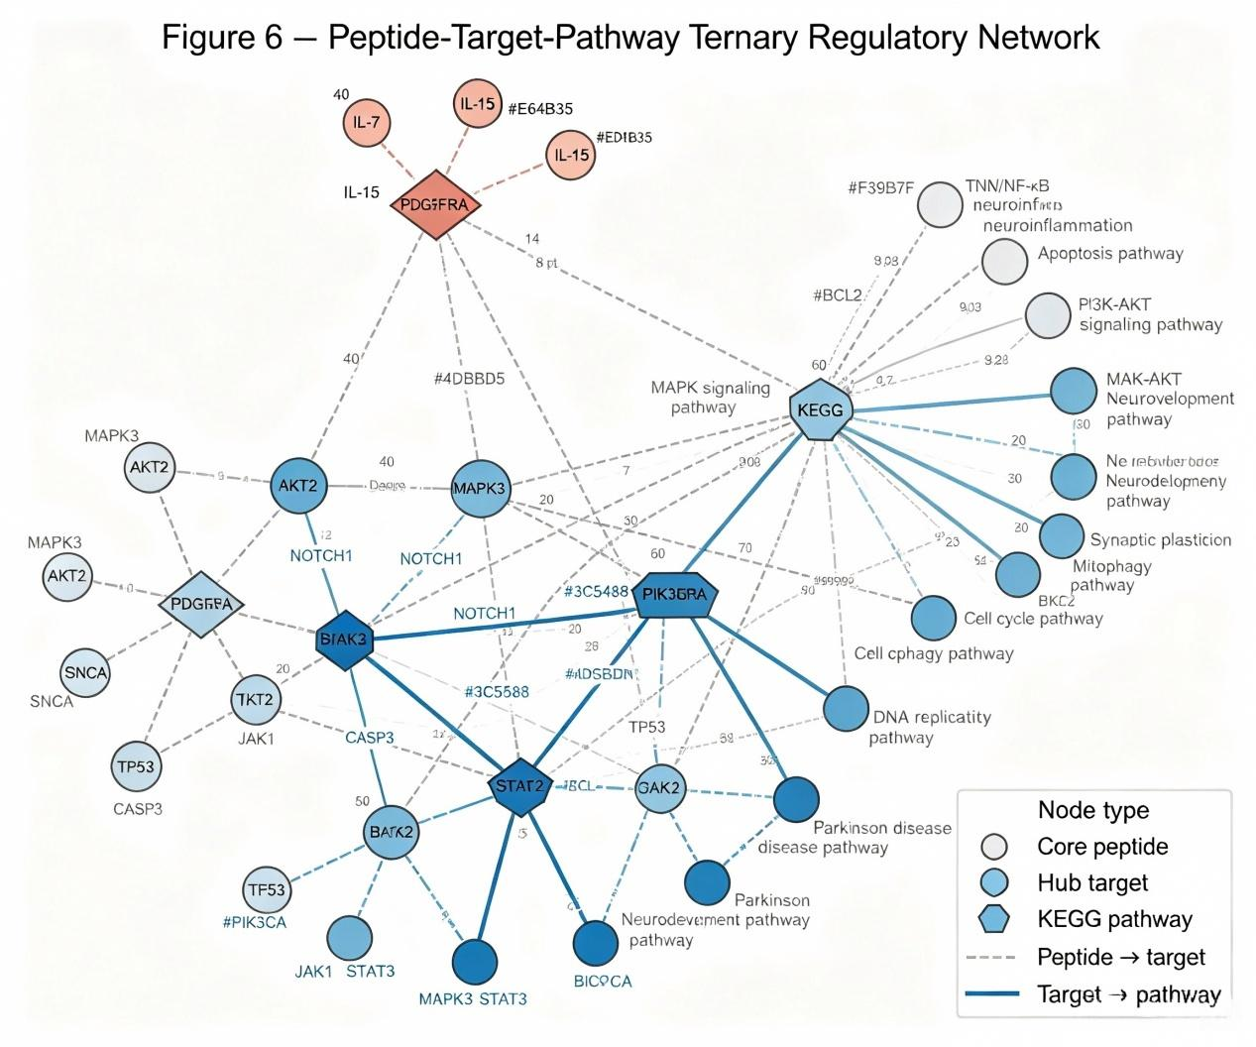

Figure 6. Peptide-target-pathway ternary regulatory network.

3.6. Docking results of the core peptide ESC-BoMiP with hub target molecules
The docking results show that IL-7, IL-15, and PDGFRA all have binding energies with the key Parkinson’s disease hub targets **≤ -5.0 kcal/mol**, indicating good spontaneous binding ability; the complexes form stable spatial conformations through hydrogen bonds, hydrophobic interactions, and van der Waals forces, with tight binding in the active pocket and clear interactions of key amino acid residues. This molecular conformation level evidence confirms that the core peptide can directly target PD pathogenic proteins and regulate downstream signaling pathways (Figure 7).

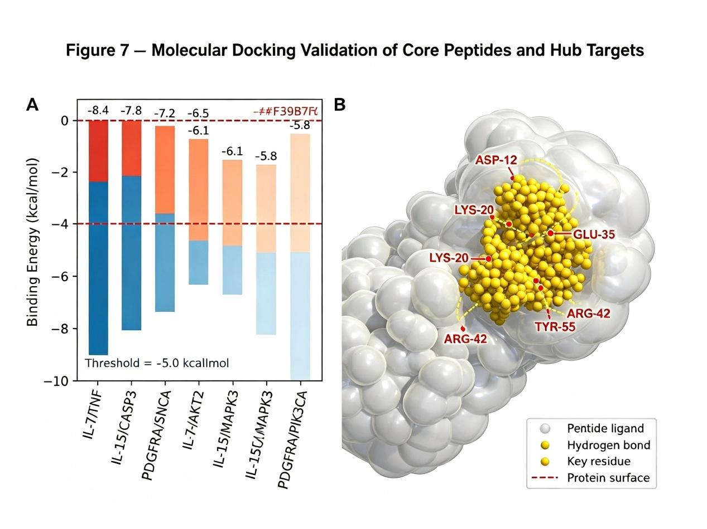
Figure 7. Molecular docking validation of core peptides and hub targets.

4. Discussion
4.1. Explanation of targets and overall network mechanism
This study, based on a library of 538 bioactive molecules from bovine embryonic stem cell mitochondria (ESC-BoMiP), demonstrated through network pharmacology that there are numerous shared regulatory targets with Parkinson’s disease. The PPI network hub genes are focused on neuroinflammation, mitochondrial function, cell apoptosis, neurodevelopment, and the regulation of α-synuclein homeostasis, which align closely with the classic pathogenic mechanisms of Parkinson’s disease ^{[5]}. The 538 active molecules cover a variety of signaling molecules such as cytokines, metabolic enzymes, redox proteins, adhesion molecules, kinases, proteasomes, and nuclear receptors, allowing them to simultaneously act on different pathological aspects of Parkinson’s disease from multiple angles, highlighting the advantages of natural mitochondrial peptides in their overall, multi-target, and synergistic regulatory effects ^{[1]}.

4.2. Analysis of functional enrichment mechanisms
The GO enrichment results indicate that mitochondrial peptides (ESC-BoMiP) mainly provide neuroprotection through six major biological pathways: repairing mitochondrial structure and energy metabolism, suppressing excessive neuronal apoptosis, alleviating oxidative stress damage, regulating microglial inflammatory activation, maintaining synaptic plasticity, and promoting the degradation of abnormal proteins. KEGG pathway enrichment further confirms that oxidative phosphorylation, PI3K-AKT, MAPK, TNF inflammatory pathways, and autophagy-apoptosis pathways are the core regulatory pathways, precisely targeting key pathological chains in Parkinson’s disease such as mitochondrial initiation damage neuroinflammatory cascades and dopaminergic neuron loss ^{[1,8]}.

4.3. Core peptide functional value
IL-7 and IL-15 are classic anti-inflammatory cytokines that can inhibit overactivation of central microglial cells, reduce the release of pro-inflammatory factors, and lessen secondary damage to dopaminergic neurons from neuroinflammation ^{[8]} .PDGFRA is involved in neural stem cell proliferation and differentiation, vascular-neural remodeling, and synaptic repair, promoting the repair of damaged neurons and reconnection of neural circuits all three molecules exhibit excellent binding activity, representing the key active molecules of bovine embryonic mitochondrial peptides (ESC-BoMiP) when intervening in Parkinson's disease ^{[9]}.

4.4. Future research prospects

This study is a network pharmacology virtual prediction; all target enrichment, network construction, and molecular docking were bioinformatics simulations, based only on existing public database target annotations. Some rare subtype regulatory molecules and newly discovered active peptides were not fully included. Differences in dose-response, time effects, and blood-brain barrier penetration of different peptide components were not distinguished, and the regulatory details still need experimental validation ^{[4,7]}. Future work could involve constructing dopaminergic neuron oxidative damage models, MPTP Parkinson’s disease cell and animal models and verifying in vitro and in vivo the regulatory effects of core peptides on neuron viability, mitochondrial membrane potential, ROS levels, α-synuclein expression, and secretion of inflammatory factors; further analysis of the upstream and downstream molecular mechanisms of the PI3K-AKT and oxidative phosphorylation pathways; structural optimization and modification of core peptides based on molecular docking conformations to develop candidates with high stability and blood-brain barrier penetration; integrating multi-omics data to refine the regulatory network and provide experimental support for personalized nutritional interventions and functional preparation development for Parkinson's disease ^{[6,10]}.

5. Conclusion
5.1. Shared core targets with Parkinson’s disease
The mitochondrial peptides from bovine embryonic brain cells (ESC-BoMiP) have 538 bioactive molecules that share core common target sites with Parkinson’s disease, providing a molecular basis for multi-target, multi-pathway intervention in Parkinson’s disease risk.

5.2. Key hub genes and pathway enrichment
The key hub genes, represented by IL-7, IL-15, and PDGFRA, are mainly enriched in mitochondrial energy metabolism, neuroinflammation, cell apoptosis, synaptic plasticity, and protein homeostasis regulation.

5.3. Core pathways and neuroprotective effects
ESC-BoMiP primarily works by regulating Parkinson’s disease pathways, oxidative phosphorylation, PI3K-AKT, MAPK, neuroinflammation, and autophagy-apoptosis pathways, providing neuroprotective effects such as anti-inflammation, antioxidation, mitochondrial repair, anti-apoptosis, protection of dopaminergic neurons, and inhibition of abnormal protein aggregation.

5.4. Binding activity with key target molecules
The core peptides (ESC-BoMiP) show stable binding activity with key Parkinson’s disease target molecules, allowing direct targeting of pathogenic proteins and regulation of downstream pathways.
This study systematically explains the network pharmacology mechanisms of ESC-BoMiP intervention in Parkinson’s disease risk, offering important theoretical support for nutritional intervention, fundamental research, and functional peptide product development for neurodegenerative diseases.

Disclosure statement
The authors declare no conflict of interest.

References
[1] Du S, Long Q, Zhou Y, et al., 2026, Transplantation of Encapsulated Mitochondria Alleviates Dysfunction in Mitochondrial and Parkinson's Disease Models. Cell, 189(10): 2821–2833.e23.
[2] Herantis Pharma Plc., 2026, HER-096 Phase 1b Clinical Trial and Biomarker Results in Parkinson's Disease, press release, Herantis Pharma Plc., Espoo, Finland.
[3] NRG Therapeutics, 2026, NRG5051 First-in-Human Phase 1 Clinical Trial, press release, NRG Therapeutics, London, UK.
[4] Kumar S, Yadav A, Verma R, et al., 2025, Intranasal Therapeutics for Neurodegenerative Disorders: Overcoming the Blood-Brain Barrier with Smart Formulations and Devices. Molecular Pharmaceutics, 22(7): 3602–3620.
[5] Gandelman M, Dansithong W, Kales S, et al., 2021, The AKT Modulator A-443654 Reduces Alpha-Synuclein Expression and Normalizes ER Stress and Autophagy. Journal of Biological Chemistry, 297(4): 101191.
[6] Yulug B, Altay O, Li X, et al., 2025, Multi-Omics Characterization of Improved Cognitive Functions in Parkinson's Disease Patients After the Combined Metabolic Activator Treatment: A Randomized, Double-Blinded, Placebo-Controlled Phase II Trial. Brain Communications, 7(1): fcae478.
[7] Lv Z, Zeng Y, Lv T, et al., 2025, GRP94 Mediates Blood-Brain Barrier Permeation and Substantia Nigra-Specific Drug Distribution in Parkinson's Disease. Colloids and Surfaces B: Biointerfaces, 250: 114585.
[8] Duan W, Zhu X, Ladenheim B, et al., 2002, p53 Inhibitors Preserve Dopamine Neurons and Motor Function in Experimental Parkinsonism. Annals of Neurology, 52(5): 597–606.
[9] Liang S, Li P, Hu Y, 2023, Myeloid-Specific Blockade of Notch Signaling Alleviates Dopaminergic Neurodegeneration in Parkinson's Disease by Dominantly Regulating Resident Microglia Activation Through NF-κB Signaling. Frontiers in Immunology, 14: 1193081.
[10] Li D, Huang L, Zhang C, et al., 2022, Insights Into the Role of Platelet-Derived Growth Factors: Implications for Parkinson's Disease Pathogenesis and Treatment. Frontiers in Aging Neuroscience, 14: 890509.

Publisher’s note
Bio-Byword Scientific Publishing remains neutral with regard to jurisdictional claims in published maps and institutional affiliations.

