A Detailed Design Scheme for Piloting Unaccompanied Ward Services in a Public General Hospital in Beijing
Ying Yan¹, Lijie Shi², Ping Ma³, Jie Li¹*
¹Beijing Liangxiang Hospital, Fangshan District, Beijing 102401, China
²Beijing Rehabilitation Hospital, Capital Medical University, Beijing 100144, China
³Beijing Anzhen Hospital, Capital Medical University, Beijing 100029, China
*Author to whom correspondence should be addressed.

Copyright: © 2026 Author(s). This is an open-access article distributed under the terms of the Creative Commons Attribution License (CC BY 4.0), permitting distribution and reproduction in any medium, provided the original work is cited.

Abstract: Objective: To construct a detailed design scheme for unaccompanied ward services, providing a reference for pilot implementation in public general hospitals. Methods: Using Liangxiang Hospital as the carrier, problems were identified through field investigations, literature research, expert consultations, and in-hospital surveys. Following the principles of “safety first and closed-loop management”, the scheme was designed across four domains: management and institutional framework, patient-centered care throughout the entire process, operational safeguards for care delivery, and quality evaluation. Pilot implementation was planned for three wards in September 2025. Results: A scheme was developed comprising a three-tier management structure with seven core institutional documents, a full-process care pathway, operational safeguards, and quality monitoring with 12 quantitative indicators, with dynamic adjustments based on evaluation results. Conclusion: This scheme provides a relatively comprehensive design covering management responsibilities, care processes, operational safeguards, and quality evaluation. It can serve as a reference for pilot implementation and standardized management in general hospitals, though its actual effectiveness requires verification through pilot practice.
Keywords: General hospital; Unaccompanied ward; Detailed design; Patient safety; Nursing management

Online publication:

1. Introduction
As population aging deepens in China, the “4-2-1” family structure has gradually become mainstream, driving increased demand for professional care services ^{[1]}. The state has prioritized optimizing the healthcare experience and improving patient satisfaction as key tasks ^{[2]}. “Unaccompanied” wards are defined as those in which registered nurses and trained nursing assistants jointly provide daily living care, enabling “family members to forgo bedside accompaniment or merely accompany without participating in care provision” ^{[3]}. In July 2025, Beijing launched pilot programs for “unaccompanied” wards ^{[4]}.
Currently, the development of unaccompanied wards in China still faces many deficiencies, including the lack of unified process standards, incomplete management systems, and insufficient risk prevention and control, resulting in a significantly elevated risk of adverse events ^{[5,6]}. Liangxiang Hospital is among the first batch of pilot hospitals for unaccompanied care in Beijing. Led by the Nursing Department in collaboration with multiple departments, a detailed design was undertaken, with plans to commence pilot implementation in September 2025 in the neurosurgery, cardiothoracic and vascular surgery, and endocrinology and rheumatology wards, followed by hospital-wide expansion once the model matures.
Therefore, this paper, using the pilot wards at Liangxiang Hospital as the basis, develops a detailed design scheme in accordance with the requirements of “safety first and closed-loop management”, thereby offering a reference for pilot implementation in public general hospitals.

2. Main problems
2.1. Low acceptance among nurses
Strong safety risk perception, after removing family accompaniment, nurses are more concerned about increased adverse events; insufficient staffing and a lack of responsibility among nursing assistants prevent effective workload sharing; rapidly escalating burden and pressure lead to decreased willingness.

2.2. Low patient willingness driven by age, family caregiving burden, and income level Individualized needs cannot be met, resulting in a poorer experience compared with family-provided care; with fewer staff and more patients, care tasks such as toileting assistance and repositioning are delayed; patients who are comatose or have cognitive impairment cannot express their needs, potentially leading to delayed condition management.

2.3. Low professional competence of nursing assistants, posing safety hazards
Lack of standardized training and certification, with numerous certifying bodies and inconsistent standards; generally low qualifications, with most dispatched by third-party agencies and poor understanding and implementation of nursing protocols and risk identification; high turnover rates disrupt continuity of care; advanced age, with 95.18% aged ≥ 50 years and 55.42% aged ≥ 55 years, resulting in lower receptivity to new technologies.

3. Nursing assistant management
After removing family accompaniment, daily living care is primarily delivered by nursing assistants, who must simultaneously care for multiple patients with diverse needs. Under prolonged pressure, lapses in care quality are likely to occur, along with decreased motivation among nursing assistants. Therefore, comprehensive consideration from the perspectives of training, environment, psychological support, and performance management is necessary.
First, patients vary in clinical condition and emotional state. Beyond daily living care, nursing assistants must also handle communication and respond to emergencies. Without sufficient experience, they struggle to respond effectively, placing additional pressure on nurses. Research has shown that after systematic training and simulation drills, nursing staff respond more rapidly and accurately to emergencies ^{[7]}.
Second, nursing assistants must frequently collaborate with nurses and peers. Unclear division of labor and poor information flow can lead to duplicated or missed care tasks. According to Herzberg’s two-factor theory, working conditions, management systems, and interpersonal relationships are classified as hygiene factors; when these fail to meet employee needs, dissatisfaction arises ^{[8]}. Conversely, providing clear requirements, a positive communication atmosphere, and a stable environment can enhance employee satisfaction and service quality.
Third, nursing assistants engage in care work over extended periods, frequently encountering critically ill or emotionally unstable individuals, making them prone to fatigue, high stress, and even occupational burnout. Research by Bernburg et al. demonstrated that mental health promotion interventions can improve stress, emotional regulation, and self-efficacy, underscoring the need to attend to the psychological well-being of patients ^{[9]}.
Fourth, task completion such as feeding assistance, repositioning, and toileting assistance does not fully reflect work quality. The long-term absence of objective performance evaluation can lead to decreased motivation ^{[10]}.

4. Detailed scheme design
4.1. Overall design framework
The scheme was developed according to the principles of safety first and closed-loop management, encompassing four components: management and institutional framework, full-process care, operational safeguards, and quality evaluation (see Figure 1).

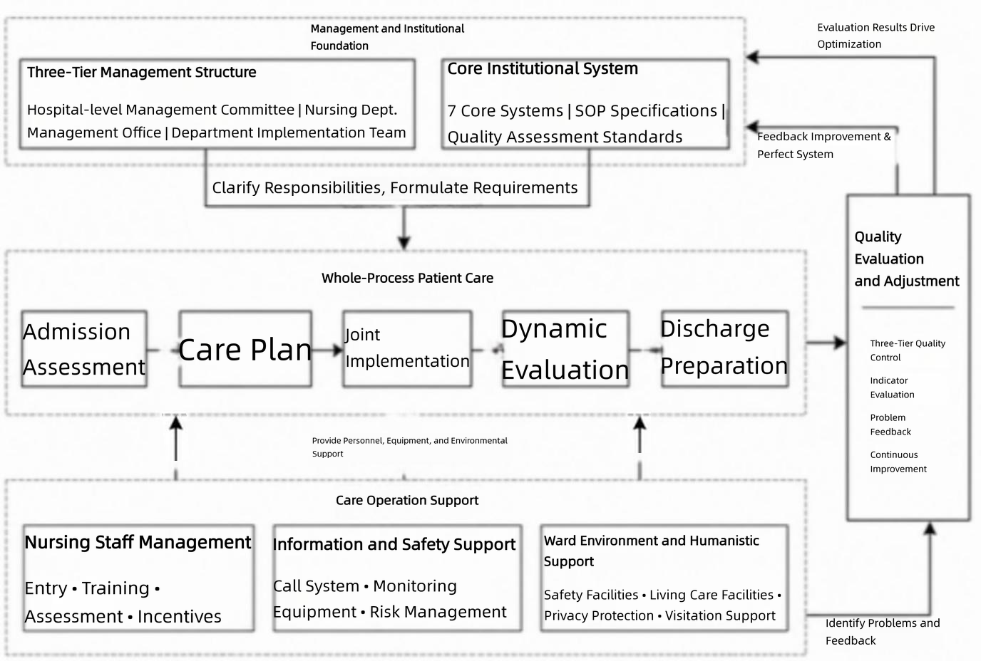
Figure 1. Overall framework of the detailed design scheme for unaccompanied ward services.

4.2. Management and institutional design
4.2.1. Three-tier management structure
The hospital establishes an Unaccompanied Service Management Committee, chaired by the vice president in charge of nursing, with participation from relevant departments to coordinate efforts. The Nursing Department establishes a Management Office (1-2 full-time staff) responsible for formulating management policies, organizing training, and conducting quality inspections. Ward-level teams, led by head nurses, are responsible for implementing care and daily management.

4.2.2. Core institutional system
The institutional system comprises seven documents, including the Unaccompanied Ward Management Policy, Medical Nursing Assistant Management Measures, and Standard Operating Procedures (SOP) for Unaccompanied Services, covering ward management, nursing assistant entry and assessment, care operations, safety risks, and emergency response.
The Standard Operating Procedures (SOP) for Unaccompanied Services specifies 23 key tasks, including admission assessment and care planning. These are used in conjunction with other institutional documents, with the Nursing Department responsible for monitoring implementation and making dynamic adjustments based on actual conditions.

4.3. Design of full-process patient care
Within 2 hours of admission, the primary nurse completes the initial assessment (activities of daily living, fall and pressure injury risks, using the Barthel Index, Morse Fall Scale, and Braden Scale), determines the nursing level and risk category, and adjusts the care plan accordingly.
(1) Within 4 hours of admission, a care plan is jointly developed with clear role assignments. For high-risk patients such as the elderly and those with impaired consciousness, additional measures including repositioning, bed rails, and fall prevention are implemented;
(2) Nurses are responsible for condition monitoring, treatment and nursing care, and health education; nursing assistants, under guidance, perform daily living care, safety monitoring, and auxiliary tasks;
(3) The primary nurse reviews the execution of the care plan daily and makes adjustments;
(4) The ward conducts a satisfaction survey weekly and continuously improves the service;
(5) Pre-discharge preparation is completed, and continuous nursing care is implemented.

4.4. Design of operational safeguards for care delivery
4.4.1. Nursing assistant safeguards
Nursing assistants are jointly provided by the hospital and a third-party company (aged ≤ 50 years, high school education or above, in good physical condition). Pre-service training covers seven domains including professional ethics, infection control, basic care, and symptom observation, totaling 120 hours; only those who pass the assessment are permitted to work. Annual refresher training and assessment are required for all employed nursing assistants.
Nursing assistants are classified into junior, intermediate, and senior levels, with monthly salaries of 4,000–5,000 CNY, 5,000–6,000 CNY, and 6,000–7,000 CNY, respectively. Performance evaluation is based on quality and safety and is linked to compensation and recognition. Benefits include five social insurance schemes and one housing fund, free accommodation, work meals, and paid annual leave.

4.4.2. Information and safety safeguards
Bedside call systems, nurse stations, and nursing assistant terminals are interconnected, with information synchronized and pushed in real time. For high-risk patients, smart mattresses, bed-exit alarms, and vital sign monitoring devices are deployed, with abnormal findings simultaneously alerted. Nursing assistants use a mobile application to document care and report abnormalities. Safety management covers eight categories of high-risk events including falls and pressure injuries, with the information system providing reminders based on assessment results.

4.4.3. Ward environment and humanistic safeguards
Ward facilities are optimized: handrails in corridors and slip-resistant flooring; emergency call buttons and safety handrails in restrooms, with non-slip mats in shower areas; privacy curtains for each bed to protect patient dignity.
Humanistic support is jointly provided by nurses and nursing assistants, with communication and emotional observation incorporated into training. Family visiting days and video visits are arranged, and patient social gatherings and rehabilitation activities are organized.

4.5. Quality evaluation and scheme adjustment
Three-tier quality monitoring is implemented: head nurses conduct daily inspections and weekly quality analysis; the Nursing Department conducts weekly spot checks and monthly comprehensive evaluations; the Hospital Management Committee conducts quarterly assessments and adjusts management content accordingly.
Quality evaluation includes 12 quantitative indicators (adverse event incidence, satisfaction, care execution compliance rate, call response time, etc.), with data collected by wards, verified by the Nursing Department, and comprehensively evaluated by the hospital. Quality issues are addressed through a closed-loop process of “identification, analysis, rectification, and evaluation”, with recurrent issues prompting adjustments to institutional documents and training.

5. Discussion
5.1. Core logic of scheme construction: Problem-oriented resolution of service pain points
This scheme forms targeted designs around three core problems: “insufficient nurse adaptability, numerous patient concerns, and unprofessional nursing assistants”. For nurse safety risks and workload, the “three-tier management structure” clarifies multi-department collaborative responsibilities, supplemented by information technology including bed-exit alarms, bedside call systems, and vital sign monitoring to assist risk identification. For patient concerns regarding individualized needs, responsiveness, and quality of special care, the full-process care pathway from admission assessment to discharge preparation enables dynamic adjustment, supported by informational, environmental, and humanistic safeguards. For nursing assistant issues including inconsistent training, low competence, high turnover, and advanced age, 120 hours of pre-service training and annual refresher training are established, alongside tiered management and comprehensive compensation and benefits.

5.2. Innovative dimensions of the scheme
First, the “systematic integration” of the management system. This scheme forms an integrated design based on four components, with the three-tier management structure, core institutional documents, and information support interconnected to avoid implementation gaps resulting from fragmented design.
Second, the “dual orientation of humanism and safety” in the care model. Addressing the deficiency of existing schemes that emphasize safety while neglecting psychological care, this scheme achieves a balance between safety and experience through “physical environment plus humanistic care”: facilities ensure safety, privacy curtains protect dignity, and visiting and rehabilitation activities alleviate loneliness and reduce resistance.
Third, the “scenario-based adaptation” of technology application. Call systems, nurse stations, and nursing assistant terminals are interconnected. For high-risk patients, smart mattresses, bed-exit alarms, and vital sign monitoring devices are deployed. Nursing assistants use a mobile application to document care and report abnormalities, forming a closed loop of “monitoring–early warning–response”.

5.3. Practical value of the scheme
This scheme aligns with the characteristics of public general hospitals: collaboration with third-party nursing assistant companies reduces recruitment pressure, and phased pilot implementation mitigates risks. Equipment is selected based on “practicality and essential need” principles, and tiered management facilitates competency-based role assignment. The scheme conforms to national pilot policies for unaccompanied care, establishes seven core institutional documents and quality evaluation indicators, and is amenable to pilot implementation within existing organizational structures.

5.4. Limitations and directions for future optimization
First, insufficient specialty adaptability. The existing “general closed-loop pathway” cannot fully address the special needs of individual specialties. Future efforts should involve collaboration with department directors and head nurses to develop “specialty-specific supplementary care protocols”, such as “airway management SOPs”.
Second, the absence of cost-benefit analysis. Cost estimation and benefit evaluation were not incorporated. Future work should collect cost data during pilot implementation, conduct cost-effectiveness and cost-benefit analyses, and provide evidence for hospital decision-making and medical insurance payment.

6. Conclusion
Starting from the problems, this paper creates a refined service plan for no-attendant wards in public general hospitals in accordance with the principles of safety first and closed-loop control. It establishes a three-tier management system, seven main systems, and a full care system from admission to discharge, improves the mechanisms for tiered training of nursing assistants, early information alerts, and humanistic care safeguards, and carries out three-tier quality closed-loop control relying on 12 quantitative indicators. This plan is highly systematic and operable, and can provide a reference for the pilot construction of no-attendant wards in general hospitals. This plan also has shortcomings such as low specialty matching and lack of cost-benefit evaluation, which still need to be continuously improved and perfected through pilot programs.

Disclosure statement
The authors declare no conflict of interest.

References
[1] Ye L, 2023, The Caring Rationale of Long-Term Care for the Elderly. Chinese Medical Ethics, 36(1): 64–68.
[2] Implementation Plan for the Campaign to Improve Healthcare Experience and Enhance Patient Experience (2023–2025), 2023. China Rural Health, 15(6): 1–4.
[3] Cai D, Xu T, Tao Y, et al., 2025, Practical Exploration of Narrative Unaccompanied Care Model Wards from the Perspective of Value-Based Healthcare. Chinese Health Service Management, 15(3): 107–112.
[4] Wang J, Liu Y, Chen F, et al., 2020, The Impact of the No-Attendant Care Model on the Safety of Elderly Inpatients. Chinese Nursing Management, 20(8): 1204–1208.
[5] Wang Y, Wang R, Dun Y, et al., 2025, A Mixed-Methods Study on Inpatients’ Willingness to Choose Unaccompanied Wards. Chinese Journal of Hospital Administration, 41(6): 473–478.
[6] Bao X, Lan M, Song J, et al., 2025, Multi-Department Collaborative Practice of “Unaccompanied” Services in Public Hospitals. Chinese Journal of Hospital Administration, 41(2): 133–138.
[7] Xenya K, Michelle R, Kevin A, et al., 2020, Training Healthcare Assistants Working in Adult Acute Inpatient Wards in Psychological First Aid: An Implementation and Evaluation Study. Journal of Psychiatric and Mental Health Nursing, 27(6): 742–751.
[8] Gao J, Yin J, Sun Q, 2025, Barriers and Challenges: A Descriptive Qualitative Study of Job Satisfaction Among Direct Care Workers Who Provide Long-Term Care Services in Shandong Province, China. BMJ Open, 15(7): e097491.
[9] Bernburg M, Groneberg D, Mache S, 2019, Mental Health Promotion Intervention for Nurses Working in German Psychiatric Hospital Departments: A Pilot Study. Issues in Mental Health Nursing, 40(8): 706–711.
[10] Huang D, Zhang L, Lu S, et al., 2026, Job Satisfaction and Organisational Determinants Among Medical Nursing Assistants Under Hospital-Based Care Reforms: A Large Cross-Sectional Study in China. Frontiers in Public Health, 14: 1793432.

Publisher’s note
Bio-Byword Scientific Publishing remains neutral with regard to jurisdictional claims in published maps and institutional affiliations.

