The Internal Logic and Operational Mechanism of School-Enterprise Task Co-construction: A Case Study of an Intelligent Manufacturing Program
Songyi Han*, Xu Cheng
School of Mechanical and Electrical Engineering, Shandong Vocational College of Industry, Zibo 256414, Shandong, China
*Author to whom correspondence should be addressed.

Copyright: © 2026 Author(s). This is an open-access article distributed under the terms of the Creative Commons Attribution License (CC BY 4.0), permitting distribution and reproduction in any medium, provided the original work is cited.

Abstract: Vocational education must reconcile occupational requirements, curricula, skills competitions, and vocational certificates, yet these sources often operate in parallel. Course articulation remains weak and enterprise participation is frequently peripheral. Taking typical work tasks as a common mediating object, this study develops a school-enterprise task co-construction mechanism based on literature analysis, action research, case analysis, expert consultation, and reform practice in an intelligent manufacturing program. The mechanism comprises five linked processes: joint translation of standards, task co-construction, collaborative development of learning scenarios, evidence-based joint assessment, and iterative co-governance. It converts occupational, competition, and certification requirements into a curriculum competency map and a progressive task chain, linking curriculum development, teaching, assessment, and collaborative governance. Evidence from the pilot indicates that competition tasks and rubrics can be incorporated into regular teaching, work-process connections among courses can be strengthened, and enterprises can move from providing equipment, lectures, and internships to participating in task development, key teaching activities, and quality assessment. The mechanism offers a transferable method for vocational programs involving complex work processes and cross-module competence. Its effective operation depends on maintaining curriculum goals, clarifying benefits for enterprises, and improving teachers’ capacity to translate workplace practice into learning.
Keywords: School-enterprise collaboration; Task co-construction; Post-Course-Competition-Certification integration; Industry-education integration; Vocational education

Online publication:

1. Introduction
Intelligent manufacturing changes the organization of work as well as production equipment. Industrial robots, programmable logic controllers, vision systems, sensor networks, digital twins, and production data now operate within integrated technical systems. Smart manufacturing and cyber-physical production systems therefore require equipment connectivity, real-time control, data integration, and continuous optimization ^{[1,2]}. Technicians must complete tasks that combine installation, programming, commissioning, diagnosis, quality control, safety, and coordination. Occupational competence develops through the combined use of knowledge, practical skills, judgment, and collaboration rather than through isolated operations.
Vocational curricula, however, are still often organized around disciplines or individual devices. Courses in mechanical drawing, PLC control, industrial robotics, sensors, fieldbus systems, and supervisory control may each contain projects, but students rarely apply their knowledge repeatedly to the same work object. Skills competitions generate integrated tasks, fault cases, and assessment rubrics, yet these resources may remain within competition teams and pre-competition training. Vocational certificates provide external standards but can become additional examinations outside the curriculum. Enterprises may donate equipment, give lectures, receive interns, or coach competitors without participating substantially in curriculum development, teaching, or quality assessment.
Chinese vocational education policy calls for closer alignment among programs, curricula, teaching processes, industry, and occupational requirements, while also using skills competitions to improve teaching ^{[3-6]}. Research on industry-education integration shows that collaboration depends on shared interests, resources, responsibilities, and rules; otherwise, participation remains fragmented ^{[7]}. Studies of Post-Course-Competition-Certification (PCCC) integration have clarified the functions of its four components and proposed curriculum-based approaches ^{[8-11]}. A remaining question is how multiple standards can be converted into a common curricular object that supports sustained school-enterprise collaboration.
Drawing on literature analysis, action research, case analysis, expert consultation, and reform practice at Shandong Vocational College of Industry, this study treats PCCC integration as an educational translation process centered on typical work tasks. It examines how occupational, competition, and certification standards can be converted into curriculum tasks; how competition and certification can serve all students; and how enterprises can participate in joint development, implementation, assessment, and improvement.

2. Internal logic of task co-construction
Occupational work, curricula, competitions, and certificates belong to different institutional settings. Occupational work concerns completing tasks under real quality and safety constraints. Curricula organize progressive learning. Competitions assess stable performance in complex tasks under time limits. Certificates confirm learning outcomes against standardized criteria. These functions are related but not interchangeable ^{[8-11]}. Directly importing workplace standards can reduce learning to short-term operational training. Copying competition tasks into ordinary classes can exceed many students’ prior knowledge, while allowing certificate criteria to replace curriculum objectives can make teaching follow an examination procedure rather than the development of competence.
Intelligent manufacturing competence requires a complete work process. Mastery of wiring, programming, or robot operation alone does not ensure that a learner can design, install, commission, and maintain a manufacturing unit. Work-process-oriented curriculum theory therefore uses typical work tasks and complete action processes to connect learning objects, knowledge structures, and professional practice ^{[12-14]}. A typical work task gives schools and enterprises a concrete object for negotiation. Enterprise engineers can specify the work setting, equipment, procedures, quality requirements, safety boundaries, and common faults. Teachers can then select suitable content, arrange prerequisites, and design levels of difficulty.
Task co-construction refers to the joint interpretation of standards, educational transformation of workplace tasks, teaching implementation, collection of assessment evidence, and revision of curriculum and collaboration rules by teachers, enterprise engineers, and relevant assessment bodies. The mechanism seeks consistency in three areas. First, it links occupational, curricular, competition, and certification goals to explainable competence requirements. Second, it connects teaching, competition, and certification through a progressive task chain. Third, it assigns responsibilities for educational translation, engineering judgment, and external assessment around the same tasks. Consistency does not mean turning a course into a production line or training every student to competition standards. Tasks must be selected, simplified, sequenced, and supplemented with conceptual knowledge so that students can transfer what they learn ^{[13,14]}.

3. Structural barriers to PCCC integration
The first barrier is the absence of a stable interface between standards and curricula. Occupational surveys, competition task books, scoring rubrics, and certificate syllabi use different terminology, levels of detail, and revision cycles. Simple cross-reference tables may list broad abilities such as system integration or digital maintenance without identifying the setting, decisions, or evidence required to demonstrate them.
The second barrier is fragmentation within teaching and assessment. Competition resources tend to benefit selected students, while high task difficulty and time pressure limit their direct use in regular classes. Project-based reform within separate courses can also preserve disciplinary boundaries: robot courses emphasize calibration and trajectories, PLC courses emphasize logic and communication, and electrical courses emphasize wiring and safety. Students complete several projects without producing one integrated work outcome. Course records, competition results, certificates, and enterprise evaluations are also stored separately, so they support display more often than curriculum diagnosis.
The third barrier concerns enterprise participation. Joint curriculum development requires engineers’ time, access to technical materials, equipment use, and organizational coordination. Peripheral activities have clearer costs and are easier to schedule. Stable participation is unlikely unless collaboration also supports recruitment, employee training, technical services, equipment feedback, or enterprise visibility. Differences between academic calendars and production cycles further increase uncertainty ^{[15,16]}.

4. Operational mechanism and program implementation
The proposed mechanism consists of five linked processes supported by collaborative governance. Occupational, competition, and certification requirements provide multiple inputs; typical work tasks serve as the common intermediary; and assessment evidence informs revisions to both curricula and collaboration rules (Figure 1).

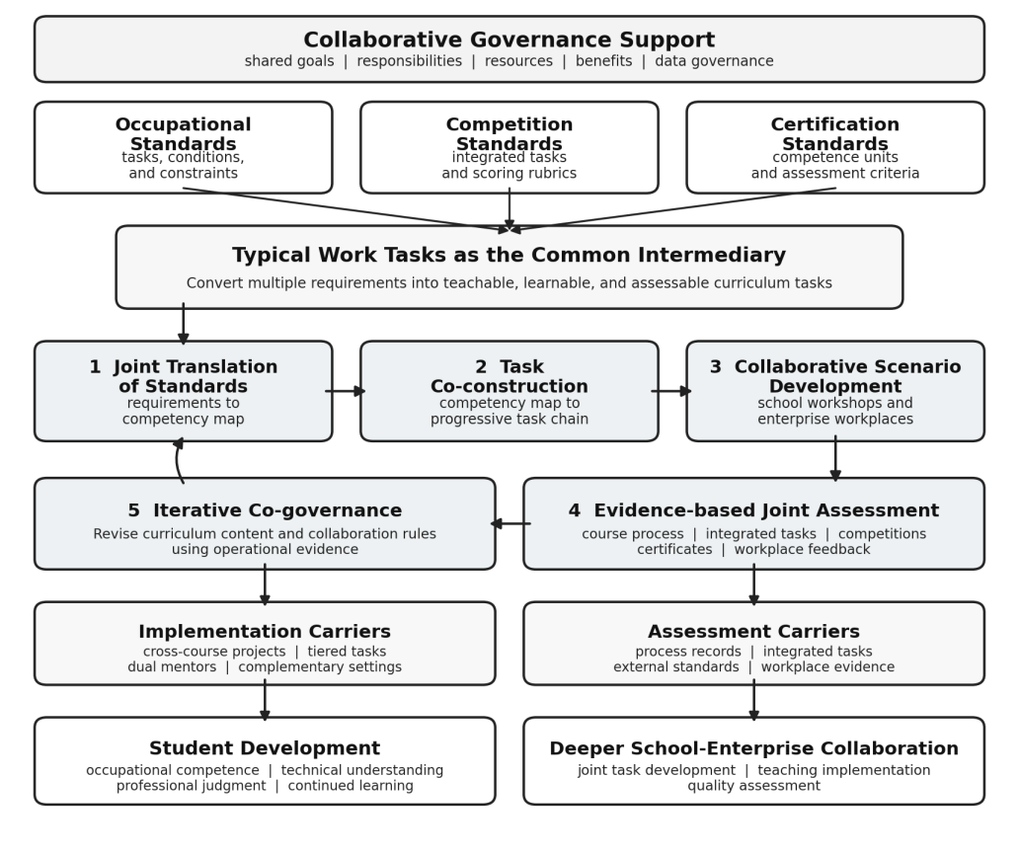
Figure 1. School-enterprise task co-construction mechanism for PCCC integration.

4.1. Joint translation of standards
Joint translation establishes a shared interpretation of competence. School and enterprise participants analyze the work object, workflow, equipment, quality criteria, safety requirements, and abnormal situations instead of stopping at job titles. For commissioning an intelligent manufacturing unit, the analysis covers I/O mapping, communication configuration, coordinate calibration, trajectory planning, safety interlocks, cycle-time adjustment, fault diagnosis, and technical documentation. Competition scoring criteria and certificate competence units are then compared with this task list. Transferable requirements are retained, device-specific or rule-dependent operations are screened, and essential theory, professional norms, and technical ethics are added. The result is a curriculum competency map linking work tasks, competence requirements, knowledge, and learning evidence.

4.2. Task co-construction
The competency map is reorganized according to knowledge dependencies and task difficulty. In the intelligent manufacturing program, the progressive chain moves from virtual modeling and layout to electrical installation and I/O configuration, PLC and fieldbus control, robot calibration and trajectories, sensor integration, system commissioning, fault diagnosis, and data-based optimization. Cross-course interfaces are explicit: layout and tooling data constrain robot trajectories; PLC logic is assessed with wiring and safety interlocks; and sensor data inform quality decisions and cycle-time improvement. Courses thus contribute sequentially to one work outcome rather than remaining parallel modules ^{[12]}.

4.3. Collaborative development of learning scenarios
School workshops and enterprise workplaces serve different educational functions. Workshops allow repeated practice, fault injection, safe trial and error, and close observation. Workplaces introduce equipment variation, production pace, team coordination, and responsibility for quality. Teachers organize conceptual knowledge, progression, and learning support, while enterprise mentors contribute technical standards and engineering experience. Joint participation is concentrated at project initiation, key process demonstrations, stage reviews, and integrated assessment. Competition resources enter teaching at three levels: basic tasks for all students, integrated tasks requiring coordination across modules, and advanced tasks with time limits, open faults, or innovation requirements.

4.4. Evidence-based joint assessment
Assessment does not add course scores, competition rankings, certificates, and enterprise ratings into one total. Each source answers a different question. Process records show how competence develops; integrated tasks reveal cross-module coordination; competitions test stable performance under constraints; certificates provide an external benchmark; and enterprise feedback indicates workplace adaptation. Teachers and enterprise mentors use shared rubrics covering technical accuracy, operating standards, fault analysis, collaboration, safety, and technical communication. Evidence must also identify why a system failed, such as wiring, communication, program logic, or team coordination. Feedback that leads to changes in learning and teaching is more useful than a final score alone.

4.5. Iterative co-governance
Course problems, competition errors, certificate weaknesses, enterprise evaluations, and student records enter joint review. Course teams can adjust task instructions, equipment parameters, and teaching schedules during a semester; program-level committees periodically review curriculum structure, mentor workload, internship quality, certificate selection, and data use. The same process evaluates the collaboration itself. Unstable enterprise participation may reflect unsuitable tasks, unrecognized workload, or unclear benefits. Intellectual property, confidentiality, and access to production data must be specified. Repeated joint revision converts personal contacts and short-term projects into institutional arrangements.
The pilot used the design, installation, commissioning, and maintenance of an intelligent manufacturing unit as the common reform object. Existing core courses were linked through a cross-course project group rather than supplemented with a separate competition curriculum. Competition resources were transformed through task decomposition, competence classification, knowledge mapping, difficulty grading, and curriculum embedding. Reusable elements included calibration, path planning, communication debugging, safety interlocks, fault injection, quality inspection, and technical reporting. Students submitted programs and wiring results together with I/O tables, parameter records, fault analyses, and technical explanations.
Enterprise personnel contributed typical tasks and common faults, demonstrated key processes, guided workplace learning, reviewed integrated tasks, and participated in assessment. Their contributions were documented by task, schedule, deliverable, and information boundary. Student competence portfolios indexed evidence by typical work task, enabling course performance, competition evidence, certificate competence units, and workplace feedback to be interpreted together.
Project records show that participating students obtained an average of 3.8 relevant vocational skill certificates, with an overall pass rate of 91.3%. Among respondents, 95% of students considered the courses practical and challenging, and 86% of employers reported that the graduates concerned could perform core tasks relatively independently. The available records do not provide the sample details required for statistical inference, so these figures are descriptive evidence rather than estimates of causal impact. More important process changes were the routine use of competition tasks and rubrics, continued implementation of cross-course integrated tasks, and more regular enterprise participation in task review and assessment.

5. Conditions and transfer boundaries
Curriculum goals must remain primary. Competition tasks can increase authenticity and difficulty, but award probability should not determine the curriculum. Learning must retain conceptual explanation, opportunities for error, and entry-level tasks for all students. Content tied narrowly to a particular competition, device, or speed requirement should be included cautiously because vocational education must support current work, technical understanding, judgment, and continued learning ^{[13,14]}.
Enterprises need visible and reasonable returns, including recruitment pipelines, employee training, technical services, equipment feedback, collaborative projects, or public recognition. Agreements should specify engineers’ workload, ownership of course outputs, intellectual property, confidentiality, and safety responsibilities ^{[15,16]}. Teachers also need the capacity to analyze work and transform complex practice into progressive learning. Enterprise placements, cross-course lesson study, competition reviews, joint rubric development, and portfolio review can support this capacity.
Certificates should be selected according to occupational relevance, industry recognition, competence coverage, and curriculum workload. Assessment data should support diagnosis rather than simple ranking, with clear limits on collection, access, use, and retention. The mechanism is transferable as a method based on typical work tasks, competency mapping, progressive task chains, complementary learning scenarios, multiple sources of evidence, and feedback. It is not a fixed task matrix. Programs in services, transport, or health care will require different work objects, relationships, and safety criteria.

6. Conclusion
Effective PCCC integration depends on whether occupational and industrial requirements are transformed into curriculum and whether schools and enterprises sustain collaboration around shared tasks. This study proposes a mechanism linking joint translation of standards, task co-construction, collaborative development of learning scenarios, evidence-based joint assessment, and iterative co-governance. The intelligent manufacturing case indicates that the mechanism can bring competition resources into regular teaching, connect courses through complete work processes, and move enterprise participation toward task development, key teaching activities, and quality assessment. Its transferable contribution is a method for joint occupational analysis, curriculum transformation, and collaborative governance rather than a standard task list. Further cross-program, cross-institutional, and longitudinal research is needed to test its conditions and limits.

Funding
Shandong Provincial Education and Teaching Research Project (Project No.: 2024JXQ185); the General Program of the Shandong Provincial Social Science Planning Research Project (Project No.: 23CJYJ23); the Research Startup Fund of Shandong Vocational College of Industry (Project No.: 2025QD001); the Youth Innovation Science and Technology Support Program for Colleges and Universities of Shandong Province (Project No.: 2025KJH128)

Disclosure statement
The author declares no conflict of interest.

References
[1] Li L, 2024, Reskilling and Upskilling the Future-Ready Workforce for Industry 4.0 and Beyond. Information Systems Frontiers, 26(5): 1697–1712.
[2] Kipper LM, Iepsen S, Dal Forno AJ, et al., 2021, Scientific Mapping to Identify Competencies Required by Industry 4.0. Technology in Society, 64: 101454.
[3] Jin X, Zhou N, Zhang X, 2025, China’s Policy Intention Regarding the Vocational Education-Industry Relationship: A Systematic Policy Review. Education + Training, 67(5–6): 668–683.
[4] Liu S, Hardy I, 2023, Understanding Chinese National Vocational Education Reform: A Critical Policy Analysis. Journal of Vocational Education & Training, 75(5): 1055–1077.
[5] Wang S, Peng F, Wang X, 2023, Application of Simulation Technology in Vocational Education Skills Competition. Proceedings of the 14th International Conference on E-Education, E-Business, E-Management and E-Learning (IC4E 2023), 100–105.
[6] James RS, 2021, Moving from Competence to Excellence: The Role of Training Managers in Providing Pedagogical Leadership in UK Further Education. Journal of Further and Higher Education, 45(5): 704–716.
[7] Liao X, Xiao C, Wei L, et al., 2026, Creating a Sustainable Vocational Education Ecosystem from the Perspective of Enterprise Perceptions. Humanities and Social Sciences Communications, 13: 453.
[8] Li Y, Pan W, 2024, The Integrated Education Mode of “Post Course Competition Certificate” in China: Its Connotation, Value and Implementation Paths. Proceedings of the 4th International Conference on New Computational Social Science (ICNCSS 2024), 95–101.
[9] Huang Y, 2024, Research on the Application of “Post-Course Competition Certificate” Model Based on Virtual Simulation Technology in Computer Assembly and Maintenance Course. Proceedings of the 2024 10th International Conference on Education and Training Technologies (ICETT 2024), 70–76.
[10] Li S, Chen Q, 2025, Construction and Research of “National Online Excellent Courses” in Vocational Colleges Based on the Random Forest Model. Proceedings of the 2025 International Conference on Big Data and Informatization Education (ICBDIE 2025), 318–323.
[11] Huang K, 2025, Analyzing Course-Certificate Integration in Vocational Education Using Random Forest: A Case of Financial Technology Majors. Proceedings of the 2025 3rd International Conference on Educational Knowledge and Informatization (EKI 2025), 344–350.
[12] Weinert T, Billert M, Thiel de Gafenco M, et al., 2023, Designing a Co-Creation System for the Development of Work-Process-Related Learning Material in Manufacturing. Computer Supported Cooperative Work, 32(1): 5–53.
[13] Hiim H, 2023, How Can Collaboration Between Schools and Workplaces Contribute to Relevant Vocational Education? Results of an Action Research Project in the School-Based Part of Norwegian Vocational Education and Training. Vocations and Learning, 16: 1–21.
[14] Rohr-Mentele S, Holtsch D, 2022, Recording Business Transactions in Textbook and Receipt Form: Measurement of Knowledge and Skills Transfer in Vocational Education and Training. Vocations and Learning, 15(2): 209–239.
[15] Lavía C, Otero B, Albizu E, et al., 2021, Exploring the Intensity of Relationships with Vocational Education Centres: A Typology of Spanish SMEs. Sustainability, 13(16): 9287.
[16] Zhang Y, Wang J, Shen X, et al., 2022, Research on the Influence Mechanism of Enterprises’ Participation in School-Enterprise Cooperation Based on the Analysis Framework of Theory of Planned Behavior. Frontiers in Psychology, 13: 860045.

Publisher’s note
Bio-Byword Scientific Publishing remains neutral with regard to jurisdictional claims in published maps and institutional affiliations.

