A Study on Teaching‑Strategy Improvement Based on a Survey of Senior High‑School Students’ Biological Cognition and Attitudes
Huixia Liu, Lan He, Fei Yu*
School of Life Sciences, Xinjiang Normal University, Urumqi 830017, China
*Author to whom correspondence should be addressed.

Copyright: © 2026 Author(s). This is an open-access article distributed under the terms of the Creative Commons Attribution License (CC BY 4.0), permitting distribution and reproduction in any medium, provided the original work is cited.

Abstract: The ultimate goal of education is to cultivate well‑rounded individuals. Senior high‑school biology plays an important role in fostering the all‑round development of students, and its teaching strategies can help teachers grasp students’ learning situations and effectively develop students’ scientific literacy. Adopting the questionnaire‑survey method, this study investigates senior high‑school students’ biological cognition and attitudes. It aims to analyze students’ actual conditions and put forward suggestions for improving teaching strategies. Survey results show that senior high‑school students have weak points in basic biological knowledge, especially insufficient in‑depth understanding of abstract concepts such as genetics and molecular biology. In terms of learning attitudes, most students show great interest in biological science, yet their cognition of the integration between theoretical knowledge and real‑world scenarios is one‑sided. Therefore, understanding the current status of students’ biological cognition and attitudes can provide suggestions and measures for teachers’ teaching research and student development, as well as favorable theoretical references for the improvement of teaching strategies.
Keywords: Senior high‑school biology; Biological cognition; Learning attitude; Teaching strategy; Survey research

Online publication:

1. Introduction
Against the background of comprehensively deepening curriculum reform and implementing the fundamental task of fostering virtue through education, “core competencies” have become the core orientation for cultivating new‑era talents ^{[1]}. With the in‑depth implementation of General High School Biology Curriculum Standards (2017 Edition, Revised in 2020), the objectives of biology teaching have shifted from mere knowledge imparting to the holistic cultivation of comprehensive abilities including life concepts, scientific thinking, scientific inquiry and social responsibility. It aims to cultivate students’ essential character and key competencies so that they can grow into socialist builders and successors with ideals, competence, and a sense of responsibility in the future.
Compared with the above‑mentioned cultivation objectives, current senior high‑school biology teaching faces practical difficulties in developing students’ core competencies. On the one hand, textbook contents extend from micro‑molecular (molecular biology) to macro‑ecological (ecology) perspectives, which sets higher requirements for teachers’ professional knowledge reserve and students’ logical thinking ^{[2‑3]}, making it harder for students to understand and flexibly apply these abstract concepts. On the other hand, biology places stress on operations and observation of experimental phenomena. If schools are poorly equipped with experimental facilities, teachers’ ability to guide students in inquiry‑based experiments within limited class hours will vary greatly. Inquiry‑based experiments may easily become formal exercises, and students’ learning efficiency as well as the educational function of practical training can hardly be realized ^{[4‑6]}. Meanwhile, obvious differences exist among students in learning motivation and cognitive foundation ^{[7]}. Some students still resort to rote memorization for examination‑oriented purposes. They cannot form in‑depth identification with biology, let alone develop initiative for independent exploration. The long‑established single lecture‑based teaching mode and evaluation system dominated by scores disconnect teaching procedures from the actual demands of students’ core‑competency development. When teachers intend to improve teaching, they often fail to grasp students’ learning situations accurately and cannot find feasible operational approaches ^{[8‑10]}. Such practical challenges urgently require teachers to seek more scientific and precise improvement methods for teaching strategies on the basis of empirical surveys. Teaching strategies themselves need to translate core competencies into quantifiable learning outcomes by incorporating them into concrete real‑world‑context problems. This requires the design and implementation of open‑ended tasks as well as the interpretation and application of evaluation results, leading to high overall implementation difficulty ^{[11‑12]}. Therefore, only by truly acquiring information on students’ core‑competency development levels, paying attention to student demands and individual differences, and putting personalized teaching into practice can we promote students’ all‑round development, enhance their core competencies, and truly implement the fundamental task of fostering virtue through education.
How to bridge the gap between “knowledge acquisition” and “practical application” in educational practice and effectively realize core‑competency cultivation has become a common issue for front‑line teachers. Given this situation, this study takes learning‑situation analysis as its entry point. Through an in‑depth survey on senior high‑school students’ biological‑cognition characteristics and learning attitudes, it makes a preliminary diagnosis of cognitive blind spots and attitude biases in current teaching. By distributing questionnaires, this paper obtains the real status of biological scientific literacy among students from a senior high school in Hotan Prefecture, analyzes the strengths and weaknesses of students’ biological literacy, adjusts existing biology teaching strategies in a targeted manner, and offers practical suggestions and improvement measures for teachers’ teaching research and students’ healthy growth.

2. Research subjects and methods
This study uses the Wenjuanxing platform to conduct a questionnaire survey on cognition and attitudes toward biological core competencies. The subjects are students from six Grade‑10, Grade‑11, and Grade‑12 classes of two middle schools in Hotan Prefecture, and 121 valid responses were collected. Among valid respondents, female students account for 57.85 % and male students account for 42.15 % (51 male students and 70 female students). Grade‑10 students make up 43.8 %, Grade‑11 students 28.1 %, and Grade‑12 students 28.1 %.

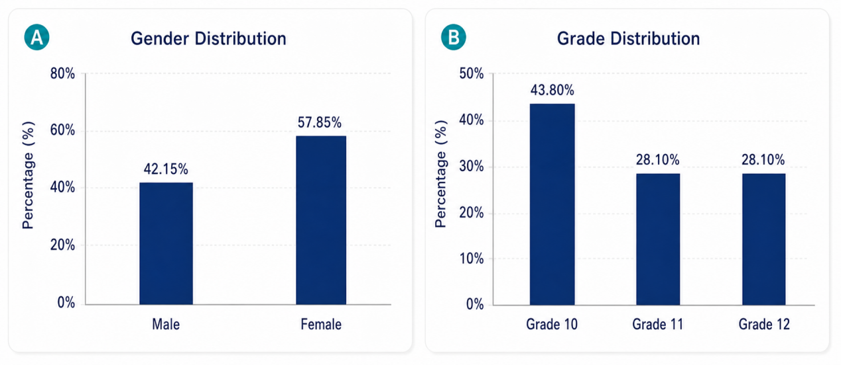
Figure 1. The proportion of the sample.

3. Results and analysis
3.1. Senior high‑school students’ interest in biology
Figure 2 shows students’ interest level in biological science. In general, 93.39 % of students (58.68 % very interested and 34.71 % somewhat interested) show strong interest in biological science, which fully reflects students’ intellectual curiosity and desire for exploration in biology.

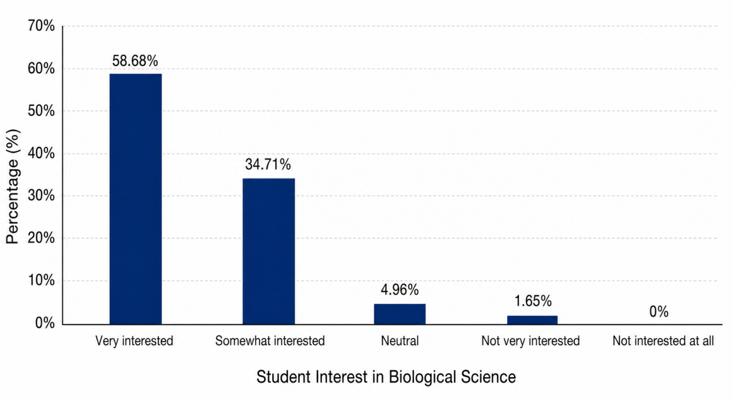
Figure 2. Students' interest level in biological sciences.

3.2. Senior high‑school students’ cognition of biology
Mastery of core biological concepts, cultivation of scientific thinking and recognition of disciplinary values among senior high‑school students have become hot topics in science‑education research. Questionnaire data show that most senior high‑school students have a solid grasp of basic theoretical knowledge, yet obvious divergence exists in systematic thinking and the integrated application of theoretical knowledge.
At the cellular‑biology level shown in Chart A, as high as 92.56 % (112 students) can correctly identify “mitochondrion” as the “power‑house of the cell”, which demonstrates students’ sound cognition of the functions of basic organelles. As shown in Chart B, 83.47 % of students can correctly classify “artificially‑bred seedless watermelons” as heritable variation caused by changes in genetic material; most students can accurately grasp the essence of genetic‑material changes. In terms of understanding ecosystem concepts, 76.86 % of students can correctly judge that energy flow is unidirectional and understand that material cycling and energy flow in ecosystems constitute key links for sustaining life. This may result from classroom experiments such as observing soil‑moisture variation and plant photosynthesis, where students record experimental results and deepen their understanding of theoretical knowledge. Judging from the distribution of cognition across major biological‑science research fields, students show diversified concerns: 90.91 % regard “genetics” as a major research field and 84.30 % choose “ecology”. This indicates that research on genetics and gene functions represents one of the fastest‑growing branches of biological science, occupying a core position in modern medicine and related biotechnological applications. Meanwhile, ecology focuses on core demands including ecological security, food security, ecosystem stability, biodiversity conservation and high‑efficiency agricultural breeding.

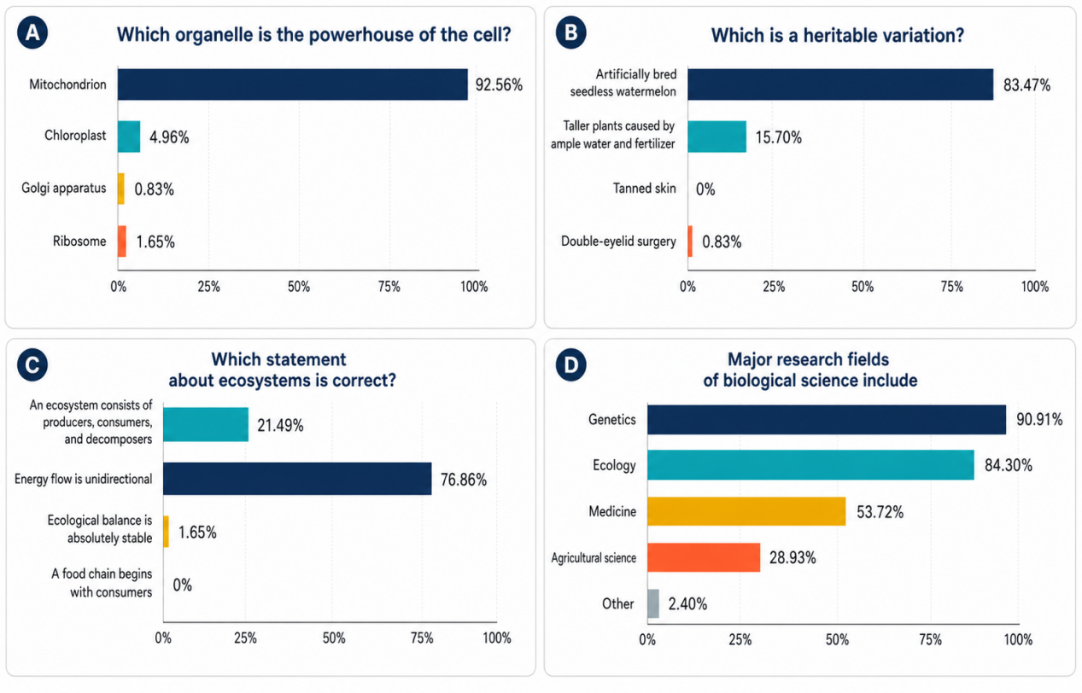
Figure 3. Current situation of senior high school students' cognition of biological sciences.

3.3. Senior high‑school students’ attitudes toward biology
As can be seen from Figure 4, a total of 85.95 % of respondents give highly positive evaluations of the role of biological science in solving real‑world social problems. It shows that the vast majority of students can go beyond pure disciplinary knowledge and establish awareness of connecting biological concepts with real‑world scenarios such as ecological protection, public health and agricultural development, which is consistent with the requirements of the Science‑Technology‑Society‑Environment educational philosophy.

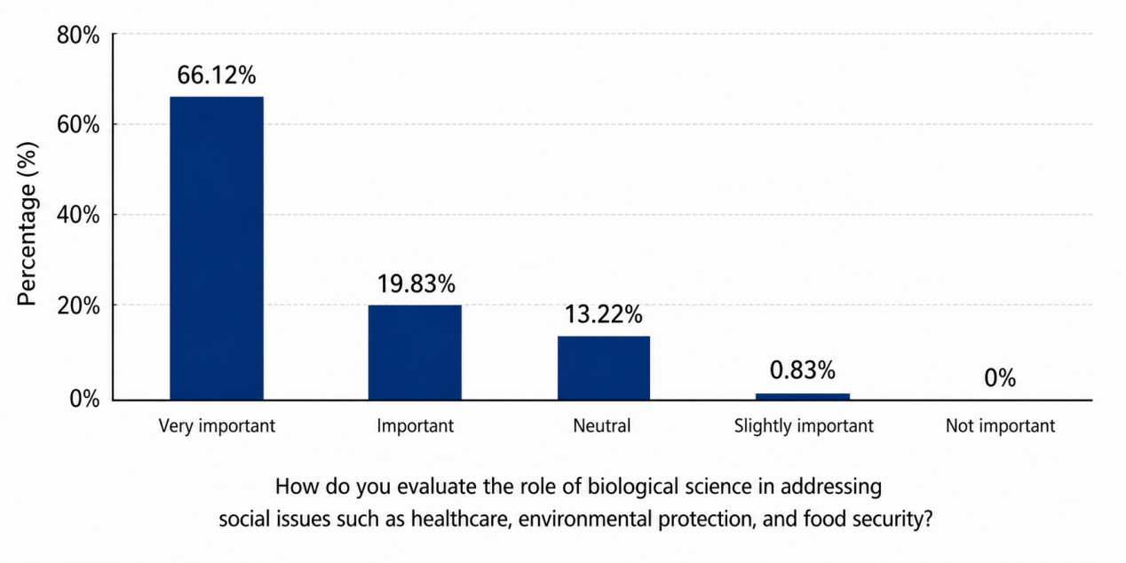
Figure 4. Current situation of senior high school students' attitudes towards biological sciences.

3.4. Analysis of factors influencing biological‑science cognition and attitudes
Further analysis of specific factors shaping students’ attitudes toward biological science shows that in‑school teaching factors play a leading role in the formation of students’ disciplinary attitudes. 54.55 % of students are restricted by the difficulty of course content, and 48.76 % are profoundly affected by teachers’ teaching methods. This suggests that when theoretical concepts are overly abstract and traditional teaching lacks sufficient interaction, cognitive obstacles will significantly weaken students’ enthusiasm for biology. On the other hand, social‑science‑popularization publicity accounts for 36.36 %, and family influence accounts for a considerable 34.71 %. It proves that a favorable social‑science‑popularization atmosphere, together with family‑education concepts, can exert positive synergistic effects on students’ recognition of disciplinary values.
In terms of curriculum‑improvement demands, data reflect students’ expectations for teaching modes featuring more practice, lower learning load and stronger real‑world connections. Specifically, 76 students (62.81 %) regard increasing experimental opportunities as the top priority for curriculum improvement, ranking first among all demands. 51 students (42.15 %) hope to reduce theoretical difficulty, and 40 students (33.06 %) suggest linking teaching content with hot social topics. This indicates that excessive theoretical difficulty may dampen students’ learning interest, while practical activities are generally regarded as a core approach to relieve the dullness of abstract theories and improve learning outcomes. Therefore, in teaching practice, part of verification experiments should be upgraded into inquiry‑based experiments, and demonstration experiments should be transformed into group student experiments as far as possible. In this way, students can gain a sense of achievement through hands‑on operations and effectively restore their academic self‑efficacy.

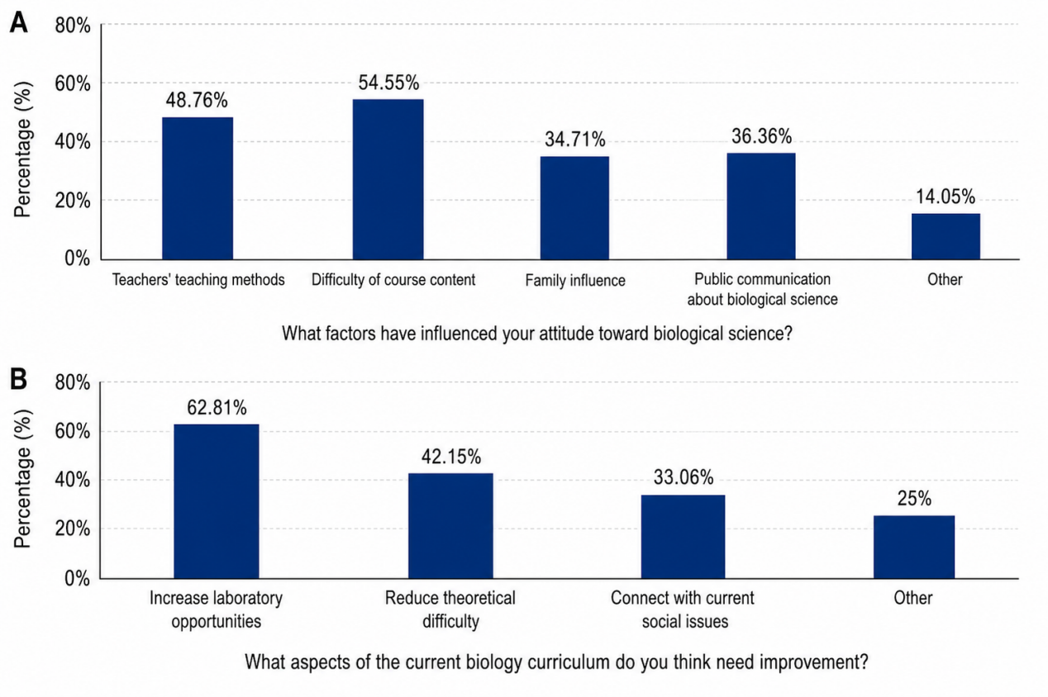
Figure 5. Factors influencing the cognition and attitudes towards biological sciences.

4. Suggestions for improving senior high‑school students’ biological scientific literacy
4.1. Optimize course content
In teaching activities, teachers should focus on helping students build a comprehensive biological knowledge system. Taking core biological knowledge points as clues, they can connect scattered knowledge points into logical chains so that students can grasp the overall framework of biological knowledge. By creating vivid, life‑oriented problem contexts, teachers can promote students’ thinking and inquiry, deepen their mastery of biological concepts, and arouse their learning enthusiasm and intellectual curiosity.

4.2. Carry out diversified teaching activities
Increase the proportion of inquiry‑based teaching activities, so that students can acquire knowledge and develop abilities through independent inquiry and cooperative communication. Conduct experiments, observe phenomena and analyze results to reproduce the discovery process and functional mechanism of plant auxin. Implement project‑based learning activities to enhance students’ comprehensive literacy and practical skills for applying biological science ^{[13]}.

4.3. Strengthen experimental teaching
Schools shall guarantee the normal delivery of biology‑experiment courses. Appropriate expansion experiments can be added according to teaching contents and students’ actual conditions to stimulate students’ innovative thinking ^{[14‑15]}. Allow students to independently select experimental materials and methods, and design multiple experimental schemes to explore the effects of factors such as temperature and pH on enzyme activity.

4.4. Pay attention to individual differences among students
Implement stratified teaching according to students’ biological-cognitive levels and learning abilities. Teachers shall observe individual differences in students’ learning process, identify existing problems in a timely manner, and provide targeted individual tutoring to help students get rid of learning difficulties, build learning confidence and develop positive learning attitudes.

4.5. Reinforce teachers’ professional development
Schools shall regularly organize biology teachers to participate in teaching training and teaching‑research activities, so that teachers can learn advanced educational concepts and teaching approaches and improve their teaching competence. Invite education experts to deliver special lectures, and arrange for teachers to attend teaching observations and teaching‑skill competitions to promote exchanges and mutual learning among teachers.

5. Conclusion
The in‑depth integration of biological‑core‑competency cultivation and classroom‑teaching reform constitutes a key approach to implementing the fundamental task of fostering virtue through education. Starting from practical problems existing in current senior high‑school students’ biological cognition and attitudes, this study further deepens classroom‑teaching reform, improves teachers’ professional literacy and practical teaching abilities on the basis of biology curriculum standards and talent‑cultivation requirements. From the perspectives of course content, teaching activities, experimental inquiry and personalized learning, it establishes a teaching philosophy of “taking competency implementation as the main line and contextualized teaching as guidance”. By integrating high‑quality educational resources and focusing on classroom‑structure optimization, experimental‑teaching innovation and core‑competency implementation, it lays a solid foundation and accumulates momentum for improving classroom‑teaching quality and efficiency.

Funding
University‑level Teaching Research and Reform Project of Xinjiang Normal University (Project No.: SDJG2019‑15)

Disclosure statement
The authors declare no conflict of interest.

References
[1] Zhang X, 2022, Constructing an Ideological-Political Education System for the New Era to Cultivate Future-Oriented Talents. Research in Higher Engineering Education, 70(3): 124–128.
[2] Tu M, 2023, Implications and Essence of the Social Construction of Teachers’ Practical Knowledge. Theory and Practice of Education, 43(25): 28–33.
[3] Shang A, Research on Cultivating Students’ Inquiry-Practice Literacy in Interdisciplinary Practical Activities of Junior High-School Biology, thesis, Henan University.
[4] Ren X, 2025, Research on Holistic Unit-Teaching Design of Senior High-School Biology Based on Project-Based Learning. Education, (07): 75–77.
[5] Huang D, 2015, Research on Teaching Design Focusing on Core Knowledge in Senior High-School Biology, thesis, Guangxi Normal University.
[6] Wang W, 2022, Practical Research on the Application of the “Problem Discussion” Column in Senior High-School Biology Teaching, thesis, Northwest Normal University.
[7] Zhou X, 2025, Application of Personalized Educational Evaluation in Senior High-School Biology Teaching. College Entrance Examination, (09): 149–151.
[8] Chen X, 2025, Examples on the Application of Micro-Courses in Senior High-School Biology Classroom Teaching. Journal of Secondary Science Education, 21(01): 63–64.
[9] Zhang X, 2023, Discussion on Dilemmas and Countermeasures of Senior High-School Biology-Experiment Teaching Under the Concept of Fostering Virtue Through Education. Weekly of Study, (32): 70–72.
[10] Li L, 2025, Research on the Application of PBL Teaching Mode in Senior High-School Biology Classroom Teaching. Weekly of Study, (08): 68–70.
[11] Zhou J, 2021, A Survey on Senior High-School Students’ Biology-Learning Motivation and Influencing-Factor Research, thesis, Tianjin Normal University.
[12] Wei Z, 2025, Research on Effective Approaches for Senior High-School Biology Teaching Under the New Curriculum Reform. Examination Weekly, (06): 120–123.
[13] Qin D, 2024, Research on Creating Problem Contexts in Senior High-School Biology Teaching. Educational Management and Education Research, 9(15): 112–114.
[14] Chen X, 2025, Research on Inquiry-Based-Teaching Practice of Senior High-School Biology Under the New Curriculum. College Entrance Examination, (02): 106–108.
[15] Yu X, 2024, Analysis of Teaching Methods and Effects of Senior High-School Biology Experiments in the Context of College Entrance Examination. College Entrance Examination, (07): 3–6.

Publisher’s note
Bio-Byword Scientific Publishing remains neutral with regard to jurisdictional claims in published maps and institutional affiliations.

