A Practical Study on Developing Students’ Interdisciplinary Literacy Based on the EDIPT Design‑Thinking Model: A Case Study of “Self‑built PCR Thermocycler”
Haonan Song¹, Juan Li¹*, Yan Wang², Xisheng Cheng², Lingfei Shen³
¹School of Life Sciences, Central China Normal University, Wuhan 430079, Hubei, China
²Hubei Shuiguohu Senior High School, Wuhan 430071, Hubei, China
³Huangpi No.1 High School, Wuhan 430300, Hubei, China
*Corresponding author: Juan Li, lijuansky@ccnu.edu.cn

Copyright: © 2026 Author(s). This is an open-access article distributed under the terms of the Creative Commons Attribution License (CC BY 4.0), permitting distribution and reproduction in any medium, provided the original work is cited.

Abstract: To implement curriculum‑standard requirements for interdisciplinary practice and resolve dilemmas in conventional secondary school biology experimental teaching such as high costs of commercial instruments, low student participation, as well as disciplinary barriers in interdisciplinary learning, this study constructs an interdisciplinary teaching model for biology experiments based on Stanford University’s EDIPT design‑thinking model. The model consists of five stages: Empathize, Define, Ideate, Prototype and Test. Taking the high‑school‑biology practical project “self‑built PCR thermocycler” as a carrier, teachers guide students to integrate multidisciplinary knowledge to complete the design, fabrication and functional verification of a PCR thermocycler. Students’ interdisciplinary literacy advances gradually at the knowledge, thinking, practice and affect levels, and students transform from “instrument users” to “innovative designers”.
Keywords: Design thinking; Interdisciplinary literacy; Self‑built PCR thermocycler; Secondary school biology experimental teaching

Online publication:

1. Introduction
In January 2025, the Central Committee of the Communist Party of China and the State Council issued the Outline for Building a Powerful Country Through Education (2024‑2035), which clearly proposes to empower the improvement of students’ innovation competence via interdisciplinary practice. In October of the same year, seven government departments, including the Ministry of Education, released the Opinions on Strengthening Science and Technology Education in Primary and Secondary Schools. Focusing on breaking disciplinary barriers, it specifies educational paths for carrying out interdisciplinary project‑based learning in junior high schools, while placing greater emphasis on experimental inquiry and engineering practice in senior high schools. A series of national policies has been successively issued, pointing out directions for the implementation of interdisciplinary practice and the cultivation of interdisciplinary literacy.

2. Existing dilemmas of interdisciplinary learning
In basic‑education practice, interdisciplinary learning faces multi‑dimensional dilemmas. From the perspective of overall practice, teachers tend to fall into the misconception of “disciplinary piecing‑together” design, fabricate superficial connections between disciplines, and ignore the organic integration of students’ subjectivity and disciplinary knowledge ^{[1]}. At the institutional‑system level, drawbacks exist such as closed traditional subject‑based teaching‑research organizations, insufficient interdisciplinary teaching‑research resources, simplified evaluation systems, and assessment that attaches little importance to literacy development ^{[2]}. In secondary school biology experimental teaching, problems including high costs and closed structures of commercial experimental instruments are commonplace. Students mostly participate in experimental operations as passive users and lack in‑depth inquiry into the logic underlying instrument design and the relevant technical principles. Design thinking serves as an effective carrier to break the above‑mentioned dilemmas and promote the development of interdisciplinary literacy. Through progressive cultivation, students can systematically integrate multidisciplinary knowledge, break the “black‑box” barrier of traditional experimental instruments, and realize the role transformation from “instrument users” to “innovative designers”. This approach provides a feasible and replicable practical paradigm for interdisciplinary practice in secondary school biology experiments.

3. Definition of core concepts and theoretical basis
3.1. Design thinking
The concept of Design Thinking can be traced back to Simon’s book The Sciences of the Artificial published in 1969, in which the “design process” was put forward as the embryonic form of design thinking. At present, three main interpretations exist for the connotation of design thinking. The methodology view regards design thinking as a method for design innovation and creative problem‑solving. The process view understands design thinking as a series of analytical and creative processes for problem‑solving. The competence view treats design thinking as an ability oriented toward knowledge creation and complex‑problem solving ^{[3]}. Though the three perspectives have different emphases, they all reflect a human‑centered orientation and a strong focus on problem‑solving.
Representative design‑thinking models and frameworks include Nelson’s Backward Thinking model, Kolodner et al.’s Learning by Design (LBD) model, Stanford d.school’s design‑thinking model, and IDEO’s design-thinking framework. Among them, Stanford d.school’s EDIPT design‑thinking model is widely applied. It divides the operational mode of design thinking into five stages: Empathize, Define, Ideate, Prototype, and Test. It not only encourages students to engage in divergent thinking and generate diverse solutions, but also guides them to continuously reflect on, evaluate, and iteratively refine their solutions.

3.2. Interdisciplinary learning and interdisciplinary literacy
Scholars in China and abroad basically hold consistent main viewpoints on the connotation of interdisciplinary learning. Interdisciplinary learning is discipline‑based ^{[4]}; it is a deep‑learning mode centered on problem‑solving ^{[5]}; it stresses knowledge integration and problem‑solving and features disciplinary comprehension, integrative connections and high‑order expansion ^{[6]}. In this study, interdisciplinary learning refers to a comprehensive learning paradigm that breaks the boundaries of single subjects. Centering on real‑world problems, themes or projects, it integrates knowledge, methods and practical paths from different disciplines. Through conceptual connection, situational application and collaborative inquiry, it cultivates students’ interdisciplinary literacy including integrated knowledge application, complex‑problem solving, critical thinking and innovation competence.
Referring to the “three‑ring and four‑dimensional” model of interdisciplinary literacy proposed by Chinese scholars Zhan Zehui et al. ^{[7]}, this study constructs a four‑dimensional model of interdisciplinary literacy covering knowledge, thinking, practice and affect (see Figure 1).
The knowledge dimension refers to categorical integration of the phenomenal world. Based on fundamental disciplinary knowledge, perceptual experience is organized and integrated via a priori cognitive categories to achieve gradual knowledge comprehension.
The thinking dimension serves as the key pathway through which knowledge is transformed into literacy. It emphasizes synthesis on the basis of analysis, identifies common ground of knowledge from different disciplines through dialectical processes, and drives cognition to shift from fragmentation to systematization.
The practice dimension refers to embodied engagement in the lived world. Taking the human body as the perception carrier, interactive knowledge construction is realized in social contexts. Multidisciplinary knowledge is connected through technical tools to achieve the application and innovation of interdisciplinary knowledge.
The affect dimension provides guidance for interdisciplinary practice. Cognitive conflicts are managed through emotional regulation; motivation is driven by learning interest; connections with real‑world social issues are established under the guidance of values and responsibility.

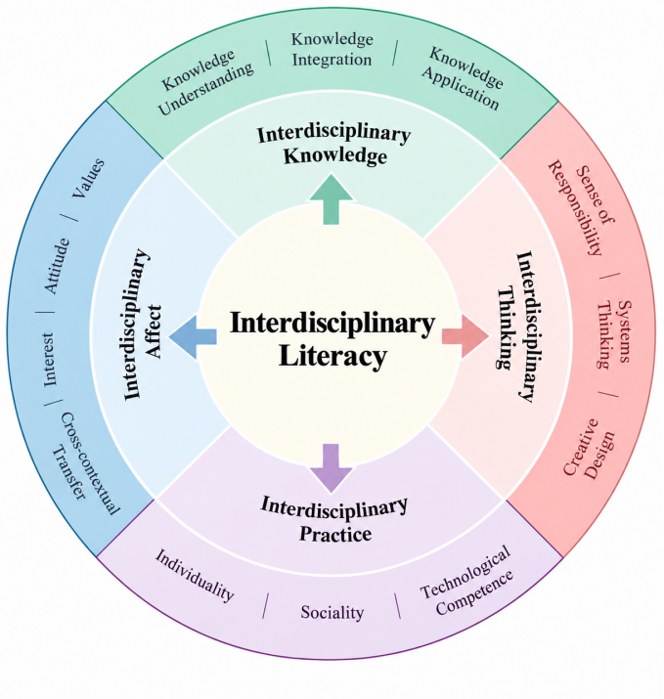
Figure 1. Four‑Dimensional Structural Model of Interdisciplinary Literacy.

4. Coupling mechanism and internal logic between design thinking and interdisciplinary literacy
4.1. Design thinking as the operating system for developing interdisciplinary literacy
Design thinking has triple attributes: a problem‑solving method, a metacognitive strategy and a knowledge‑integration framework. It acts as the core operating system driving the development of interdisciplinary literacy. Interdisciplinary literacy represents the objectives and content of literacy cultivation, while design thinking provides implementation paths and structured operational workflows for achieving such literacy. From the perspective of underlying conceptual logic, the human‑centered and real‑situation‑oriented core principles of design thinking are consistent with the essential requirements of interdisciplinary literacy. In terms of thinking features, design thinking itself breaks the cognitive limitations of single disciplines and emphasizes boundary breaking and multi‑party collaboration, which responds to the core demands of interdisciplinary literacy.

4.2. Intrinsic fit between the five stages of the EDIPT design‑thinking model and interdisciplinary literacy
The core objectives and practical requirements of each stage in the EDIPT design‑thinking model are highly consistent with the core elements of the four‑dimensional structure of interdisciplinary literacy.
The Empathize stage centers on the affect dimension. Relying on affective traits such as value recognition and social empathy, students transcend self‑cognitive limitations, integrate perceptual experience from multidisciplinary perspectives including sociology and psychology, and lay foundations for problem‑solving.
The Define stage highlights the role of the thinking dimension. By engaging in dialectical reflection, systems thinking and problem deconstruction competence, students analyze and synthesize diverse information obtained in the Empathize stage and accurately define the essence of problems.
The Ideate stage focuses on cross‑domain thinking such as creative design and correlative transfer. It drives the integration and application of knowledge and methods from different disciplines and stimulates the spirit of inquiry and research.
The Prototype stage takes the practice dimension as its practical core. Abstract schemes generated by integrating thinking and knowledge dimensions are transformed into concrete practical outputs with the aid of technical tools.
The Test stage is thinking‑driven and practice‑supported. In the process of trial‑and‑error optimization, students develop affect-related capacities, including emotion regulation, frustration tolerance and the spirit of inquiry. Categorical integration in the knowledge dimension keeps improving through practice, and coordinated development of four‑dimensional elements of interdisciplinary literacy is achieved.

5. Interdisciplinary practice based on design thinking: A case study of “self‑built PCR thermocycler”
Based on the EDIPT design‑thinking model, combined with the core literacy objectives of biology and interdisciplinary literacy cultivation goals, this study establishes an interdisciplinary teaching model for biology experiments characterized by design thinking. It contains five stages: Clarify themes and define objectives; Trace origins and adopt problem‑driven approaches; Knowledge transfer and brainstorming; Practical integration and instrument prototyping; Scheme innovation and iterative reflection ^{[8]} (see Figure 2).

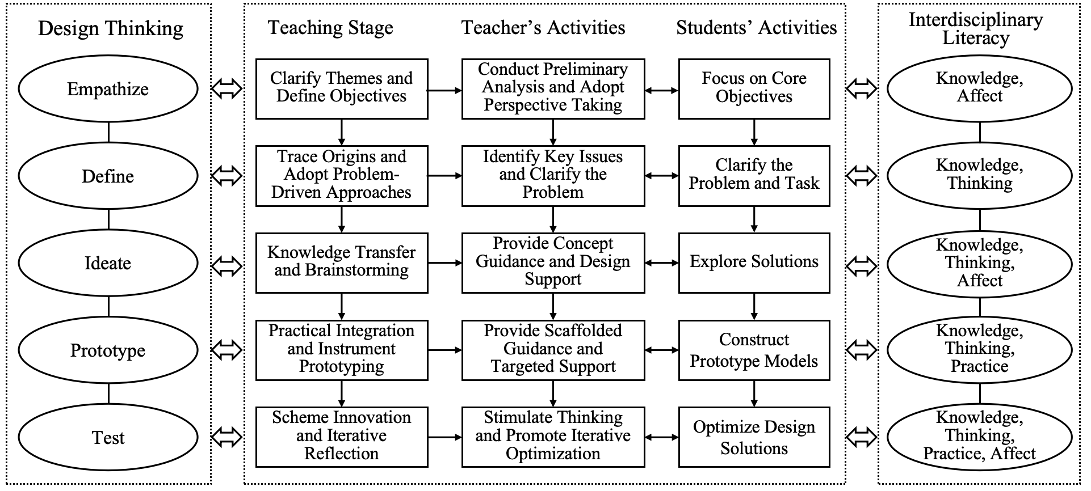
Figure 2. Interdisciplinary Teaching Model for Biology Experiments Based on the EDIPT Design‑Thinking Model.

The experiment “Amplification and Electrophoretic Identification of DNA Fragments” is included in the “Inquiry & Practice” section of Chapter 3, Section 2 in the Selective Compulsory Volume 3 Biotechnology and Engineering of the PEP senior high school biology textbook. The 2017 Edition (2025 Daily Revision) General High School Biology Curriculum Standards suggests “amplifying DNA fragments by Polymerase Chain Reaction (PCR) and completing electrophoretic identification” in teaching tips for this section, requiring students to master PCR technical principles, electrophoretic‑operation skills and result‑analysis methods. Due to complicated experimental preparation and high experimental costs, experimental‑video teaching or direct theoretical lecturing are often adopted in actual teaching, and inquiry‑based practice cannot be effectively carried out. This experiment serves as an excellent topic for interdisciplinary practice. By integrating design thinking into experimental teaching and enabling students to independently and collaboratively finish PCR‑instrument design, students can deepen their understanding of principles for DNA amplification and identification, and continuously develop interdisciplinary literacy in the process of exploring problem‑solving schemes.

5.1. Empathize with demands: Clarify themes and define objectives
Based on curriculum‑standard requirements and students’ cognitive reality, teachers set teaching objectives and the practical theme of “self‑built PCR thermocycler”. Taking the real‑world situation of “high costs and closed structures of commercial PCR thermocycler” as an entry point, teachers stimulate students’ inquiry interest and innovative motivation. Centering on the theme, students mobilize disciplinary knowledge such as principles of DNA replication and fundamentals of engineering instrument design, and complete preliminary integration of perceptual experience for interdisciplinary problems, achieving initial comprehension in the knowledge dimension. Meanwhile, by reflecting on questions such as “conditions for in‑vitro DNA replication” and “core functions of a self‑built PCR thermocycler”, students initially build awareness of connections among multidisciplinary knowledge, spark budding development in the thinking dimension, and clarify directions for subsequent practice‑dimension implementation.

5.2. Define problems: Trace origins and adopt problem‑driven approaches
Teachers guide students to break down the core task of “building a self-built PCR thermocycler” based on the analysis from the previous stage: first, the instrument design shall fulfill the core functions of PCR reactions, namely accurately achieving temperature cycling of denaturation above 90 °C, annealing at approximately 50 °C, and extension at around 72 °C, as well as enabling control over the number of cycles; second, the instrument structure shall balance safety, simplicity and practicality, adapt to senior high school laboratory conditions, and be easy to assemble and operate; third, students shall complete DNA fragment amplification using the self‑designed instrument, and verify instrument performance and amplification results through electrophoretic identification.
Guided by the above requirements, students further identify key problems to be solved: How to set temperature cycles for the PCR thermocycler? What electronic components or mechanical structures can realize its thermal‑cycling control? How can engineering‑structure design for the instrument balance uniform heating and easy operation? How to perform electrophoretic‑identification experiments for amplified DNA fragments? In this process, students conduct secondary sorting and categorical integration of multidisciplinary knowledge, promoting interdisciplinary knowledge from preliminary comprehension toward in‑depth integration. Meanwhile, they adopt dialectical reflection and problem decomposition to analyze and filter diverse information and accurately grasp problem essences.

5.3. Ideate solutions: Knowledge transfer and brainstorming
This stage constitutes a critical phase for breaking inertial thinking and applying design thinking, as well as an important part for exploring interdisciplinary solutions. Teachers guide students to diverge their thinking and conceive multiple schemes via brainstorming. For instance, in designing the “PCR‑instrument thermal‑control system”, students propose multiple feasible temperature‑control solutions: adopting a single‑chip microcomputer together with temperature sensors for precise temperature control; or building integrated circuits with small‑sized computers and sensing devices to monitor temperature data and make real‑time adjustments. Regarding temperature‑switching logic, students propose using timers to automatically control the duration of each thermal phase, or manually switching circuits to realize thermal cycles.
In the solution‑design process, teachers guide students to anticipate potential risks of proposed schemes, such as failed amplification caused by insufficient temperature‑control precision and low experimental efficiency due to slow heating‑and‑cooling rates. Students further think about coping strategies and finally determine preliminary instrument‑design schemes and corresponding experimental workflows through thinking collisions.

5.4. Prototype products: Practical integration and instrument prototyping
After discussing design solutions, students choose to build a single‑chip‑microcomputer‑based self‑built PCR thermocycler consisting of a control system, a thermal‑control system and a mechanical system (see Figure 3). The control system centered on the AT89S52 single‑chip microcomputer receives user instructions, controls motor driving, coordinates the work of each module, and manages operation logic for the PCR reaction device. The thermal‑control system consists of three water baths set to denaturation, annealing and extension temperatures respectively. Under instructions from the control system, the mechanical system rotates, rises and descends in chronological order to different water baths to complete heating, cooling and temperature‑holding procedures. After assembly, teachers guide students to conduct no‑load performance tests and check whether instrument operation meets expectations.

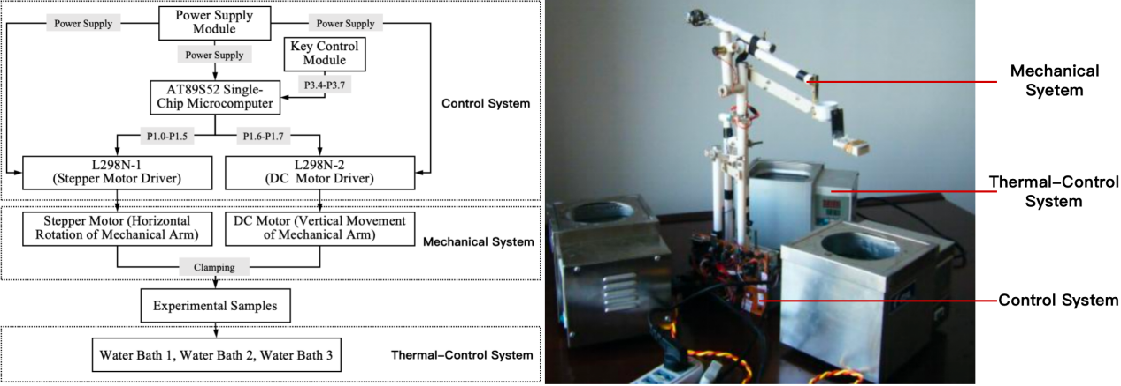
Figure 3. A Self‑Built PCR Thermocycler. Left: Block diagram of the control system for the PCR reaction device based on the AT89S52 single‑chip microcomputer; Right: Photograph of the self-built PCR thermocycler.

5.5. Test and iterate: Scheme innovation and iterative reflection
Teachers set comprehensive test indicators covering instrument thermal‑control precision, amplification effects and operational safety. Students perform DNA amplification and electrophoretic identification with the self‑built PCR thermocycler and submit instrument‑design reports. Electrophoretic results of amplified products from the self‑built PCR thermocycler (see Figure 4) show that clear target bands appear for products amplified by the commercial PCR thermocycler (A), as well as products amplified by the self‑built PCR thermocycler (B, C). Sample (B) is the experimental result with mineral oil added to the identical reaction system; sample (C) is the result without mineral oil. Amplification bands in (C) are relatively faint with fewer products, but do not affect result judgment for secondary school experimental teaching. The above results prove that the self‑built PCR thermocycler can basically realize in‑vitro PCR amplification and identification, yet improvements are still needed for reaction‑container structural sealing and other aspects. Based on experimental results, students adopt reflective‑critical and dialectical‑analytical capabilities to judge problem causes and iterate experimental schemes.

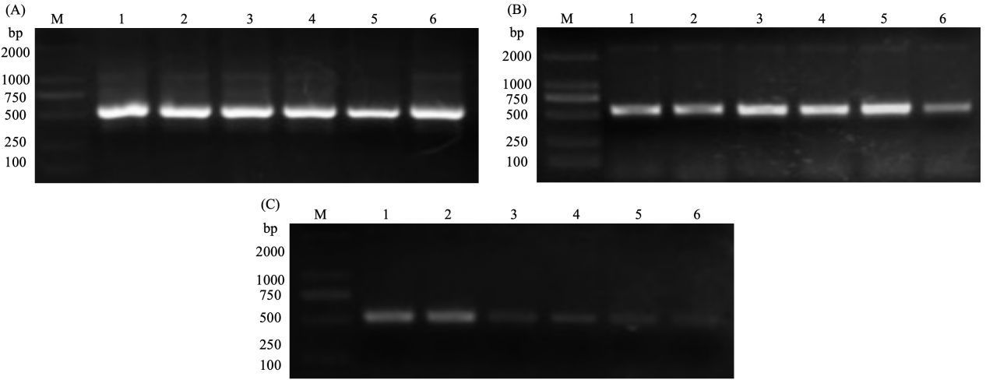
Figure 4. Electrophoretic Analysis of PCR Products Amplified Using Commercial Thermocycler and Self-built Thermocycler. Lane M: DNA marker; Lanes 1–6: PCR amplification products. (A) Products amplified with the commercial thermocycler. (B) Products amplified using the self-built thermocycler with mineral oil overlay. (C) Products amplified using the self-built thermocycler without mineral oil.

6. Conclusions and reflections
Targeting interdisciplinary‑literacy‑cultivation requirements for basic education, this study constructs an interdisciplinary teaching model for biology experiments based on the EDIPT design‑thinking model. Taking “self‑built PCR thermocycler” as the practical carrier, students finish solution design, product prototyping and functional testing for the PCR thermocycler. The self‑built instrument successfully achieves in‑vitro amplification of DNA fragments, and its electrophoretic outputs satisfy secondary school experimental teaching requirements. The feasibility of this teaching model is verified. Students transform from “instrument users” to “innovative designers”, and coordinated development is achieved across the four dimensions of interdisciplinary literacy: knowledge, thinking, practice and affect. In the future, the application scenarios of this model can be further expanded, cutting‑edge technologies can be integrated, instrument designs can be optimized, and diversified evaluation systems can be improved. Interdisciplinary learning can be promoted for regular implementation in basic education to lay solid foundations for cultivating innovation-oriented talents.

Funding
Postgraduate Teaching Reform Research Project of Central China Normal University (2021), “Exploration and Practice of PLC‑UCS Multi‑Level Integrated Training Model for Improving Master of Education Students’ Teaching‑Research Competence” (Project No.: 2021JG18)

Disclosure statement
The authors declare no conflict of interest.

References
[1] Zhang W, Li M, 2025, Real-World Dilemmas, Connotation Interpretation and Practical Paths of Interdisciplinary Thematic Learning. E-Education Research, 46(12): 19–25.
[2] Nie Z, Shi Y, Han X, et al., 2024, Systematic Reflections on Interdisciplinary Thematic-Learning Activity Design: Dilemmas and Strategies. China Educational Technology, (10): 94–102.
[3] Lin L, Shen S, 2016, Concept Connotation and Cultivation Strategies of Design Thinking. Modern Distance Education Research, (06): 18–25.
[4] Cheng L, 2023, Re-Affirming the Disciplinary Standpoint of Interdisciplinary Learning. Global Education Outlook, 52(03): 25–34.
[5] Zhang H, 2017, Interdisciplinary Learning: True-Meaning Discrimination and Practical Paths. Primary and Secondary School Management, (11): 21–24.
[6] Wu H, Tian L, 2023, Interdisciplinary Thematic Learning: Origin, Connotation and Implementation Suggestions. Global Education Outlook, 52(03): 35–47.
[7] Zhan Z, Ji Y, 2025, Phenomenological Interpretation of Interdisciplinary Literacy: Composition and Evaluation. E-Education Research, 46(07): 77–84.
[8] Shi J, Xie X, 2023, Teaching-Design Research for High-School-Biology Experiments Based on Design Thinking. Biology Teaching in Middle School, (17): 69–72.

Publisher’s note
Bio-Byword Scientific Publishing remains neutral with regard to jurisdictional claims in published maps and institutional affiliations.

