Application Research of Multidisciplinary Team New Media Rehabilitation Training for Elderly Patients Undergoing Hip Replacement Surgery
Yongwei Song¹†, Mingxing Zhao¹†, Xingguo Wang¹, Huili Deng²*
¹The First Affiliated Hospital, Zhejiang University School of Medicine, Liang Branch (The First People’s Hospital of Yuhang District, Hangzhou), Hangzhou 310000, Zhejiang, China
²Hangzhou Xixi Hospital Affiliated to Zhejiang University School of Medicine, Hangzhou 310000, Zhejiang, China
† These authors contributed equally to this work and share the first authorship.
*Corresponding author: Huili Deng, huili5944@sina.com

Copyright: © 2026 Author(s). This is an open-access article distributed under the terms of the Creative Commons Attribution License (CC BY 4.0), permitting distribution and reproduction in any medium, provided the original work is cited.

Abstract: Objective: To explore the application effect of multidisciplinary team combined with new media technology in the rehabilitation training of elderly patients undergoing hip arthroplasty. Dseign: A total of 100 patients with hip arthroplasty were divided into experimental group (Multi-disciplinary team cooperation, combined with new media technology) and the control group. The effectiveness of the model was evaluated by comparing the experimental group and the control group. Results: the results showed that the hip function, the incidence of complications and the recovery of balance function of the elderly patients who received the multidisciplinary team rehabilitation training were better than those of the control group. There were significant differences in hip function and balance function (p<0.05). Conclusion: The multidisciplinary team new media rehabilitation training has a positive significance for improving the rehabilitation effect of elderly patients undergoing hip arthroplasty.
Keywords: Multidisciplinary team, New media, Rehabilitation, Geriatrics, Hip replacement

Online publication:

1. Introduction
1.1. What is known
The incidence of femoral neck fracture and avascular necrosis of the femoral head in the elderly is increasing year by year,It need to provide more efficient and convenient rehabilitation services for elderly patients with hip replacement by integrating the advantages of multidisciplinary expertise and new media technology.

1.2. What is new
The application of multidisciplinary team new media rehabilitation training in elderly patients undergoing hip arthroplasty has yielded significant results. The model not only improves the rehabilitation effect and quality of life.
With the intensification of the aging trend of the population, the incidence of femoral neck fracture and avascular necrosis of the femoral head in the elderly is increasing year by year. Elderly patients often face multiple challenges during the rehabilitation process following hip arthroplasty^{[1,2]}. Although traditional rehabilitation training methods can promote patient recovery to some extent, they still suffer from issues such as poor patient compliance, difficulties in continuously monitoring and evaluating training effects. According to the Statistical Report on the Development of the Internet in China, as of June 2023, there are 136 million elderly Internet users aged 60 and above in China, and the Internet penetration rate has reached 46.2%. New media technology has the characteristics of fast information dissemination, wide coverage and strong interactivity, which can effectively make up for the shortcomings of traditional rehabilitation training methods and improve the rehabilitation effect and compliance of patients^{[3,4]}. In addition, multidisciplinary teamwork is becoming more and more widely used in the medical field. The multidisciplinary team is able to integrate expertise in different fields such as orthopedics, rehabilitation, nutrition, and psychology to provide patients with comprehensive and personalized rehabilitation guidance.According to related studies, multidisciplinary team cooperation can significantly improve the rehabilitation effect, shorten the rehabilitation time and reduce the incidence of complications^{[5]}. Therefore, this study aims to explore the effectiveness of multidisciplinary team-based new media rehabilitation training in elderly patients undergoing hip replacement. We hope to provide more efficient and convenient rehabilitation services for elderly patients with hip replacement by integrating the advantages of multidisciplinary expertise and new media technology^{[6]}. It provides a new rehabilitation model for clinical practice, improves the quality of rehabilitation and promotes the innovation and development of medical service. Specific experimental content is reported as follows.

2. Methods
2.1. General information
This study was approved by the Ethics Committee of our hospital. A total of 100 elderly THA patients were selected for treatment in our hospital after the project was established. 50 were included in the control group: 27 males and 23 females, aged 60-79 years, with a mean of (71.3±5.8) years, and 50 were included in the experimental group: 28 males and 22 females, aged 60-81 years, with a mean of (71.7±5.5) years. The control group was given conventional rehabilitation training, while the experimental group was selected with a variety of rehabilitation training modes on the basis of conventional rehabilitation training mode.

2.1.1. Inclusion criteria
(1) Age: Patients must be 60 years old or above.
(2) Type of surgery: Patients must have undergone hip arthroplasty, either total hip arthroplasty or partial hip arthroplasty.
(3) Rehabilitation stage: Patients must be in the postoperative rehabilitation stage and have the ability to participate in rehabilitation training.
(4) Health status: Patients must have stable vital signs, such as blood pressure and heart rate within the normal range, and no other serious health issues, such as heart disease or respiratory diseases, to ensure their safety during participation in rehabilitation training.
(5) Cognitive ability: Patients must have basic cognitive abilities to understand and follow rehabilitation training instructions.
(6) Consent to participate in the study: Patients or their legal guardians must agree to participate in the study and sign the relevant informed consent form.
(7) New media access ability: Considering the characteristics of new media rehabilitation training, patients must have basic ability to use new media devices (such as tablets, smartphones, etc.).
(8) All surgeries were performed by the same group of experienced surgeons. Patients included in the study will complete a hip arthroplasty information form.

2.1.2. Exclusion criteria
(1) Long-term bed rest before surgery: For patients who have been bedridden for a long time before surgery, they may already have problems such as muscle atrophy and osteoporosis, which may affect the effectiveness and safety of rehabilitation training.
(2) Combined malignant tumors: Patients with malignant tumors are usually in poor physical condition and may not be able to withstand the pressure of rehabilitation training, and the treatment of malignant tumors may also conflict with rehabilitation training.
(3) Severe heart, brain, and nervous system diseases: These diseases may affect the patient’s motor ability, cognitive ability, and rehabilitation potential, making them unable to fully participate in rehabilitation training.
(4) Inability to use new media devices: Considering that the study involves new media rehabilitation training, patients who are unable to use new media devices (such as smartphones, etc.) will not be able to carry out relevant rehabilitation training.
(5) Cognitive impairment or inability to understand research requirements: Patients with cognitive impairment or who are unable to understand the research requirements may not be able to participate in rehabilitation training correctly and may also be unable to provide accurate data and feedback needed for the study.
(6) Other serious health issues: Severe respiratory diseases, liver and kidney dysfunction, and other such conditions may affect a patient's rehabilitation potential and safety.

3. Study design
3.1. The conventional group adopts the traditional rehabilitation mode
Including systematic testing, including pulse, heart rate, etc., and give the patient correct medication guidance, preventive measures for complications, etc., give correct dietary guidance, correct bad eating habits, and carry out routine rehabilitation guidance; postoperative routine functional rehabilitation training, including ankle pump exercise, muscle strength training, dressing change and medication guidance, health education, complication prevention and control, etc.postoperative 3D bed under the walker weight-bearing walking, discharge within 1 week, if the patient has obvious activity discomfort or severe hip pain, timely medical treatment.

3.2. Implementation and recording of the new media rehabilitation training model
The new media rehabilitation training model was adopted in the experimental group on the basis of the routine group, and the nursing staff made the records. See Figure 1 and Figure 2 for details.
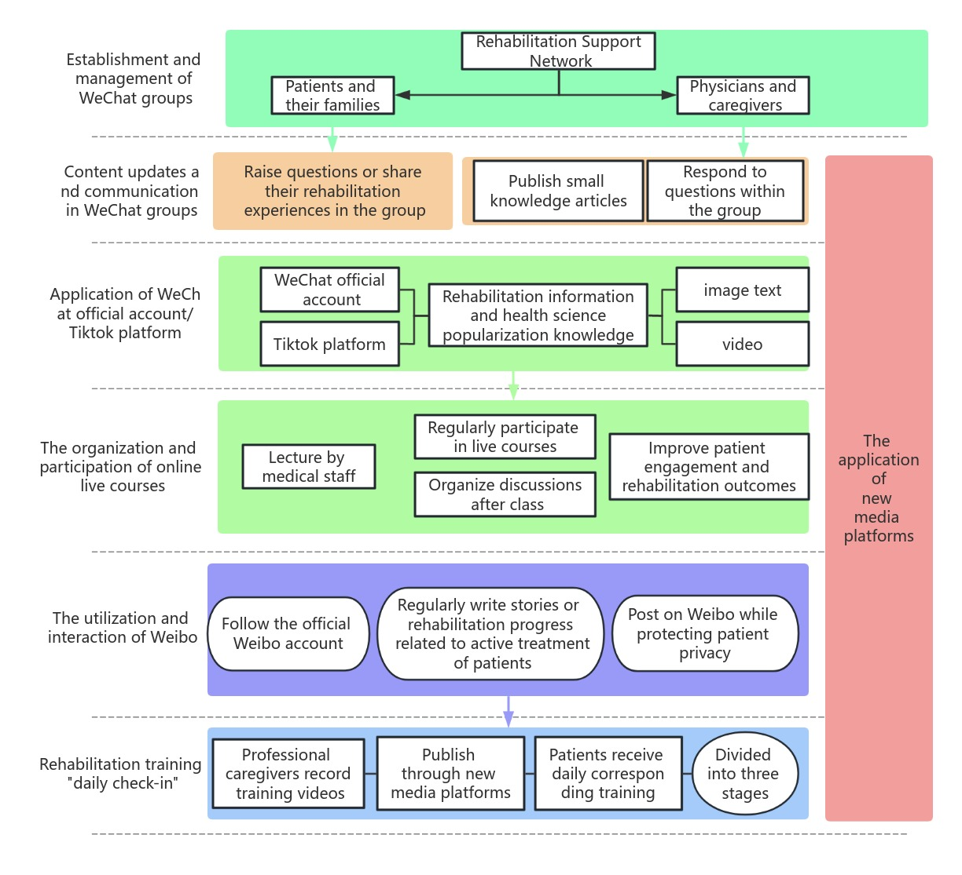
Figure 1. The intervention mode of the experimental group

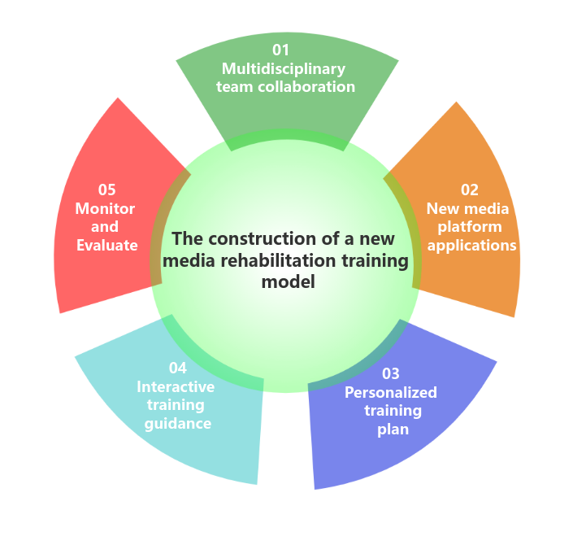
Figure 2. The construction of a new media rehabilitation training model

3.2.1. Establishment and management of WeChat groups
The group was is established by the doctors and nurses ensures the professionalism and activity of its members to provide timely and accurate rehabilitation guidance to patients. Patients and their families in the experimental group are gradually invited to join the group, forming a close rehabilitation support network.

3.2.2. Content update and communication in the WeChat group
In the WeChat group, three articles related to postoperative health care are published every day, covering rehabilitation skills, nutritional advice, psychological adjustment, etc.

3.2.3. Application of WeChat public account/Douyin platform
These contents are presented in the form of pictures, texts and videos, which are more vivid and intuitive, and are easy for patients and their families to understand and learn.

3.2.4. Organization and participation in online live streaming courses
To provide more in-depth guidance on rehabilitation training for patients and their families, online live streaming courses are also organized.

3.2.5. Utilization and interaction of microblogging
In addition, information dissemination and interaction are carried out through microblogging, a social media platform. Patients and their families are asked to follow the official Weibo account, and physicians will regularly write stories about the patient's active treatment or recovery progress, and post them on Weibo on the premise of protecting the patient’s privacy. In this way, other patients are encouraged to read and learn, creating a good atmosphere for recovery.

3.2.6. “Daily check-in” of rehabilitation training
First of all, the professional nurses in our department are responsible for recording the rehabilitation training video.These video contents are carefully designed according to the rehabilitation stage and needs of the patients to ensure that they can safely and effectively perform the training at home. A detailed phased training plan was developed for the rehabilitation needs of elderly hip arthroplasty patients. In the first stage (1-2 days after surgery), patients are mainly instructed to carry out active training, such as ankle plantar flexion and dorsal extension exercises, gluteal muscle contraction exercises, quadriceps training, etc., to help patients recover basic muscle function as soon as possible.In the second stage (3-4 days after surgery), the training content gradually transitions to exercises such as straight leg raising, hip lifting, etc., to strengthen the core muscle strength of the patient. By the third stage (5-7 days after surgery), the patient begins to practice seated balance, sitting to standing, standing balance, walking, and other exercises, laying the foundation for future walking ability recovery. During rehabilitation, patient tolerance is crucial. At the same time, through the interaction and communication of new media platforms, we can better understand the needs and feedback of patients, and continuously optimize and improve our rehabilitation training program.

3.3. Observation indicators
3.3.1. Hip function assessment
Hip function assessment is to observe the recovery and functional performance of the hip joint after surgery^{[7]}. The condition of the hip joint at different time points was systematically and quantitatively evaluated by using the Harris Artificial Hip Function Rating Scale. The assessment time points included discharge, 1 month postoperatively, 3 months postoperatively, and 6 months postoperatively. This scale covers four main areas: hip deformity, range of motion, functional mobility, and pain. The maximum score for each item is 25 points, and the total score is 100 points. A higher score means that the patient has better hip function recovery, less pain, higher range of motion, and better overall performance.

3.3.2. Incidence of complications
After surgery, detailed records were kept of possible complications that patients may experience, particularly common complications such as bedsores, deep vein thrombosis (DVT) of the lower extremities, and wound infection^{[8,9]}. These complications not only affect the speed of patient recovery but may also pose a threat to the overall health of the patient. By recording and comparing the incidence of complications between the two patient groups, the effectiveness of the multidisciplinary team’s new media rehabilitation training in reducing these risks was assessed.

3.3.3. Assessment of balance function
Balance function is an area of special concern for older patients after hip replacement surgery. In order to quantitatively assess the balance ability of patients, the Berg Balance Scale (BBS) was used before intervention, at the 4th week of intervention and at 8th week of intervention. The scale consists of 14 items, each of which is scored on a scale of 0 to 4 based on the patient’s performance, with a total of five levels out of 56. This assessment not only helps the physician understand the patient's balance ability, but also guides the adjustment of rehabilitation exercises to help the patient return to balance function more quickly^{[10]}.

3.4. Statistical methods
In this study, SPSS 25.0 statistical software was used for data analysis, and the continuous data were expressed as mean ± standard deviation (± s), and the t-test was used for comparison between groups, and the difference was statistically significant at P<0.05.

4. Results
4.1. Hip function comparison
After comparative analysis, the Harris hip score of the experimental group was higher than that of the control group before surgery, 3 months after surgery, and 6 months after surgery, and the difference was statistically significant. At the same time, the joint mobility and functional mobility of the patients in the experimental group were also significantly better than those in the control group. See Table 1 for details.

Table 1. Comparison of hip function between the two groups
Constituencies | Malformation |  |  | Pain |  |  | Range of motion |  |  | Functional activities
Constituencies | Preoperatively | 3 months postoperatively | 6 months postoperatively | Preoperatively | 3 months postoperatively | 6 months postoperatively | Preoperatively | 3 months postoperatively | 6 months postoperatively | Preoperatively | 3 months postoperatively | 6 months postoperatively
Experimental  (n=60) | 2.15±0.27 | 3.43±  0.37* | 3.87±  0.15*# | 21.21±3.85 | 32.13±2.27* | 42.15±0.19*# | 2.28±  0.343. | 34±0.46* | 4.43±  0.76*# | 15.87±2.033 | 2.12±  4.17*4 | 2.13±  4.12*#
Control (n=60) | 2.13±  0.35 | 3.47±  0.28* | 3.85±  0.18*# | 20.25±3.93 | 32.69±2.05* | 41.11±  0.18*# | 2.13±  0.32 | 2.18±  0.39* | 4.18±  0.81*# | 16.20±2.09 | 29.63±  3.62* | 40.21±  3.64*#
t-value | 0.345 | 0.145 | 0.845 | 0.018 | 0.714 | 1.776 | 1.789 | 2.455 | 2.016 | 0.261 | 2.624 | 2.091
P-value | 0.658 | 0.897 | 0.432 | 0.932 | 0.467 | 0.278 | 0.074 | 0.012 | 0.039 | 0.825 | 0.010 | 0.039
Note: Compared with the same group before surgery, *P<0.05: compared with the same group 3 months after surgery, #P< 0.05.

4.2. Comparison of complication rates
The results showed that the incidence of postoperative complications in the experimental group was lower than that in the control group, and the difference was statistically significant. Specifically, the incidence of complications including bedsores, lower extremity venous thrombosis (DVT) and wound infections in the experimental group was significantly lower than that in the control group. See Table 2 for details.

Table 2. Comparison of complication rates between the two groups[n(%)]
Constituencies | Number of examples | Venous thrombosis of the lower extremities | Pressure sore | Wound infection | Total incidence
Experimental group | 50 | 0(0.00) | 2(4.00) | 0(0.00) | 2(4.00)
Control group | 50 | 1(2.00) | 3(8.00) | 1(2.00) | 5(10.00)
χ² value  P-value |  |  |  |  | 2.205  0.138

4.3. Comparison of balance functions
The results showed that the balance function scores of the experimental group were higher than those of the control group before the intervention and at 6 months of intervention, and the difference was statistically significant. Specifically, patients in the experimental group scored higher on the BBS scale, indicating that they had better balance in different activity scenarios. See Table 3 for details.

Table 3. Comparison of balance function between the two groups
Projects | Pre-intervention |  |  |  | Post-intervention
Projects | Control | Experimental | t | P | Control | Experimental | t | P
Rise from one’s seat | 1.34±  0.13 | 1.31±  0.15 | 1.375 | 0.179 | 3,49±  0.27* | 3.60±  0.30# | 2.314 | 0.021
Standing unsupported | 1.62±  0.14 | 1.70±  0.15 | 0.778 | 0.435 | 3.80±0.37* | 3.93±0.41# | 1.988 | 0.047
No backrest seat, but feet on the ground or on a stool | 1.59±  0.16 | 1.58±  0.17 | 0.324 | 0.751 | 3.67±  0.33* | 3.79±  0.41# | 2.048 | 0.043
Sit down from a standing position | 1.11±  0.15 | 1.08±0.14 | 1.312 | 0.189 | 3.22±  0.26* | 3.37±  0.31# | 3.272 | 0.001
Transfer | 1.35±  0.12 | 1.38±0.18 | 1.041 | 0.311 | 3,53±  0.31* | 3.64±  0.34# | 2.025 | 0,047
Stand with eyes closed without support | 1.16±  0.12 | 1.19±  0.12 | 1.312 | 0.191 | 3.42±  0.25* | 3.54±  0.24# | 2.718 | 0.006
Stand unsupported with feet together | 1.49±  0.13 | 1.47±0.17 | 0.758 | 0.452 | 3.52±  0.28* | 3.67±  0.29# | 3.102 | 0.003
The upper limbs are extended and moved forward in the standing position | 1.37±  0.15 | 1.39±0.13 | 0.811 | 0.423 | 3.45±  0.27* | 3.59±  0.28# | 3.000 | 0.002
Pick up objects from the ground while standing | 1.32±  0.11 | 1.31±0.17 | 0.542 | 0.587 | 3.47±  0.25* | 3.58±  0.21# | 2.810 | 0.007
Standing position turn and look behind you | 1.38±  0.12 | 1.37±  0.11 | 0.335 | 0.741 | 3.48±  0.30* | 3.67±  0.32# | 3.610 | <0.001
Turn 360° | 1.29±  0.13 | 1.27±  0.19 | 0.767 | 0.450 | 3.26±  0.25* | 3.39±  0.28# | 2.886 | 0.005
Place one foot on a step or stool while standing unsupported | 0.98±  0.13 | 0.96±  0.07 | 1.181 | 0.242 | 3.16±  0.20* | 3.28±  0.22# | 3.363 | <0.001
Standing unsupported with one foot in front | 1.29±  0.14 | 1.27±  0.14 | 0.939 | 0.348 | 3.46±  0.24* | 3.59±  0.26# | 3.062 | 0.004
On one leg | 0.78±  0.08 | 0.76±  0.12 | 1.241 | 0.218 | 3.04±  0.18* | 3.21±  0.16# | 5.887 | <0.001
Berg Balance Scale | 18.17±  1.52 | 18.04±  1.45 | 0.512 | 0.609 | 47.97±  3.25* | 49.85±  2.84# | 3.633 | <0.001
Note: *P<0.05, compared with the control group before intervention; #P<0.05, compared with the experimental group before intervention.

5. Discussion
5.1. Construction of new media rehabilitation training model
The new media rehabilitation training model, based on modern information technology and new media platforms, deeply integrates professional knowledge from multiple disciplines to provide personalized and interactive rehabilitation training services for elderly patients undergoing hip arthroplasty. This model not only embodies the interdisciplinary collaboration concept of modern medicine, but also optimizes the rehabilitation experience of patients through the introduction of technology^{[11,12]}.
The new media platform provides an interactive training guide for the new media rehabilitation training mode. Patients can interact with trainers in real time through the platform, ask questions, share training experiences, etc. This interactive approach enables patients to have a deeper understanding of the importance and skills of rehabilitation training, while enhancing their enthusiasm and initiative to participate in rehabilitation training^{[13,14]}. The trainer can give timely feedback and guidance according to the specific situation of the patient, help them correct the wrong training posture and method, and ensure the correctness and effectiveness of the training. This interactive training guide not only significantly improves the effect of rehabilitation training, but also further enhances the trust and communication between patients and trainers.
In this study, WeChat Group has become an important communication platform. Patients or family members have any questions or confusion can be directly raised in the group, doctors and nurses will give timely answers and guidance. This immediate feedback mechanism not only solves the problems that patients may encounter during their recovery, but also makes them feel the care and support of the medical team. This new rehabilitation training model undoubtedly brings patients a more comprehensive and personalized rehabilitation experience.
Monitoring and evaluation are an indispensable part of the new media rehabilitation training model^{[15]}. Collect patient training data through new media platforms and conduct real-time monitoring and evaluation. Based on these data, trainers can adjust their training plans in a timely manner and provide personalized guidance according to the actual situation of patients. This continuous monitoring and evaluation not only improves the scientific and effective nature of rehabilitation training, but also provides patients with more comprehensive and personalized rehabilitation services.
In this study, the role of monitoring and evaluation is particularly prominent in the“Daily check-in” of rehabilitation training. Monitoring and evaluation play a vital role in rehabilitation training. Through the daily punching in this specific way, not only can improve the scientific and effective rehabilitation training, but also provide patients with more comprehensive and personalized rehabilitation services. This is of great significance for promoting the rehabilitation process of patients and improving the quality of life.
In summary, the new media rehabilitation training model has broad application prospects and important practical value in the rehabilitation process of elderly patients with hip replacement.

5.2. Improvement of rehabilitation effectiveness
THA can cause certain degrees of damage to the patient's muscles, tendons, ligaments, and affect the coordinated movement and balance of the hip joint, increasing the risk of falls in patients^{[16,17]}. This study showed that the postoperative Berg balance scale scores of THA (total hip replacement) patients who received new media rehabilitation training mode were significantly higher than those of the control group (P<0.05). This result proves the effectiveness of multidisciplinary teams combined with new media technology mode in improving postoperative balance ability of THA patients.
The rehabilitation team carefully plans and adjusts the training content, training time and training intensity according to the actual conditions of the patients in the early rehabilitation stage to ensure that the progress of rehabilitation is scientific and reasonable^{[18]}. The training covers a variety of balance training factors from static to dynamic transition, back and forth switching of the body's center of gravity, change of walking direction, and reduction of hip support area.
In summary, the new media rehabilitation training model has performed well in the rehabilitation training of THA patients.

5.3. New media rehabilitation training mode improves hip function after operation
The results of this study showed that the hip function scores of the patients with the new media rehabilitation training mode were significantly higher than those of the control group with the traditional rehabilitation training mode, it shows that the new media rehabilitation training model has a significant advantage in improving hip function after THA.The source of this advantage is mainly due to the unique design and implementation of the new media rehabilitation training model. In the early stage of rehabilitation, the model provides patients with periodic and simple rhythmic movement guidance such as sitting, standing and foot training through new media platforms, such as mobile phone apps and online videos. The new media rehabilitation training model can be adjusted and optimized at any time based on the specific conditions and rehabilitation progress of individual patients, ensuring that each patient receives the most suitable rehabilitation training. This personalized training model not only helps accelerate the rehabilitation process of patients but also reduces complications and discomfort during recovery.
In conclusion, the new media rehabilitation training model has significant advantages in improving hip function in THA patients after surgery.

5.4. New media rehabilitation training model reduces the occurrence of complications
Infection is one of the most serious postoperative complications, which can lead to surgical failure and the need for joint reimplantation. Thrombosis and detachment may lead to deep vein thrombosis or pulmonary embolism, which can be life-threatening in severe cases^{[19,20]}. Joint dislocation is usually caused by improper surgical operation or improper postoperative rehabilitation training. Loose or worn prostheses may be caused by poor surgical techniques, improper selection of prostheses, or patient factors.After THA surgery, timely complication prevention and management is very important. The rehabilitation intervention mode of multidisciplinary team combined with new media technology has certain advantages in the prevention and treatment of postoperative complications. Through personalized rehabilitation plan, scientific and rigorous training program and diversified training content, the risk of postoperative complications can be effectively reduced and the rapid recovery of patients can be promoted. THA patients who received the new media rehabilitation training mode showed a lower incidence of postoperative complications, especially the incidence of lower limb venous thrombosis and hypostatic pneumonia was significantly reduced. This positive outcome is likely to be closely related to patients getting out of bed at an early stage and actively cooperating with rehabilitation training.However, the difference in the total incidence of complications between the two groups in this study did not reach statistical significance, which may be related to the small overall sample size of the study. A small sample size may limit the stability and reliability of the results, making it difficult to detect small differences between the two groups. In addition, the overall follow-up time of this study was relatively short, and it may not have been possible to fully observe all the complications. Some potential complications may only become apparent during long-term follow-up, so short-term research results may not be sufficient to fully reflect the true situation of complications.
In order to make up for these shortcomings, future research needs to further expand the sample size to improve the stability and reliability of the results. Meanwhile, it is necessary to extend the follow-up time in order to have a more comprehensive understanding of the occurrence of postoperative complications.

5.5. Challenges and prospects
Although the multidisciplinary team new media rehabilitation training model has shown great potential and advantages in the rehabilitation of elderly patients undergoing hip replacement surgery, the challenges it faces must also be addressed in practical applications. Firstly, information security and patient privacy protection are issues that cannot be ignored on new media platforms. In the process of collecting, transmitting, and using patient information, it is necessary to strictly comply with relevant laws and regulations to ensure that patient privacy is protected to the greatest extent possible. At the same time, the technical security and stability of the platform are also crucial to prevent unexpected situations such as data leaks or platform crashes. Secondly, the efficiency and effectiveness of multidisciplinary team collaboration also need to be continuously improved. This involves multiple aspects such as communication and coordination among team members, complementarity of professional knowledge and skills, etc. To achieve more efficient collaboration, regular team building activities and professional training can be considered to enhance the understanding and cooperation among team members.
To sum up, the application of new media rehabilitation training mode of multidisciplinary team in elderly patients with hip replacement has important practical significance and value. Through the application of this model, it is expected to improve the rehabilitation effect and life quality of elderly patients, and promote the innovation and development of medical services. At the same time, it is also necessary to constantly sum up the experience and lessons, improve the shortcomings of this model, and provide more scientific and effective guidance for future clinical application.

6. Conclusion
After a series of in-depth research and practical applications, the following conclusions have been drawn regarding the application of multidisciplinary team new media rehabilitation training in elderly patients undergoing hip replacement surgery:
On the one hand, through the integration of multidisciplinary expertise and technology, combined with the interaction and convenience of new media, personalized rehabilitation training programs are provided for elderly patients with hip replacement, which significantly improves the rehabilitation effect of patients. Patients showed significant improvements in strength, balance, and gait, which improved their quality of life. On the other hand, through interactive training guidance and real-time feedback, the new media rehabilitation training mode not only enhances the rehabilitation motivation of patients, but also improves the rehabilitation experience of patients. Patients can more easily understand their training status, communicate with the medical team in real time, and adjust the training plan in time, making the rehabilitation process smoother and more enjoyable. In addition, the new media platform has been used to achieve tele-rehabilitation training guidance and monitoring and evaluation, reducing the frequency and time of patients to receive on-site training in the hospital, thus optimizing the utilization of medical resources. This not only alleviates the tension of medical resources, but also provides patients with more convenient and efficient rehabilitation services. However, although the multi-disciplinary team new media rehabilitation training model shows great potential in the rehabilitation of elderly hip replacement patients, it still faces some challenges, such as information security, patient privacy protection, technology update and maintenance. In the future, it is necessary to further strengthen technology research and development and innovation, and improve the rehabilitation training model and process to ensure its wide application and sustainable development in clinical practice.
In conclusion, the application of multidisciplinary team new media rehabilitation training in elderly patients undergoing hip arthroplasty has yielded significant results. The model not only improves the rehabilitation effect and quality of life, but also optimizes the allocation of medical resources and the rehabilitation experience of patients. Although there are still some challenges, it is believed that this model of rehabilitation training will play a greater role in clinical practice in the future with the development of technology.

Disclosure statement
The authors declare no conflict of interest.

References
[1] Yu L, Cheng H, Qin Y, et al., 2026, Four Night Eating Behavior Subtypes in Young and Middle-aged Adults with Type 2 Diabetes: Insights for Targeted Public Health Interventions. Front Public Health,14:1718149.
[2] Zhu L, Li L, Yin B, et al, 2021, Effect of Continuous Nursing Combined with Salcatonin on Postoperative Pains in Elderly Patients After Hip Replacement, American Journal of Translational Research, 13(5):5264-5271.
[3] Zhang B, Meng H, Zhang H, et al., 2024, Influencing Factors of Chronic Pain after Total Knee Replacement in Osteoarthritis Patients: A Nomogram Prediction Model. Am J Transl Res,16(9):4479-4491.
[4] Shan L, Shan B, Graham D, et al., 2014, Total Hip Replacement: A Systematic Review and Meta-analysis on Mid-term Quality of Life, Osteoarthritis and Cartilage, 22(3), 389-406.
[5] Mengrong H, Yufang Y, Yefen W, et al., 2019, Perioperative Nursing Strategy and its Improvement Effect on Prognosis in Elderly Patients with Femoral Neck Fracture Undergoing Artificial Hip Replacement, China Modern Doctor, 26(12), 2080-2091.
[6] Dai Y, Xi Y, Chen X, et al., 2018, Treatment of Avascular Necrosis of Femoral Head in Patients with Human Immunodeficiency Virus Infection by Cementless Total Hip Arthroplasty, Chinese Journal of Reparative and Reconstructive Surgery, 32(12), 1507-1511.
[7] Li F, Zhu L, Geng Y, et al, 2021, Effect of Hip Replacement Surgery on Clinical Efficacy, VAS Score and Harris Hip Score in Patients with Femoral Head Necrosis, American Journal of Translational Research, 13(4):3851-3855.
[8] Zhou Y, Bao Y, Kan Y, et al., 2025, Evaluation of Early Rehabilitation Intervention-based Nursing Care in Total Knee Arthroplasty. Medicine (Baltimore),104(32):e43319.
[9] Zheng Y, Huang Z, Dai L, et al., 2022, The Effect of Preoperative Rehabilitation Training on the Early Recovery of Joint Function after Artificial Total Knee Arthroplasty and Its Effect Evaluation. J Healthc Eng, 3860991.
[10] Zou L, Zheng X, Wang C, et al., 2025, Factors Associated with Constipation after Total Hip Arthroplasty and Nursing Countermeasures, Medicine (Baltimore),104(42):e45226.
[11] Shi Z, 2020, Effect of Stage Nursing on Complications and Quality of Life of Patients with Pituitary Tumor Resection, Nursing Practice and Research,17(15):94-96.
[12] Carkci E, Polat AE, Ozturkmen Y, et al., 2021, Long-term Results of Total Hip Arthroplasty Performed Using a Cementless Expansive Acetabular Cup and Spotorno Femoral Stem, Pak JMed Sci,37(1):52-58.
[13] Stmart JP, Goh EL, Shah Z, et al., 2020, Robotics in Total Hip Ar-throplasty: A Review of the Evolution, Application and Evidence Base, EFORT Open Rev, 5(12):866-873.
[14] Snell DL, Jerram KAS, Dunn JA, et al., 2020, Use of Rehabili-tation After Hip and Knee Replacement in New Zealand: A Nationalsurvey, N Z Med J, 133(1510):45-55.
[15] Ritter S, Dannenmaier J, Jankowiak S, et al., 2018, Total Hip and Knee Arthroplasty-utilization of Postoperative Rehabilitation Rehabilitation(Stuttg), 57(4):248-255.
[16] Klein GR, Posner JM, Levine HB, et al., 2017, Same Day Total Hip Arthroplasty Performed at an Ambulatory Surgical Center:90-day Complication Rate on 549 Patients, J Arthroplasty, 32(4):1103-1106.
[17] Colibazzi V, Coladonato A, Zanazzo M, et al., 2020, Evidence Based Rehabilitation After Hip Arthroplasty. Hip International : The Journal of Clinical and Experimental Research on Hip Pathology and Therapy, 30(2_suppl), 20-29.
[18] Snell DL, Hipango J, Sinnott KA. et al., 2018, Rehabilitation After Total Joint Replacement: A Scoping Study, Disabil Rehabil, 40(14):1718-1731.
[19] Naylor JM, Frost S, Farrugia M, et al, 2021, Patient Factors Associated with Referral to Inpatient Rehabilitation Following Knee or Hip Arthroplasty in a Public Sector Cohort: A Prognostic Factor Study, Journal of Evaluation in Clinical Practice, 27(4), 809-816.
[20] Mousley JJ, Gill SD, Page RS, 2023, Rehabilitation for Total Shoulder Replacement: An Australian Perspective, ANZ Journal of Surgery, 93(6):1471-1473.

Publisher’s note
Bio-Byword Scientific Publishing remains neutral with regard to jurisdictional claims in published maps and institutional affiliations

