CRISPR/Cas9 Editing of miR-146a Suppresses Immobilization-induced Muscle Atrophy
Lu Li¹†, Xiang Gao²†, Hui Wan¹, Li Qiao¹, Xiao Xu¹, Yuxin Yan¹, Jiahao Yao¹, Jiayu Bai¹, Zhirong Xia³, Shuai Miao¹*
¹Department of Orthopaedic Surgery, Haishu People’s Hospital, Ningbo315010, Zhejiang, China
²Department of Orthopedics Surgery, Hangzhou First People’s Hospital, Hangzhou 310000, Zhejiang, China
³Department of Rehabilitation Medicine, Yuyao Fourth People’s Hospital, Ningbo 315010, Zhejiang, China
† These authors contributed equally to this work and share the first authorship.
*Corresponding author: Shuai Miao, m15558239208_1@163.com

Copyright: © 2026 Author(s). This is an open-access article distributed under the terms of the Creative Commons Attribution License (CC BY 4.0), permitting distribution and reproduction in any medium, provided the original work is cited.

Abstract: Immobilization-induced muscle wasting is notoriously hard to counter pharmacologically. We tested whether CRISPR-mediated knockdown of miR-146a could offer protection and asked what might explain such an effect. Four sgRNAs were designed against the mouse miR-146a precursor; the best performer (lentiCRISPR miR-146a-3#), which gave ~80% cleavage in T7EI assays, was packaged into lentivirus. Forty C57BL/6 mice were randomly assigned to receive either this editing construct or a control vector, then underwent sham surgery or hindlimb immobilization. Western blotting confirmed Cas9 expression, and qPCR verified miR-146a reduction. In immobilized mice, miR-146a rose markedly, accompanied by elevated Atrogin-1 and MuRF-1 mRNAs, reduced myofiber cross-sectional area, and diminished p-mTOR and p-Akt signals. By contrast, animals given the miR-146a-editing virus showed lower atrogene expression, larger fibers, and restored mTOR/Akt phosphorylation. These results suggest that CRISPR-based miR-146a ablation mitigates disuse atrophy, and this benefit appears to be linked to reactivation of the mTOR/Akt anabolic pathway.
Keywords: CRISPR/Cas9; miR-146a; muscle atrophy; mTOR/Akt signaling

Online publication:

1. Introduction
Skeletal muscle is the body’s heaviest organ, accounting for about 40% of adult weight. But calling it just a motor for movement misses the point—it holds up the skeleton, keeps us upright, produces heat, and plays an active part in glucose and fat metabolism ^{[1]}. When muscle mass declines, the consequences go far beyond weakness. Metabolism suffers, insulin resistance creeps in, and a vicious cycle takes hold that is notoriously difficult to break ^{[2]}.
Atrophy—the shrinking and weakening of muscle—can arise from many causes: ageing, nerve damage, poor nutrition, or simply not using the limbs. In the elderly, sarcopenia gets much attention, rightly so. But in orthopaedic wards, immobilisation after fractures, ligament repairs, or joint surgeries is just as problematic. A cast or external fixator may be essential for bone healing, yet the price is often severe muscle wasting in the affected limb. Rehabilitation drags on, and sometimes strength never fully returns ^{[3]}. What actually happens inside the muscle? Myofibres shrink, their nuclei decrease in number, protein synthesis slows down, and degradative systems—especially the ubiquitin-proteasome and autophagy-lysosome pathways—become overactive ^{[4–6]}. Contractile proteins are lost in large amounts. After all these years, we still have no reliable drug to stop this process, and our understanding of what drives it remains incomplete.
MicroRNAs are short non-coding transcripts, around 22 nucleotides long, that fine-tune gene expression by pairing with target messenger RNAs, usually at the 3′ UTR, leading to mRNA decay or translation blockade ^{[7]}. When miRNAs go awry, they contribute to cancers, heart disease, neurodegeneration, and metabolic disorders ^{[8,9]}. In muscle, the well-studied myomiRs—miR-1, miR-133, and miR-206—govern differentiation and regeneration ^{[10,11]}. Yet muscle contains many other miRNAs whose jobs are still obscure. Take miR-146a. Immunologists know it well as a brake on inflammatory signalling, but lately it has turned up in myoblasts and mature fibres, raising the possibility that it does something in muscle repair or disease. What we do not know is whether miR-146a changes during disuse atrophy, whether it helps or hurts, and through which pathways. That is exactly what we set out to answer.
CRISPR/Cas9 has changed how we do functional genetics. It can knock out or modify protein-coding genes, but it also works nicely for disrupting non-coding sequences, miRNA hairpins included ^{[12–14]}. Compared with transient inhibitors or sponges, CRISPR gives permanent knockout, wiping out all activity of the target miRNA and sidestepping the instability and off-target headaches that plague oligonucleotide strategies ^{[15,16]}. For probing miRNA function in living animals under disease-like conditions, this is hard to beat.
With that in mind, we built a lentiviral CRISPR construct to edit miR-146a specifically in mouse gastrocnemius, then immobilised the hindlimb to model clinical disuse. We wanted to know: (1) does immobilisation alter miR-146a expression? (2) does knocking it down protect the muscle from atrophy? and (3) what signalling changes accompany any such protection? We expect the answers will shed light on miR-146a’s role in muscle wasting and maybe point towards new treatment ideas.

2.Materials and methods
2.1. Experimental animals and grouping
Forty healthy male C57BL/6 mice (28–30 g, Shanghai Laboratory Animal Center, CAS) were housed under SPF conditions with free access to chow and water. They were equally divided into four groups (n = 10): (1) lentiCRISPR v2 + sham; (2) lentiCRISPR v2 + immobilization (Imo); (3) lentiCRISPR miR-146a + sham; (4) lentiCRISPR miR-146a + Imo. All procedures were approved by our institutional Animal Ethics Committee.

2.2. Main reagents and instruments
Paraformaldehyde (Kaiji Biotechnology); WGA staining solution (Sigma-Aldrich); TRIzol reagent (Thermo Fisher Scientific); RevertAid First Strand cDNA Synthesis Kit (Thermo Fisher Scientific); SYBR Premix Ex Taq (Thermo Fisher Scientific); protein lysis buffer and protease inhibitor cocktail (KeyGEN); BCA protein assay kit (TAKARA); PVDF membrane (Sigma-Aldrich); horseradish peroxidase-conjugated goat anti-rabbit IgG antibody (Boster Biological Technology); ECL chemiluminescence substrate (Tanon Bio); T7 endonuclease I (T7EI, NEB).

2.3. Design of single-guide RNAs (sgRNAs) and construction of lentiCRISPR miR-146a-3# Vector
Four pairs of sgRNA oligonucleotides were designed against the stem-loop region and the Dicer cleavage site of the miR-146a precursor sequence using the online tool CRISPR DESIGN (http://crispr.mit.edu/). Each pair of sgRNAs was annealed and ligated into the digested lentiCRISPR v2 vector at 37 °C for 1 h. The recombinant plasmids were transformed and subsequently verified.

2.4. T7 endonuclease I (T7EI) cleavage assay
Using 100 ng of mouse genomic DNA as template, a genomic fragment targeting miR-146a was amplified with primers (miR-146a-F: 5′-CAATCAGCAATCTCTGCCAT-3′; miR-146a-R: 5′-CCTCTTTTTGCCTTGTTTGA-3′). the PCR product was purified and then denatured at 95 °C for 5 min, followed by annealing from 95 °C to 75 °C at a rate of 0.1 °C per cycle (200 cycles) and then from 75 °C to 15 °C at the same rate (600 cycles), with a final hold at 4 °C. One unit of T7EI was added and the mixture was incubated at 37 °C for 1 h. The reaction products were analyzed by 2% agarose gel electrophoresis.

2.5. Lentivirus packaging and in vivo injection
The three-plasmid system (lentiCRISPR sgRNA 6 μg, psPAX2 4.5 μg, pMD2.G 3 μg) was co-transfected into HEK293T cells at 70% confluency. Eight hours after transfection, the medium was replaced, and the viral supernatant was collected 72 h later, followed by centrifugation at 1500×g for 15 min to remove debris. Concentrated lentivirus (1×10⁴ GU) was injected into the gastrocnemius muscle of mice using a three-point injection method.

2.6. Hindlimb immobilization-induced muscle atrophy model
Forty 8-week-old C57BL/6 mice were randomly divided into immobilization and sham groups. After intraperitoneal anesthesia with 4% chloral hydrate, the skin was shaved and disinfected. In the immobilization group, the left forelimb, right forelimb and left hindlimb were fixed to the operating table, and a bone pin was inserted into the right hindlimb joint and slowly screwed in. In the sham group, the same procedure was performed without inserting the bone pin. Postoperatively, mice were placed on a 37 °C warming blanket for recovery and then returned to their cages for normal housing.

2.7. Western blot analysis
Small pieces of mouse gastrocnemius muscle were excised, disrupted by vibration, and placed into EP tubes containing RIPA protein lysis buffer. protein samples were extracted from muscle tissue using protein and immunoprecipitation lysis buffer supplemented with a protease inhibitor cocktail. equal amounts of protein, determined using a BCA protein assay kit, were separated by SDS-PAGE and then transferred onto PVDF membranes. the membranes were blocked with 5% BSA at room temperature, incubated with primary antibodies overnight at 4 °C, and then incubated with horseradish peroxidase-conjugated secondary antibodies at room temperature. protein signals were visualized using an ECL chemiluminescence kit and a Bio-Rad chemiluminescence imaging system. the primary antibodies used in this study were as follows: Cas9 (1:1,000; Bioworld Technology, Nanjing, China), p-mTOR (1:1,000; Cell Signaling Technology, MA, USA), mTOR (1:1,000; Cell Signaling Technology), p-Akt (1:1,000; Cell Signaling Technology), Akt (1:1,000; Cell Signaling Technology), and GAPDH (1:1,000; Bioworld Technology).

2.8. RT-qPCR
Small pieces of mouse muscle tissue were excised, disrupted by vibration, and total RNA was extracted using TRIzol reagent. RNA concentration and purity were determined using a UV spectrophotometer. two micrograms of mRNA were reverse-transcribed into cDNA using the RevertAid First Strand cDNA Synthesis Kit (Thermo Fisher Scientific, MA, USA). Using the cDNA as template and specific primers, PCR amplification was performed on a Roche real-time PCR detection system with SYBR Premix Ex Taq. the reaction conditions were: initial denaturation at 95 °C for 30 s, followed by 40 cycles of denaturation at 95 °C for 5 s, annealing at 60 °C for 30 s, and extension at 60 °C for 37 s. The primer sequences used for RT-qPCR were: Atrogin-1 forward, 5′-ATCACCGACCTGCCTGT-3′; Atrogin-1 reverse, 5′-CCCGTCACTCAGCCTCT-3′; MuRF-1 forward, 5′-CCTCATCCGCCAGTACG-3′; MuRF-1 reverse, 5′-ATTGCCCCGACCTTGTT-3′. 18S rRNA was used as an internal control.

2.9. WGA staining
Frozen sections of mouse hindlimb muscle were removed from −80 °C, warmed to room temperature for 10 min, and washed with PBS to remove OCT. the sections were fixed with 4% paraformaldehyde for 20 min, permeabilized with 0.5% Triton X-100, incubated with WGA staining solution for 30 min at room temperature, and counterstained with DAPI for 20 min. after washing with PBS, images were acquired under a fluorescence microscope.

2.10. Statistical analysis
Data were analyzed using SPSS 22.0 software and presented as mean ± standard deviation. comparisons among multiple groups were performed by one-way analysis of variance (ANOVA), with a P-value <0.05 considered statistically significant. Graphs were generated using GraphPad Prism 8.0 software subsequent work.

3. Results
3.1. Successful construction of sgRNAs targeting miR-146a
The mouse miR-146a precursor (71 nt) was targeted by four sgRNAs covering the stem-loop and Dicer sites (Figure 1A). After cloning into lentiCRISPR v2 and transfection into HEK293T cells, puromycin selection and T7EI digestion revealed that sgRNA #1 yielded ~50% cleavage, sgRNA #3 ~80%, and sgRNAs #2 and #4 showed lower activities (Figure 1B). Therefore, sgRNA #3 was chosen for all subsequent work.
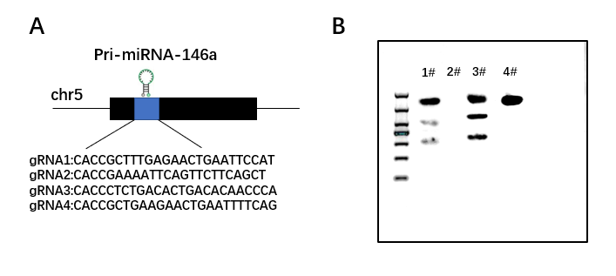
Figure 1. (A) Schematic representation of the four gRNA target sites within the genomic locus of pri-miR-146a. (B) Detection of the editing efficiencies of different gRNAs by T7 endonuclease I (T7EI) cleavage assay.

3.2. The lentiCRISPR/Cas9 system effectively reduces miR-146a expression in the gastrocnemius muscle of hindlimb-immobilized mice
The constructed lentiCRISPR miR-146a-3# recombinant plasmid or the empty lentiCRISPR v2 control vector was co-transfected with the helper plasmids psPAX2 and pMD2.G to package lentiviruses, which were then injected into the gastrocnemius muscle of hindlimb-immobilized (Imo) and sham-operated mice. western blot analysis revealed a marked increase in Cas9 protein expression in the gastrocnemius muscle of mice injected with lentiCRISPR miR-146a (Figure 2A). qPCR analysis showed that, compared with the sham group, miR-146a expression was significantly upregulated in the gastrocnemius muscle of the Imo group; conversely, injection of lentiCRISPR miR-146a lentivirus substantially reduced its expression (Figure 2B).
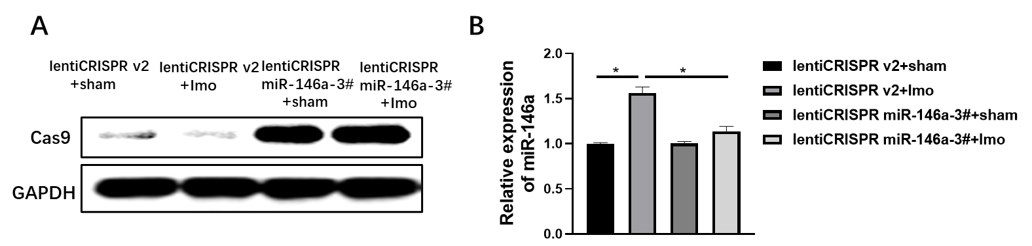
Figure 2. (A) Western blot analysis of Cas9 protein expression in the gastrocnemius muscle of mice from each group. (B) qPCR detection of miR-146a expression levels in the gastrocnemius muscle. (*P<0.05)

3.3. lentiCRISPR miR-146a inhibits hindlimb immobilization-induced muscle atrophy
qPCR results demonstrated that, compared with the control group, the expression levels of the muscle atrophy marker genes Atrogin-1 and MuRF-1 were markedly increased in the gastrocnemius muscle of the Imo group. however, following lentiCRISPR miR-146a treatment, the expression of both genes was significantly downregulated (Figure 3A). WGA staining showed that the cross-sectional area of myofibers was substantially reduced in the Imo group, whereas lentiCRISPR miR-146a intervention significantly restored myofiber size (Figure 3B).
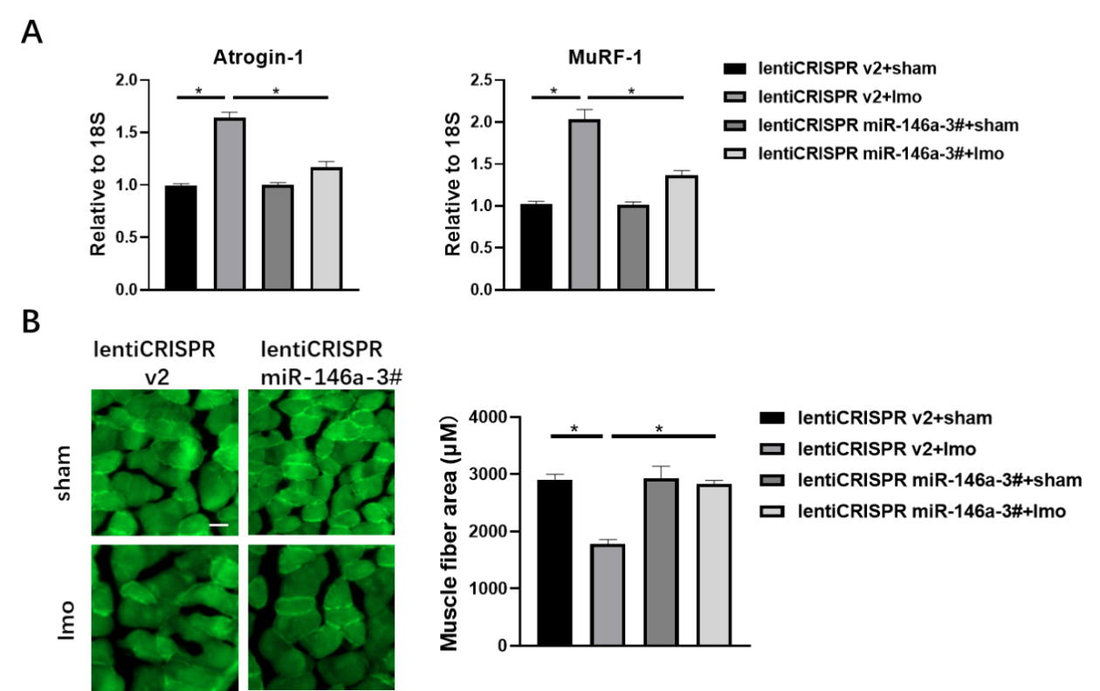
Figure 3.(A) qPCR analysis of Atrogin-1 and MuRF-1 mRNA expression in the gastrocnemius muscle. (B) WGA staining showing myofiber morphology (scale bar: 100 μm). (*P<0.05)

3.4. miR-146a knockdown restores mTOR/Akt phosphorylation
Western blot analysis of the gastrocnemius revealed that immobilization reduced p-mTOR and p-Akt levels relative to total mTOR and Akt. Importantly, lentiCRISPR miR-146a treatment significantly elevated both phosphorylated proteins (Figure 4).
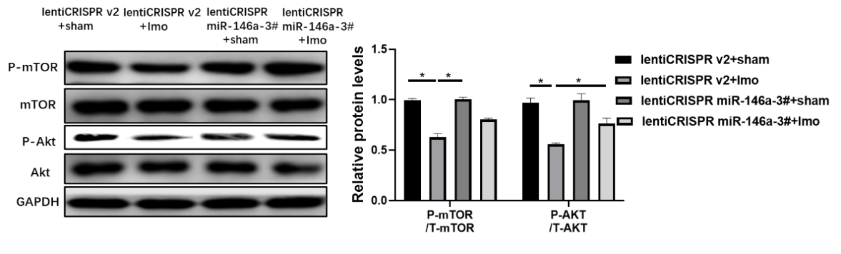
Figure 4. Western blot analysis of p-mTOR, mTOR, p-Akt, and Akt protein expression levels in the gastrocnemius muscle, along with statistical quantification of their relative expression levels. (*P<0.05)

4. Discussion
We started with a simple question: would editing miR-146a in muscle alter the course of disuse atrophy? The idea was not without precedent—CRISPR had been used to knock down miR-21 in cancer cells, with some success in xenograft models ^{[17]}. So we took a similar approach, delivered a lentiviral SpCas9 system into mouse gastrocnemius, and watched what happened. The editing worked: miR-146a dropped, and the muscle held up better against immobilisation. Myofibres stayed larger, and the usual surge of Atrogin-1 and MuRF-1 transcripts was blunted. These findings, we think, make a reasonable case for miR-146a ablation as a protective manoeuvre in muscle wasting, and they give us enough confidence to propose further preclinical work.
Why choose CRISPR over other methods? The older tools—antisense inhibitors and sponges—are fine for short-term experiments, but they are transient and not always faithful to their intended targets ^{[18,19]}. Homologous recombination is precise, no doubt, but it is cumbersome and slow for everyday use in animals. CRISPR sits in a sweet spot: efficient, relatively clean, and easy to adapt ^{[20,21]}. We aimed for the endogenous miR-146a locus and avoided its close cousin miR-146b, which tells us the targeting was reasonably specific. We also injected locally into the muscle, a route that feels closer to how one might treat a patient than pumping virus into the bloodstream. That adds some practical appeal, though we would be the first to admit that clinical translation is still a long way off.
What about the mechanism? The PI3K/Akt/mTOR axis is central to protein synthesis in muscle ^{[22–24]}. In our immobilised animals, phosphorylation of Akt and mTOR was down, as expected. Knockdown of miR-146a brought both back up. That suggests the protective effect runs, at least in part, through re-activating this anabolic route. Whether miR-146a binds directly to some component of this cascade or works through intermediaries is something we cannot yet answer. That will have to wait for a dedicated mechanistic study, probably starting with a screen for direct mRNA targets.
We should also be honest about the study’s boundaries. All our animals were male; we do not know if females respond differently. We did not do a genome-wide search for off-target mutations, nor did we follow the animals long enough to know whether the editing persists for months. And while we measured phosphorylation, we did not actually measure protein synthesis rates or breakdown fluxes—so the link to mTOR/Akt remains inferential at this stage. These are not minor quibbles, and they need to be addressed before anyone thinks about taking this to the clinic. Still, the proof-of-concept is solid enough to justify further work, perhaps with muscle-specific promoters or lipid-based delivery systems to improve safety.

5. Conclusion
To wrap up: miR-146a editing by CRISPR protected against immobilisation-induced atrophy, and the effect tracked with restored mTOR/Akt signalling. Larger animals, longer follow-up, and a deeper mechanistic dive are what comes next. Whether this eventually becomes a therapy is uncertain, but we think the door is now open a crack.

Disclosure statement
The authors declare no conflict of interest.

References
[1] Lopes J, Russell DM, Whitwell J, et al., 1982, Skeletal Muscle Function in Malnutrition, Am J Clin Nutr, 36(4): 602-610.
[2] English C, Mclennan H, Thoirs K, et al., 2010, Loss of Skeletal Muscle Mass after Stroke: A Systematic Review, Int J Stroke, 5(5): 395-402.
[3] Topp R, Ditmyer M, King K, et al., 2002, The Effect of Bed Rest and Potential of Prehabilitation on Patients in the Intensive Care Unit, AACN Clin Issues, 13(2): 263-276.
[4] Booth FW, Seider MJ, 1979, Recovery of Skeletal Muscle after 3 Mo of Hindlimb Immobilization in Rats, J Appl Physiol Respir Environ Exerc Physiol, 47(2): 435-439.
[5] Tischler ME, Rosenberg S, Satarug S, et al., 1990, Different Mechanisms of Increased Proteolysis in Atrophy Induced by Denervation or Unweighting of Rat Soleus Muscle, Metabolism, 39(7): 756-763.
[6] Jaspers SR, Tischler ME, 1984, Atrophy and Growth Failure of Rat Hindlimb Muscles in Tail-cast Suspension, J Appl Physiol Respir Environ Exerc Physiol, 57(5): 1472-1479.
[7] Ivey KN, Srivastava D. microRNAs as Developmental Regulators, 2015, Cold Spring Harb Perspect Biol, 7(7): a008144.
[8] Von Haehling S, Ebner N, Dos Santos M R, et al., 2017, Muscle Wasting and Cachexia in Heart Failure: Mechanisms and Therapies, Nat Rev Cardiol, 14(6): 323-341.
[9] Bei Y, Xiao J, MicroRNAs in Muscle Wasting and Cachexia Induced by Heart Failure, 2017, Nat Rev Cardiol, 14(9): 566.
[10] Horak M, Novak J, Bienertova-Vasku J, 2016, Muscle-specific microRNAs in Skeletal Muscle Development, Dev Biol, 410(1): 1-13.
[11] Rau CS, Jeng JC, Jeng SF, et al., 2010, Entrapment Neuropathy Results in Different microRNA Expression Patterns from Denervation Injury in Rats, BMC Musculoskelet Disord, 11: 181.
[12] Nelson CE, Hakim CH, Ousterout DG, et al., 2016, In Vivo Genome Editing Improves Muscle Function in a Mouse Model of Duchenne Muscular Dystrophy, Science, 351(6271): 403-407.
[13] Wei Y, Chen Y, Qiu Y, et al., 2016, Prevention of Muscle Wasting by CRISPR/Cas9-mediated Disruption of Myostatin In Vivo, Mol Ther, 24(11): 1889-1891.
[14] Xu L, Park KH, Zhao L, et al., 2016, CRISPR-mediated Genome Editing Restores Dystrophin Expression and Function in mdx Mice, Mol Ther, 24(3): 564-569.
[15] Lataniotis L, Albrecht A, Kok FO, et al., 2017, CRISPR/Cas9 Editing Reveals Novel Mechanisms of Clustered microRNA Regulation and Function, Sci Rep, 7(1): 8585.
[16] Huo W, Zhao G, Yin J, et al., 2017, Lentiviral CRISPR/Cas9 Vector Mediated miR-21 Gene Editing Inhibits the Epithelial to Mesenchymal Transition in Ovarian Cancer Cells, J Cancer, 8(1): 57-64.
[17] Chang H, Yi B, Ma R, et al., 2016, CRISPR/cas9, A Novel Genomic Tool to Knock Down microRNA in Vitro and in Vivo, Sci Rep, 6: 22312.
[18] Li J, Chan MC, Yu Y, et al., 2017, miR-29b Contributes to Multiple Types of Muscle Atrophy, Nat Commun, 8: 15201.
[19] Liu X, Xiao J, Zhu H, et al., 2015, miR-222 is Necessary for Exercise-induced Cardiac Growth and Protects Against Pathological Cardiac Remodeling, Cell Metab, 21(4): 584-595.
[20] Friedmann T, Roblin R, Gene Therapy for Human Genetic Disease?, Science, 1972, 175(4025): 949-955.
[21] Nelson CE, Robinson-Hamm JN, Gersbach CA., 2017, Genome Engineering: A New Approach to Gene Therapy for Neuromuscular Disorders, Nat Rev Neurol, 13(11): 647-661.
[22] Egerman MA, Glass DJ, Signaling Pathways Controlling Skeletal Muscle Mass, 2014, Crit Rev Biochem Mol Biol, 49(1): 59-68.
[23] Kok K, Geering B, Vanhaesebroeck B, 2009, Regulation of Phosphoinositide 3-kinase Expression in Health and Disease, Trends Biochem Sci, 34(3): 115-127.
[24] Yoon MS, 2017, mTOR as a Key Regulator in Maintaining Skeletal Muscle Mass, Front Physiol, 8: 788.

Publisher’s note
Bio-Byword Scientific Publishing remains neutral with regard to jurisdictional claims in published maps and institutional affiliations.

